**Rimbleton Primary School- Acceptable Use of Technology Policy**

**The following policy outlines the guidelines and behaviours that our pupils are expected to follow when using school technology.**



**SAFE** - Safe use of technology

1

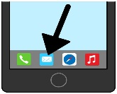I will only use tablets and computers when a teacher or adult is with me.

2

I will use apps and websites that my teachers say are safe and fun.

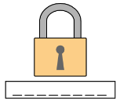3

I will not share my password with anyone.

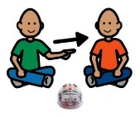**KIND** - Kind use of Technology

4

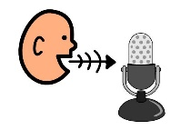I will take turns and share technology and computers with my friends.

5

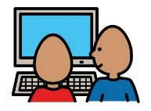I will be kind when using technology and say nice things when typing or recording my voice.

6

I will help my friends if they need it while using technology.

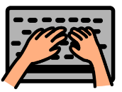RESPECTFUL - Respectful with technology

7

I will be gentle and careful when using technology.

8

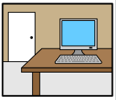If carrying equipment, I will use two hands and walk carefully.

9

I will tidy all equipment away when I am finished using it.



Ambitious – Ambitious when using technology

10

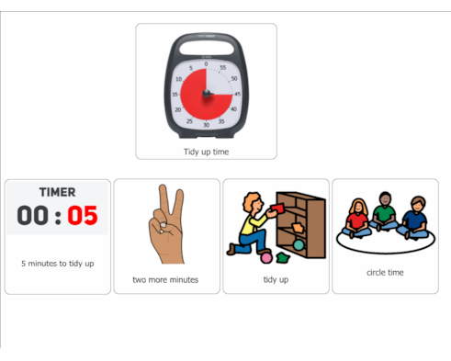I will try my best to do new things independently.

11

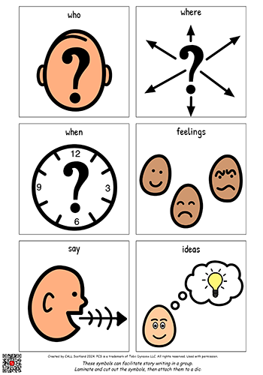I will ask questions when I need help with digital technology.

12

I will share my digital ideas in creative ways.

** Senior Acceptable Use Policy**

**In addition to the above terms, our Primary 4-7 pupils have also agreed to the following:**

|  |
| --- |
| * I will only print if my teacher has given me permission to do so. * I will always log off the netbook or computer when I am finished. * I will speak to an adult I trust if something happens to either myself or another child which makes me feel worried, scared or uncomfortable. * I know that being responsible means that I should not search for inappropriate images, violent or unsuitable games. * I understand that all access to internet and emails will be monitored. * I will write online messages or emails carefully and politely as I know they could be seen by someone else. * I will only talk with, and open messages from people I can trust or someone a teacher has connected me with. * I know that bullying in any form (on and offline) is not OK, and I know that technology should never be used for bullying. I will not use technology for this purpose. * I understand that I need to look after technology at home, as well as in school. |

Pupils understand that if they do not follow this Acceptable Use Policy, their access to digital technology may be limited or removed to support Rimbleton's school values and promote a positive behaviour environment.

**\*There is also an acceptable use policy created by ‘Transforming Learning in Fife’ on our school website\***