**Rimbleton Primary - Acceptable Use of Technology Policy**

**The following policy outlines the guidelines and behaviours that our pupils are expected to follow when using school technology.**

SAFE - Safe use of technology

1

I will only use tablets and computers when a teacher or adult is with me.

2

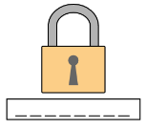I will use apps and websites that my teachers say are safe and fun.

3

I will not share my password with anyone.

KIND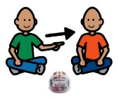 - Kind use of Technology

4

I will take turns and share technology and computers with my friends.

5

I will be kind when using technology and say nice things when typing or recording my voice.

6

I will help my friends if they need it while using technology.

RESPECTFUL - Respectful with technology

7

I will be gentle and careful when using technology.

8

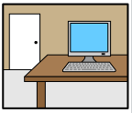If carrying equipment, I will use two hands and walk carefully

9

I will tidy all equipment away when I am finished using it.

In addition to these terms, our Primary 4-7 pupils have also agreed to the following

* I will only print if my teacher has given me permission to do so.
* I will always log off the netbook or computer when I am finished.
* I will speak to an adult I trust if something happens to either myself or another child which makes me feel worried, scared or uncomfortable.
* I know that being responsible means that I should not look for bad language, inappropriate images, violent or unsuitable games.
* I understand that all access to internet and emails will be monitored.
* I will write online messages or emails carefully and politely as I know they could be seen by someone else.
* I will only talk with, and open messages from people I can trust or someone a teacher has connected me with.
* I know that bullying in any form (on and offline) is not OK, and I know that technology should never be used for bullying. I will not use technology for this purpose.

Pupils understand that if they do not follow this Acceptable Use Policy, their access to digital technology may be limited or removed to support Rimbleton's school values and promote a positive behaviour environment.

*This is a summarised version of the policy. The full version can be found on our school website.