8 FEB - SAFER INTERNET DAY

February 8 is Safer Internet Day across the world and we want to make it a successful SAFER INTERNET FIFE FOCUS.
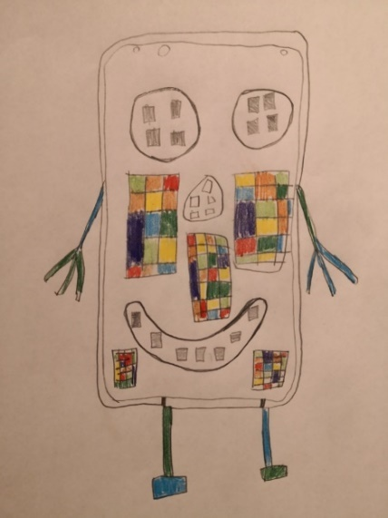
Across Fife, and the country, we are all living our lives online more than we ever have. There’s never been a better time to focus us all on the risks and opportunities, tools to keep us safe and what to do when it goes wrong.
Parents report that a shared focus for learning can help them manage different work with multiple children and so a school focus on safer internet during this week can help support our staff, learners and families to be safe, informed and learning together.
The following resources and links will support your planning in school to ensure that, across Fife, we are all safer and happier online.
Click Here to access the excellent resources from South West Grid for Learning – How schools can celebrate Safer Internet Day remotely
As a result of remote learning, the UK Safer Internet Centre has put together guidance on how schools can still celebrate Safer Internet Day remotely. They have put together overviews of the exciting resources available, outlining how schools and other settings can still enjoy the day no matter where they are. This is to ensure that we can spread the message about 'Together for a better internet’ for Safer Internet Day taking place on the 8th February 2022.
The site has resources for age groups 3-7, 7-11, 11-14 and 14-18 along with quizzes, films and resources for parents and carers. Click the link above.

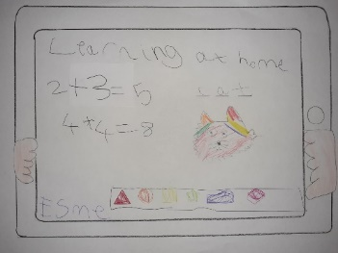
The Safer Internet Day website (click here) has practical ways in which you can get involved in the celebrations. Whether you are a young person, a parent or carer, a teacher or an educator, a policy maker, or whether you represent an organisation or industry, everyone has a role to play in creating and maintaining a better online world.

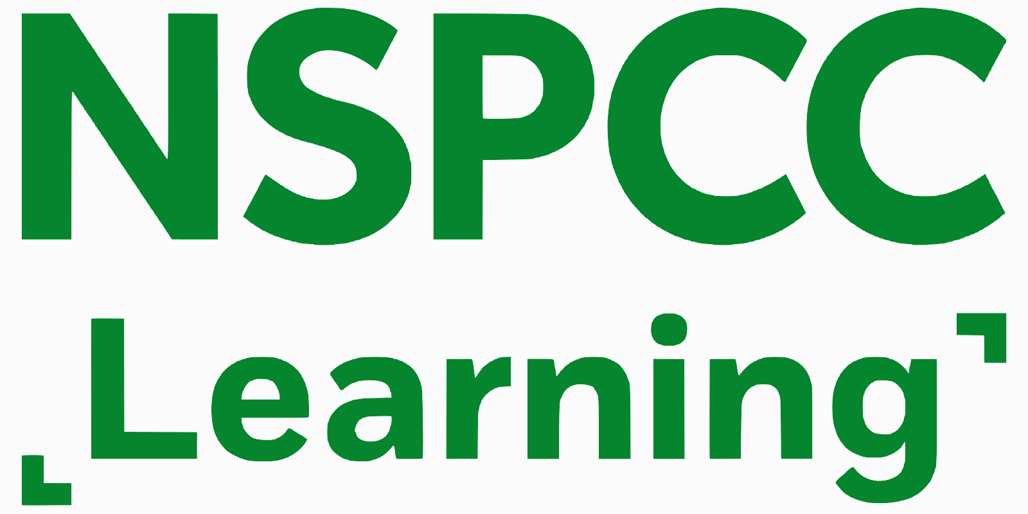
It can be hard to know how to talk to your child about online safety. From setting up parental controls to advice on sexting, online games and video apps, NSPCC can help staff and parents/carers to understand the risks and keep children safe online. Click here to access the site.

Share Aware Teaching Resources from the NSPCC covers information, lessons and resources on sharing information online safely. Including the PANTS resource, online safety training for staff, information for parents and e-safety. Click here to access the site.

E-Safety for schools from the NSPCC covers a range of advice, guidance and training in areas including teaching e-safety, Social Media, Livestreaming, supporting parents and carers and on IT and data protection. This information can help schools to:

- create e-safety policies and procedures that will help mitigate risk and respond to concerns;
- ensure teachers have the knowledge to teach learners about e-safety;
- provide advice on using social media and live streaming;
- support and include parents and carers by sharing helpful advice and resources;
- review and update your e-safety provision on an ongoing basis.

E-safety and online security is an ongoing safeguarding consideration for schools. Click here to access the site.

Other links to guidance, support and resources online including links to critical reading and thinking resources:

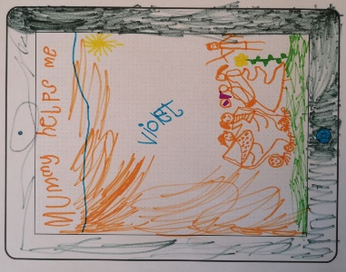
- https://thinkuknow.co.uk
- https://childline.org.uk/info-advice/bullying-abuse-safety/online-mobile-safety/staying-safe-online/
- https://childnet.com/resources/online-safety-activities-you-can-do-from-home
- https://internetmatters.org/resources/online-safety-guide/
- https://www.net-aware.org.uk/
- https://www.theguardian.com/newswise-unit-of-work
- https://wordsforlife.org.uk/activities/how-navigate-news/
- https://www.bbc.co.uk/bitesize/topics/zdtsxbk/articles/zj9tqfr
- https://education.gov.scot/improvement/scotland-learns/resources-for-practitioners/literacy-and-english-activities/research-reliable-facts-second-level/
- https://www.bbc.co.uk/teach/live-lessons/bbc-news-live-lesson/zn4kqp3

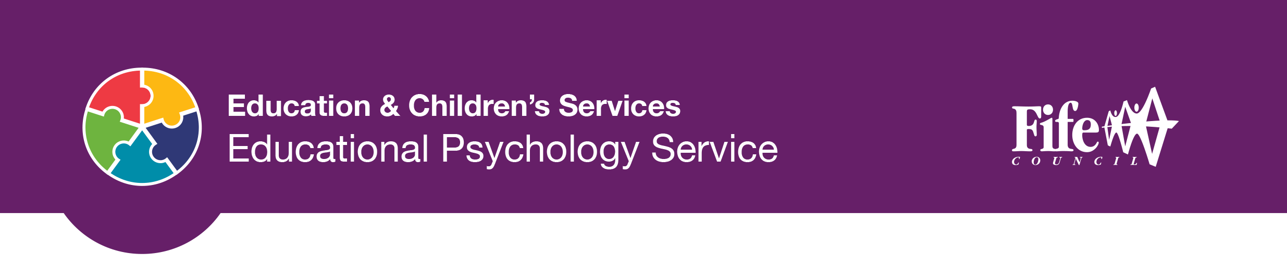
Cyber Safety Training Pack from the EP Service

Who is this pack for?
This training pack is aimed at Fife education staff seeking to develop their own knowledge and skills around social media and keeping safe online. The pack also contains resources which are aimed at young people and their families to support knowledge around the risks and opportunities that social media use may present.

Purpose of this pack
This pack aims to take account of the most up to date research, advice and guidance regarding the risks and opportunities of children and young people’s use of social media. It also aims to provide information and support for staff on their own use of social media and protection of their own and school’s professional identity.

Increased access to social media opens many new and exciting opportunities to share information and resources. There are benefits but also potential risks. During the pandemic people are relying even more on online technology. Recent figures indicate that Covid -19 has pushed up internet use by as much as 70% as young people and adults around the world seek new ways to keep connected, informed, entertained as well as accessing education and work. Services such as Tik-Tok and Zoom are seeing unprecedented growth according to Ofcom’s latest study into the nation’s online lives. Now, more than ever, it is important that we all know how to keep ourselves and others safe and protected to ensure we have a positive online experience.

Intended outcomes
- To support the development of staff skills and awareness by bringing together relevant guidance, resources and materials on cyber safety.
- To provide a research informed lens to our knowledge of key issues, risks and opportunities.
- To support staff in how to engage children/young people and their families to keep them safe in their use of social media.

RIGHT CLICK HERE AND SELECT “COPY HYPERLINK”
The Pack is available on a ‘Prezi’. Right click above and select copy hyperlink. Paste this link into Google Chrome or Edge – NOT Internet Explorer and press PLAY on the screen to the right of the page. The presentation will launch and, once fully loaded, you can navigate using the arrow keys. There is a wealth of information, resources, videos and clickable links.

