

**Believe to Achieve**

**W**elcoming **E**veryone **S**uccessful **T**ogether

Relationships and Behaviour Policy 2024

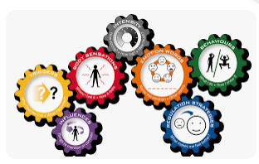



**RATIONALE**

The ethos at Pitteuchar West Primary School is one of high expectations and aspirations for all. We are a nurturing and caring community where everyone plays an important role in working to the vision and values of the school:

**At Pitteuchar West primary we**:

‘**Believe to Achieve’**

**‘W**elcoming **E**veryone **S**uccessful **T**ogether’

**ACHIEVING POSITIVE BEHAVIOUR**

At Pitteuchar West Primary we recognise that our positive behaviour approach has been critical to the school’s success of good discipline which contributes immensely to the quality of teaching and learning. Managing behaviour is not just about responding to inappropriate behaviour. It is about creating conditions that encourage positive behaviour.

‘*All learning environments should have a positive influence on children and young people. This can be achieved by promoting inclusion and equality and through approaches to developing positive relationships and behaviour’. (Education Scotland)*

We achieve this by:

* Ensuring each class has an agreed charter which is linked to the UN Convention on the Rights of the Child.
* Building positive relationships and connections with pupils, and parents.
* Each class teacher adopts a reward system that meets the needs of each child.
* We provide an environment which is nurturing, uses praise, encourages growth mindset and is inclusive to every child.
* A restorative approach is used in dealing with any issues alongside Emotion Works at universal level, and individual basis if necessary.
* Integrating the Compassionate and Connected Classroom resource into every class where pupils have the opportunity to develop their compassion, empathy and tolerance to others whilst recognising the importance of the United Nations Rights of the Child.

As a school, we regularly celebrate the success of positive behaviour, whether in the classroom, with a Teacher Reward/Depute Reward/Headteacher Reward and through Kindness Awards presented weekly in assemblies or as part of the whole school community.

* 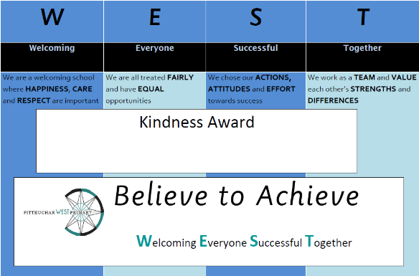Kind to ourselves
* Kind to each other
* Kind to our environment

We also regularly share successes through class sways that are shared through our school app. We welcome all parents to help us celebrate these successes together.

**RESPONSIBILITIES**

Pitteuchar West Primary School recognises that everyone has a responsibility on the implementation of our positive behaviour ethos. Staff, pupils and parents/carers all play a vital role in delivering this successfully in line with Fife Council’s de-escalation procedures.

We do recognise that at times children may need a bit more support in dealing with relationship and/or behaviour issues in their lives.

We use Emotion Works scripting throughout the school and nursery. Our Emotion Works ‘Fix It’ folders are available in class and in communal areas to allow pupils to share their feelings either verbally or non-verbally through Boardmaker symbols, as well as being supported to identifying the emotions behind their own or others’ behaviours.

Restorative actions are supported, with a focus on repair, to reinforce the ethos and values important to our whole school community.

Working effectively with parents and carers enables us to tackle these issues and successfully achieve an outcome. Working in partnership with parents not only supports the child but can also offer support to the parent.

Children with particular social and emotional behavioural needs will be further supported through individual planning in conjunction with parents and carers.

Our buddies use Emotion Works scripting, worn on a lanyard, with the cogs also displayed in the playground.

Each class has their own calm corner, designed by pupils to ensure these meet the needs of individuals within each class.

All staff are Kitbag trained, with additional daily sessions run by our Kit Bag Pupil Ambassadors.

Kitbag mini kits are shared with families to support conversations at home. This session, we have engaged with Decider Skills Scotland Good2Go, to further support the development of skills which promote, teach and support children in their capacity to manage emotions.

**CONCERNS**

If there are any concerns about a child’s behaviour or if a child is **consistently** not meeting the school’s expectations then more intensive supportive actions will take place.

These can include:

* The class teacher to record the times when school values are not met by the pupil using ABC charts to identify possible triggers and consequences.
* Professional judgements between the class teacher and the School Leadership Team to discuss when to share with parents.
* The child to be removed from the class setting to work with a member of the school leadership team, PSA or other teacher to de-escalate and keep others safe.
* For a meeting to be organised for the child and parent/carers with the Headteacher/Depute Headteacher.
* We use the Fife SEEMIS system to record and track behaviours or concerns and encourage parents to discuss any concerns with us.

As a school we will work as a team in guiding the child through these barriers to their learning.

*‘In partnership we can work together to help the child develop good relationships, enjoy being at school, and learn as effectively as possible.’*

*(Fife Council)*

**POLICY**

This policy is part of the Relationship and Behaviours Policy, which also include:

* Nurture
* Mindset
* Anti-bullying
* E-Safety
* Pupil Leadership

These policies highlight a number of ways we support children to develop and maintain positive relationships and to achieve the four capacities. All of these policies will help children to become:

* Successful learners
* Confident Individuals
* Effective Contributors
* Responsible Citizens

