Pitteuchar East PS

School Travel Plan

Head Teacher: Mrs J M Knussen
School Address: Glamis Avenue
Glenrothes
Fife
KY7 4NU
Telephone No: 01592 583452

Contents

Summary Page

1.0 Introduction
  - School Background

- Policies and Objectives
  - Formation of Junior Road Safety Officers

3.0 Current Travel Patterns
3.1 Hands Up Survey
3.2 Questionnaire Surveys

4.0 Mapping Work

5.0 Route Audit of key routes to School

6.0 Staff Questionnaire Data

7.0 Behavioural Action Plan

8.0 Monitoring and Evaluation

9.0 Distribution of School Travel Plan

Appendix 1 – Comments raised by Parents

Appendix 2 – Route Audit Document

Summary Page

The following travel plan is a collaborative plan as parents, children, staff and stakeholders were all involved in researching and devising the content, agreeing the actions and aims to make the overall journeys to and from Pitteuchar East PS safer, healthier and more enjoyable by:

- Making journeys to and from school safer for everyone;
- Reduce traffic in front of the school by reducing the total number of cars used for the
school journey;
- Increase awareness of active travel and educating all about road safety;
- Improving Active Travel facilities (bike and scooter storage, helmet storage, etc.);
- Promoting alternatives to car travel (cycling, walking and scooting), increasing the percentages of active travel.

The key issues and perception relating to journeys to and from school were identified as – safer crossing facilities on busy roads for children, more road safety lessons and a reduction to inconsiderate parking outside school gates, which causes problems including: -

- Congestion
- Blocked vision for walkers and cyclists
- Blocked vision for other drivers
- Low proportion of children actively travelling to school, especially in bad
weather
- Concerns about road safety and speed of traffic

47% of those who answered this question within the survey highlighted that they lived within a 2 mile radius of the school.

Routes identified as safer routes to school are:

- Glamis Avenue
- Blair Avenue remote path links to Stenton
- Remote Path links within Pitteuchar

Proposed Behavioural Actions

Promote Active Travel School
Promote Safer Routes to School
Road Safety Education
Reduce Congestion around the school gate.
Deliver Cycle Training School (Bikeability)

This plan is valid for 6 years and will be reviewed during year 3.

1.0 INTRODUCTION

1.1 School background

Pitteuchar East Primary School is in the town of Glenrothes, situated approximately 2 miles from Glenrothes town centre. It is one of two Primary Schools serving the Pitteuchar area.
The school was opened in 1970 to serve the southern Glenrothes precincts of Pitteuchar, Stenton, Finglassie and Lochty View and has remained at 264 in the school, and up to 137 in the nursery. The staff team comprises Headteacher, Depute Headteacher, 14 class teachers, Learning Support teacher, seven Pupil Support Assistants.
There are 4 pedestrian gates (Glamis Avenue, Megginch Place, East Gate and West Gate) plus 2 vehicle gates (both Glamis Avenue) at the school and nursery. There is one public entrance each to the school and nursery buildings, with 2 pupil entrances to the school building. The school has 20 car parking spaces, none of which are available to parents, with 6 spaces at the nursery. Visitors are permitted to park within the school and nursery grounds.
Surrounding streets are within a 20mph zone. There are zebra crossings on walking routes to schools and 1 school crossing patroller operates on the route. There is a designated Park and Stride site where cars can park safely, and children can walk a short distance to/from school. This is located within the Glamis Centre Car Park. The safer routes to and from school are marked on footpaths throughout the catchment although these are now worn and hard to recognise.

There is a school bus which operates within the area. The timetable is shown below:
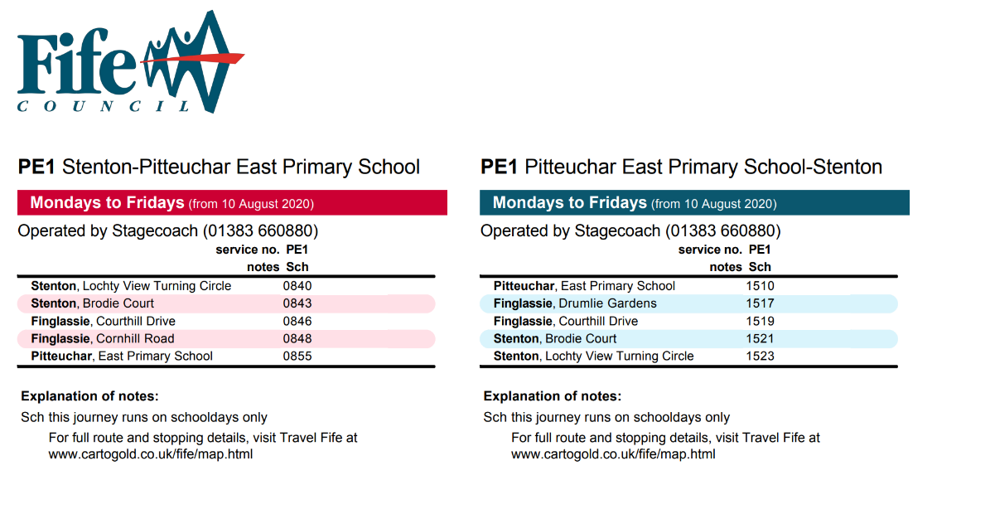
The nursery is set in its own building within the campus, with a staff team comprising Principal Teacher and 17 Early Years Officers and capacity for 122 pre and ante-preschool children and 15 Under 3s. We also have three office staff who carry out the admin and clerical tasks within the busy school.
Pitteuchar East Primary is one of 9 primary schools associated with Auchmuty High School, with almost all P7 pupils transferring there.
We are privileged to work in an ethos of respect and improvement, where everyone’s views matter. Our school is driven by our values of Nurture, Inclusion, Respect, Compassion and Ambition. Our school motto is “It’s all about the bairns”. And it is!

2.0 POLICY AND OBJECTIVES

2.1 Formation of Junior Road Safety Officers

It is recommended to create JRSO’s (Junior Road Safety Officers) within the school to help raise road safety awareness and promote road safety issues to everyone in the school and the wider community.
For more information on JRSO see website www.jrso.com
There is also a dedicated team that will assist with the development of JRSO’s, email them for more information. Safercommunities.projectofficers@fife.gov.uk

3. CURRENT TRAVEL PATTERNS

3.1 Hands Up Survey

The hands up survey looks at how children travel to school. This information is captured in the month of September on any given day. The information captured for Pitteuchar East in 2022 highlighted that out of 231 chiildren who were present on the day, 42% walked, 4% cycled, 3% scooter/skate, 20% park and stride, 27% driven and 3% bus. Please see the diagram below:

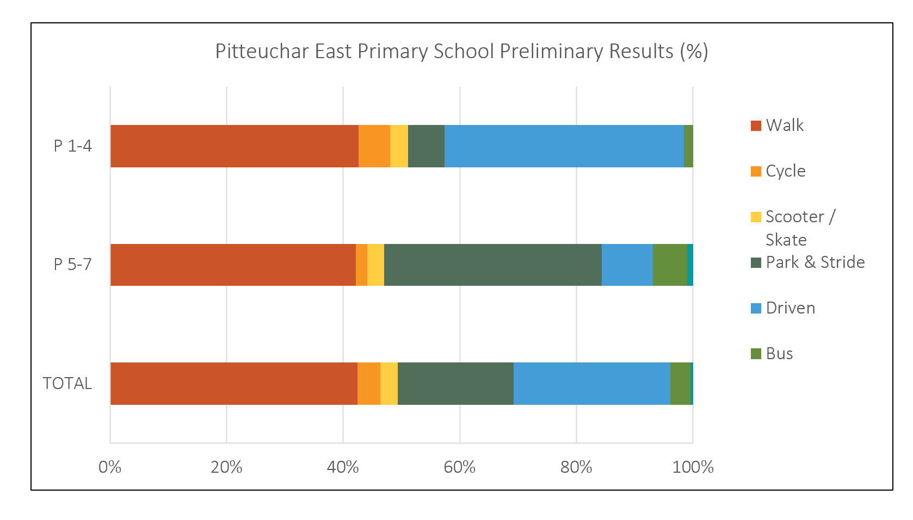

3.2 Questionnaire Surveys

A questionnaire was issued to families and staff prior to completing a route audit. During the consultation period 77 families and 25 staff members responded, and the following analysis is based on the data from those surveys.
Family Survey Data
43 families highlighted that walking was the main mode of travel to school with an additional 4 families stating that they either get the school Bus or use Pubic Transport.
30 families stated that driving was their preferred mode of travel.
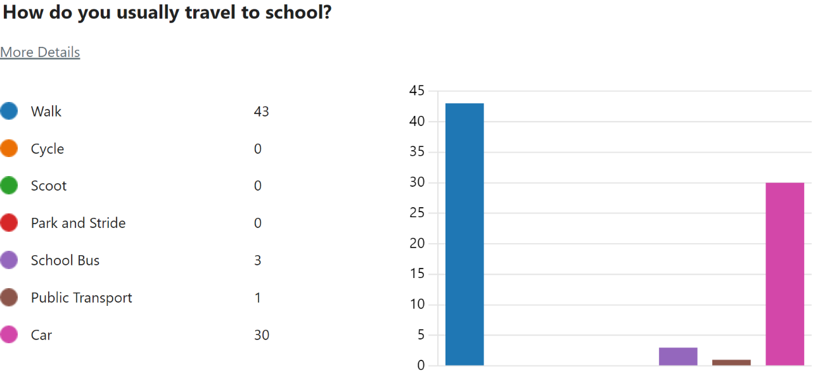

The main reasons given for travel mode choices are:
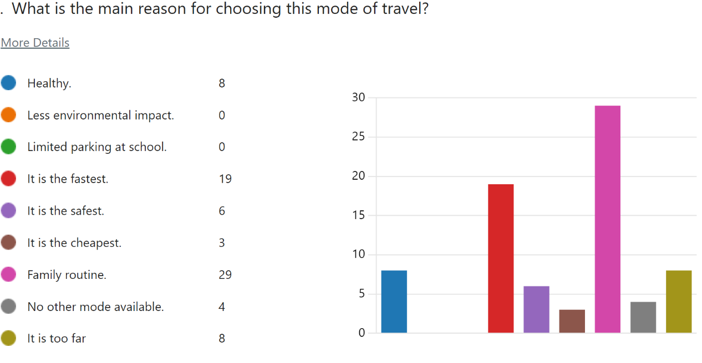

When asked how far from the school do you travel 13% of families stated they live within a 1 mile radius with a further 19% saying that they lived within a 2 mile radius.
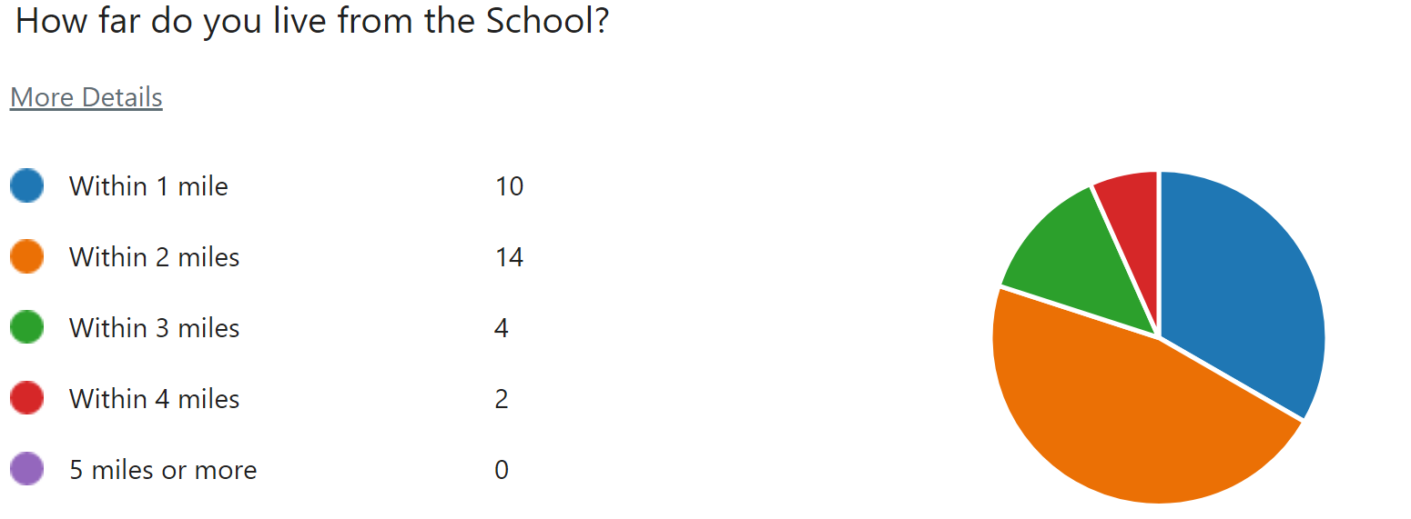

43% of family say the journey to school takes less than 5 minutes with 40% saying it takes 5-10 mins.
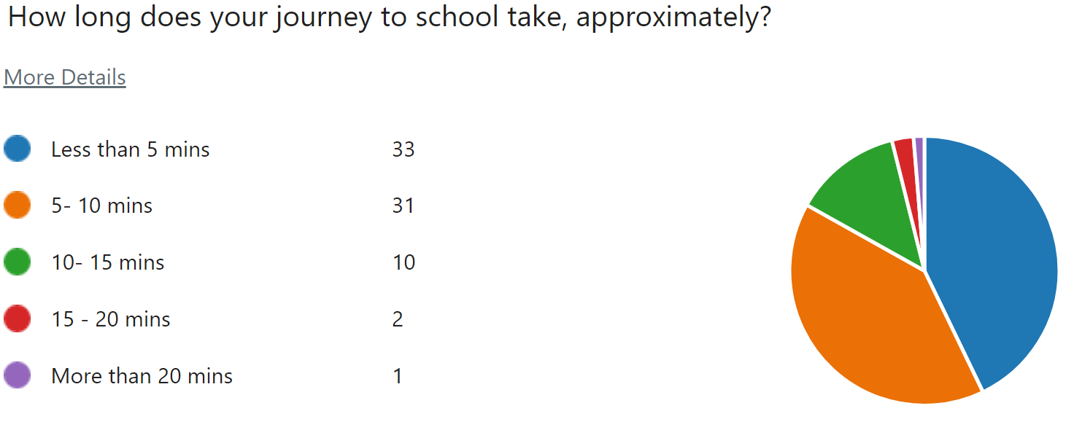

According to the survey 67% of parents are very satisfied with the way their child/children travel to school with only 11% stating that they were neither satisfied or dissatisfied, but none gave a reason to why they felt dissatisfied with their journey.
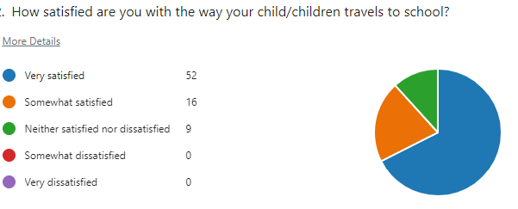

Parents were also asked “to what extent do they agree with the following statements about your child/children journey to school”.
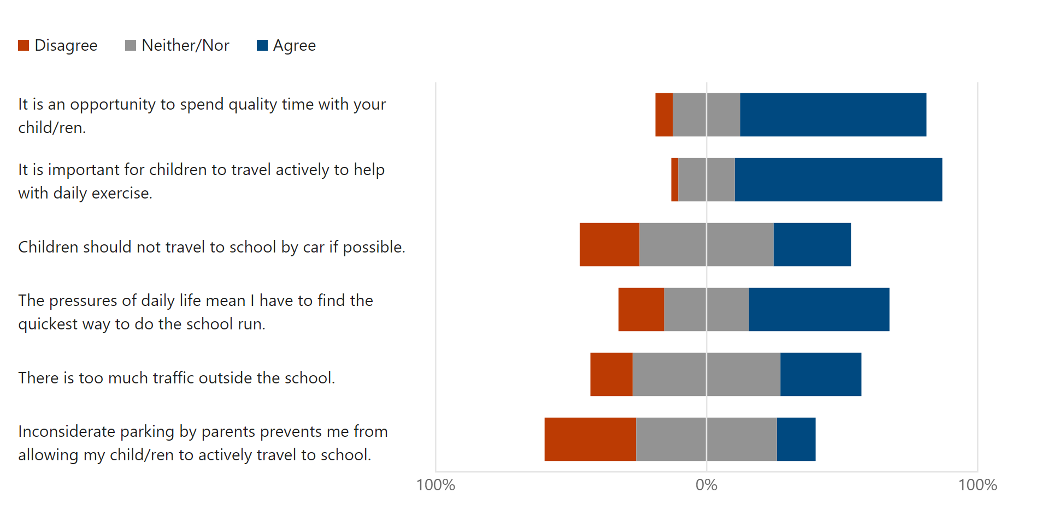

Parents then went on to state that the following factors have an impact on their decision on whether they would allow their child/children to actively travel to school.

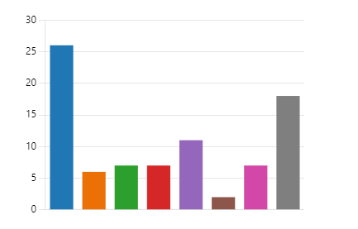
Safe crossing facilities on busy roads.
Vehicle speed reducing measures.
Knowing that other children are walking/ cycling.
Knowing that other children are walking/ cycling
More road safety for children.
More information on the health and
environmental benefits of walking and cycling.
Reduction of inconsiderate parking at the gate.

Parents were asked if they were aware of any initiatives being taken at school to encourage more sustainable travel patterns. The following diagrams highlights their response.
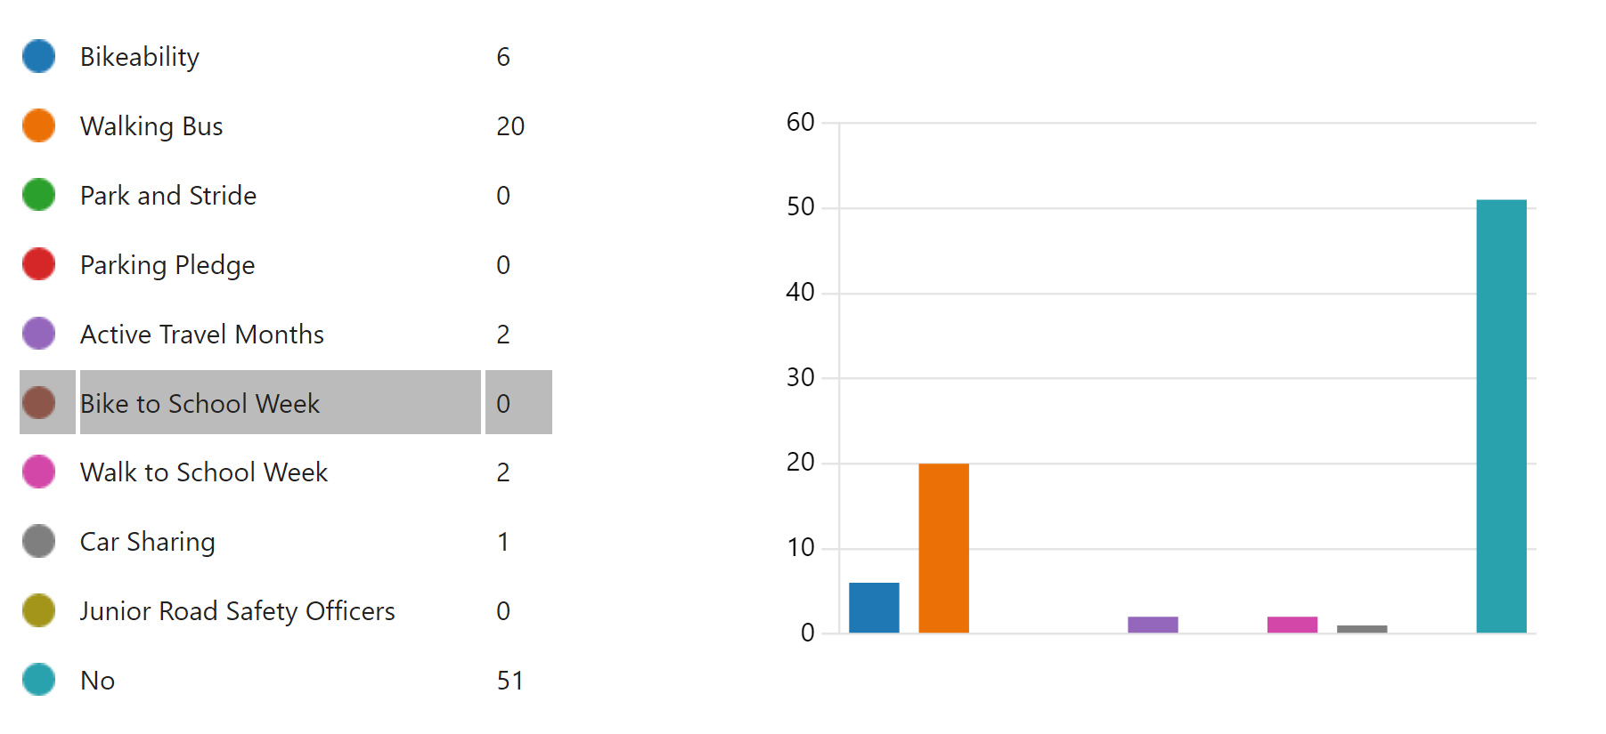
Finally, when asked if there was anything else, they would like to tell us about their journey the main issues raised were inconsiderate parking and safety. Full List in Appendix 1

4.0 MAPPING WORK
A mapping exercise was carried out with each class and the four main routes identified were collated and inserted into one map. These routes are:

- Glamis Avenue
- Blair Avenue remote path links to Stenton
- Remote Path links within Pitteuchar
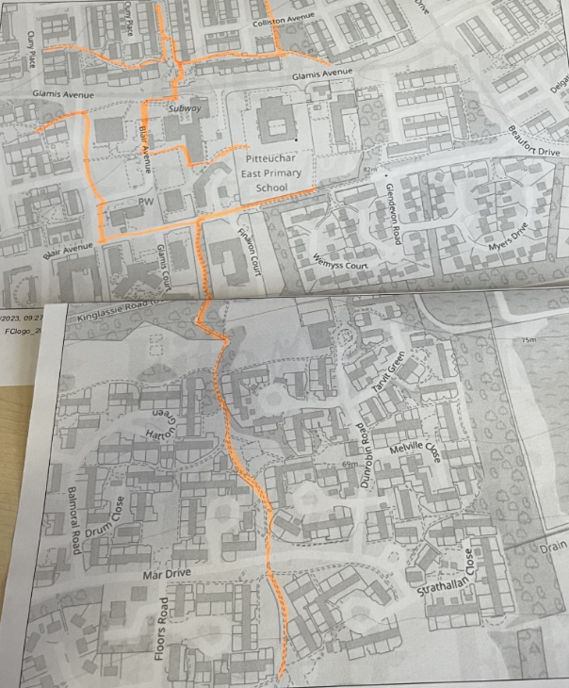

5.0 ROUTE AUDIT OF KEY ROUTES TO SCHOOL
A site visit of the above key routes was took part on Tuesday 18th April 2023. The JRSO’s and the School Travel Plan Co-Ordinators walked the routes highlighted in the mapping exercise.

For full audit report please refer to appendix 2.

6.0 STAFF QUESTIONNAIRE DATA
Members of staff undertook an online survey on how they travel to school and the impact this has on the school run. The following analysis highlights their mode of travel.

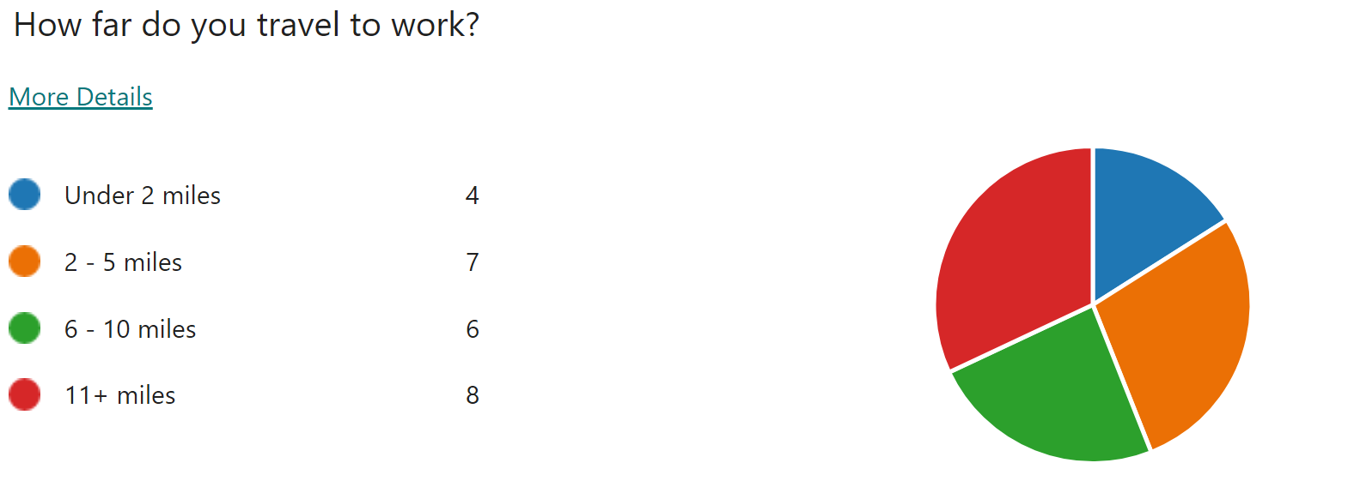

Majority of staff cited that they drove to school and parked within the school grounds with 1 person parking outwith. 40% of Staff would consider Car Sharing.
When asked what would encourage them to consider alternative modes of transport majority stated that nothing as they have other commitments outside school. Some stated that they would consider using public transport if it was quicker and more accessible.
When asked about any improvements they could make to their journey to ensure the routes to school were less congested most stated that they would consider car sharing or leaving the house earlier to avoid school drop off times.

7.0 BEHAVIOURAL ACTION PLAN

Action | Solution | Action Owner | Target Date (Academic year)
Promote Active Travel | Take part in Active Travel Months  Take part in Bike Week  Take part in the SUSTRANS BIG WALK AND WHEEL  Walk to school week | School/TAG  School/TAG  School/TAG  School/TAG | Term 2 & Term 4  Term 4  Term 3  Term 4
Promote Safer routes to school | Upload map to website  Upload bus timetable to website/social media pages and share with parents  Pitteuchar-East-PS.pdf (travelfife.com)  Put information board up at parents nights  Articles/videos in school newsletters, social media and assemblies to encourage parents to use park and stride sites identified and to encourage sustainable travel where possible | School  School  School/TAG  School/TAG | Term 1  Term 1  Term 2  Term 4  Ongoing
Road Safety Education | Run poster campaigns  Take part in Road Safety Week. | School/TAG | Ongoing  Term 2
Reduce congestion around school gate | Develop the following:  Parking Pledge  Park N Stride Site  Walking Bus | School/TAG | Ongoing
Bikeability | Offer cycle training to all pupils | School | Ongoing

8.0 MONITORING & EVALUATION
The JRSO’s will continue to meet periodically to monitor progress and will review the Travel Plan on an annual basis.
Specific progress will be monitored by participation in the “Hands Up Survey Scotland” each year and a repeat of the full travel survey will take place 6 years after initial launch.
The school’s ongoing commitment to travel planning will be publicised in the school handbook, the school newsletters, the Parent’s notice board and through assemblies.

9.0 DISTRIBUTION OF SCHOOL TRAVEL PLAN

The following bodies will receive a copy of the School Travel Plan:

- Fife Council Assets, Transport and Environment via the Travel Plan Team
- Fife Council Education Service
- Fife Council School Estates Team
- Parent Partnership
- Active Schools
- Copies will also be made available to the parents from the School Office and
via the school information site.

Appendix 1
Is there anything else you would like to tell us about your journey to school?

It’s a good way of communicating with your child about anything they want to discuss on a one-to-one time.
I previously used to walk my son to nursery, or he would cycle, but moving further away means using the car is often the quickest way to get him there and make it to work on time.
We only take the car as need to go straight to work from drop off.
My boy goes on walking bus and it's a huge help. Plus, he really enjoys it.
I do worry about kids crossing at the Magginch car park as well as the school’s car park entrance. The parking at the Glamis Centre can be dangerous as well due to speed of some drivers. But I know unfortunately this is out if the schools control.
Very busy roads, cars do not always stop at zebra crossings and often will go over the zebra crossing before we are finished walking across.
I do agree with being more active and walking or cycling to school, but my disability makes this option unavailable.
It does allow some time to chat with daughter, unfortunately too far away to walk due to working full time.
Parking at the school is not ideal, the carpark at the Glamis is not big enough and the one at the back is dangerous. I also think the crossing from Blair Avenue should be a zebra crossing. There used to me a lolly pop man there, but this service has never been replaced.
My only concern is the crossing heading to and from school drivers drive to fast don’t see the kids and even if they do see kids’ majority don’t stop. Crossing heading into streets towards Delgatie Avenue.
I go straight to work from the school and 2 of my children are too young to walk alone.
We live too far away for my son to walk or cycle to school but have decided he would be best to stay at this school as he is used to this school.
I live across the road from the school so it would be inconsiderate to do anything but walk.
Unfortunately, due to working hours and distance from work, there is no alternative until my youngest child is deemed old enough to walk to school on their own with their older siblings.
My son now walks to school on his own but in the past, he used the walking bus which was a fantastic service that supported me through hard times as a single parent working nights and without such a thing life would have been much more difficult. It built his confidence and was something he really enjoyed being part of. I’ve never given any feedback regarding this but wanted to mention now what a huge impact it had on our lives years ago.
I enjoy the short walk to school. It will get my son used to it for when he can eventually walk up himself when he's older.
We live close to the school, so walking is really the best option.
Although they have a lollypop person in the morning, there is nobody after school when the road is busier.
Dropping of by car means I can get to work in time. It’s not always feasible to walk for working parents.
I would love to have the opportunity to walk or give my child a lift to school. However, due to work commitments, I am unable to do so.
Too far to walk.
Some of the local parents like to help each other out with picking kids up/dropping them off whilst walking their own children to school. This has been beneficial for myself when I was pregnant and had a new baby and now, I take my turn to pick up my daughters' friends on the way to school too.
The school bus is great, especially as I can get on with her then head up to work once, she goes to school. She also enjoys socialising with her friends on the bus.
We drive as my daughter is autistic and it’s her routine to do this plus, we both work and it does save time. We adhere to school policy about the parking measures that are in place for the safety of everyone.
I work far away and always make sure my child is safely in the school before heading off! Safety for my child includes the fact that there have been incidents in the past involving adults fighting on my child’s route! Also, a few more extreme acts of violence! Therefore, with due care and attention to school safety I make sure my child gets there without me worrying! I do not block gates! I do not sit waiting! 15-30 seconds to say goodbye to my child! I am aware of the safety aspect but do agree you should be firmer with the driving parents! Spar car park is fine!
Although we drop off by car in morning. My child gets the school bus home. She would get the bus to school however it means crossing a particularly busy road as the bus does not come along the main road.
More safe crossings.
We could try the bus, but I have 1 child in nursery. Who cannot travel by bus and needs an adult to pick up.
Sometimes the lolly pop man isn’t there.

APPENDIX 2

FIFE COUNCIL
ASSETS, TRANSPORTATION & ENVIRONMENT

Route Audit of Key Routes to School.

A site visit of the key routes was carried out on the morning of Tuesday 18th April 2023. The weather conditions were dry and sunny. Those in attendance were the school travel plan team and the JRSO’s.

The areas audited were: -
- Glamis Avenue
- Blair Avenue and the remote path links to Stenton
- Remote path links within Pitteuchar

The school has three pedestrian entrances on Glamis Avenue, remote path link from Blair Avenue and a remote path link from the Glamis Centre and one vehicle entrance on Glamis Avenue.
The residential areas adjacent to the school are covered by a full time mandatory 20mph speed limit and has associated traffic calming features and repeater signs.
At the time of undertaking the key route audit all school keep clear signage and other relevant markings were clear and readable.

Glamis Avenue
Issue
Pupils walking from the remote streets around Pitteuchar use the main gate on Glamis Avenue to access the school grounds. JRSO’s stated that this area is particularly congested at drop off and pick up times by those parents who drive their children to school.
All raised the issue of parents parking in the dedicated bus bay forcing the school bus to drop off pupils either further down the street or beyond the school gate.

Recommendation
Investigate options for improving parking and reducing congestion around the school gate.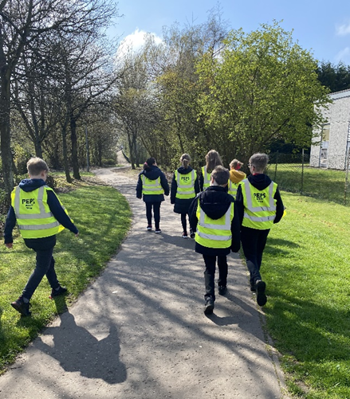

Action
School Travel Plan team to work with the JRSO’s to develop parking campaigns to highlight the danger parents are causing by parking in the dedicated bus lane.
Reinstate the park and stride site from the Glamis Centre.
School to contact the local police for support in moving parents out of the bus lane and the school travel plan team to speak with the parking enforcement team about adding the school to their list of periodic site visits.

Blair Avenue and Remote path link to Stenton
Issue
Blair Avenue is connected by remote footpaths that lead to and from Stenton area. Pupils who travel from this area stated that the bridge over the dual carriageway, although safe, needs some repairs and pointed out a quite a few hazards that they believe were barriers to active travel.
They also commented about the broken glass and debris on and around these remote paths.
Recommendations
Investigate which department within the council is responsible for the bridge and report the JRSO concerns.
Action
JRSO’s to run campaigns with the school about pupil behaviour and the choices they make while actively travelling to school.

Remote path link Pitteuchar
Issues
There is a very good network of remote footpaths and cycleways including part of the Boblingen Way. The main issues derived from undertaking the route audit is that the pupils were not really aware of their surroundings when joining the busy Glamis Avenue from these footpaths.
Recommendations
Deliver Road Safety Campaigns
Action
There are no real actions required other than the school delivering actions or campaigns set out in their action plan within this document.

Summary

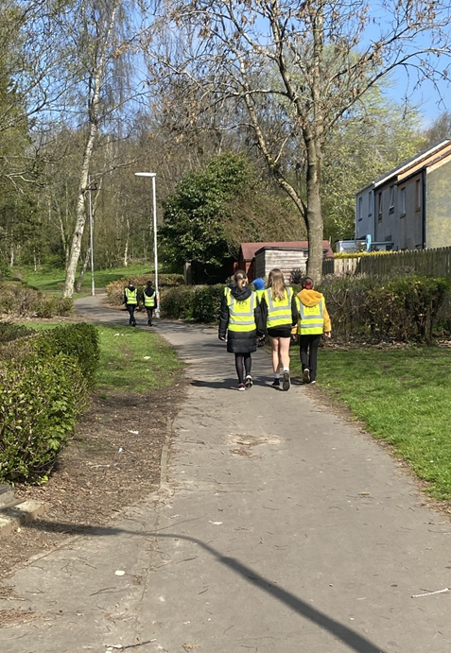
Pitteuchar East school is well served by existing crossing points and footways.
The challenge at Pitteuchar will be encouraging parents to change their behavioural patterns and introduce active travel into their daily routine.
This will help reduce congestion and improve safety around the school gate. Promoting safe walking routes and seeking the implementation of the recommendations should make the trip to school more enjoyable and encourage more participation in active travel.

