
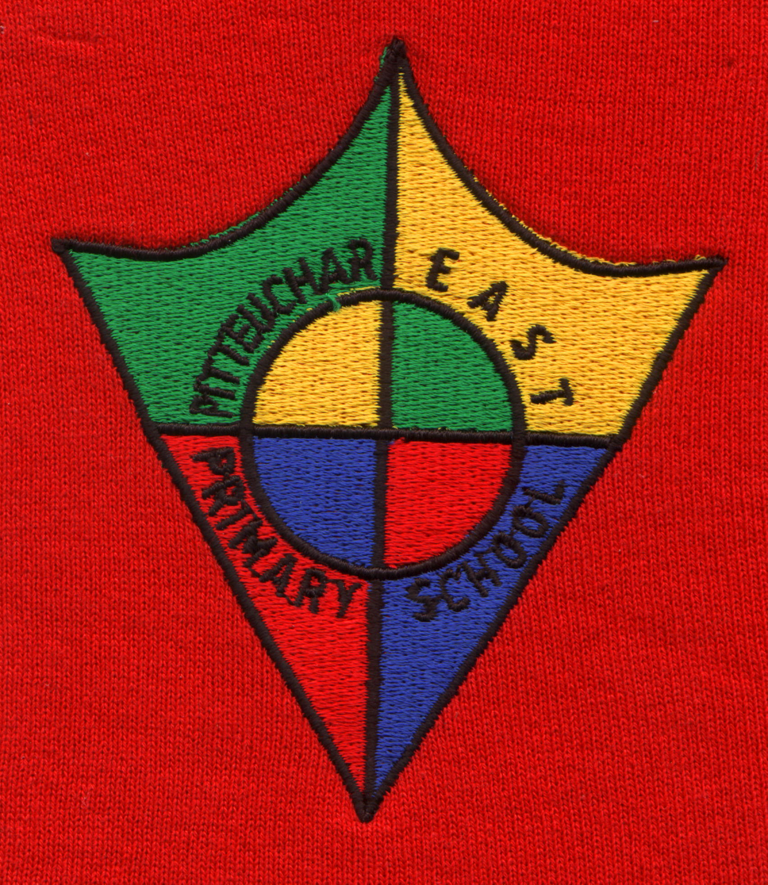

PITTEUCHAR EAST PRIMARY SCHOOL & NURSERY CENTRE
GLAMIS AVENUE
GLENROTHES
KY7 4NU
Telephone: 01592 583452
Email: pitteuchareastps.enquiries@fife.gov.uk
Website: www.fife.gov.uk/schools

Education and Children’s Services - Pupil Enrolment Form

To the Parent/Carer

The information given on this form will be held by Fife Council to support your child during the course of their nursery and school career.

Further information on how your child’s data is used by Fife Council and a copy of our full privacy notice can be found here.

www.fifedirect.org.uk/privacy/education

The Council’s Data Protection Officer can be contacted on: dataprotection@fife.gov.uk

IT IS THE RESPONSIBILITY OF PARENTS/CARERS TO ENSURE THAT THEY INFORM THE SCHOOL IF THERE ARE ANY CHANGES TO THE INFORMATION HELD.

I declare the information on this form to be correct to the best of my knowledge and I will ensure that I inform the school in writing if there are any changes to the information held.
Signed ................................................................................(Parent / Carer) | Date.........................

Permission (Delete as appropriate)
I am happy to be contacted by text and email about matters relating to the life of the school. | Yes / No

STAFF ONLY – complete when documents provided (do not photocopy documents)
Date completed form received in school |  |  |  | Baptism Certificate seen if applicable  Yes / No  Date of Baptism:  Place of Baptism:
Birth Certificate or Passport Seen | Proof of Address provided (2)  Type of document 1:  Type of document 2:
Placing request | Yes / No | Name of Catchment School/Nursery
Class Allocated
Previous School/Nursery
GLOW user | Yes / No |  | MyFife registered card holder |  | Yes / No

PLEASE COMPLETE THIS FORM USING BLOCK CAPITALS
Forename |  |  |  | Known As

Surname
Date of Birth |  |  |  | Gender
Names of brothers & sisters already at this school (if any)

Pupil’s home address

Postcode
Parents / Carers living at same address as pupil
 |  | First | Second

Relationship to pupil (e.g. Mother)

Title

Forename

Surname
Can be contacted in an  emergency during the day |  | Yes / No | Yes / No

SOS Rank (e.g. 1,2,3)

Telephone No. (Home)

Telephone No. (Mobile)

Telephone No. (Daytime)

Email Address
Additional parental contacts
For the purposes of the school records, a pupil’s parent is defined as his/her natural parent and any other person who is his/her carer, who has custody of, or who is likely to maintain, him/her. Please add below anyone who comes into this category but who is not included on a separate sheet.
Relationship to pupil (e.g. Mother)
Title
Forename
Surname
Can be contacted in an  emergency during the day |  | Yes / No | Yes / No
SOS Rank (e.g. 1,2,3)

Telephone No. (Home)

Telephone No. (Mobile)

Telephone No. (Daytime)

Email Address

Address

Postcode

Emergency contacts (other than carers)
Relationship to pupil (e.g. Aunt)
Title
Forename
Surname
Can be contacted in an emergency during the day | Yes / No | Yes / No
SOS Rank (e.g. 1,2,3)

Telephone No. (Home)

Telephone No. (Mobile)

Telephone No. (Daytime)

Email Address

Address (if different from child)

Postcode

Nursery Information – this box should only be completed for nursery applications

Previous Experience
Has your child spent longer periods of time with other adults or children (eg playgroup, childminder, mother and toddler group, other family etc)

In the event of ‘accidents’ may we bathe and change your child |  | Yes / No
Nursery staff will apply sunscreen to nursery pupils when appropriate. I give permission for my child to have sunscreen applied. |  | Yes / No
Can you give us your assurance that a responsible adult (over 16 years old) will always collect your child?  Please can you let us know beforehand if someone else is going to collect your child either regularly or in an emergency |  | Yes / No

Student Needs
Declared Disabled |  |  |  |  | Yes / No

Medical Details
Doctor’s Practice |  |  |  |  |  |  |  |  |  |  |  |  |  |  |  |  |  |  | Tel No

Address
Health Visitor  (nursery applications only) |  |  |  |  |  |  |  |  |  |  |  |  |  |  |  |  |  |  | Tel No

Address

Parents may convey relevant medical information here or under separate cover to the school. The information is processed electronically but in coded form to enable staff to respond to pupils’ needs.

Health Conditions
Does your child have any additional support need (e.g.) developmental delay, learning difficulty, long-term illness? |  |  |  |  |  |  |  |  |  |  |  |  |  |  |  |  |  |  |  |  |  |  |  | Yes / No  Not disclosed
If Yes, please give details

Has there been a professional assessment? |  |  |  |  |  |  |  |  |  |  |  |  |  |  |  |  |  |  |  |  |  |  |  | Yes / No
If Yes, can you provide a copy of this assessment |  |  |  |  |  |  |  |  |  |  |  |  |  |  |  |  |  |  |  |  |  |  |  | Yes / No
Medical Conditions
Does your child have any medical conditions (including any allergies)? |  |  |  |  |  |  |  |  |  |  |  |  |  |  |  |  |  |  |  |  |  |  |  | Yes / No  Not disclosed
If Yes, please give details of any medication required. Please note a separate medication request form must also be completed.

If your child has spent a considerable amount of time in hospital, please give details

*I give permission for school staff/Active Schools staff to administer any first aid treatment considered necessary during the time my child is attending the school |  |  |  |  |  |  |  |  |  |  |  |  |  |  |  |  |  |  |  |  |  |  |  | Yes / No
*I give permission for my child to be attended to by a doctor or taken to a hospital, in an emergency situation if emergency contacts cannot be reached. |  |  |  |  |  |  |  |  |  |  |  |  |  |  |  |  |  |  |  |  |  |  |  | Yes / No
If you tick No to either statements * above, please explain

Dietary Requirements
Does your child have any dietary requirements? |  |  |  |  |  |  |  |  |  |  |  |  |  |  |  |  |  |  |  |  |  |  |  | Yes / No
If Yes, please give details. Please note a separate dietary requirements form must also be completed.

There are events during the school year where food is available to children. This may be for a treat or as part of the curriculum. I give permission for my child to handle and taste all food in school. |  |  |  |  |  |  |  |  |  |  |  |  |  |  |  |  |  |  |  |  |  |  |  | Yes / No

Armed Forces

Parent/Carer is currently a serving member, or has previously served in, the armed forces
Regular |  |  |  |  |  |  |  | Reserve |  |  |  |  |  |  |  |  |  |  | Veteran

Main Home Language (please see table on page 6)
Recorded main language |  |  |  |  |  |  |  |  |  |  |  |  | If main language is missing or incorrect, please specify
Additional Languages
Recorded additional languages
If additional languages are missing or incorrect, please specify

Religious Affiliation (please see table on page 6)
Recorded religion |  |  |  |  |  |  |  |  |  |  |  |  | If religion is missing or incorrect, please specify
National Identity (please see table on page 6)
(Please circle the one category which best describes your child’s National Identity)
Scottish |  |  | English |  |  |  | N. Irish |  |  |  | Welsh |  |  |  |  |  | If you have answered ‘Other’, please give the specific National Identity here: -
British |  |  | Not Disclosed |  |  |  | Not Known |  |  |  | Other

Ethnic Origin (please see table on page 6)
Recorded ethnic group
If ethnic group is missing or incorrect, please specify:
Asylum Seeker/Refugee Status
Asylum Seeker |  |  |  | Yes / No |  |  |  |  |  |  |  |  |  | Refugee |  |  |  |  |  |  |  |  |  | Yes / No
Outside Agencies
Please indicate any agencies your child is involved with along with contact names
Social Work
Barnardos
Speech and Language
Child Psychologist
Other Agencies
General Permission
(Any changes to the permissions agreed below, please contact the school office in writing)
Performances and activities should not be photographed or recorded without the express permission of the school. In addition, photographs should not be taken from any Fife Council Social Media pages and redistributed.  Photographs / recordings of pupils are often taken to support learning as well as to celebrate successes in school or as part of school life. These photographs may be displayed in school. They may also be published in local press and used on Fife Council Social Media sites, including Fife Council approved apps, e.g. Seesaw. Do you give permission for your child’s photograph to be published in local press, and used on Fife Council Social Media sites and approved apps?  I give permission for my child to participate in live interactive online learning sessions, including live two-way video sessions, in school and at home, which may be recorded if the functionality becomes available. |  |  |  |  |  |  |  |  |  |  |  |  |  |  |  |  |  |  |  |  |  |  |  |  | Yes / No  Yes/No
In school, DVDs may be shown to support children’s learning. These DVDs will be age appropriate. I give permission for my child to watch DVDs in school. |  |  |  |  |  |  |  |  |  |  |  |  |  |  |  |  |  |  |  |  |  |  |  |  | Yes / No
Is there any specific information you want to make us aware of which would prevent your child from taking part in festivals, events or activities? Please provide details below:

 | Main Home Language and Additional Languages
 | Afghans  Afrikaans  Akan  Albanian  Algerian  Amharic  Arabic  Armenian  Ateso  Azerbaijani  Bahasa Indonesia  Bahasa Malaysia  Bajuni  Balinese  Bangala  Bangli  Bari Pojulu  Basque  Belorussian  Bemba  Bengali  Bini  Bosnian  Breton  Bulgarian  Burmese  Cantonese  Catalan  Cebuano  Chechen  Chewa  Chichewa  Chinese (Cantonese)  Chinese (Modern Standard/  Mandarin) |  |  | Coorge  Creole  Croatian  Czech  Danish  Dari  Dioula  Doric  Duri  Dutch  Edo  English  Estonian  Ewe  Faroese  Farsi  Fijian  Filipino  Finnish  Flemish  French  Friesian  Gaelic (Irish)  Gaelic (Scottish)  Georgian  German  Goran  Greek  Gujarati  Gurani  Hakka  Hausa  Hebrew  Hindi |  |  |  |  | Hokkien  Hungarian  Ibo  Icelandic  Igbo  Indonesian  Isoko  Italian  Japanese  Jola  Kagoro  Kannada  Kaonde  Kashmiri  Katchi  Khmer  Kikuyu  Kinyarwanda  Kirundi  Kiswahili  Kodagu  Konkani  Korean  Kurdish  Kutchi  Latvian  Lingala  Lingola  Lithuanian  Loma  Luganda  Luxembougish  Magyar  Malay |  |  |  |  |  | Malagasy  Malayalam  Maltese  Mandarin  Mandinka  Marathi  Mazanderani  Memmoni  Memni  Mirpuri  Moldavian  Mongolian  Ndbele  Nepalese  Northern Sotho  Norwegian  Not Disclosed  Nyanja  Pashto  Pashtu  Persian  Polish  Portuguese  Punjabi  Pushto  Pushtu  Romanian  Romany  Russian  Scots  Serbian  Serbo-Croation  Setswana  Shanghainese |  |  |  |  |  |  | Shona  British Sign Language  Other Sign Language  Sinhalese  Siswati  Slovak  Slovene  Somali  Sourashtra  Spanish  Swahili  Swedish  Tagalog  Tamil  Telugu  Thai  Tigre  Tigrigna  Tiv  Tonga (SW Africa)  Tongan  Tswana  Tumbuka  Turkish  Turkmani  Twi  Ukrainian  Urdu  Urhobo  Uyghur  Uzbek  Vietnamese  Walloon  Welsh
 | Code Tables
 | Ethnic Origin
 | 01  02  03  05  06  07  08  09  10  12 | White – British  African – African / Scottish / British  Caribbean or Black – Caribbean / British / Scottish  Asian – Indian/British/Scottish  Asian – Pakistani / British / Scottish  Asian –Bangladeshi / British / Scottish  Asian – Chinese / British / Scottish  White – Other  Not Disclosed  Mixed or multiple ethnic groups |  |  |  |  |  |  |  |  |  |  |  |  | 17  19  21  22  23  24  25  27  98  99 |  |  | Asian – Other  White – Gypsy/Traveller  White – Other British  White – Irish  White – Polish  Caribbean or Black – Other  African – Other  Other – Arab  Not Known  Other – Other
 | National Identity |  |  |  |  |  |  |  |  |  |  |  |  |  | Religion
 | 01  02  03  04  05  99  10  98 | Scottish  English  Northern Irish  Welsh  British  Other  Not Disclosed  Not Known |  |  |  |  |  |  |  |  |  |  |  |  | 01  02  03  04  05  06  97  98  99 |  |  | Buddhist  Christian  Hindu  Jewish  Muslim  Sikh  No Religion  Other  Not known or not divulged

Level of English |  | Gaelic Education
01  02  03  04  05  EN  LC  NA | New to English  Early Acquisition  Developing Competence  Competent  Fluent  English as a “first-language”  Limited communication  Not assessed | 01  02  03  04 | Gaelic medium education  Gaelic the only subject taught through Gaelic  Gaelic taught as learner  No Gaelic taught

Excursion Permission Consent Form

This form seeks permission from parents/carers for your child to participate in the following types of excursion that may take place in an academic session:

- Full day or part day trips not involving adventurous activities (sometimes arranged at short notice), e.g. walks in the local area, public transport/bus trip to museum
- UK residential trips not involving adventurous activities e.g. sightseeing trip to London, study experiences at an outdoor learning centre

You will still receive information about these excursions in advance via a communication from the school and you can still elect to withdraw permission, if you choose for them not to participate in particular excursions.

Permission for trips that are full day, part day or UK residential trips which include adventurous activities, as well as any overseas trips, will be sought from you separately in advance by completion of a specific permission letter/form for these. Permission for your child to be photographed or videoed on the excursion is not being sought here as this is requested separately.

These excursions are covered by Fife Council Public Liability Scheme which is insurance against claims for injury, or loss/damage to property for participants and any other third parties, as a result of negligence on the part of the Council. There is NO cover for personal accident or loss of personal property so you may wish to consider taking out your own insurance for this when your child goes on an excursion.

School activities and trips, particularly adventurous activities, can never be entirely free from risk. Whilst the chances of serious injury are extremely remote, minor bumps and bruises, feelings of discomfort (cold, wet etc.) and perhaps anxiety are possible outcomes. We endeavour to minimise the risks involved allowing pupils to benefit fully from their experiences.

For the purposes of collating pupil data in advance of excursions, the school will rely on information, including emergency contact details and medical information, contained in the Council’s pupil management information system. Parents/Carers have the responsibility to ensure that they provide updates to the school as required to ensure that this information is accurate. Further information on how your and your child’s information is used by Fife Council can be found here: www.fifedirect.org.uk/privacy/education

To be completed by  Parent / Carer if the participant is under 18 years at the time of the excursion(s) | I give permission for my child to participate in the excursion(s) described.  I do NOT wish my son / daughter to take part in the following activities: ______________________  _________________________________________________________________________________  I undertake to see that my son / daughter is provided with the requested clothing/equipment and that the appropriate excursion contribution is paid.  I declare that, to the best of my knowledge, my son / daughter is fit to participate in the activities involved and that the medical information retained by the school is accurate.  Signed:_____________________________ Name: _________________________ (block capitals)  Date: ______________________________
To be completed by  Participant if  18 or over, or  Participant is 16 or 17 | I acknowledge receipt of information about the excursion(s). I am aware of, and accept, any risks involved and understand that procedures are in place to minimise them.  I declare that, to the best of my knowledge, I am fit to participate in the activities involved and that the medical information given above is accurate. I undertake to notify the Centre/Organisation if that information changes in any way.  Signed:____________________________ Name: _________________________ (block capitals)  Date: ______________________________  Signed:____________________________ Name: _________________________ (block capitals)  Date: ______________________________

