PAXTON ELC
Selkirk Street, Methil, Fife, KY8 3LX
Telephone 01334 659361
Head of Centre: Sandie Johnston



Standards and Quality Report
Academic Session; 2024-2025

Achieving Excellence and Equity



Context of Paxton Nursery Early Learning and Childcare Setting
Demographic | Paxton nursery current roll consists of 76 children.  - 3 years to 5 years provision -66 children.  - Early Entrant (under 2’s) provision- 10 children.  Further breakdown analysis of our cohorts in 2024-2025;  - Children having English as an additional language- 5  - Refugees-1  - Children with significant additional support needs-8  - LAC children- 5  - Children on the child protection register-5  Our Setting;  Paxton Nursery is situated in Methil within the Levenmouth area. We provide early Learning and childcare for children aged 2 to 5 years old. The setting operates a 9am - 3pm session, 39 weeks of the year. During holiday periods we continue to support our families with referrals to our ‘sister nursery’ – Woodlands FNC which is located within a short walking distance of Paxton Nursery.  Our building comprises of 2 bright spacious 3-5-year-old playrooms, a nurturing 2-year-old provision and a large family room where we deliver an abundance of family learning groups. We have a purposeful dining space for children to enjoy a homely quality lunch experience.  Our outdoor provision boasts a wealth of space individually to each playroom and additionally as two large open spaces for children to enhance and extend their skills using various equipment and apparatus. Children are encouraged to mix with peers from different playrooms to build on their social skills. Special consideration has been given to all our environments for our children to learn, thrive and grow to their full potential.  Currently 52% of our children and families sit within SIMD 1, 38% within SIMD 2 and 39% within SIMD 3.  SIM-D No of children Percentage of roll  1 39 52%  2 29 38%  3 7 9%  4 1 1%

Vision, values and aims | 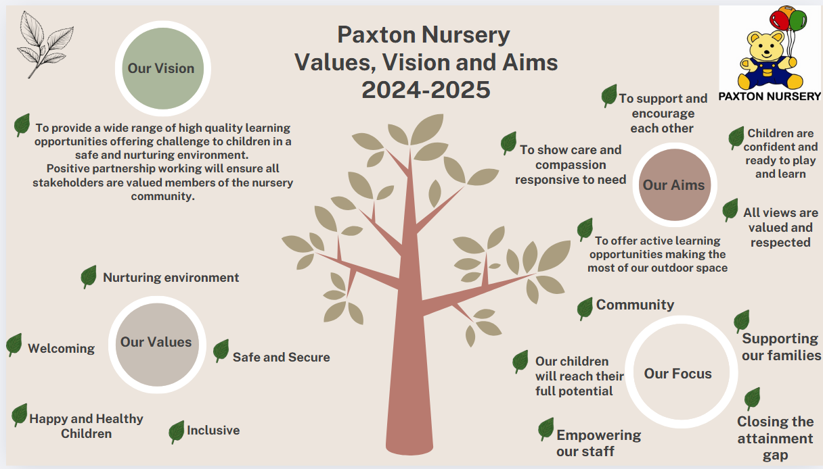  As the illustration above highlights our vision, values and aims are a shared ethos of our core values and what we hope to achieve for our children. They incorporate all the key essential drivers to ensure our children are nurtured, safe and empowered to reach their full potential. All stakeholders play a role in shaping our vision, values and aims and are valued members of our nursery community.  As we look to 2025-2026, we will be revisiting and refreshing our current values, vision and aims. Not only will this reaffirm our purpose, but it will allow us to adapt to growth and change within the community by building a strong cohesive culture that focuses on supporting our children, families and community.
Attendance | Our overall nursery attendance from 2024-2025 is 82.6%.  Robust systems have been put in place to ensure families and children are supported with nursery attendance. This academic session we introduced engagement and tracking audit sheets. The documents allowed the senior leadership team to have an overview of children with low attendance, reasons behind this and what strategies and interventions could be put in place to support the families and children to attend nursery. We also collaborated and consulting with other partner services.  Our staff members have carried out some individual pick up and drop offs for a few of our most vulnerable families to support children to attend in times of need.  As we approach our 4th year of carrying out home visits linked to non attendance/no contact we have encouraged a high attendance rate for our families to ensure equity to all our learners.  As detailed in the graph above, a sample was taken throughout the academic session to monitor attendance across the setting.
Summary of consultation with stakeholders | All stakeholders were asked to carry out a questionnaire digitally. Special consideration was given to the children’s voice questionnaires to ensure equity and inclusion. Neurodiverse children were given the opportunity to voice their opinions though questionnaires that were age and stage appropriate.  Pupil Voice  A total of 65/76 children completed the questionnaire  A summary of the questionnaire:  - 100% of all children felt that the adults in the nursery helped them learn something new  - 100% of children felt they were consulted on what resources they wanted in the playroom.  - 100% of the children felt that all adults in the playroom listened to them.  - All children within the setting were able to voice that they would seek help from adults within the playroom when upset. Using language such as “tell the teacher, get a hug, get a cuddle from the teacher, the teachers make it better.”  Evaluation: The pupils voice questionnaire has allowed us to see that our children value the creative and imaginative areas of the setting and feel safe, nurtured and valued.  Questionnaires were created for our staff members working directly with learners. Our practitioners are given the opportunity throughout the academic session to voice their opinions through weekly staff meetings, training opportunities and regular professional dialogue with the senior leadership team.  Practitioner Questionnaires  A total of 19 practitioners completed the questionnaires.  A summary of the questionnaire;  - The setting has effective strategies to support children with their learning and development, including those requiring additional support. 79% strongly agreed, 21% agreed.  - Practitioners have a shared understanding of how young children  develop early language and mathematical skills. 79% strongly agreed,  21% agreed.  - Children are provided with experiences which meet their learning and development. 71% strongly agreed, 29% agreed.  Parent Questionnaires  A summary of the questionnaire:  A total of 25 parents completed the questionnaire  - My child’s learning and development is well supported by the staff in the setting 68% Strongly Agree, 32% Agree  - My child is making good progress at Paxton Nursery. 68% Strongly Agree, 32% Agree.  - The learning experiences my child has at Paxton Nursery are at the right level for them 56% strongly agree 40% agree 4 disagree.  Evaluation: Next session we will share what level children are working within, during parent chats between key workers and parent/carers.  Partner agencies questionnaires;  A summary of the questionnaire;  - The setting values the contribution made by my service/organisation- 100% agreed  - There are opportunities to network and share practice 100% agreed  - Overall, partnership working with the setting works well 100% agreed.
Cost of the School Day statement | Supporting our children, families and community  As a setting at the heart of the community it is essential for us to ensure the cost of the school day is minimised as much as possible to ensure our families and children’s participation and wellbeing is at the forefront of their learning. As a setting in a high area of deprivation many of our families are facing many socio-economic challenges ranging from limited access to employment, food and fuel poverty, housing insecurity, education barriers and poor health outcomes.  We respond to the challenges our families face by offering a range of supportive mechanisms throughout the year, e.g:  - A weekly “pop up shop” using the Fare Share  - weekly food packages to our most vulnerable families  - We work with local partner agencies such as The Big Hoose to provide household and clothing items.  - A health pantry is available within our nursery to support our families with toilet paper, washing powder, soap and other basic amenities.  - We run family groups to help our families manage and boost their budgets with the aid of citizens advice.  - We signpost our families to partner agencies for benefit checks to maximise the most of their money.  - During the holiday periods we refer our families to Café Inc locations within the local community to ensure children and families have access to free nutritious meals.  - Throughout the winter period we support our families who are in the most poverty by providing their children with Christmas gifts, food parcels including Christmas dinner and warm winter coats.  - We host an array of low-cost open days, fairs and events throughout the academic session for our parents/carers to create memorable experiences with their children.  - Fundraising within local community- local businesses have pulled together with donations to help us raise money to purchase a new trim trail. We are at 40% of our target. These donations prove to us how well the nursery is valued within the community.  - Signposting parents to financial assistance whilst allowing us to form strong links with outer agencies such as Cozy Kingdom and Home Start.

Summary of Progress and Impact from last session’s Improvement Plan and Next Steps

School Improvement Priority 1:
- Children’s literacy skills will be enhanced with and through digital technology
- This will be offered to all children through rich core provision both in the indoor and outdoor environment

HGIOS 4/HGIOELC Quality Indicators:
2.2 Curriculum
2.3 Learning, teaching and assessment
3.3 Developing creativity and skills for life and learning
Has this priority been:  (please highlight) | Fully achieved | ✓ | Partially achieved |  | Continued into next session
Progress to be detailed;

- All practitioners engaged in digital professional learning and tailored workshops. Practitioners’ confidence, knowledge and ability has had a profound effect on children’s literacy skills. This evidence has allowed us to reach our target in early level literacy of 95% - early progressing. 15% over the initial target.
- A UNCRC Rights captain called “Captain Digi” was introduced to all our children. This mascot was a visual aid for children to learn about digital technology and the skills associated with different resources. This allowed children to learn how to use resources purposefully, learning new skills and being responsible. We incorporated our SIMOA elephant to ensure cyber resilience and internet safety.
- All stakeholders were involved in the implementation of our improvement priority. Special consideration was given to ensure inclusion of all children through assistive technology creating an inclusive environment for all children to develop imagination, inspiring creativity and problem solving.
- Parental awareness on digital safe behaviour and digital literacy was rolled out through our family learning groups, sways and digital stay and plays.
- A noticeable increase of parental engagement in children’s learning has been captured digitally. Analytic evidence gathering has allowed us to share, capture, celebrate and extend children’s learning through digital forums.

Impact to be detailed:

- As a result of our digital literacy training programme all practitioners have been upskilled and empowered with new skills and knowledge to further extend children’s literacy skills using digital technology.
- All practitioners were able to enhance our rich provision by integrating digital technology in various core provision areas. Through child centred pedagogy our indoor and outdoor learning spaces allowed increased opportunities for children to engage in playful literacy and deepen their digital literacy skills.
- Through robust moderation and audit procedures an increase of 49% of skilled observations and cross referencing was seen in the technology curriculum in children’s PLJ’s.
- All children have shown progression, with almost all children being able to talk confidently about what skills they have learnt from digital resources.
- Paxton Nursery was awarded The Digital Schools Award in May 2025, which is a national awards scheme to promote, recognise and encourage a whole school approach to the use of digital technology in schools.
Next Steps

- Enhancing digital literacy across all curricular areas entwinning the meta skills. Allowing our learners to create opportunities for them to recognise, understand, articulate, and record their skills development.

Summary of Progress and Impact from last session’s Improvement Plan and Next Steps

Improvement Priority 2:
- To create an inclusive learning community which will increase our capacity for supporting learners who have additional support needs.
- Improve collaboration with families to ensure children’s needs are valued and supported.
- Children with additional support needs will thrive, attend and achieve positive and equitable outcomes
HGIOELC Quality Indicators:
  - – Self-evaluation for self-improvement
1.3 – Leadership of change
2.2 – Curriculum
2.3 – Learning, teaching and assessment
2.6 – Transitions
2.7 – Partnerships
3.1 – Ensuring well-being, equity and inclusion
3.2 – Securing children’s progress
Has this priority been:  (please highlight) | Fully achieved | ✓ | Partially achieved |  | Continued into next session
Progress
- All practitioners received training on trauma informed practice. This included a focus on emotional regulation support for children
- Practitioners created dedicated nurturing spaces in each playroom, with access to resources to support children with emotional regulation. All children independently access resources, as well as doing this with the support from practitioners
- All practitioners received training on Social Communication, use of Up, Up & Away Circle Framework and understanding of Neurodiversity from the Supporting Learners Service
- Practitioners were supported to use the Circle Framework to feel more equipped in identifying effective strategies to engage children and plan for progress and achievements, linked to stages of development
- Support files were updated to include relevant information and strategies to support children to overcome barriers to learning. Parent helpline numbers are easily accessible for practitioners to share with parents – this is done through a supportive and coaching approach where appropriate
- Practitioners collaborated to create a nursey charter for inclusion which promotes consistent approaches across the setting
- We now gather data to find out if any of our children were born prematurely
- Practitioners document individual children’s need on an overview sheet to ensure all practitioners working with the child have a shared understanding of their needs and support strategies
Parents are supported to be involved in their child’s learning and support needs
Impact
- Practitioners have tailored the learning environment to meet the needs of children. Children’s needs are well supported through access to stage appropriate resources and supports
- All children are thriving in environments which meet their needs and where practitioners are more confident in identifying and meeting individual children’s needs
- All children receive high quality nurturing interactions from practitioners who are skilled in understanding their needs
- Using the Circle framework to assess children’s needs has enabled practitioners to target support for individuals and plan for success and achievements for all children. This has removed barriers for those children with specific difficulties so that activities and opportunities can be adapted to meet their needs
- Practitioners use updated support files to support individual children’s needs and plan targeted support and improve outcomes
- All practitioners use shared language and strategies to ensure all children are welcomed, respected and included
Parents are informed and included in supporting their child’s needs
- Our average attendance data for our ASN learners was; 90%. This reflects our meticulous individual planning process for supporting all of our children to access the curriculum.
Next Steps
Continue to be responsive to the needs of individual children and seek training opportunities and support from additional agencies to ensure appropriate supports are in place for individuals. Consider training opportunities for practitioners linked to Prem Awareness. We will link with our local feeder school Aberhill to implement similar early support strategies and draw on their knowledge and expertise.

Improving Outcomes

Attainment;

Below is a table illustrating that 95% of our pre-school children exited the nursery, working within early progressing in literacy and numeracy this academic session. The 5% of children who exited within early initial engagement had already shown progress by completing the pre-early level milestones. All children have made progress across the curriculum.

Literacy statistics Across the nursery – 39 N5’s

Literacy area | % of N5 leavers working within Early Initial engagement | % of N5 leavers working within Early Progressing
Reading | 5% | 95%
Writing | 5% | 95%
Listening and Talking | 5% | 95%

Numeracy statistics Across the nursery – 39 N5’s

Numeracy areas | % of N5 leavers working within Early Initial engagement | % of N5 leavers working within  Early Progressing
Number, Money and measurement | 5% | 95%
Shape, position and movement | 5% | 95%
Information Handling | 5% | 95%

Achievements;
Paxton Nursery ELC Significant pupil achievements

Opportunities for Personal Achievement;

Paxton Nursery has obtained The Digital Learning Through Play Award in Early Learning Childcare, which is a national awards scheme to promote, recognise and encourage a whole setting approach to the use of digital technology in ELC settings. We were also awarded a special recognition award for digital wellbeing for excellence through strong cyber resilience and internet safety practices.

Learning with and through technology is recognised and celebrated throughout the framework. The award values the development of a whole setting approach and is specific to Scottish ELC context (Realising the Ambition: Being me, Curriculum for Excellence early level Technologies Experiences and Outcomes, the National Digital Learning and Teaching Strategy for Scotland and current national self-evaluation framework for ELC).

Our children’s award journey has been unique and told its own story specific to the interests and needs of our children, available resources, infrastructure and the diverse components of the wider setting including; our staff team, parents and carers and community partners.
This award recognises the importance of the balance between digital and non-digital play. It advocates children have had personalisation and choice in the various forms of digital technology that enhances elements of their learning provision. We have meaningfully involved our children in planning and documenting learning (through continual observing, evidence capturing, reflecting and evaluating), we have clearly evidenced the distinctive digital technology integration that works best for our setting and its users.

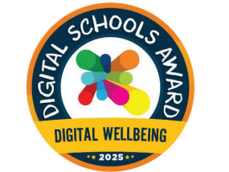


Attached is the award logos for digital wellbeing and digital learning and teaching.

Evaluations (School)
 | 2022-23 | 2023-24 | 2024-25 | Inspection Evaluations  (since August 2024)
1.3 Leadership of Change
2.3 Learning, teaching and assessment
3.1 Ensuring wellbeing, equity and inclusion
3.2 Raising attainment and achievement
Evaluations (ELC)
 | 2022-23 | 2023-24 | 2024-25 | Inspection Evaluations
1.3 Leadership of Change | 5 | 5 | 5
2.3 Learning, teaching and assessment | 5 | 5 | 5
3.1 Ensuring wellbeing, equity and inclusion | 5 | 5 | 5
3.2 Securing children’s progress | 5 | 5 | 5
Care Inspectorate Evaluations (ELC)
 | 2022-23 | 2023-24 | 2024-25
How good is our care, play and learning? |  | 6
How good is our setting? |  | 5
How good is our leadership? |  | 6
How good is our staff team? |  | 5
Statement about feedback from Education Scotland/Care Inspectorate if inspected this session.

