

Fresh Air Frankie’s
School Travel Plan

School: Park Road Primary School

Headteacher: Erika Anderson

School address: Park Road, Rosyth, KY11 2NH

Telephone No: 01383 602426

Social Media/Website: Website

Contents Page

3: 1.0 WHY HAVE A SCHOOL TRAVEL PLAN

3.: 2.0 BENEFITS OF HAVING A SCHOOL TRAVEL PLAN

4: 3.0 Current Travel Habits

3.1 Family Questionnaire Data

8: 4.0 ROUTE AUDIT OF KEY ROUTES TO SCHOOL

4.1 Access Arrangements

10: 5.0 ACTION PLAN

11: 6.0 MONITORING AND EVALUATION

11: 7.0 DISTRIBUTION OF SCHOOL TRAVEL PLAN

1.0 Why have a school travel plan

School-related traffic congestion and the risks congestion poses to the safety of the pupils, teachers, parents, residents, and motorists in and around school locations is a significant problem in communities around Fife.

The most obvious cause of traffic congestion around our schools is vehicles, and the biggest source of those vehicles is parents’ dropping off and picking up their children from school.

Statistics highlight that 1 in 4 cars during the hours of 8:30 to 9:15 and 2:30 to 3:15 is primary school traffic.

Encouraging active travel—such as walking, cycling, or scooting to school—offers children a healthier, more energising start to their day. It helps improve physical fitness, boosts mood and concentration, and reduces traffic congestion and pollution around school gates, making the environment safer for everyone.

Fife Council’s Road and Transportation Service are working with schools in Fife to develop School Travel Plans; a practical framework to promote sustainable travel and address barriers families may face by supporting Frankies Active Campaigners Team (FACT) to lead activities, raise awareness, and celebrate progress. These initiatives empower children to take pride in their choices and inspire others to get moving – making active travel a positive part of everyday school life.

2.0 BENEFITS OF HAVING A SCHOOL TRAVEL PLAN?

The benefits of encouraging active travel are clear and a school travel plan can ensure that your school has a long–term vision with aid to support your FACT group with delivering campaigns that will;-
- Improve health and well-being by reducing harmful emissions and increasing activity levels.
- Improve safety through engineering measures and increasing road safety education.
- Improve access and opportunity by developing pupils’ skills for safe and independent travel.
- Improve the environment by reducing pollution and CO2 emissions.
- Gain school accreditations such as Fresh Air Frankie STP Awards, Active School Award and Eco Schools.
All work associated with School Travel Planning has been designed to fit into the Curriculum for Excellence.

3.0 CURRENT TRAVEL HABITS

Each year all Fife schools undertake the hands up survey which gives a true reflection of how pupils are travelling to school, and the 2024/25 results show that 76% of pupils are actively travelling to school. However, with over 23% still being driven to school the school must remind parents of their responsibilities around the school gate.

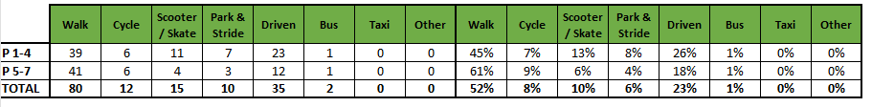

3.1 Family Questionnaire

40 families answered the online questionnaire, and the results are as follows.

What year group is your child/children in?
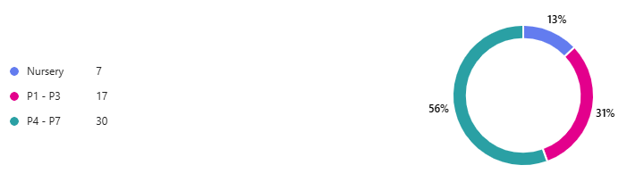

How far do you live from the school? 36 of the families that completed the questionnaire said that they live within a 1-mile radius from the school.

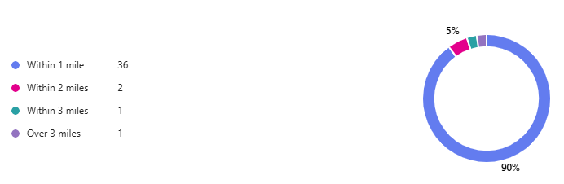

How long does your journey usually take? 33 families live within 10 minutes from the school. Now let’s break this down further to see how they travel!

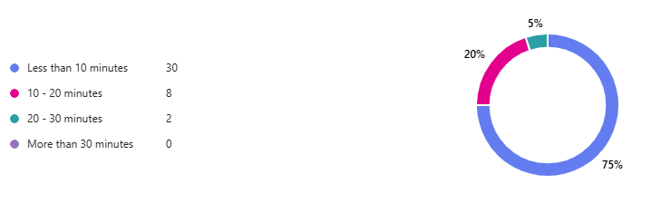

Those families that stated they lived within 1 mile of the school, and their journey took less than 10 minutes predominantly used active travel as their mode of transport. When further asked if they faced any barriers travelling to the school most parents said no.

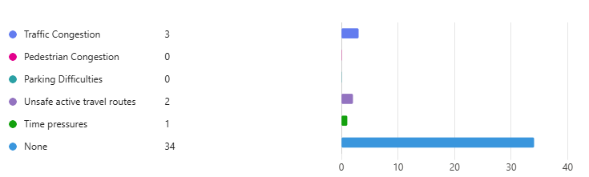

On further research into active travel families mentioned the following:

Just the parked cars by other parents being unsafe
Child walks every day with childminder or grandparents
No however, would be good to bring back a bike shed to the school. Especially in the winter as their bike seats are wet for travelling home and their bikes are getting rusty.
The main path to the school gates is far too narrow for child safety. Especially if you are promoting bike safety. I would suggest the side gate on Harley Street a better suggestion if coming to school on a bike.
Were very fortunate to live so close to the school, and while there is a busy crossroads at the school, it’s a very rare occasion that there is no crossing guard. For us, walking to school is very easy.
Everything is fantastic, there is nothing to tell about
Child will walk, scoot or cycle to school.

Active Travel Routes are not safe

- Middlebank street. Cars parked by other parents around the bend and blocking the view to cross safely,
- The intersection of King's Rd and Park Road, the admiralty Rd Then there are no traffic lights at the Mowi roundabout.

3.2 Staff Questionnaire

16 members of staff completed the online survey and the following diagrams are a representation on those findings.

How far do you travel to work?
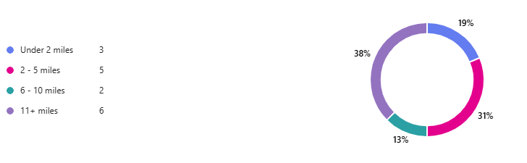

How do you travel to work?

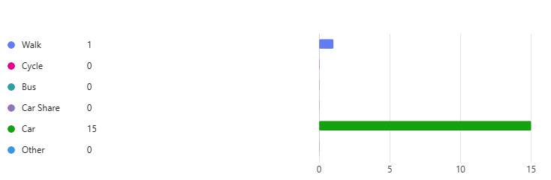

Where do your park?
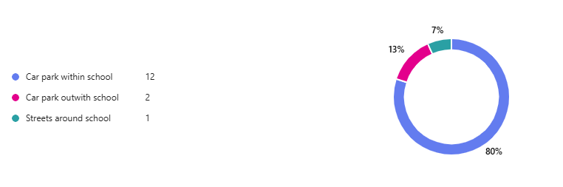

The one member of staff who parks in the surrounding streets said they either park on Middlebank Street or Park Road.

Cycle training is a vital part of pupil’s education would you be willing to help your school deliver Bikeability?
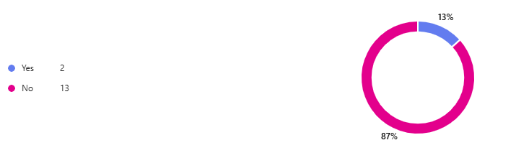

The following are the answers to “what would encourage them to consider an alternative mode of transport to work”.

- Better and quicker bus route
- Working closer to home
- I can’t cycle and I have no time to commute to collect my children
- I don’t think there is and alternative suitable for me.
- I find this challenging, as headteacher I need to drive to various meetings in other parts of Fife
- I walk in nicer weather when I can. Although better paths and crossing places would be beneficial.
- Nothing as I live too far away from work (more than 30 miles on motorways) to have benefit from any other mode of transport. I live in North Lanarkshire.
- Nothing
- I can't because I need to pick up my own children after work from the childminder.
- If there was another member of staff who lived close by to car share
- I live too far away and nobody else that works at my school lives in the same place as me
- Possibly car share
- living closer

4.0 MAPPING WORK AND ROUTE AUDIT

By analysing the geographic distribution of pupil residences, we identified key clusters and common travel corridors that assisted in creating a strategic map of routes that prioritise safety, accessibility and connectivity to the school using existing infrastructure.

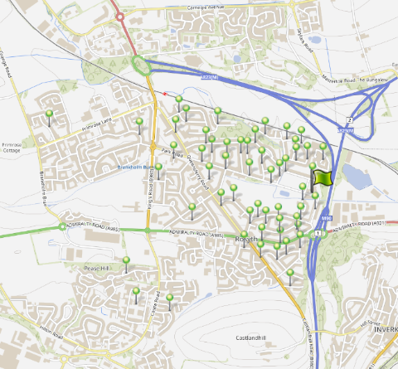

4.1 Access Arrangements and Route Audit

There are several entrances to the school building. The main school entrance is located on Park Road. There is a staff only school car park sited on Middlebank Street. The area is covered with school keep clear markings and there is a school crossing patrol officer sited on the corner of Harley Street and Park Road.

Route Audit Overview

Overview:
This audit assesses the pedestrian infrastructure and safety features along key routes to school within the residential area around the school.

The area benefits from wide pavements, adequate dropped kerbs, and traffic calming measures including 20 mph speed zones. There is a network of off road paths through the greenspace next to the school. However, there is ongoing concerns with regards to speed of traffic and congestion even though these were not highlighted in the data research.

Key Findings:
- Pavement Quality and Width:
- Pavements throughout the area are consistently wide, allowing for safe passage of children, parents, and mobility aid users.
- Surfaces are generally smooth and well-maintained, with minimal trip hazards or obstructions.
- Dropped Kerbs and Crossing Points:
- Dropped kerbs are present at major junctions and crossing points, supporting accessibility for wheelchairs, pushchairs, and visually impaired pedestrians. However, like most towns and villages in Fife there are a few missing along the routes to school.
- Tactile paving is in place at most crossings, enhancing safety for visually impaired users.
- The area where the school crossing patrol officer stands has been designed so that pupils cross in one direction – however it was noted that some pupils like to cross park road to the west where there is no drop kerb facilities. The school must work with the FACT group to highlight the designated safe route to school.
- Traffic Calming and Speed Limits:
- The 20 mph speed limit is clearly signposted and contributes to a safer environment for school children. The strategic map highlights that most pupils who actively travel to school travel through these 20 mph zones.
- Residential streets show evidence of traffic calming features such as speed humps and narrowed carriageways.
- Visibility and Lighting:
- Street lighting is adequate along main routes, ensuring visibility during early morning and late afternoon travel times.
- Sightlines at junctions and crossings are generally clear, reducing the risk of vehicle-pedestrian conflict.
5. Signage and Wayfinding:
- There is adequate signage outlining the 20 mph zone and a school crossing. The School Keep Clears are very faded and in need of refreshing. It was also noted that there was only one school patrol sign at the bottom of Harley Street. As the complaints about speeding are along Middlebank and Park Road if additional signage was incorporated this may help reduce speeds.

5.0 ACTION PLAN

Action | Solution | Action Owner
Promote School Travel Plan | - Upload plan to website and social media pages.  - Create a FACT notice board.  - Upload generic social media posts throughout each term.  - Keep the school travel plan team updated on all work carried out by completing your FACT floor book. | School
Fresh Air Frankie Awards Campaigns | Term 1  Hands up Survey Active Travel  FACT Assembly about Active Travel Month  Send out generic Social Media Posts  Active Travel Month (distribute and collect Fresh Air Frankie  Travel Passports)  Term 2  Launch #dontparkhere Campaign  FACT Assembly  Send out generic Social Media Posts  Road Safety Week  Term 3  Frankie’s Step into Spring Campaign  FACT Assembly  Big Walk and Wheel  Term 4  FACT Assembly about Active Travel Month  Send out generic Social Media Posts  Active Travel Month (distribute and collect Fresh Air Frankie  Travel Passports) | School – full details held within your FACT folder
Reduce congestion | Consider developing the following:- Parking Pledge  Walking Bus  Campaigns to increase active travel to school. | School – full details held within your FACT folder
Bikeability | Deliver Level 2 Bikeability and apply for Cycle Friendly School Award | School/Bikeability
Annual Active Travel Award | Top 3 schools that can showcase the largest increase in Active Travel to School will be crowned champions. Data will be collated from the HUSS and our own travel tracker. | School/Travel Plan Team

6.0 MONITORING & EVALUATION
The FACT will continue to meet periodically to monitor progress and amend strategies to comply with the actions set out in this plan. Specific progress will be monitored by participation in the “Hands Up Travel Tally” each year and a review travel survey will take place in 2028/29.

The school’s ongoing commitment to travel planning will be publicised in the school handbook, the school newsletters, the Parent’s notice board and through assemblies.

7.0 DISTRIBUTION OF SCHOOL TRAVEL PLAN
The following bodies will receive a copy of the School Travel Plan:
• Fife Council Sustainable Transport and Travel via the Travel Plan Team
• Fife Council Education Service
• Parent Partnership
• Copies will also be made available to the parents from the School Office and via
the school information sites.

