
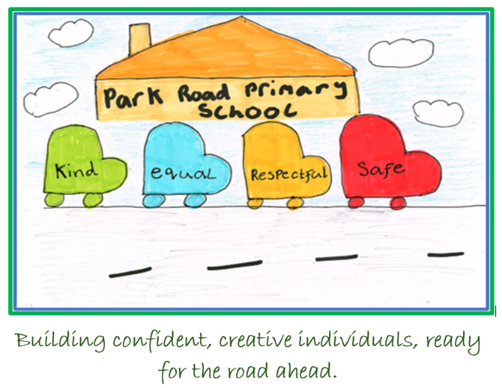
Park Road Primary Meeting Learners Needs Policy
Pupil Friendly Version
This is our school plan to help everyone learn and feel happy. We follow children’s rights and make sure everyone is treated fairly.
Your Rights (UNCRC):
● Article 2: Everyone is treated fairly and equally.
● Article 12: You can share your ideas and adults will listen.
● Article 23: Children with additional needs get the help they need.
● Article 28: You have the right to learn and go to school.
● Article 29: Learning should help you grow and be the best you can be.

How We Help:
Universal Support – for everyone:
• Calm corners in classrooms
• Movement breaks and soft starts
• Access to technology and different ways to learn
Additional Support – for some children:
• Special workspaces and Now & Next boards
• Flexible seating and extra breaks
• Lunch club and sensory supports
- Summary of Support – this helps everyone know what you find difficult and what helps you
- Sometimes other adults in school may do specific learning jobs with you
Intensive Support – for a few children:
• A Child’s Plan with extra help from teachers and other helpers
• Meetings with your family and people who can give more support
- Sometimes adults who don’t normally work in the school will support you

We want everyone to feel safe, respected, kind and equal at Park Road Primary.

For an audio version Click here or use the QR code
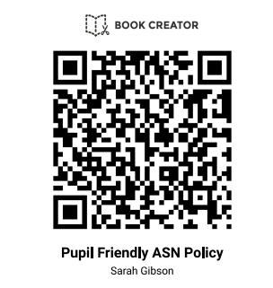
https://read.bookcreator.com/NQhBRtgRMMSRaXtAzqEAESeki8V2/arWe5c5sRIG4AoXfMB-Apg

