Park Road
Primary School and Nursery

Positive Relationships, Equality, Inclusion and
Anti-Bullying Policy
2025-26

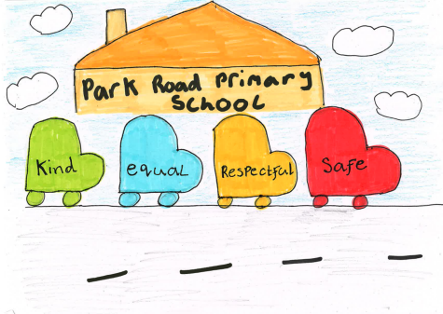

Policy Statement
At Park Road Primary School, we are committed to fostering a nurturing, inclusive, and respectful environment where every child, staff member, and parent feels valued, supported, and empowered. This policy is informed by the voices of our staff, pupils, and parents, and underpins our school vision and values. It is rooted in the principles of Getting it Right for Every Child (GIRFEC) and aims to counteract bullying in all its forms.
We believe that positive relationships are the foundation of a thriving school community. Through mutual respect, empathy, and collaboration, we create a safe and welcoming space where everyone can flourish.
Our Core Expectations at Park Road
- Equality and Inclusion
We celebrate diversity and ensure that all individuals are treated fairly and with dignity. We actively promote inclusive practices that remove barriers to participation and achievement.
- Positive Relationships
We cultivate strong, respectful relationships among pupils, staff, and families. These relationships are built on trust, kindness, and open communication.
- Resilience
We encourage all members of our school community to develop resilience by embracing challenges, learning from setbacks, and supporting one another.
- Self-Regulation
We support children in understanding and managing their emotions and behaviours, fostering independence and emotional intelligence.
- De-escalation
We use proactive and calm strategies to prevent and reduce conflict, ensuring that situations are managed with sensitivity and care.
- Restorative Approaches
We use restorative practices to repair harm, rebuild relationships, and promote accountability. These approaches empower pupils to reflect, take responsibility, and make positive choices.
- Anti-Bullying Policy and Practice
We take a zero-tolerance approach to bullying. Our procedures ensure that incidents are addressed promptly, fairly, and effectively. We educate our community about the impact of bullying and promote a culture of respect and inclusion.
Implementation and Review
This policy is embedded in our daily practice and is regularly reviewed in consultation with our school community. Training, resources, and support are provided to ensure consistent and effective implementation across all areas of school life.
Together, we strive to create a school where every child feels safe, respected, and ready to learn

Positive School Ethos
At Park Road, the needs and rights of our children and young people are at the heart of everything we do. We recognise that all behaviour is a form of communication and respond with a nurturing, supportive approach that promotes safety, emotional wellbeing, and positive choices.
We build strong relationships with pupils and families, working proactively to foster a culture of respect, inclusion, and readiness to learn and our shared goal to promote effective Learning, Positive Relationships, and Wellbeing guides our ethos and daily practice.
Our restorative approach encourages pupils to be safe, respectful, equal and kind in their interactions and to facilitate learning. We celebrate success and promote positive behaviour through a range of strategies, including:
- House system and class rewards
- Park Road Skill Builder Award
- Good news phone calls and postcards
- Star Writers and achievements in assemblies
- Weekly updates on the School App to share success
- Independent learning and wider achievement board
- Class welcomes and newsletters
- Extra-curricular and sports opportunities
- Opportunities for pupil voice and leadership
Together, these initiatives create a vibrant, inclusive school community where every child is supported to thrive.
Equality and Inclusion for All
At Park Road Primary School and Nursery, we are committed to protecting, nurturing, and respecting every child through the principles of GIRFEC, the UNCRC, and the Wellbeing Indicators—ensuring all children are safe, healthy, achieving, nurtured, active, respected, responsible, and included.
We promote an inclusive ethos where every member of the school community is treated equally and equitably, supported to thrive in a positive learning environment. In line with the Equality Act 2010, we uphold and protect the nine protected characteristics: age, sex, race, marriage and civil partnerships, pregnancy and maternity, gender reassignment, disability, sexual orientation, and religion or belief. At Park Road, we maintain a zero-tolerance approach to any forms of discrimination.

What does Equality and Inclusion look like at Park Road?
- A Rights Respecting School where all children are treated fairly and with dignity.
- Staff are respectful, inclusive, and responsive to each child’s identity and needs.
- Pupils are encouraged to express themselves and respect others’ views.
- Discrimination is actively challenged, and diversity is celebrated.
- Parents are supported in nurturing their child’s holistic development.
- Learning is differentiated to meet social, emotional, and academic needs.
- Open communication is maintained across the school community.

Positive Relationships
At Park Road, we believe that strong, positive relationships are the foundation of effective learning and a thriving school community. We prioritise trust, respect, and connection between staff, pupils, and families.
What This Looks Like:
- Staff build meaningful relationships with pupils and families.
- Every child has a trusted adult they can speak to.
- Pupils are praised for living our values: Kind, Equal, Respectful, Safe.
- Staff model respectful, inclusive behaviour.
- Differences are accepted and celebrated.
- Responses to behaviour are consistent, nurturing, and supportive.
- Parents are actively involved in their child’s development.
- Pupils are supported to build positive peer relationships using strategies from Fife’s Continuum of Support.
We encourage reflection and teach coping strategies to help children manage challenges. Through universal, additional, and intensive supports, we promote resilience, self-regulation, de-escalation, and restorative practice, ensuring every child is calm, supported, and ready to learn.

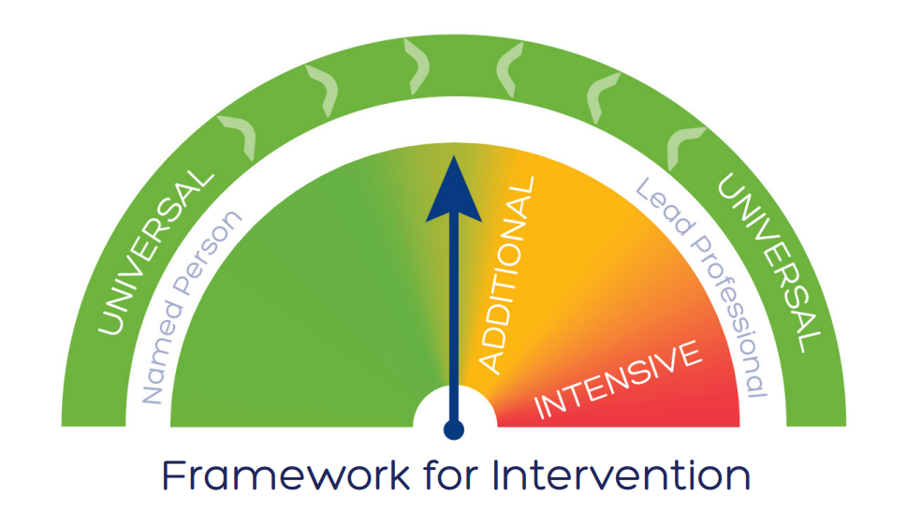
Resilience
Resilience is a vital life skill that empowers children to cope with challenges, adapt to change, and persevere through setbacks. At Park Road, we actively nurture resilience to help pupils build confidence, emotional strength, and a positive mindset. Through supportive relationships, restorative practices, and targeted strategies, we equip every child with the tools to manage difficulties, regulate emotions, and stay engaged in their learning—ensuring they are prepared not just for school, but for life beyond it.

What does resilience look like at Park Road?
Park Road, pupils are encouraged to take risks, embrace mistakes, persevere through challenges, and believe in their ability to succeed. They learn to recognise stress and use tailored strategies—universal, additional, and intensive—to cope effectively.

Being Ready to Learn is a key Park Road method for building resilience. It promotes positive attitudes, restorative language, and high expectations across the school. Pupils are supported to reflect on their choices and understand their responsibilities.

Ready to Learn Behaviours:
- Listening ears, looking eyes, quiet bodies
- Thinking minds and one voice
- Prepared with learning materials
- Positive movement and lining up

Celebrating Resilience and Readiness:
- Displaying names/photos
- House points and certificates
- Praise phone calls and postcards
- Weekly assembly recognition
These practices help children develop confidence, self-regulation, and a mindset for lifelong learning.

Self-Regulation at Park Road
At Park Road, staff model and teach self-regulation and emotional literacy to help pupils manage stress, anxiety, and challenging emotions. When needed, children receive additional support to develop effective coping strategies.
What This Looks Like:
Pupils are supported to self-regulate through:
- Emotion Works (introduced in session 2025/26)
- Five-point scale and emotional prompts
- Fix-it folders with symbols
- Restorative scripts with peers and adults
- Nurture spaces in classrooms and across the school
- Social stories
These tools help children recognise emotions, respond calmly, and stay ready to learn. However, on occasion, some pupils who may not be ready to learn, may need Time to Think, Time to Talk and on occasion more intensive measures to promote their readiness to learn.

De-escalation at Park Road – A Time to Think
At Park Road, staff build strong relationships with pupils and use personalised strategies to prevent escalation. By identifying triggers early and responding calmly, we support children in managing their emotions and behaviours.
What This Looks Like:
- Early identification of triggers and use of proactive strategies
- Individual action plans to support emotional regulation
- Reflection and review when pupils are ready
- Integration with the Five-Point Scale
When pupils become distressed, Time to Think offers intensive support through:
- Access to calm spaces in or outside the classroom
- Restorative conversations in a safe environment
- Calming and sensory resources
- Visual prompts and strategies across learning areas
- Time for reflection and planning a positive way forward
- Proactive management strategies tailored to individual needs
These approaches help pupils regain control, reflect, and return to learning in a supportive and respectful environment.

Restorative Approaches – A Time to Talk
Staff at Park Road support learners who are not ready to learn by encouraging reflection through:
- Time out of the playground (with SLT agreement)
- Restorative Discussion using guided questions
- Teacher phone call home after 3 Time to Talks in a week or a particularly challenging day
- HT/PT phone call to arrange a meeting if concerns persist, to review strategies and next steps
Positive relationships between children and staff are central to successful restorative conversations and follow-up actions. These discussions should take place in a calm, quiet space where everyone is ready to listen and resolve the issue respectfully.
Restorative Discussion Questions:
- What happened?
- How did you feel?
- How did you react?
- What would help?
- What else could you do?
- How can we make this better?
In some cases, a ‘rocket chart’ or coloured timetable may be used to promote positive behaviour. Staff review progress frequently and regularly up to more intensive bursts of 30 minutes if necessary, encouraging pupils to “keep it green” and avoid amber or red.

In order to ‘Keep it Green’ and ensure pupils are ‘ready to learn’, there should be an active focus on:
Rights of the learner
I have the right to… | I should …
Learn | - Focus on my own work and not disrupt the learning of others
Achieve | - Aim high and never give up
An opinion | - Be respectful when voicing my opinion and listen to the opinions of others
Be respected | - Treat others the way I want to be treated and ensure that everyone feels valued and included
Be treated fairly | - Treat others with respect and fairness

Expectations of our school community
Nurturing Relationships
Relationships | Purposeful, respectful relationships are modelled and developed.
Staff Approach | A consistent staff approach promoting positive behaviour, using positive and restorative language.
Curriculum | Social and emotional aspects of the curriculum are visible and differentiation takes account of needs.
School Organisation | Vision and values are evident in school organisation and robust systems, policies and procedures are in place.
Partnership Working | Other agencies and professionals are engaged in partnership working. Parents are engaged in the life of the school.
Physical Environment | A safe and secure physical environment provides a variety of sensory experiences and quiet spaces in classrooms.
Parents’ Approach | To model and promote positive behaviour and relationships when communicating with others.

Additional strategies to support resilience and self-regulation at Park Road:
To help pupils recognise and manage their emotions, staff may use a Five Point Scale. This tool supports pupils in identifying how their body feels during emotional states and encourages discussion around calming strategies. Scales are tailored to each child, with younger or neurodivergent pupils often using a simplified Three Point Scale.

Below is an example scale created by staff, showing common signs of pupil distress and suggested strategies to support regulation:
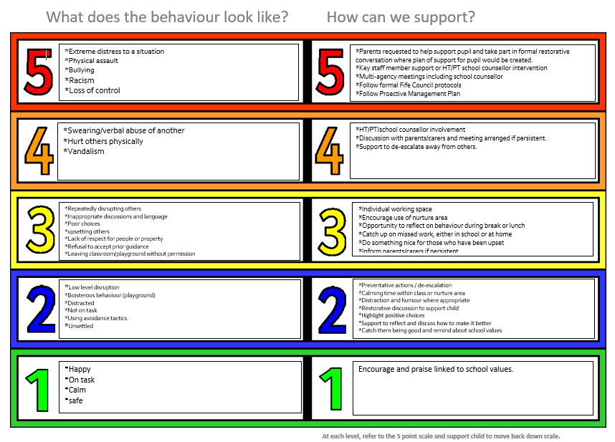

Use of Scripts and Social Stories

Emotion Works

Anti-Bullying
“Bullying is both behaviour and impact; the impact is on a person’s capacity to feel in control of themselves. This is what we term as their sense of ‘agency’. Bullying takes place in the context of relationships; it is behaviour that can make people feel hurt, threatened, frightened, and left out. This behaviour happens face to face and online.”
Respectme, 2015
Intricately linked with the Fife Council and the Children’s Services Directorate’s own anti-bullying policy, Park Road PS is opposed to bullying of any form, and all stakeholders have a duty to identify, report and act upon any instances which may occur. Fife Council’s policy, and therefore this policy also, defines bullying as:
“behaviour, which may or may not be deliberate, by one person or a group, which upsets, hurts, harms or injures another, impacting directly on their quality of life. Bullying may take many forms, including verbal, physical and social behaviour, and increasingly it may involve the use of technology, such as mobile phones or computers. It is likely to be associated with a power difference between those who bully and those who are bullied, to lead to hurt, fear and anxiety, and is often the result of a difference, perceived or real.”

Fife Council Anti-Bullying Policy (2018)
At Park Road we may encounter bullying behaviours that involve:
- Name calling, teasing or making fun of someone
- Any form of physical violence
- Having belongings taken, vandalised or damaged
- Being ignored, left out, or isolated
- Having rumours spread about someone, in person or online
- Being humiliated in front of others
- Receiving abusive messages by phone, text or online
- Being targeted because of someone’s personal characteristics
Combatting bullying at Park Road?
- Staff and pupils are aware of the distinction between conflict resolution and bullying.
- Staff are trained on anti-bullying policy and have a duty to report any incidences formally, using Fife Council guidance and protocol.
- Staff will communicate with all stakeholders involved, including parents and victims of bullying.
- Pupils feel listened to and respected when reporting issues related to bullying; they know their concerns will be taken seriously.
- Pupils understand that bullying is unacceptable and that there are strict consequences for any bullying behaviour. These will include:
- Reporting any instances of bullying on Fife Council system
- Parental involvement to encourage proactive management and prevention of future instances occurring
- Intensive anti-bullying work with school, pupils and families involved
A culture that encourages respect, values opinions, celebrates difference and promotes positive relationships will make it difficult for bullying behaviour to flourish or be tolerated.
Respectme, 2015

