Parkhill Newsletter
March 2026

In this edition:
- Parent Council/School Association Update
- Nurture and Wellbeing groups that run in Parkhill
- Comic Relief
- Thank you to Oscar’s coffee house
- Dates for your diary
- Attendance

Introduction
As we approach the end of term we are delighted to update you on a few developments this term and in March. This is always a busy term and this term has been no different. The children and staff have worked very hard and this is evident in their classrooms.
We hope everyone has a lovely spring holiday.

Parent Council/School Association Updates
The Parent School Association have spent the hard-earned fundraising money on items to improve our playground. Below are pictures from our playground launch of the things the money has been spent on along with items that have been donated by you too. A huge thank you to everyone who has helped fundraise this fantastic amount. A huge thank you also to out PSA who have not only fundraised but have built up all the items and stored them in the relevant sheds. The items will all make a huge difference to the quality of breaks and lunchtimes for our kids.

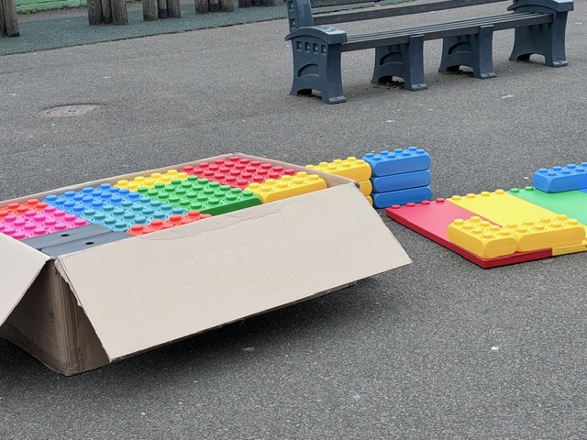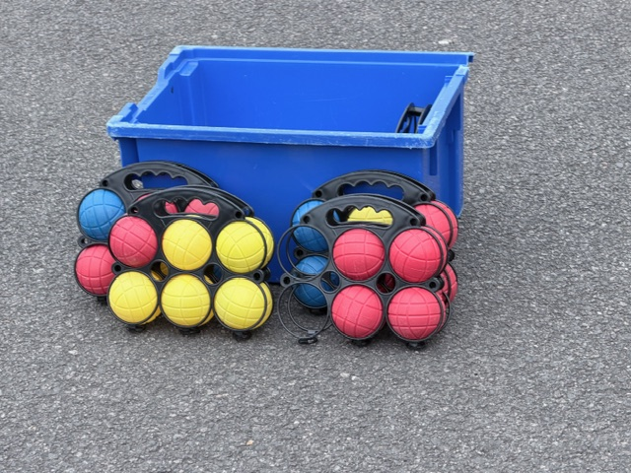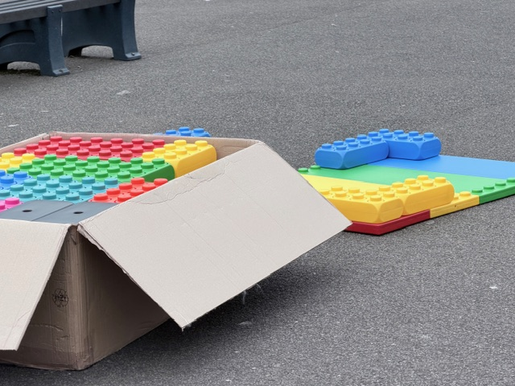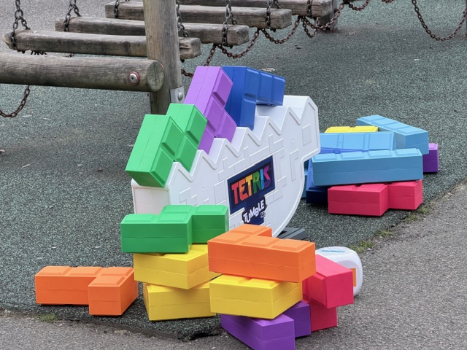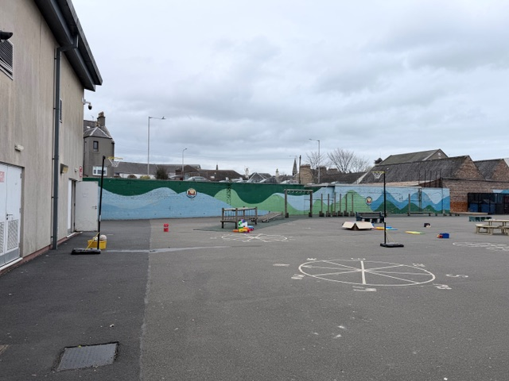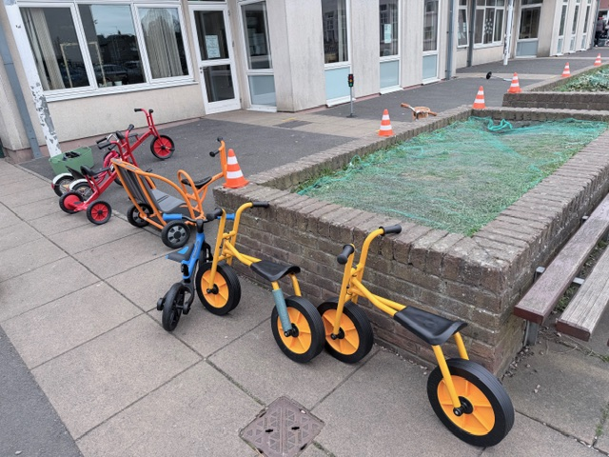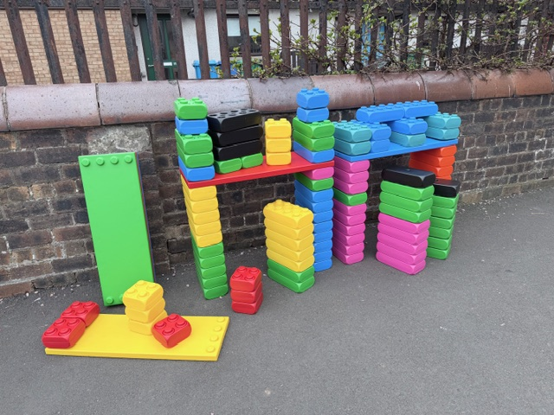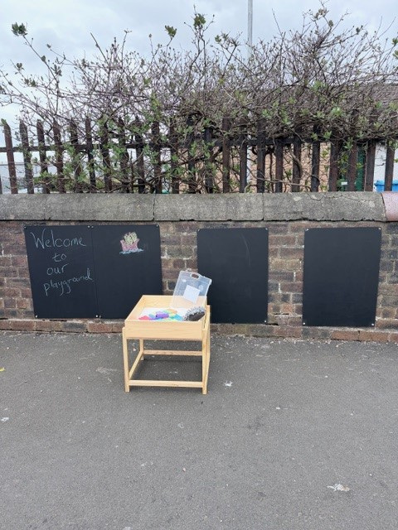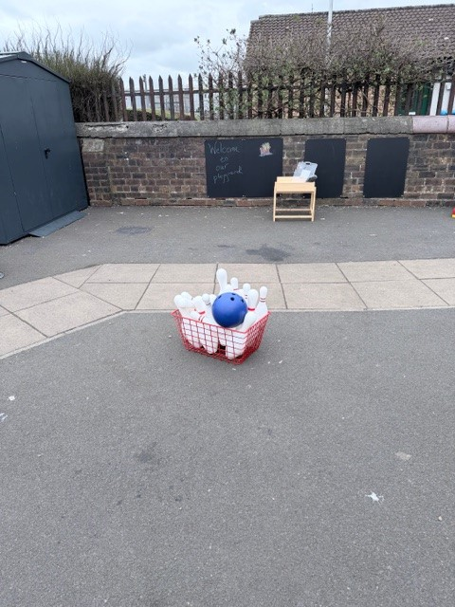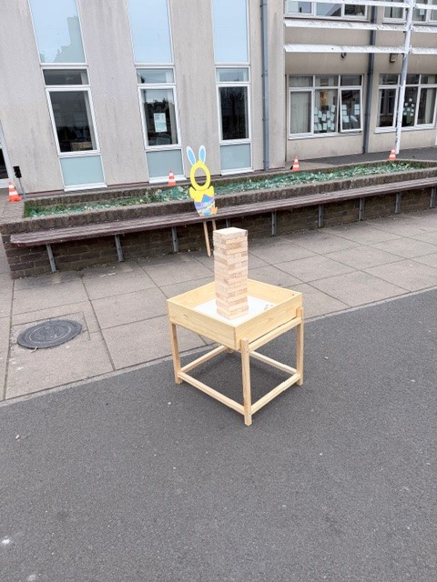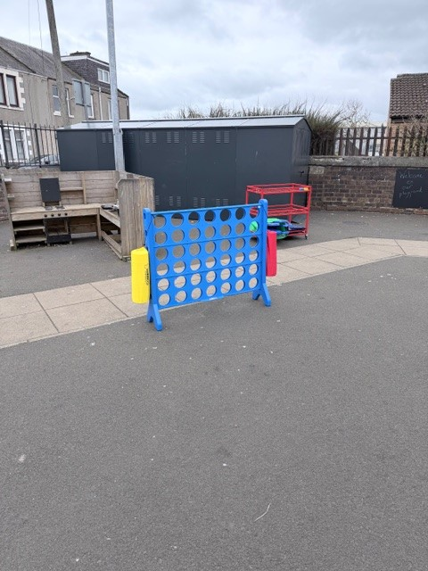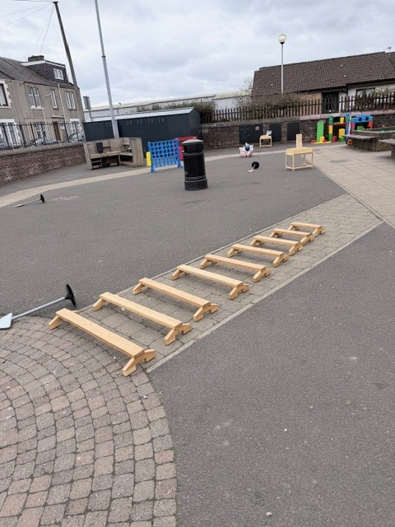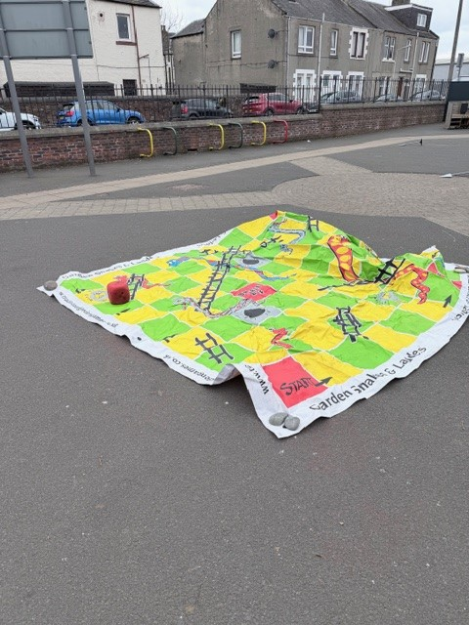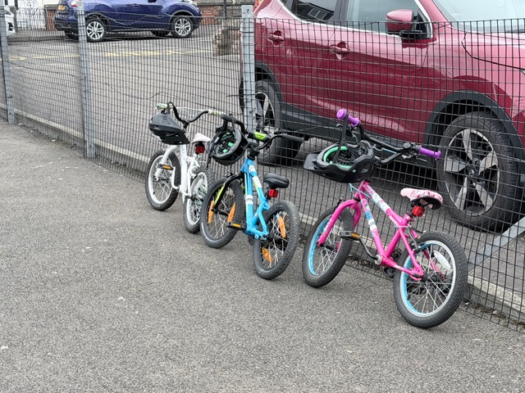

Nurture and Wellbeing groups that run at Parkhill
This year we have run a variety of nurture and wellbeing groups across the session. Some of the groups our learners have been involved in are: Settled Start, Social Skills, Life Skills, Mindfulness, Football Skills, Swimming, Outdoor Learning, Soft Finish and Sensory Circuits. Parent and pupil feedback has been extremely positive, and we are looking forward to running more nurture groups in the coming term. Look out for a letter in your child’s school bag! (These groups may be cancelled at short notice due to staff availability).

Comic Relief
Last week we enjoyed fundraising for another charity Comic Relief. The school raised an amazing £553.87 so thanks to all who donated. Many thanks to our Captaincy Team for organising. Below are some pictures from the day.
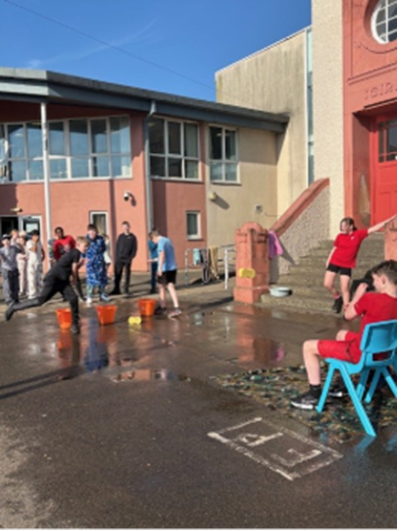

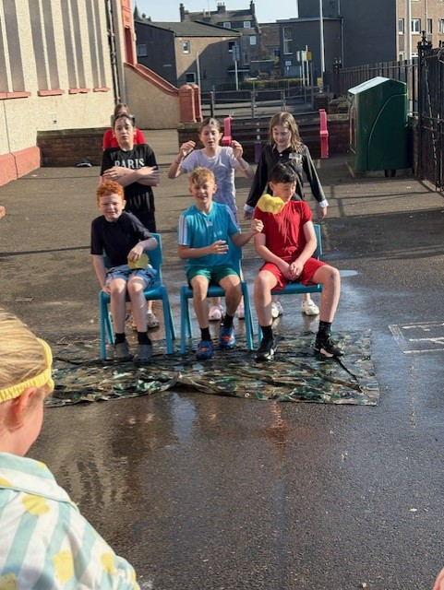
Some of Parkhill’s Captaincy Team who had wet sponges thrown at them by pupils and staff.

Oscar’s Coffee House
We were invited up to Oscar’s coffee house this week as they have very kindly been fundraising and have donated the £312 raised by their customers to us. As you know any money raised is very valuable to us and we can’t thank Oscar’s enough for this very kind donation of money and for the Easter eggs they gave to our pupils who went up to represent the school.

Dates for your diary
I have highlighted the dates for your diary for next term.
Date | Time | Event
20th April 2026 |  | School returns for term 4
4th May 2026 |  | School Closed
7th May 2026 |  | INSET DAY closed to pupils
14th May 2026 | 9.15 - 9.45 | Open Morning – Expressive Arts (Music, ART, Drama, Dance)
22nd May 2026 | 11.00am - 2.30pm | School Sports Day (Weather permitting) Beachfront
12th June 2026 |  | Progress Jotters go home
30th June 2026 | 1.45 - 3.00 | P7 Leavers Assembly
3rd July 2026 |  | School Finishes for summer at 3pm
Please note we may on occasion need to change dates but will try to give as much notice as possible.

Attendance
CURRENT ATTENDANCE 93.37% our target is 93.9%
Attending school enables children the opportunity to become Successful Learners, Responsible Citizens, Effective Contributors and Confident Individuals.
Excellent attendance will allow your child to benefit from:
• Consistent and progressive learning and teaching
• Meeting friends and developing friendships
• Routine and organisation
• Developing new skills
• Building confidence and self-esteem
Use this link to report your child’s absence: parentsportal.scot | The digital doorway to your child's school. or contact the school office.

