#Learning Together – Achieving Together
September 2021

I can’t believe it is September already! After a few weeks our new pupils are much more familiar with routines and have got to know all the staff at Parkhill.

As with the rest of Fife / Scotland we have seen positive Covid 19 cases in school. You will know the guidance has changed from last session. Whole classes are not asked to isolate if there is a positive case, but a “Warn and Inform” email is distributed. If there is a positive case in the household and pupil tests negative on PCR (not lateral flow) they can return to school if no symptoms. If you are in any doubt, keep your child at home and book a PCR test.

The situation, obviously, impacts on staff and where we have staff absence / isolation we work hard to use other school staff / supply staff to cover.

We only have one DHT now – Mrs Julie Brown. Mrs Brown and Mrs Harper (HT) are responsible for all of Parkhill Primary and Viewforth Nursery. If you have a concern and don’t get a reply / answer straight away, please be patient.

P6 and P7 Theatre Visit
Every year we offered a P6 Theatre Visit. Last year “The Lion King” at Edinburgh Playhouse in March 2020 had to be cancelled. However, we have secured seats for a high quality production of “Beauty and the Beast” at Edinburgh Playhouse for present P6 and P7. The cost is £20. Letters have already gone out to parents – if you feel that you might struggle with this cost, please contact school.

Visiting a theatre is an experience that most of us would only do occasionally. We hope it will be something that will be a positive memory for all our children.

Lunches
We were asked to consider gradual easing of restrictions / bubbles. Therefore, in a couple of weeks we will give all parents information of lunch break timings.

The middle corridor have played in Large Playground separately from Upper Corridor. Although this had meant Senior Leadership and Support Staff are supervising the Dinner Halls and playgrounds over a longer period of the school day, it has resulted in happier, less congested playtimes. We don’t want to simply return to all middle and upper children playing together for 45 minutes. We will provide some time that they can have more space with their corridor children and some overlap time with both corridors together. We have taken on board feedback from staff and pupils and we strive for all to have happier playtimes.

Lost Property
We have never had so many items of Lost Property left each day! Please label all belongings – uniform, water bottles, packed lunch boxes etc. Please speak to your child about taking care of their belongings.

On Friday we will put a trolley / bench of lost property in small playground at 2.55pm. Any parent wanting to look for / claim belongings can do so then.

Parent Council
Our next meeting is Monday 20th September at 6.30pm – meeting via Google Meet. It may be my last Parent Council Meeting as Headteacher of Parkhill, before taking early retirement in October.

The Parent Council has been a small, hardworking and interested group. It has been a pleasure to work with them. If you would like to join please email Jennifer Innes (Present Chair) via parkhillps.enquiries@fife.gov.uk.

Travel
Thanks to all parents / carers who have taken on board all messages about not congesting the pathways and pavements. Remember our Park n Walk facility is at the Retail Park. It is a good opportunity to have a little walk, fresh air and chat with your child before the school day begins.

Our theme of “Sailing for Success” has been displayed in the foyer – well done to all classes who shared their aspirations for their school year.

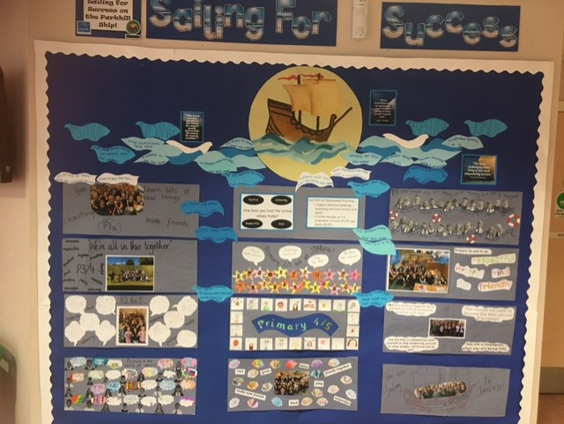

Mrs Susan Harper Mrs Julie Brown
Headteacher Depute Headteacher

Follow us on twitter @Parkhill_PS
Contact us: parkhillps.enquiries@fife.gov.uk
01334 659433

