**SNSA Numeracy Historical Analysis – 2018/19 to 2022/23 – Identifying Trends Over Time**

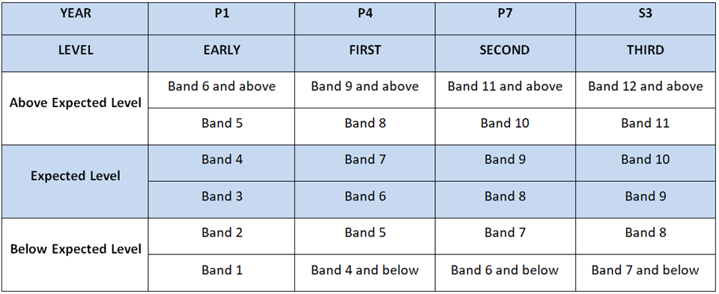

For the purposes of exploring trends in **Areas for Development** across the NSA from 2018/19 to 2022/23 we filter by:

* Expected Level (i.e. at Second Level filter by Band 8 and Band 9)
* Percentage Correct in Group – filter by colour. Firstly filter by red.
* Task Descriptor – Sort from A-Z to start to analyse questions and to identify trends over time (*Note: If the same task descriptor appears as a Strength or Area for Development over 2 or more years this is highlighted as a trend)*

Repeat the process from:

* Percentage Correct in Group – filter by colour. Secondly filter by amber.
* Task Descriptor – Sort from A-Z to start to analyse questions and to identify trends over time (*Note: If the same task descriptor appears as a Strength or Area for Development over 2 or more years this is highlighted as a trend)*

*Note: For* ***Areas of Strength*** *repeat the above process but filter by green for colour*

**SNSA Historical Analysis – 2018/19 to 2022/23 - Numeracy**

|  |  |  |
| --- | --- | --- |
| **SNSA Numeracy** – 2018/19 to 2022/23 | | |
| **Early Level** | **First Level** | **Second Level** |
| **Strengths** | **Strengths** | **Strengths** |
| **Number** | **Number** | **Number** |
|  |  |  |
| **Fractions, Decimal Fractions and Percentages** | **Fractions, Decimal Fractions and Percentages** | **Fractions, Decimal Fractions and Percentages** |
|  |  |  |
| **Information Handling** | **Information Handling** | **Information Handling** |
|  |  |  |
| **Measurement, Time and Money** | **Measurement, Time and Money** | **Measurement, Time and Money** |
|  |  |  |

|  |  |  |
| --- | --- | --- |
| **SNSA Numeracy** – 2018/19 to 2021/22 | | |
| **Early Level** | **First Level** | **Second Level** |
| **Areas for Development** | **Areas for Development** | **Areas for Development** |
| **Number** | **Number** | **Number** |
|  |  |  |
| **Fractions, Decimal Fractions and Percentages** | **Fractions, Decimal Fractions and Percentages** | **Fractions, Decimal Fractions and Percentages** |
|  |  |  |
| **Information Handling** | **Information Handling** | **Information Handling** |
|  |  |  |
| **Measurement, Time and Money** | **Measurement, Time and Money** | **Measurement, Time and Money** |
|  |  |  |