Guide to Downloading NSA Diagnostic Report
Login to NSA using the following link:
Sign in - National Standardised Assessments for Scotland
Note: you will need to be on a Fife Council Network to access the NSA login
Once logged in you will see the following:
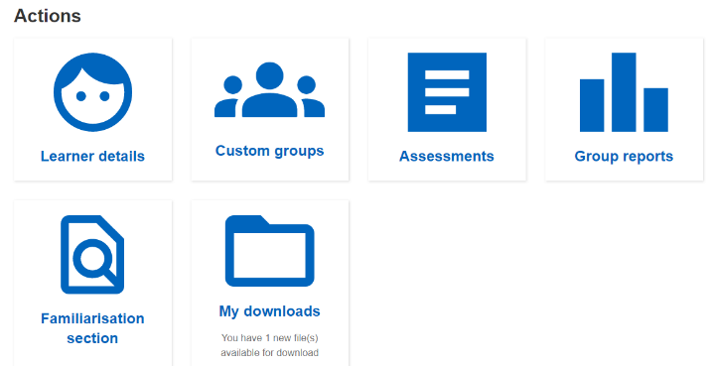
Click on the Icon called Group Reports:
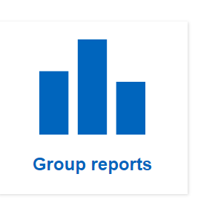
Click on the Icon called Group Diagnostic:
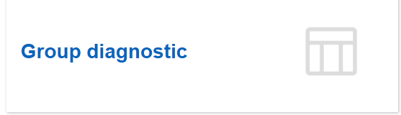
Choose the following from the dropdown menu and press View Report:
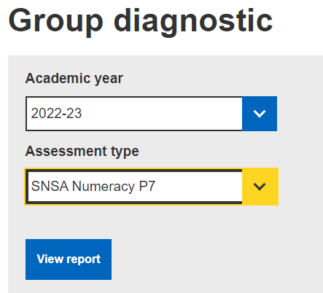

Click on Export Data (XLSX):
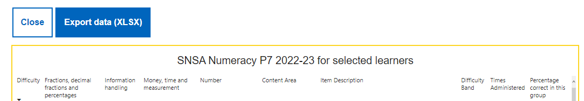

Click on My Downloads:
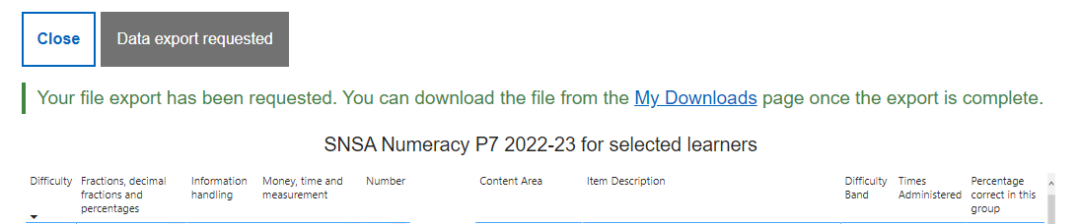
Click on the Download Icon:
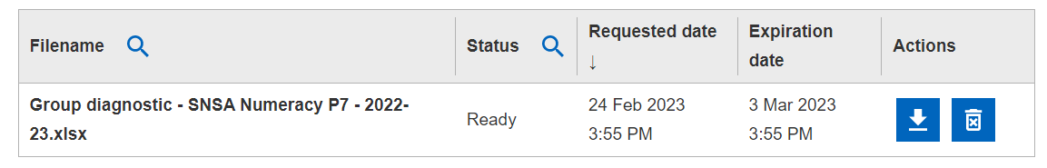
Save the document with the following name:
SchoolNameNSAP7Numeracy

