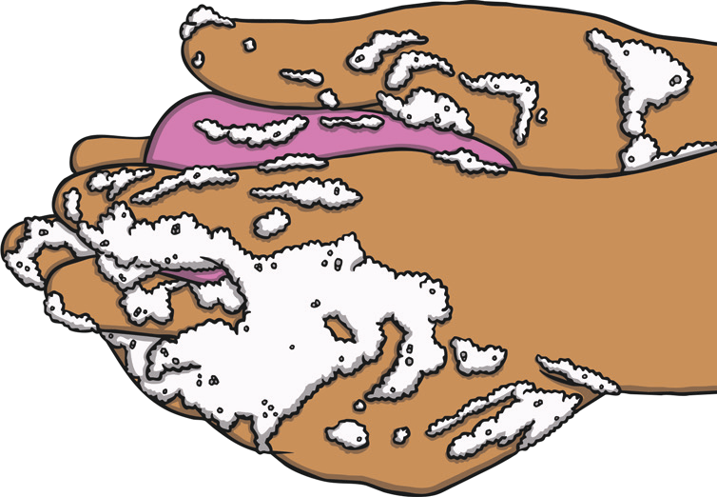

**Why Soap Works Experiment**

|  |  |
| --- | --- |
| **You will need:** | |
| * A bowl * Some water * A sprinkle of black pepper (or another spice) | * Liquid hand soap * A hand towel * A camera (optional) |

In this experiment, you are going to find out why soap works and why it is better than using just water to wash your hands.

In the experiment, the surface of the water in the bowl represents your hands. The pepper represents harmful dirt and germs that need to be washed away.

There are two tests in this experiment and they will show you what happens when you wash your hands with and without soap.

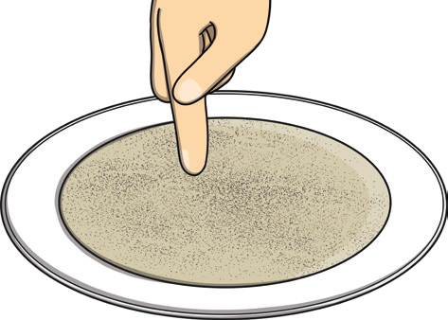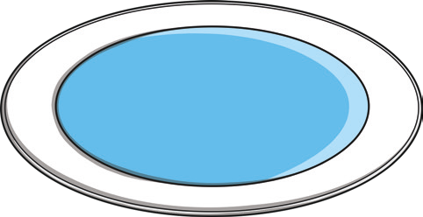

|  |  |
| --- | --- |
| **1** | Fill the bowl with water, but not all the way to the top. |
|  |  |
|  |  |
| **2** | Sprinkle some black pepper on to the surface of the water. You should see the black pepper floating. |
|  |  |
|  |  |
| **3** | **Test 1**: Dip your finger into the centre of the bowl of water. Watch what happens to the pepper and record this. |

**Why Soap Works Experiment**

|  |  |
| --- | --- |
| **4** |  |
|  | Dry your hand, then dip your finger into the liquid hand soap. |
|  |  |
|  |  |
| **5** | **Test 2**: Dip your soapy finger into the centre of the bowl of water. Watch what happens to the pepper and record this. |

t

