MILESMARK PRIMARY SCHOOL
School Improvement Plan 2025 - 2026
Aiming MILES high to make our MARK

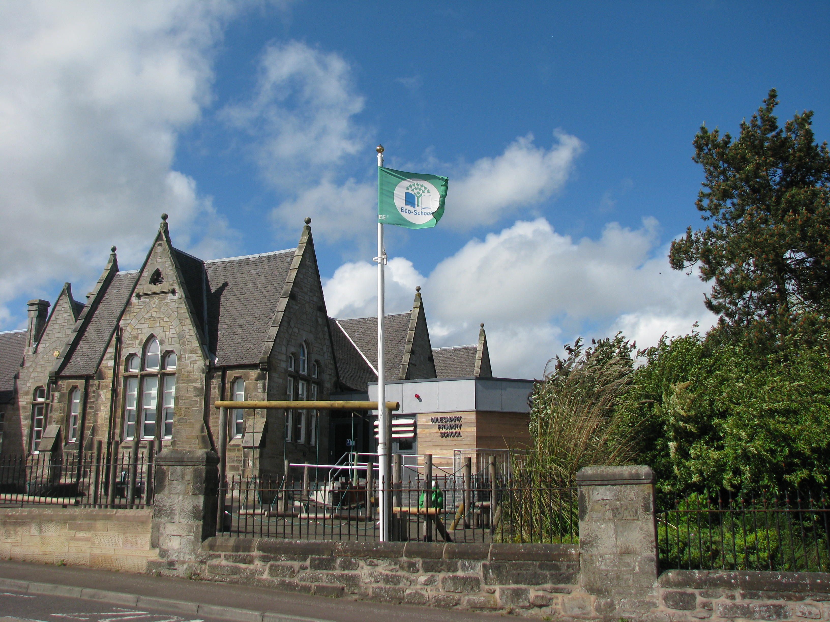

Context of the School

Milesmark Primary School is a small school in the local community. It consists of 4 classes in a listed Victorian building, and hutted accommodation which houses an infant classroom. The new extension to our building opened at the beginning of 2018 and we now have an extra classroom, new entrance, toilets and office space.
There is a gym/dining/assembly hall and a fairly large resources room, which has been revamped to incorporate a library. The Learning Support Teacher and PSAs use this room.

There is a very mature garden with picnic tables to create a quiet area for pupils which is also used by our gardening club, Eco Committee and for outdoor learning activities. There is a trim trail and fixed playground equipment that are well used by all children.

During our Education Scotland Inspection (2018), the team reported that the staff at Milesmark Primary School work as a team to provide the children with high quality learning experiences tailored to their individual needs and that all staff in school know the children and families very well. There are strong positive relationships between the school and the community.
We engage families and the community in continuous improvement and parents and pupils know that their views inform change and improvement.

This session the school roll will be 92 pupils. We will have 4 classes in session 2025-2026 organised as P1/2, P3/4, P4/5/6 and P6/7. Our management team comprises of Mrs Gillian Souter (Joint Headteacher with McLean) and Mrs Stephanie Owsnett (Temp PT). We will be allocated a probationary teacher again and Mrs Owsnett will mentor her.

The children attend a number of local nurseries before joining us in Primary 1.
The catchment high school is Queen Anne High School which is generally where all of our pupils go.
The school offers brass instrumental instruction.
One full time and two part time Pupil Support Assistants support our children at Milesmark.

School Vision, Values & Aims

School Motto: Aiming MILES high to make our MARK
Vision statement

At Milesmark Primary School we aspire to create a learning community where all are challenged and supported to aim high, and where the needs of children are at the heart of all that we do.
School values
In carrying out all aspects of our work, the following values will underpin our actions:
Milesmark Primary School – where children SHINE and feel;
Successful
Happy
Included
Nurtured
Engaged
School aims
At Milesmark Primary School we aim high to:
- Make sure our school is happy and safe and everyone enjoys being here. We want parents, people from our area and new families to feel welcome.
- Learn lots of new skills to help us be responsible citizens in our local and global environment.
- Be confident individuals, successful learners and effective contributors.
- Do the best we can in everything we do.
- Be an eco friendly school through our work with the Eco Council, children, staff and parents and aim to be responsible citizens.
Education Directorate Improvement Plan: Achievement
Focused Priority:
- Plan a progressive curriculum for all children across 8 curriculum areas ensuring that all children receive their entitlement to a broad general education.
- Use benchmarks for all curriculum areas to measure children’s progress and achievement of a level across the broad general education using a range of assessment evidence to inform professional judgements.
HGIOS4 Quality Indicators
1.2 – Leadership of Learning
1.3 – Leadership of Change
2.2 – Curriculum
2.3 – Learning, Teaching and Assessment
3.1 – Ensuring wellbeing, equality and inclusion
3.2 – Raising attainment and achievement
Expected Impact | Strategic Actions Planned | Responsibilities |  | Measure of Success  (Triangulation of Evidence/QI Methodology) | Timescales
All children will experience planned, progressive learning experiences across the broad general education.  All staff will enhance their assessment skills through planned assessment and moderation activity, this will ensure all children are making progress across all areas of the curriculum  All staff will track children’s progress across the broad general education and use assessment evidence to support professional judgements to ensure children experience their entitlement to a broad general education.  Through planned opportunities with parents/carers, knowledge of the broad general education will be developed and this will ensure they can support children in their learning across the curriculum | Forward Planning  - All staff will improve confidence in using new online planning formats using the progression pathways for all curriculum areas to ensure planned learning experiences are progressive for all children.  - Attainment and Forward Planning dialogues will support assessment within all curriculum areas linked to assessment evidence which informs professional judgements.  - Staff will become aware the Numeracy phases and start to use the diagnostic assessments.  - Staff will develop confidence in planning for assessment.  Tracking & Monitoring  - Develop agreement around jotter standards.  - Involve staff in moderation of work and standards across Milesmark and McLean so that staff feel more confident in their CfE judgements.  Learning, teaching and assessment  - Continued focus for parent/carer workshops/shared starts and finishes to share progression across identified curricular areas  - Continue with digital schools award | Led by SLT  All staff  Led by SLT  All staff  Led by cluster PT  Led by DHT |  | Data  Analysis of attainment data in Literacy, Numeracy along with all/identified areas of the curriculum  Analysis of CFE and BASE/NSA data  Analysis of data for identified cohorts e.g., SIMD ASN, EAL, LAC, AF etc  People’s Views  Teacher views on new system  Teacher professional dialogue with SLT at FP & Attainment Meetings  Feedback from moderation activity  Parent/carer views on children’s experiences of BGE  Children’s views gathered through class groups and pupil focus groups on the learning experiences across the curriculum  Observations  Forward planning documentation monitoring  Jotter sampling – literacy/numeracy and other curriculum areas  Classroom observations linked to identified areas of the curriculum (QA calendar)  Focus for LP – analysis of data, learning experiences across the curriculum/identified area of curriculum, parent/pupil views of the delivery of the curriculum | October 2025  Jan 26  May 26
Ongoing Evaluation

Education Directorate Improvement Plan: Achievement
Focused Priority:
- Support and enhance the delivery of high-quality learning, teaching and assessment through professional learning on for all staff on the use of digital technology.
- To support all staff through the use of digital technologies to create a more inclusive, engaging and personalised learning environment leading to improved outcomes for children and young people.
HGIOS4 Quality Indicators
1.3 Leadership of Change
2.2 Curriculum
2.3 Learning, Teaching and Assessment
2.4 Personalised Support
2.6 Transition
3.2 Raising Attainment and achievement
3.3 Increasing creativity and employability

Expected Impact | Strategic Actions Planned | Responsibilities |  | Measure of Success  (Triangulation of Evidence/QI Methodology) | Timescales
All children will experience improved engagement and motivation in learning through creative approaches to delivering learning and teaching using a wide range of digital tools.  Through professional learning all staff will enhance their skills in using digital tools to deliver high-quality learning, teaching and assessment with appropriate differentiation, leading to improved outcomes for all children.  Children in P6 and P7 will become more proficient in using digital tools to support them in their learning, preparing them with skills for learning, life and work.  All staff will increase their knowledge of how to personalise learning using a wide range of software, digital skills, and accessibility tools to meet the needs of all children/young people at universal, additional and intensive levels.  Through planned opportunities with parents/carers, knowledge of the use of digital technology will be developed and this will ensure they can support children in their learning across the curriculum. | Professional Learning Activity  - As part of the agreed WTA of 5 collegiate sessions and 3 cluster sessions, staff will engage in professional learning on the use of iPads and associated apps to enhance the quality of learning, teaching and assessment.  - All staff will have the option to upskill their knowledge through the awareness of resources and self-led professional learning available on the Apple Education Community and further professional learning will support teachers to make effective use of the software library and develop their digital skills.  - All staff will engage in a small scale Practitioner Enquiry around differentiation using i-pads and be able to present their findings.  Enhancing learners’ experiences  - Enable all staff to personalise learning by tailoring content on digital platforms to suit individual/class needs.  - Enable all staff to use digital tools to make learning and teaching more engaging.  - Accessibility features will be available to ensure learning is more inclusive for children with ASN whilst promoting independence.  - Staff will ensure they are able to always demonstrate safe and responsible use of digital.  Learning, Teaching and Assessment  - Teachers will use their digital skills to plan appropriate learning based on Fife’s curriculum progression pathways.  - Teachers will use a range of digital tools to create and share explanations and to model learning processes.  - Planning for key learning to be shared via digital platforms to support P6 and P7 children, to access during and outside of lessons.  - Teachers will plan for differentiated learning by providing access to learning materials digitally allowing children to use the accessibility features and/or to access at their own pace.  - Teachers involve children in the planning process, actively engaging them in decision making, allowing them to contribute ideas, select learning activities and co construct success criteria.  - All staff will improve the way they gather evidence of learning through digital means and jotters. This will be monitored closely by SLT and mediated by staff.  Assessment and Feedback  - All staff will develop skills to improve their knowledge of the digital tools available that can be used to provide instant feedback to children.  - Development of Digital Portfolios to showcase learning over time using Showbie.  - Data to be gathered from the use of digital platforms in conjunction with all assessment evidence to plan for next steps in learning.  Curriculum Rationale  - Our Curriculum Rationale will be further developed to ensure that this reflective of the experiences all children are experiencing across the school in relation to the use of digital technology. | Led by ESO’s, Digital PT’s  All staff led by digital Ambassador, LD  Led by GS (HT) and EW (DHT)  Led by ESO’s, Digital PT’s  Led by SLT  All staff  Led by SLT  All staff  Led by LW (DHT)  Led by SLT  All staff  SLT |  | Data  Analysis of attainment data in Literacy, Numeracy along with all/identified areas of the curriculum  Analysis of CFE and BASE/NSA data  Analysis of data for identified cohorts eg SIMD ASN, EAL, LAC, AF etc  People’s Views  Staff views on use of digital technology to enhance learning.  Self-evaluation (2.3) on strengths and next steps.  Staff professional dialogue with school/cluster colleagues.  Feedback from Professional Learning activity.  Parent/carer views on children’s experiences.  Children’s views gathered through class groups and pupil focus groups on the use of digital technology to support and enhance learning experiences.  Observations  Forward planning documentation.  Classroom observations linked to the use of digital technology to enhance learning, teaching and assessment.  Focus for LP – analysis of learning experiences through the use of technology. | May 26  Feb 26  April 26  May 26  May 26
Ongoing Evaluation

Session 2025 - 2026 Improvement Plan
Improvement Priority 2 – Health and Wellbeing
Education Directorate Improvement Plan: Equality & Equity, Health & Wellbeing, Attendance & Engagement
Focused Priority:
- To create a supportive school environment that fosters mental and emotional wellbeing, enabling pupils to thrive academically and personally.
HGIOS4 Quality Indicators |  |  | HGIOELC Quality Indicators
1.2 – Leadership of Learning  1.3 – Leadership of Change  3.1 – Ensuring wellbeing, equality and inclusion |  |  | 1.2 – Leadership of Learning  1.3 – Leadership of Change  3.1 – Ensuring wellbeing, equality and inclusion
Expected Impact | Strategic Actions Planned | Responsibilities |  | Measure of Success  (Triangulation of Evidence/QI Methodology) | Timescales
All staff will be confident in using consistent de-escalation strategies.  All staff will record bullying incidents accurately  Through workshops, families will understand resources (such as kitbag, emotion works, scripts) used to support health and wellbeing in school and will feel confident in adopting these strategies at home. | Professional Learning:  - Staff to attend training around Emotion Works and this will be used consistently in as part of our Positive Relationships and anti-Bullying Policy.  - Strategic plan to be agreed and started for implementation of de-escalation being used throughout school.  - Staff to attend further training around the Circle framework.  Curriculum:  - Work towards our Gold award for Rights Respecting Schools.  - Continue to work towards our eco goals with continuation of our Green Flag status  - Deliver assemblies and class lessons which encourage acceptance of diversity and build on our inclusion and equality work. | Led by HL (LS Teacher)  RRS group  Eco group  SLT  Pupils  Families  LS Staff |  | Data  - Analysis of H&S violence and aggression reports  - Analysis of Seemis reports on bullying incidents  - Analysis of power BI data around SIMD, gender and other protected characteristics  People’s Views  - Parent/carer views on behaviour policy and bullying incidents ad how they are managed.  - Family views on workshops and strategies used.  - Children’s views gathered through class groups and pupil focus groups on their experiences of bullying, inclusion and equality throughout the school.  - Staff views on success of de-escalation and other strategies and impact on classroom ethos.  Observations  - LP visit feedback around classroom ethos and use of policy.  - SLT observations  - Feedback from other agencies visiting school on ethos | May 26  Feb 26
Ongoing Evaluation

