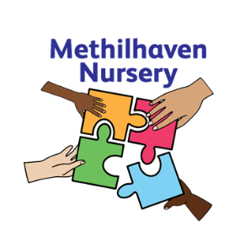
Methilhaven Nursery
Kirkland Parade, Methil, KY83DL

Tel: 01334 659486

Information for Families

Dear Parent
A warm welcome is extended to you by everyone at Methilhaven Nursery.
For many of you, starting nursery will be the beginning of a long journey through the education process with your child.
Our nursery team firmly believes in building a positive partnership with our families. We aim for all children to be happy, confident individuals who are able to work with each other and who go on to develop a love for learning.
We have prepared this booklet to answer some of the questions you may have and, more importantly, to invite you to chat to us about any points you would like clarified. We look forward to working with you and your child.

Yours sincerely
Sandie Johnston
Head of Centre

Methilhaven Nursery

FIFE COUNCIL EDUCATION SERVICE

WHAT WE STAND FOR
The Education Service in Fife plays a key role in taking forward the wider aims of Fife Council. As part of the Education and Children’s Services Directorate, our vision and what we stand for is “Improving Life Chances for All”.

THE VALUES AND PRIORITIES OF THE EDUCATION SERVICE
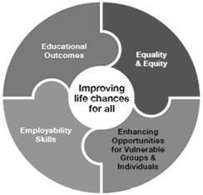
Our approach towards “Improving Life Chances for All” is founded on the values of Compassion; Ambition; Respect and Equality as we develop the capacity of young people to become:
- Successful Learners
- Confident Individuals
- Responsible Citizens
- Effective Contributors
The four priorities of the Education Service are
Educational Outcomes, Employability skills, Equity and Equality and Enhancing Opportunities for
Vulnerable Groups and Individuals.

These priorities and themes and the associated actions are described in the Education Service Plan and are reflected in the work of the Nursery.

Educational Outcomes focusing on | Employability Skills focusing on
Improving Outcomes for Learners including a focus on raising attainment in Literacy and  Numeracy  Developing Excellence in Learning and Teaching  Building an excellent Curriculum | Universal learning programmes to ensure all young people learn about careers and develop recognised employability skills  Focussed programmes to ensure particular groups are guided towards specific careers, especially as they enter the senior phase Targeted programmes of learning to ensure we make effective provision for those most at risk of finding a negative destination when leaving school
Equality and Equity focusing on | Enhancing Opportunities for Vulnerable Groups and Individuals Most at Risk
Breaking the cycle of disadvantage including reducing the attainment gap  Early Years  Supporting children, young people and families | In our focus on Educational Outcomes, Equality and Equity and Employability we will target our work towards improved outcomes for disadvantaged groups and those individuals most at risk

The information contained in this booklet refers to the current Nursery year and is accurate at the time of publication.
We hope this information will be helpful to you and will answer many of your questions about the nursery. Should you have any further enquiries, please do not hesitate to call in at the nursery where we shall be pleased to help you.

Contact Details

Head teacher: Sandie Johnston
Address: Kirkland Parade, Methil, KY83DL
Telephone No: 01334 659486

Other Information
The nursery has a Complaints, Concerns and Compliments policy, the details of which are displayed on our notice boards throughout the nursery. However, we would encourage parents and stakeholders to contact the nursery directly should there be any issue regarding the service or their child.

NAMED PERSON

The Children and Young People (Scotland) Act 2014 includes making a Named Person available for every child, from birth until their 18th birthday (or beyond, if they are still in school). In most cases, the Named Person will not have to do anything more than they normally do in the course of their day-to-day work.
Most children and young people get all the help and support they need from their families, from teachers and health practitioners, and from their wider communities – the Named Person does not change these roles.
However, some families may need extra help and that's where the Named Person comes in. This means that the child and their family have a single point of contact who can work with them to sort out any further help, advice or support if they need it.
The Named Person for your nursery child is the NHS Health Visitor. Should you need help in contacting your Health Visitor Nursery staff can help you with this.
BUILDING

Methilhaven Nursery is a newly established 49 week nursery which opened in August 2020.

We have one room for our 3-5 age children, and one room for our early entrants. The children attend our nursery Monday-Friday – either morning or afternoon sessions. The times are 8:00-12:40, 1:20-6:00

We have one playroom for our 3-5 year old children and a playroom for the Early Entrants. All nursery playrooms offer quality, rich learning and play experiences and each has direct access to secure and recently developed outdoor provision. Staff listen to, and work with the children to ensure learning is embedded from the Curriculum for Excellence and in line with current early years thinking.
Our children are also offered a range of visits within the local community including the woods, the beach and the local library.

OUR VISION
To provide a wide range of high quality learning opportunities offering challenge to children in a safe and nurturing environment. Positive partnership working will ensure all stakeholders are valued members of nursery community.

OUR AIMS AND VALUES
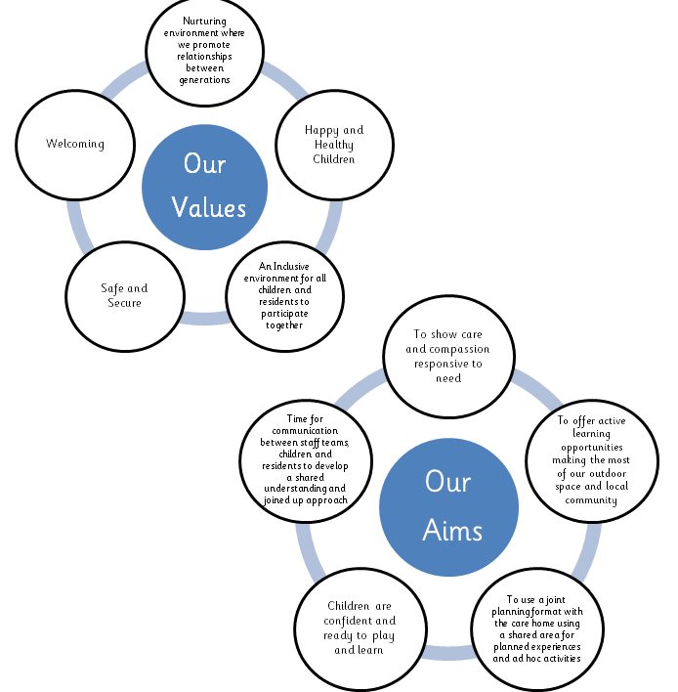

STAFFING

Headteacher/Manager Alexandria (Sandie) Johnston
Depute Head of Centre Courtney McLaughlin
Principal Teacher Jill McIntosh
Senior Early Years Officers Emma Jex/Brianne Harley
Early Years Lead Officer Dianne Grindle
Early Years Officers Jacqueline McGowan, Elspeth McKendrick, Laura Smith, Corey Thomson, Michelle Martin, Rhiann Anderson, Lesley Barnes, Sarah Pitcaithly, Debbie Kazoubic, Lewis Ogg
Early Years Officer Apprentice Wendy Grieve
Janitor Bill Blyth

NURSERY HOURS

A nursery place, equivalent to a total of 1140 hours per year is offered to all children from the term after their 3rd Birthday.

Nursery session for all children- 4 hours 40 min: 8am-12:40pm/1:20pm-6pm

Starting Nursery in August – child must be 3 before 31/8
Starting Nursery in January – child must be 3 before 31/12
Starting Nursery in April – Child must be 3 before the last day in February

Children are entitled to a meal in nursery.

APPLYING FOR A NURSERY PLACE FOR YOUR CHILD

You are asked to provide 5 choices on your application form as some nurseries or session times will be oversubscribed. In the event we are unable to offer you your first choice we will then look at your 2nd and then 3rd choice nurseries / pattern of attendance to see if we can offer you one of these.
An admissions policy is in place to ensure fairness when allocating places – this can be found at www.fifedirect.org.uk and searching for Early Learning and Childcare Admissions Policy.
Please note that the place you are offered may not be in your local nursery/catchment school nursery.

Is my two year old eligible?
You can find out if your two–year–old is eligible for early learning and childcare, on www.fifedirect.org.uk and searching for Early Years. You can also get this information from your local office, local nursery or Educational Home Visiting Service.

HOW TO APPLY
Application forms are available from all Fife Council nurseries, local council offices or online at www.fifedirect.org.uk. Applications should be returned to your first-choice nursery, along with any proof requested.

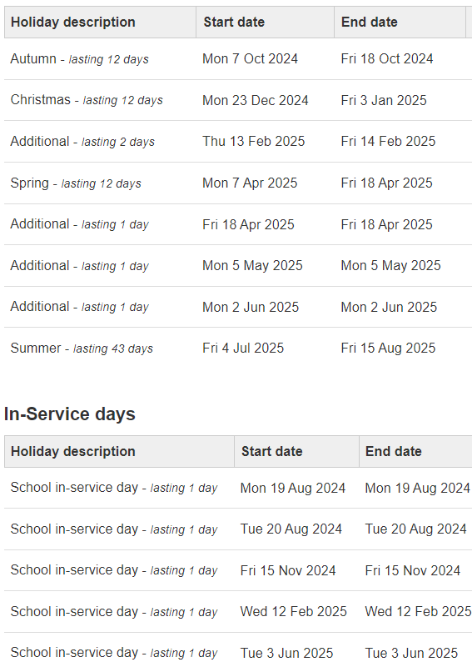

NURSERY MEALS AND MILK
The current cost of a Nursery meal is Free

SPECIFIC DIETARY REQUIREMENTS
Fife Council is committed to providing a Nursery meal service to all pupils who require them and will provide a specialised dietary service for certain children through discussion between the child, parent/guardian, and the Nursery. Special diets will be provided on the basis of
Religious requirements
Cultural/ethical reasons
Therapeutic diets will be provided on the basis of Medical conditions (as recommended by a doctor or dietician.)
If the child is known to have an allergy to nuts/nut products then our Allergen – Policies/Guidelines should be read in conjunction with this policy.

NURSERY MILK

Fresh, chilled milk is available in all nurseries.
Milk is provided free to all nursery children.

FREE FRUIT IN NURSERY

The Free Fruit in Nursery initiative targets the youngest children, where eating fruit and vegetables is most likely to be habit forming and where the health gain might be the greatest in the long term.
All nursery children are offered fruit on a daily basis alongside other heathy snacks.
WATER IN NURSERY SCHEME
All pupils have access to chilled water throughout the Nursery day.

SNACKS
We encourage children to eat healthily and make healthy choices. As part of the fruit and vegetable initiative, we use our fruit and vegetables to enhance the snack provision. Milk and water are always available for the children to access.
Snack is not only as an opportunity to eat, but as an opportunity to socialise and to learn about different taste, texture, how fruit and vegetables grow and seasonal changes. We use our fruit and vegetables creatively e.g. making soup, smoothies. Our children are involved in planning our snack menu and in its preparation.

CONTRIBUTION
No charge is made for attendance at nursery. However, it is normal practice to ask for a small contribution to cover the cost of snacks, baking ingredients, nursery parties, outgoings and special treats. At Methilhaven £1.50 per week.

CURRICULUM FOR EXCELLENCE

The Scottish government’s aspirations for each child is that they should become:

- Successful learners

- Confident individuals

- Responsible citizens

- Effective contributors

Children’s experiences in Methilhaven Nursery will contribute to the achievement of these aims.

They will develop these capacities by, for example:

- Successful learners through using their imagination and creativity, tackling new experiences and learning from them, and developing important skills including literacy and numeracy through exploring and investigating while following their own interests

- Confident individuals through succeeding in their activities, having the satisfaction of a task accomplished, learning about bouncing back from setbacks, and dealing safely with risk

- Responsible citizens through encountering different ways of seeing the world, learning to share and give and take, learning to respect themselves and others, and taking part in making decisions

- Effective contributors through playing together in leading or supporting roles, tackling problems, extending communication skills, taking part in sustained talking and thinking, and respecting the opinion s of others

We plan for the following areas of your child’s development and are pleased to discuss what we are doing with you, you are also welcome to stay and join in!

LITERACY

Literacy is fundamental to all areas of learning. Being literate increases opportunities for adults and children in all aspects of life through reading, writing, speaking and listening. Children need to have access to effective experiences and a rich environment.

Children should be learning to:-
- Communicate with adults and children.
- Build relationships.
- Talk about their learning experiences.
- Show good recall and understanding through role play.
- Access ICT and a range of media.
- Access and appreciate a multicultural society.
- Have an understanding of language through a variety of
experiences such as reading, writing, listening and speaking.
- Talk within groups or on a 1:1 basis.
- Listen to and appreciate other’s feelings and share their own feelings and thoughts.

MATHS AND NUMERACY

Numeracy is a skill for life, learning and work. Having well-developed numeracy skills allows young people to be more confident in social settings and enhances enjoyment in a large number of leisure activities. Being numerate helps us to function responsibly in everyday life and contribute effectively to society. Nursery should support your child to:-

- Develop essential numeracy skills to ensure full participation in society. Identify and count money.
- Understand the need for timetables and charts and identify what they are used for.
- Interpret numbers and information.
- Think logically and solve problems.
- Experience different types of technology.
- Investigate colour, shape and size.
- Sort, match and categories.
- Develop an awareness of time, clocks and calendars.
- Measure and compare.

HEALTH AND WELLBEING

Nursery should support children to: -
- Develop self-awareness, self-worth and respect for others.
- Meet challenges, manage change and build relationships.
- Experience personal achievement and build resilience and confidence.
- Understand and develop physical, mental and spiritual wellbeing and social skills.
- Understand that food, exercise and decisions about behavior and relationships have an effect on physical and mental wellbeing.
- Participate in a range of activities which promote a healthy lifestyle.
- Access help and resources to make choices.
- Assess and manage risk and understand the impact of risk-taking behavior.
- Identify strengths and skills to make choices when planning next steps.
- Acknowledge cultural diversity and challenge discrimination.

OTHER AREAS OF THE CURRICULUM

We also support children’s learning and development through the following curriculum areas:

- Technology
- Expressive Arts
- RME
- Social Subjects
- Science

ATTENDANCE
If your child is absent can you contact us as early as possible on the first day of absence. If we do not hear from you we will then call you, if we have no contact after 2 days staff will carry out a home visit.

HEALTH CARE

Should your child be taking medicine or have a medical condition, it is essential that you notify the Nursery. This information will be treated in strictest confidence to ensure the wellbeing of your child. Where necessary an Education Health Care Plan will be developed for your child in consultation with you and relevant health services.
Should your child become ill or have an accident while at Nursery that requires medical attention, we shall:
- Try to contact you by telephone, or arrange for a message to be sent to you. So please make sure we have an up-to date phone number.
From time to time children are offered a medical examination or review by the schools Community Paediatrician or School Nurse from the School Health Service. These can be either routine examinations carried out for all children, or where a health concern has been identified. As parent/carer you will be notified in good time so that you may be present if possible.

CHILD PROTECTION
Our nursery, like all nurseries in Fife, is concerned with all aspects of a child's health and wellbeing. We aim to provide a safe and supportive environment and work together with other agencies to ensure that all children are safe and protected from harm. The nursery follows the
Education and Children's Services Child Protection Guidelines in all aspects of Child
Protection and Care and Welfare. Our nursery has a child protection co-ordinator (Vicky Calley and child protection deputes Emma Jex and Brianne Harley) who will deal with all child protection issues and with whom any concerns can be discussed.

SUPPORT FOR PUPILS

Some children require additional support to make progress in nursery. Such support takes a range of forms – extra consideration by their early year’s officer or support from a Pupil Support Assistant. In some cases, help may be provided from services external to the school such as the Psychological Service or by the Supporting Learners Service.
If you are worried about your child’s progress you can either raise this with nursery staff when you first enrol your child at nursery or make an appointment to discuss this with the Headteacher. Nursery staff will listen closely to all your concerns and together you can decide on the next steps. Ongoing support will be co-ordinated by the Headteacher.
Each Early Year’s Officer will ensure learning needs are met for all children and be aware of any concerns about a pupil’s wellbeing.

PARTNER AGENCIES

Staff work in partnership with other services to ensure children are appropriately supported in their learning. In addition to staff from health and social services we link with many other agencies

EQUAL OPPORTUNITIES

Fife Council’s nurseries promote Equal Opportunities for all pupils. All nurseries take problems of bullying and racism very seriously, and have procedures for dealing with hate incidents and supporting pupils and parents.

PARENTAL INVOLVEMENT
At Methilhaven we encourage participation with parents at every opportunity. This can be supported in a variety of ways. In nursery, we are fortunate to have daily contact with parents where informal exchanges take place. Your child’s PLJ (Personal Learning Journey) is shared regularly and opportunities exist to raise any issues or concerns. As well as accessing our Facebook Page, you can share your child’s learning via the SeeSaw App.
.
https://www.facebook.com/methilhavennursery

THE SCHOOL TO WHICH YOUR CHILD WILL TRANSFER

We work closely with our local schools and liaise with the staff to ensure your child is confident and ready to start their Primary learning journey. Further information on this is contained in the booklet 'Choosing a School - A Guide for Parents' which is found at www.scotland.gov.uk/Publications/2010/11/10093528/0
Where a child goes missing from school without warning then the education service is obliged to link with other services to discover where the child has gone and confirm their safety and wellbeing.

NURSEY IMPROVEMENT

We regularly seek to improve the curriculum through staff audits and feedback from children and families via questionnaires.
Our ongoing commitment to self-improvement includes the following:

Priority 1: As we move into our shared location, children and older adults in the care home will develop mutually beneficial relationships through shared learning opportunities and experiences which are embedded into the nursery day.

Priority 2: Children will experience high quality play pedagogy with an enhanced focus on literacy skills

Priority 3: All children will experience equality and non-discriminatory experiences in our ELC and will develop and learn the skills in applying empathy and respect for themselves and others

Data sharing helps:
protect children and young people from suffering harm, abuse or neglect; ensure children and young adults with additional needs get the services they require; enable pupils to achieve their academic potential and attain their goals; plan future services

What information can be shared?
Information collected through enrolment forms or provided by parents and other carers will be held on computer systems and used within Fife Council for the purposes of furthering education and training, pupil care, career guidance, health monitoring and Parent Council elections and advice.
Information will be shared with partner agencies when there are clear concerns about the care, safety and welfare of children, young people or vulnerable adults and to aid careers planning. If you have any questions or comments on the information we share please contact David Smith, MIS Team Leader at education.data@fife.gov.uk
Personal data will not be shared out-with the above circumstances and information will not be disclosed to any third parties except where permitted or required by law or where informed consent has been received. The uses of the information are covered by the Council’s registration under the Data Protection Act 1998.
MORE INFORMATION
Further information on Fife Council’s use of data and the Data Protection Act 1998 can be found on Fife Council’s website www.fifedirect.org.uk

SEVERE WEATHER CONDITIONS
Unless specifically advised, nurseries will remain open during periods of severe weather. It is vital that parents/carers ensure that nurseries have the means to contact them should this position change. Decisions to close will be made as early as possible.
To be kept up to date with closure information:
- By text or email through Fife Direct – Notification of a nursery closure is done by nursery through Fife Direct. To sign up to receive text or email alerts, please enter your contact details via www.fifedirect.org.uk/alerts, click on Alerts and under Alert Services click on join fifedirect.
- By text or email through your nursery – Make sure that you have given your up to date mobile number and email address details to the nursery so that they can contact you via Groupcall. These messages will provide supplementary information to the above.
- Visit www.fifedirect.org.uk/closures. Also, check the website of your own school.
- Follow-us on facebook.com/fifecouncil and twitter.com/fifecouncil.
- Listen to Kingdom FM, Forth One and Tay FM.
- Check TV on Sky channel 539, press red or Virgin channel 233, press red.
Please note: If your child moves nursery or attends more than one establishment, you should amend the nursery details on your account in Fife Direct to ensure you receive information from the correct nursery.
Nursery also circulate severe weather information for parents and carers at the start of the winter term. This may be added to their websites, shared through email or text messages and/or distributed via school bag mail drop.

ALTERNATIVE FORMATS


