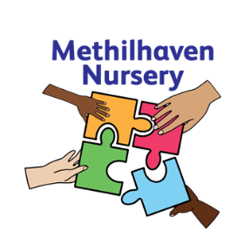
Methilhaven Nursery
Kirkland Parade, Methil,
KY83DL

Tel: 01334 659486

Methilhaven Nursery – Who We Are

Methilhaven Nursery is a newly established 49-week nursery which opened in August 2020. We moved into our permanent location in June 2023. We are part of the first Intergenerational Learning Site in Scotland, so we will have close links with the Care Home. Here we have we have one playroom for our 3-5-year-old children and a playroom for the Early Entrants. All nursery playrooms offer quality, rich learning and play experiences. Both areas have secure access to our outdoor play spaces.

Our staff are all highly motivated and enthusiastic which is reflected in the high standards we hold as a setting. Strong links have been formed this session between ourselves and Methilhaven Care Home which will stand us in good stead as we continue to develop our intergenerational learning this session. We are a 49-week provision, which means our sessions are Monday-Friday 8-12:40pm or 1:20-6pm. Children are offered a morning brunch or afternoon tea during their session, which is delivered to the nursery and served within their playrooms. Our meal service is free flow within 3-5 room, with children choosing when they are ready for their meal. Within our Early Entrants room, their meal is served all together.

All practitioners are highly skilled and are offered training throughout the year to enhance their skills and knowledge. Staff work with the children to ensure learning is embedded from the Curriculum for Excellence and in line with current early years thinking. Our children are also offered a range of visits within the local community including the woods, the beach and the local library.

Methilhaven staffing consists of:

1 Lead Officer
5 Full Time Early Years Officers
4 Part Time Early Years Officers

Head Teacher (Shared across 3 settings)
Depute Head of Centre (Shared across 2 settings)
Principal Teacher (Shared across 3 settings)
2 Senior Early Years Officers

Families, children, and staff were consulted in April 2023 to reflect on our vision, values and aims. Throughout the consultation process it was agreed that we felt all these values were of equal importance, this is reflected in the way that we have created them. These values and aims reflect the intergenerational aspect of our setting.

Our Vision, Value and Aims
Our Vision

To provide a wide range of high-quality learning opportunities, offering challenge to children in a safe and nurturing environment. Positive partnership working will ensure all stakeholders are valued members of the nursery community.

Our Improvement Priorities:
Priority 1: As we move into our shared location, children and older adults in the care home will develop mutually beneficial relationships through shared learning opportunities and experiences which are embedded into the nursery day.
Priority 2: Children will experience high quality play pedagogy with an enhanced focus on literacy skills
Priority 3: All children will experience equality and non-discriminatory experiences in our ELC and will develop and learn the skills in applying empathy and respect for themselves and others

Intergenerational Learning:
As an intergenerational learning site, practitioners from both Methilhaven Nursery and Care Home work closely together to meet the needs of all service users.

“Intergenerational Learning occurs when projects or activities are purposefully planned to include one or several learning aims and outcomes across the generations. i.e. both sides learning from or with each other to gain skills, values and knowledge”
(Generations Working Together)

Activities and projects are well planned with the children and older adults at the centre. This relates to Health and Social Care Standard 2.21 “I take part in daily routine, such as setting up activities and mealtimes, if this is what I want”. There has been a lot of research carried out relating to intergenerational learning and the positive impact it has on all who are involved. More information on this can be found in:
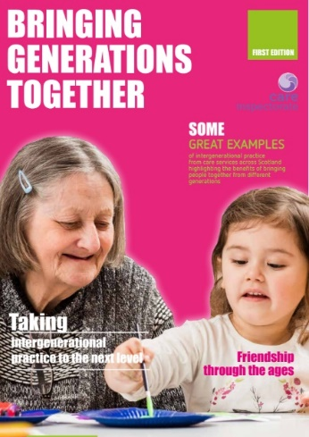
Bringing Generations Together –
Care Inspectorate, 2019

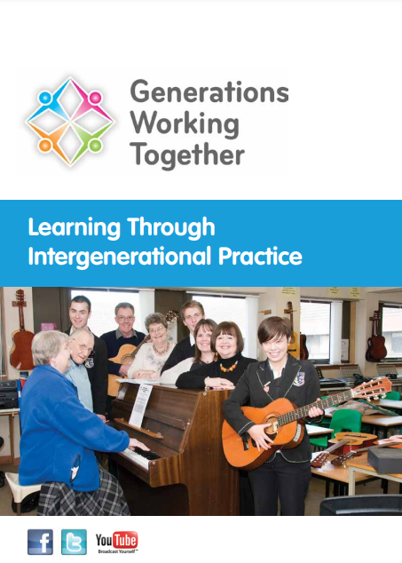
Learning Through Intergenerational Practice – Generations Working Together

Mutual and Reciprocal Benefit  All participating generations should gain benefit. | Culturally Grounded  The needs context and attitudes of cultures differ widely. An approach adopted in one area may not work or be relevant due to these differences.
Participatory  The participants should be fully involved in shaping the activity to feel a sense of ownership. | Strengthens Community Bonds and Promotes Active Citizenship  Engagement across the generations to emphasise positive connections with the aim of building stronger, better connected communities with increased social capital and citizenship.
Asset Based  Build on strengths and success, understanding and mutual respect. | Challenge Ageism  Both young and old are victims of ageism. Meeting each other means that they can explore who they really are and what they have to gain from each other.
Well Planned  Attempt to create positive changes which are an addition to naturally occurring processes. | Cross-disciplinary  Broaden the experience of professionals to become more involved in working in an inclusive way and to think much more broadly about how they undertake their work.

“Intergenerational Practice aims to bring people together in purposeful, mutually beneficial activities which promote greater understanding and respect between generations”
(Beth Johnson Foundation, 2009)

Some of the benefits of learning are:
- Improved social connections between people of different ages
- Increased understanding and respect, reducing negative stereotypes
- Opportunities for older and younger people to learn from and teach one another
- Improved health and wellbeing
- Builds strong and inclusive communities
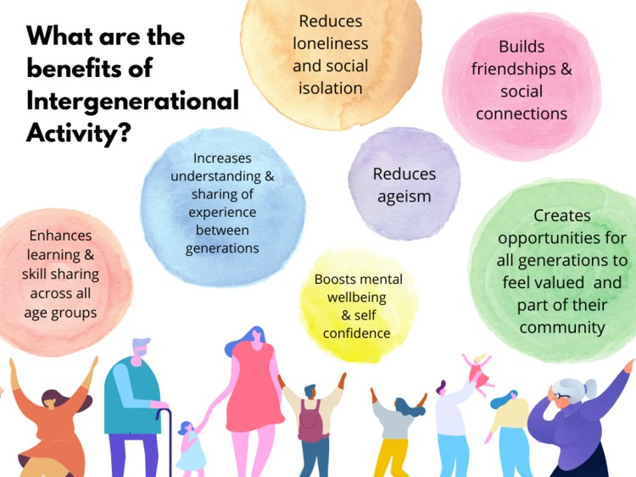
Taken from the LGNI website on:
https://www.linkinggenerationsni.com/intergenerational-practice-explained/#Section_3

