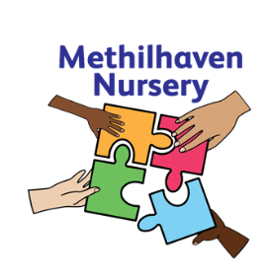
Methilhaven Nursery
Kirkland Parade, Methil,
KY83DL

Tel: 01334 659486

“What is Intergenerational Learning?”

Dear Parent/Carer
We are sure you may have some questions about what intergenerational learning is and how it works for our nursery. This booklet aims to share information with you regarding what intergenerational learning is, the benefits for our children’s development in addition to the benefits for the older adults and the wider community.

We have prepared this booklet to answer some of the questions you may have and, more importantly, to invite you to chat to us about any points you would like clarified.

Yours sincerely
The Methilhaven Nursery Team

Methilhaven Nursery

“Intergenerational Learning occurs when projects or activities are purposefully planned to include one or several learning aims and outcomes across the generations. i.e. both sides learning from or with each other to gain skills, values and knowledge”
(Generations Working Together)

In Methilhaven Nursery, activities and projects are well planned with the children and older adults at the centre. This relates to Health and Social Care Standard 2.21 “I take part in daily routine, such as setting up activities and mealtimes, if this is what I want”

There has been a lot of research carried out relating to intergenerational learning and the positive impact it has on all who are involved. More information on this can be found in:
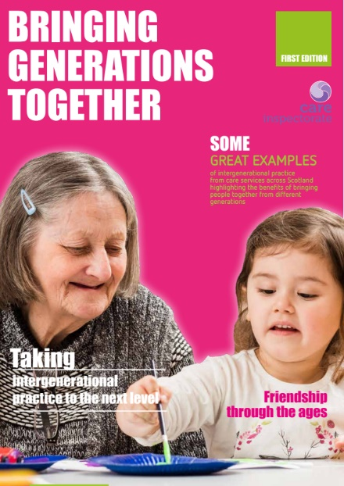
Bringing Generations Together –
Care Inspectorate, 2019

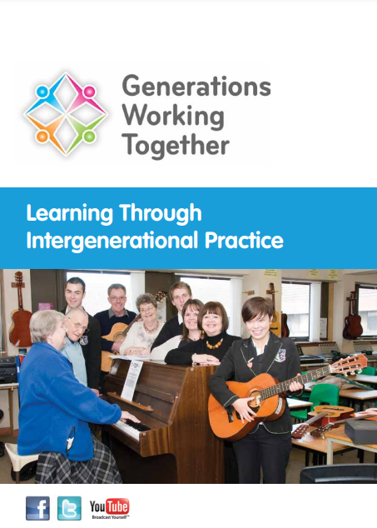
Learning Through Intergenerational Practice – Generations Working Together

Mutual and Reciprocal Benefit  All participating generations should gain benefit. | Culturally Grounded  The needs context and attitudes of cultures differ widely. An approach adopted in one area may not work or be relevant due to these differences.
Participatory  The participants should be fully involved in shaping the activity to feel a sense of ownership. | Strengthens Community Bonds and Promotes Active Citizenship  Engagement across the generations to emphasise positive connections with the aim of building stronger, better connected communities with increased social capital and citizenship.
Asset Based  Build on strengths and success, understanding and mutual respect. | Challenge Ageism  Both young and old are victims of ageism. Meeting each other means that they can explore who they really are and what they have to gain from each other.
Well Planned  Attempt to create positive changes which are an addition to naturally occurring processes. | Cross-disciplinary  Broaden the experience of professionals to become more involved in working in an inclusive way and to think much more broadly about how they undertake their work.
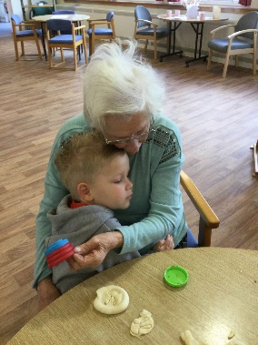
Some activities you see at Methilhaven Nursery may include:
- Making playdough – (working on fine motor strength when mixing, weighing and measuring the ingredients, team building skills)
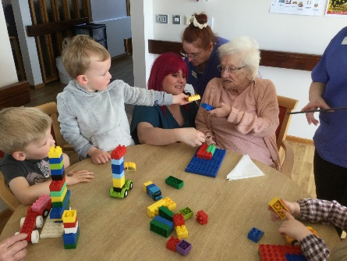
- Singing – (having shared enjoyment while singing familiar and new songs, action songs to promote physical skills)
- Boardgames – (developing concentration skills, sorting and matching, learning to take turns)
“Intergenerational Practice aims to bring people together in purposeful, mutually beneficial activities which promote greater understanding and respect between generations”
(Beth Johnson Foundation, 2009)

Some of the benefits of learning are:
- Improved social connections between people of different ages
- Increased understanding and respect, reducing negative stereotypes
- Opportunities for older and younger people to learn from and teach one another
- Improved health and wellbeing
- Builds strong and inclusive communities
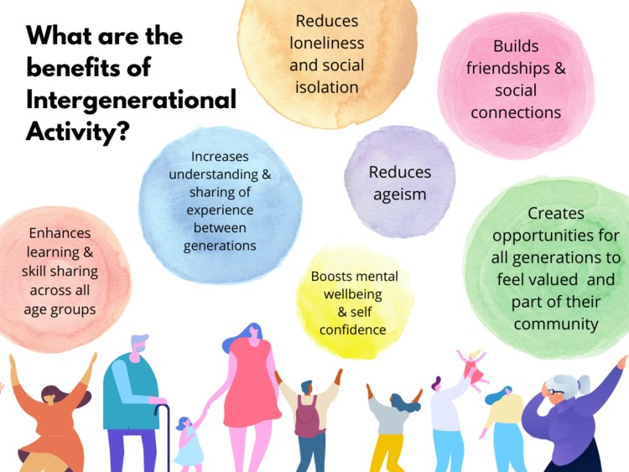
Taken from the LGNI website on:
https://www.linkinggenerationsni.com/intergenerational-practice-explained/#Section_3

