McLean Nursery and Primary School
Nursery Improvement Plan 2026 - 2027
Learning, Celebrating and Achieving Together

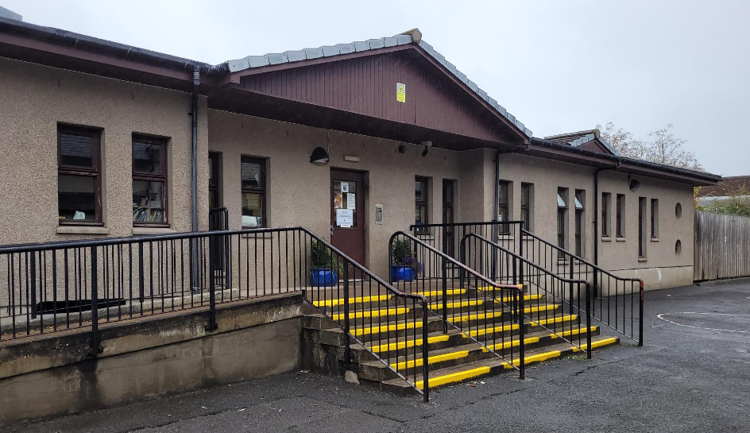

Creativity Leadership Ambition Nurture

Context

McLean Primary School was opened in 1896, by Andrew Carnegie.
The building was modernised in 1984 and the internal accommodation is arranged in semi open plan areas and classrooms.

There are currently 13 classes accommodated in the school.

A purpose-built nursery is set within the school grounds, which has 2 playrooms; Rainbow and Sunflower, both of which have outdoor play spaces. Our nursery is a 49-week provision offering a morning and afternoon session each day.

McLean serves a mixed catchment of private and local authority housing in northwest Dunfermline. The current school and nursery roll is approximately 467 children. Within Nursery, this is approximately 65 children. Around 18% of the children at McLean receive free school meals.

McLean is part of the Queen Anne Cluster, which is made up of 14 Primary Schools and Queen Anne High School.

The current leadership team comprises Gillian Souter (Joint Head Teacher with Milesmark PS), Laura Walker (Depute Head Teacher) and Emma Walker (Depute Head Teacher) Within Nursery, the leadership team extends to a Peripatetic Nursery Teacher, Niamh Hepburn (Senior Early Years Officer) and Carol McEneany (Senior Early Years Officer)

Vision, Values and Aims

Vision Statement

Learning, Celebrating and Achieving Together

McLean Values

Creativity Leadership Ambition Nurture (CLAN McLean)

McLean Aims

As a School and Nursery:

We will be friendly, honest, fair and respectful to each other and behave responsibly.
We will try our best in our learning and be proud of our achievements in and out of school.
We will work together to look after our environment and everyone and everything in it.
We will work together to make our school even better, involving our parents and others in our community.

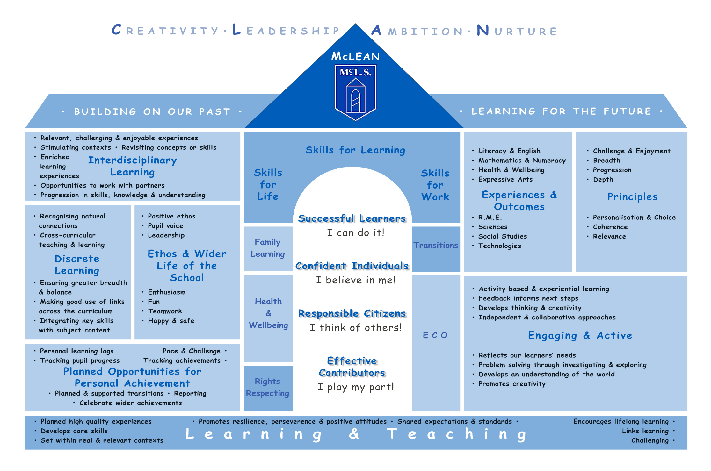

Session 26-27 Improvement Priority 1: Equality & Equity/Achievement
Focused Priority:
- Embed current planning, tracking, and monitoring systems to ensure the best learning outcomes for all children
HGIOELC:
2.2 Curriculum
2.3 Learning, teaching and assessment
3.2 Securing children’s progress
3.3 Developing creativity and skills for life and learning
1.3 Leadership of change
Expected Impact | Strategic Actions Planned | Responsibilities | Measure of Success | Timescales
- Staff feel confident and comfortable with new planning and tracking format. Planning is positively impacting children’s experiences.  - Learning experiences are developmentally appropriate with a range of opportunities to extend learning. Experiences are tailored to meet all children’s individual and diverse learning needs and developmental stages.  - Staff use appropriate and creative ways to involve all children in the planning of their learning experiences and take an active part in setting their next steps.  - Tracking and monitoring systems will allow for better evaluation of children’s progress and next steps across the whole curriculum.  - Moderation of the learning cycle across all teams will impact pace and challenge, improving outcomes in learning for children. | - Continue to embed current planning for learning processes.  - Review current Daily/Responsive and long-term planning formats with all staff. Meet weekly to engage in intentional planning discussions with staff.  - Engage with professional and outside agencies to enhance personalised support for individuals, including supporting ASN needs.  - All Learning Experiences to be carefully planned and facilitated by follow the interests of learners to Inspire creativity and challenge thinking.  - Staff will record children’s views and opinions in a variety of ways using learner conversations, floor books and digital technology.  Embedding systems in place to support children to identify and plan their next steps in learning. | - Whole Team led by PNT  - Whole Team led by SLT  - Whole Team led by SLT  - Whole Team  - Whole Team led by SEYOs  - Whole Team led by SLT | Data  - Development of new curriculum rational and child focused NIP.  - High quality weekly and daily planning in place in all sessions. Additionally, long term planning is used to inform short term planning.  - All children are fully supported to follow interests.  - Learning is visible in displays/Floor books and in children’s personal learning journeys.  - Increased staff confidence.  - Increased level of children’s participation in planning.  - children more able to discuss their next steps.  - All staff are skilled in making children aware of learning, how they are doing it and the process of learning is made explicit visually and verbally.  - Parents/carers and children are sharing and discussing learning.  - “Progress” tracking system is embedded and effectively used by all staff.  - Increased staff confidence when discussing children’s progress and planning their next steps in learning.  - Staff have an increased level of confidence in identifying gaps in learning for individuals and putting in place support.  - Analysis of attainment data in Literacy, Numeracy along with identified areas of the curriculum  - Looking outwards will allow staff the opportunity to be more reflective and critically evaluate their own practice to support improvement.  - Staff’s skills and knowledge with regards to the learning cycle will increase improving outcomes for children.  People’s Views  - Continue to improve and expand Parent/carer views on children’s experiences of BGE and the quality of playroom environment.  - Children’s views gathered through pupil focus groups on the learning experiences across the curriculum  - Team views on new reporting system  Observations  - Playroom observations linked to identified areas of the curriculum | - By Dec 2026  - By Dec 2026  - By May 2027  - By May 2027  - By May 2027  - By Dec 2025
Ongoing Evaluation

Session 25-26 Improvement Priority 2 – Family Engagement
Focused Priority:
- To engage families in learning by Offering targeted, skills-based sessions for families that improve outcomes, wellbeing, and resilience.
HGIOELC
3.1- Ensuring wellbeing, equality and inclusion
2.4 - Personalised support
2.5- family learning
2.7 - Personalised support
Expected Impact | Strategic Actions Planned | Responsibilities | Measure of success | Timescales
- Through stay and play and PEEP, families will understand resources (such as kitbag) used to support health and wellbeing in nursery and will feel confident in adopting these strategies at home  - Parents/carers will see an improvement in the numbers of opportunities for them to be involved in the life of our setting.  - Families will feel more involved in their child’s learning and life at nursery  - We aim to break down as many barriers as possible for families.  - We will provide clear, consistent, and continuous communication for all families. | - Designated nursery Family zone to facilitate family learning sessions and engagement.  - Increase family involvement in nursery through developing family learning opportunities in literacy, numeracy and Health and Wellbeing  - provide a family booklet with diverse system for families around family engagement | SfL, SFL and SEYO  SfL and SEYO  Whole team, led by SEYO  Whole team  SLT/Whole Team  Whole Team  Whole Team  Whole Team, led by PNT | People’s Views  - Family views on family events and strategies used  - Children’s views gathered through class pupil focus groups  - Staff views on success of family learning zone.  - Staff and parent views on new booklet.  Observations  - LP visit feedback around nursery ethos  - SLT observations throughout year | By Dec 2025  By Dec 2025  By May 2026  By May 2026  By Oct 2025  By May 2026
Ongoing Evaluation

Session 25-26 Improvement Priority 3 – Curriculum & Assessment. Parent/Carer Involvement and Engagement
Focused Priority 3:
- To enhance the Core Provision and spaces within the learning environment to ensure it meets the needs of all children, challenges learning and fosters creativity.
HGIOELC:
3.3 Developing creativity and skills
3.2 Securing children's progress
3.1 Ensuring wellbeing, equality, and inclusion
1.4 Management of staff and resources
1.2 Leadership of learning
Expected Impact | Strategic Actions Planned |  | Responsibilities | Measure of Success | Timescales
- Core provision and spaces within the Learning environment will be rich in quality literacy & numeracy experiences, provide challenge, promote children’s curiosity and enquiry.  - Spaces are planned carefully and creatively to provide flexibility to support all children’s needs.  - The Learning Environment and spaces within the playrooms will allow all children to relax, play and take part in a wide range of cultural and artistic activities.  - Outdoor learning and learning within the community will be planned for ensuring all children gain access to a variety of wider learning opportunities.  - Children will be able to apply their knowledge and understanding to further their learning about their key rights under UNCRC. | - Staff will further develop their knowledge on how pedagogical theory about play links to daily practice.  - Staff will identify aspects of daily practice which link to pedagogy.  - Staff will develop their understanding about the links between Realising the Ambition and pedagogy and building upon the revised Delivering a Quality Curriculum Course.  - Revision of outdoor provision currently being offered by engaging with the CI guidance in the “Out to Play” document. Continue to make us of the quad and community spaces to provide outdoor experiences.  - Continue to work towards embedding Rights Respecting language within the setting.  - Further develop current practices across the centre to include more children’s voice in planning and implementation of events. |  | - Whole Team led by PNT/Dev Officer  - Whole Team led by SLT/Dev Officer  - Whole Team led by SEYO  - DHT/Whole Team  - Whole Team led by SEYOs  - Whole Team led by SLT | Data  - Staff’s deeper understanding about the links between Realising the Ambition and pedagogy and building upon the revised Delivering a Quality Curriculum Course will ensure a richer learning environment to provide increased pace and challenge for all children.  - The outdoor areas will be richer and provide more opportunities and challenge for all children.  - Staff will be more confident in their role in setting up quality provision outdoors to support children with more risky play and to develop skills across the curriculum.  - Achievement of the Award for Rights Respecting Schools  - Evaluation of participation across the four arenas from staff, families and children.  - Evidence in Planning formats.  - Evidence in children’s PLJs. | - By Dec 2026  - By Dec 2026  - By May 2027  - By May 2027  - By May 2027  - By June 2027  - June 27

