McLean Nursery and Primary School
School Improvement Plan 2026 - 2027
Learning, Celebrating and Achieving Together



Creativity Leadership Ambition Nurture

Context of the school

McLean Primary School was opened in 1896, by Andrew Carnegie.
The building was modernised in 1984 and the internal accommodation is arranged in semi open plan areas and classrooms.

There are currently 13 classes accommodated in the school as well as an ICT suite, sensory room, nurture space, library and Teacher Resource Area.
Our hall is used for PE, Drama, Assemblies and also for lunches. It is a small hall, considering the size of the school, and this makes it very difficult to accommodate the number of children we have in school who stay for lunch or to have whole school assemblies or events for parents. Plans are in place to provide us with a second gym space.
The hutted provision to the rear of the school has two rooms, which will be used as a music base, library and sensory room in session 2026 – 2027. We also have another temporary modular accommodation (TMA) to the front of our school, which will host two of our classes.

A purpose-built nursery is set within the school grounds, which has 2 nursery rooms; Rainbow and Sunflower, both of which have outdoor play spaces. Our nursery is a 49-week provision offering a morning and afternoon session each day.

McLean serves a mixed catchment of private and local authority housing in northwest Dunfermline. The current school and nursery roll is approximately 467 children. Around 20% of the children at McLean receive free school meals.

McLean is part of the Queen Anne Cluster, which is made up of 14 Primary Schools and Queen Anne High School.

The current leadership team within the school comprises of a Joint Headteacher, Gillian Souter (Joint with Milesmark), Laura Walker (Depute Headteacher) and Emma Walker (Depute Headteacher).

Vision, Values and Aims

Vision Statement

Learning, celebrating and achieving together.

School Values

Creativity Leadership Ambition Nurture (CLAN McLean)

School Aims

As a school and Nursery:

We will be friendly, honest, fair and respectful to each other and behave responsibly.
We will try our best in our learning and be proud of our achievements in and out of school.
We will work together to look after our environment and everyone and everything in it.
We will work together to make our school even better involving our parents and others in our community.

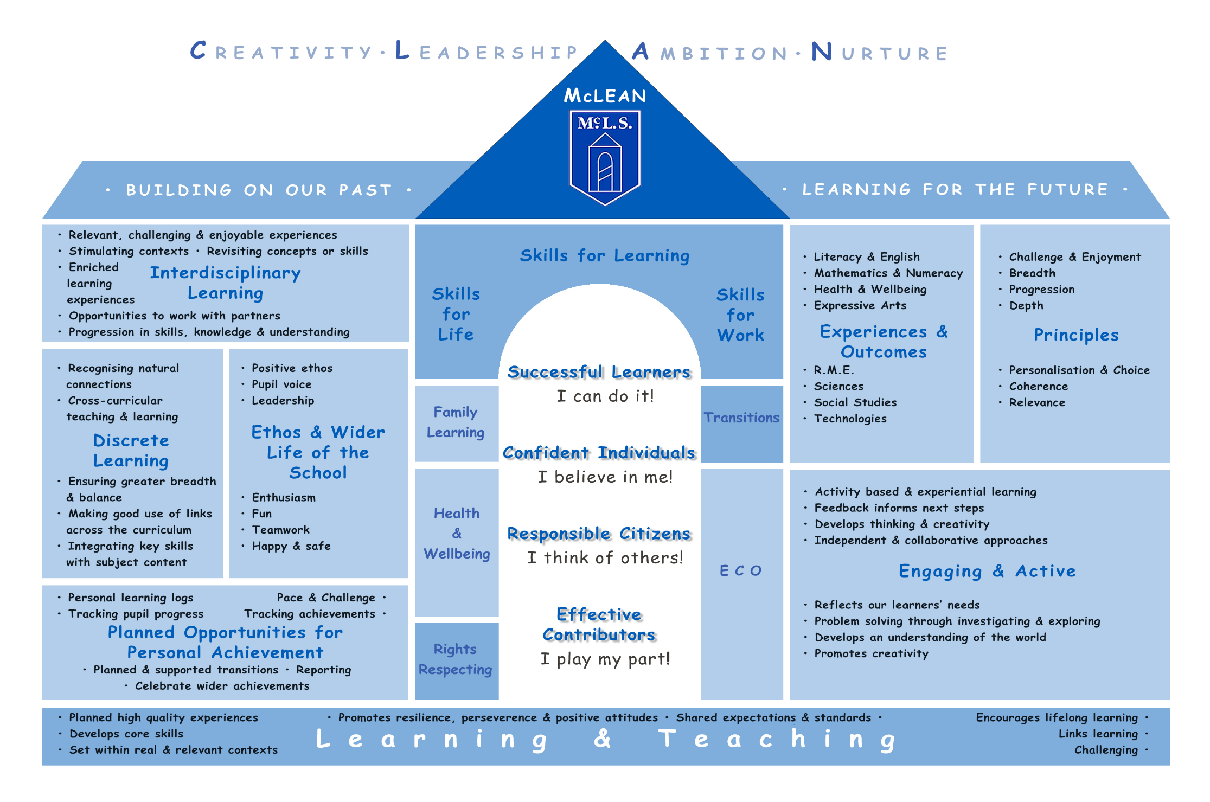

Session 2026 -2027 Improvement Plan
Improvement Priority 1 - Achievement
Education Directorate Improvement Plan: Improving Learning and Teaching
Focused Priority: Enhancing Pace, Challenge, and Tracking
- To improve outcomes for all learners by increasing the pace and challenge of learning and ensuring robust tracking across the entire Broad General Education (BGE).
HGIOS4 Quality Indicators |  |  | HGIOELC Quality Indicators
1.2 – Leadership of Learning
1.3 – Leadership of Change
2.2 – Curriculum
2.3 – Learning, Teaching and Assessment
3.1 – Ensuring wellbeing, equality and inclusion
3.2 – Raising attainment and achievement
Expected Impact | Strategic Actions Planned | Responsibilities |  | Measure of Success  (Triangulation of Evidence/QI Methodology) | Timescales
All children will experience appropriately challenging learning that matches their needs.  Learners in P1–3 experience play-rich environments that are reflective of their needs and support a smooth transition from nursery | - P4-7 staff will participate in collegiate sessions to complete small audits of their current differentiation practice. Following these, teachers will trial one new strategy (such as high-order questioning or varied Success Criteria) before returning to share the impact with colleagues.  - P1–P3 staff will participate in professional learning focused on the role of the adult in play and balancing intentional teaching with child-led inquiry | HT / All Staff  P1-3 staff led by IS |  | Increased percentage of pupils making very good progress beyond age-related expectations. | Oct 2026 – May 2027
Robust tracking across all 8 curricular areas ensures BGE entitlement.  Improved use of observational evidence to track progress in all curricular areas within play contexts | - Collegiate time will be dedicated to fully mastering the "Progress" tracking system.  - Staff will work together to ensure Records of Understanding (RUs) are consistently updated across at least 4 curricular areas, while using benchmarks across all 8 curricular areas.  - SLT will further develop the use of the “Tracking Attainment Over Time” spreadsheet to involve staff in robust tracking of a child’s attainment journey throughout their time at Mclean.  - P1-3 staff will collaborate to moderate learning outcomes achieved through play, ensuring professional judgements are robust and evidence-based | All Staff led by SLT  P1-3 staff led by IS |  | - Staff express increased confidence in professional judgements during attainment dialogues.  - RUs will be updated termly and support progress | Ongoing through May 2027
Consistency in learning, teaching and assessment pedagogy improves learner clarity.  Increased staff confidence in effectively using play as one of our lenses for learning and teaching in P2 and P3. | "4-Part Lesson" Refinement:  - Building on previous successes, staff will engage in professional development to ensure Learning Intentions (LI) and Success Criteria (SC) are not just shared, but revisited and co-constructed with pupils during lessons and match learning not activity.  - Staff will work together to ensure understanding around effective LI and SC and how feedback around these can support pace and challenge.  - P1-3 staff will engage in collegiate sessions to audit P1–3 learning environments against Fife Playful Pedagogy toolkit. ensuring they offer challenge and variety | Led by DHT  All Staff  P1-3 staff led by IS |  | Direct observation of consistent LI/SC usage in all learning visits. | By Dec 2026
Increased accuracy in CfE level judgements. | Joint Moderation with Milesmark Primary:  - Scheduled collegiate time will be used for staff to meet with partner school colleagues to calibrate standards and Curriculum for Excellence (CfE) level judgements. These sessions will involve jotter sampling and comparing assessment evidence to ensure a shared understanding of national standards. | Led by DHT |  | - Evidence of high-quality assessment evidence used to support declarations.  - Declarations will match standardised data such as base and NSAs. | Jan – May 2027
Ongoing Evaluation

Education Directorate Improvement Plan: Improving Learning and Teaching
Focused Priority: Learning, Teaching, and Assessment – Digital Innovation for Inclusion
- Support and enhance the delivery of high-quality learning, teaching, and assessment through the continued "Transforming Learning" digital initiative to create a more inclusive and personalised environment.
HGIOS4 Quality Indicators
1.3 Leadership of Change
2.2 Curriculum
2.3 Learning, Teaching and Assessment
2.4 Personalised Support
2.6 Transition
3.2 Raising Attainment and achievement
3.3 Increasing creativity and employability
Expected Impact | Strategic Actions Planned | Responsibilities |  | Measure of Success  (Triangulation of Evidence/QI Methodology) | Timescales
Improved engagement and motivation through transforming learning approaches.  Improved pace and progression across stages. | - Use iPads and associated apps to provide effective universal and targeted support.  - Use Showbie and AI tools effectively to plan for adapted learning approaches.  - Use Showbie to support robust planning, assessment and feedback  - Work towards and achieve digital schools award | Digital Ambassador (LD) / All Staff |  | Pupil views gathered through focus groups show improved motivation. | Feb 2027
Increased independence for children with Additional Support Needs (ASN). | - Maximise iPad accessibility features to support learners with ASN in universal settings. | Support for Learning Teacher / digital ambassador (LD) |  | Data from "Progress" tracking showing narrowed attainment gaps for ASN cohorts. | Ongoing
Clear evidence of learning over time available to families. | - Further develop Showbie portfolios to showcase pupil work and provide instant feedback.  - Use Showbie communities to share wider school information with families.  - Use Showbie portfolios to support consistency in learning between P7 and S1 | Led by digital ambassador (LD). |  | Parent survey data indicates improved understanding of child's next steps in learning. | May 2027
Staff lead pedagogical change through research. | - Engage staff in small-scale enquiry focused on how digital tools enhance differentiation. | All Staff |  | Presentation of enquiry findings during collegiate sessions. | April – May 2027
Ongoing Evaluation

Session 2025 - 2026 Improvement Plan
Improvement Priority 2 – Health and Wellbeing
Education Directorate Improvement Plan: Meeting Learner Needs
Focused Priority: Strengthening Relationships and Resilience
- To foster a supportive environment that prioritises mental and emotional wellbeing while improving communication with families regarding bullying and resilience.
HGIOS4 Quality Indicators
1.2 – Leadership of Learning
1.3 – Leadership of Change
3.1 – Ensuring wellbeing, equality and inclusion

Expected Impact | Strategic Actions Planned | Responsibilities |  | Measure of Success  (Triangulation of Evidence/QI Methodology) | Timescales
Reduction in incidents and improved reporting accuracy. | Anti-Bullying Review:  - Review and clearly communicate anti-bullying procedures to address the 2026 ParentWise feedback (only 52.94% positive on action taken). | SLT |  | Improved positive response rates in ParentWise surveys regarding bullying concerns. | Review By Dec 2026
Pupils feel better equipped to handle challenges. | Resilience Building:  - Explicitly teach resilience skills and coping strategies to pupils (addressing the 50% positive 2026 baseline).  - LS Teacher and DHT to attend training on Decider skills to gauge how this approach might help build resilience within McLean pupils.  - Continue to work towards being a Rights Respecting School.  - Work as a cluster towards the “We Promise” Award ensuring all staff effectively support our care experienced children. | Led by LS teacher and DHT  Cluster Priority |  | 90%+ of pupils in PupilWise survey report they feel resilient.  Achieve Silver RRS award  Achieve “We Promise” school award as a cluster | May 2027
Improved consistency in managing distress. | De-escalation:  - Continue to ensure consistent use of trauma-informed de-escalation strategies through staff training and induction using The Circle Framework.  - Continue to engage staff in moderation of Learning Environments ensuring universal support is available to all and environmental checklist in The Circle Framework has been considered. | LS teacher / Educational Psychologist |  | Health & Safety violence and aggression reports reduce from 40 to 30. | Feb 2027
Recognition of the whole child. | Wider Achievement:  - Improve visibility and communication of wider achievement opportunities outside of school.  - Develop how we track wider achievements for our pupils.  - Gain our Sports Award | DHT/ All Staff  HC |  | Increased positive response in PupilWise survey Q28 regarding school knowing their interests. | May 2027
Ongoing Evaluation

Improvement Priority 3: Leadership – Enhancing Communication and Staff Engagement
Education Directorate Improvement Plan: Meeting Learning Needs and Improving Learning and Teaching
Focused Priority: Leadership – Enhancing Communication and Staff Engagement
- To improve school-wide communication and ensure all staff are active participants in the school’s self-evaluation and improvement processes.
HGIOS4 Quality Indicators
1.2 – Leadership of Learning
1.3 – Leadership of Change
3.1 – Ensuring wellbeing, equality and inclusion

Expected Impact | Strategic Actions Planned | Responsibilities |  | Measure of Success  (Triangulation of Evidence/QI Methodology) | Timescales
Improved workplace wellbeing and transparency. | Internal Communication:  - Address the 52.2% negative StaffWise response regarding communication by reviewing internal channels and meeting structures. | SLT |  | Positive trend in 2028 StaffWise data regarding effective communication. | By Jan 2028
Staff feel ownership of the improvement journey. | SIP Engagement:  - Strengthen staff understanding of their role in the SIP through regular refresh sessions and collegiate self-evaluation time. | SLT |  | All staff can confidently discuss their contribution to the SIP during learning visits. | Ongoing
Professional dialogue is grounded in standards. | HGIOS4 Integration:  - Embed the use of Quality Indicators in regular professional dialogue and self-evaluation activities. | All Staff |  | Self-evaluation documentation is detailed, purpose-driven, and evaluative. | May 2027
Ongoing Evaluation

