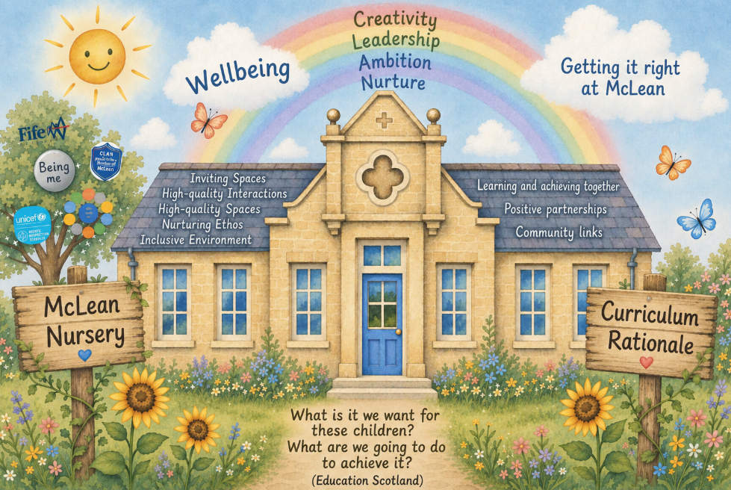

At McLean Nursery, we want every child to feel happy, safe, valued and included. Through nurturing relationships, play-based learning, outdoor experiences and strong partnerships with families and the wider community, children develop confidence, independence, curiosity and kindness as they grow into lifelong learners.

