McLean Primary School 2025 - 2026



Dear Parents/Carers,

Welcome to a new session at McLean. We are delighted to welcome new pupils and families to our school and welcome back all of our pupils and families who were with us last session. It has been lovely to see all of the children settling into their new classrooms and looking very smart in their school uniform.

There is quite a lot of information in this newsletter so that you and your child(ren) have a smooth start to the new session. You will also be receiving a Parent Diary in word format which will give you a list of important dates throughout the coming academic year. We provide this diary in word format so that it can be easily printed and referred to throughout the school year. This hopefully gives you the chance to plan ahead and not miss anything.

# Vision, Values and Aims

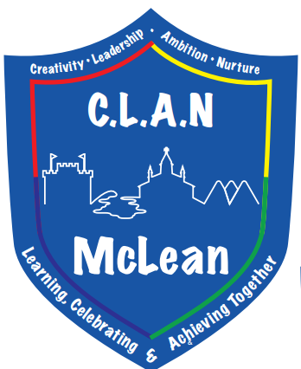

Vision Statement:

Learning, Celebrating and Achieving Together.

Values:

CLAN McLean

Creativity

Leadership

Ambition

Nurture

Aims:

As a school and Nursery:

* We will be friendly, honest, fair and respectful to each other and behave responsibly.
* We will try our best in our learning and be proud of our achievements in and out of school.
* We will work together to look after our environment and everyone and everything in it.
* We will work together to make our school even better involving our parents and others in our community.

Our aims will be realised through the development of excellent relationships and partnership working, quality learning and teaching for all and a curriculum that meets the needs of all our pupils.

# School Improvement Plan

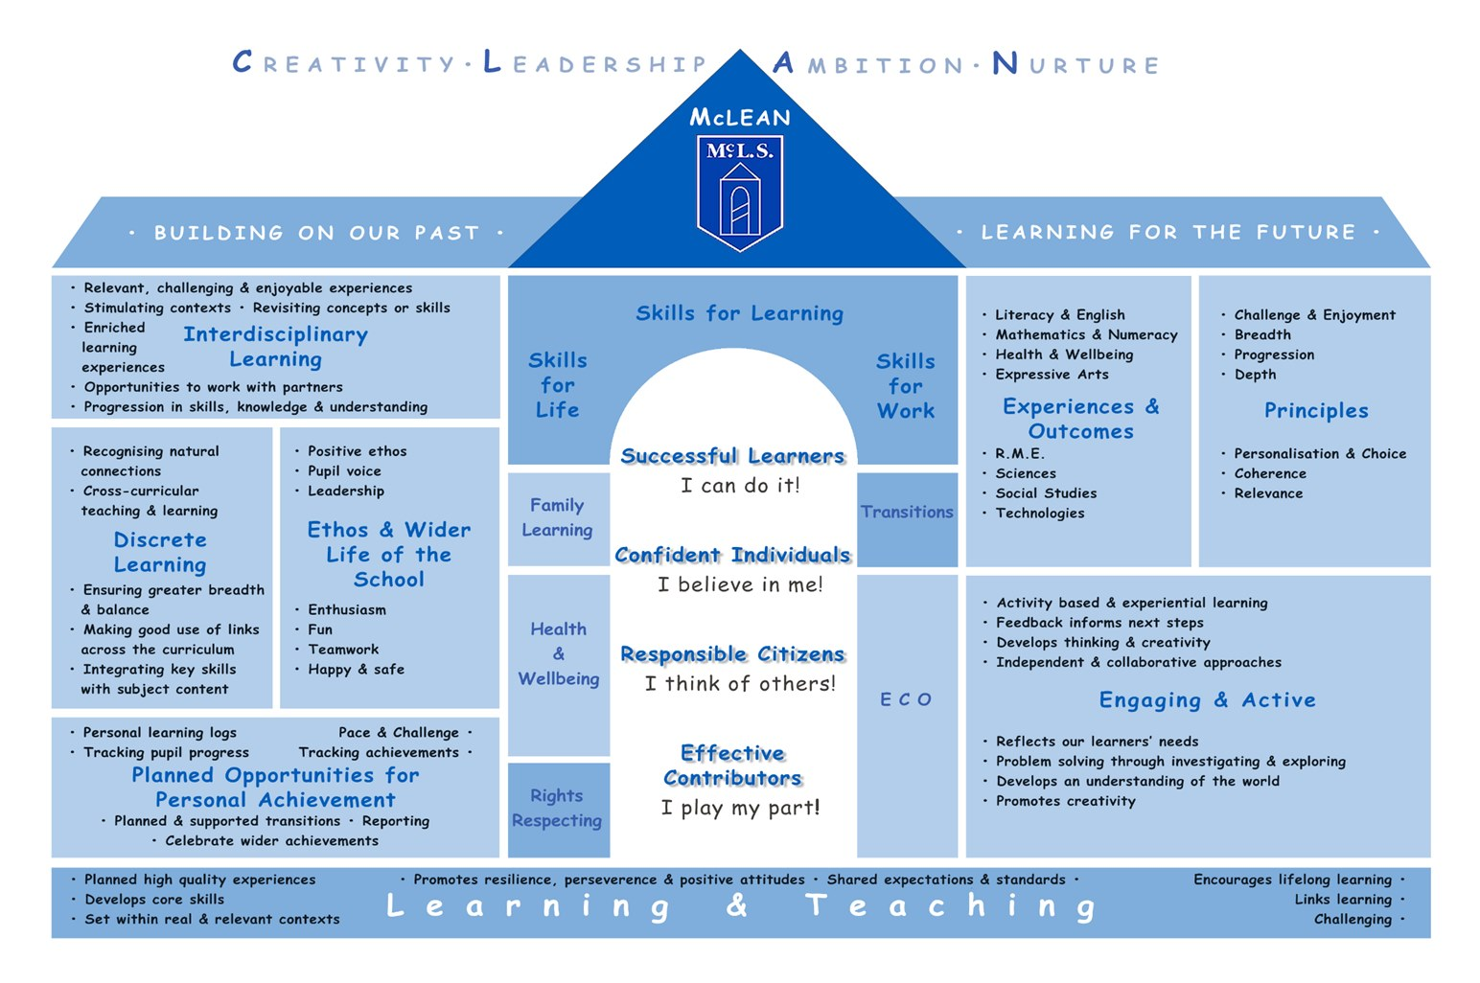

Thank you to those who completed our survey last session to help us identify our school strengths and development needs.

Our School Improvement Priorities for this session are:

Achievement

* Continue to look at and embed our new online planning which supports a progressive curriculum for all children across all 8 curriculum areas
* Support and enhance the delivery of high quality learning, teaching and assessment through professional learning for all staff on the use of digital technology.
* To support all staff through the use of digital technologies to create a more inclusive, engaging and personalised learning environment leading to improved outcomes for our children.

Health and Wellbeing

* To continue to build a supportive school environment that fosters mental and emotional wellbeing, enabling our children to thrive academically and personally. We will do this through building on our work around de-escalation strategies, emotion works, kitbag and The Circle framework.

# Staffing Update

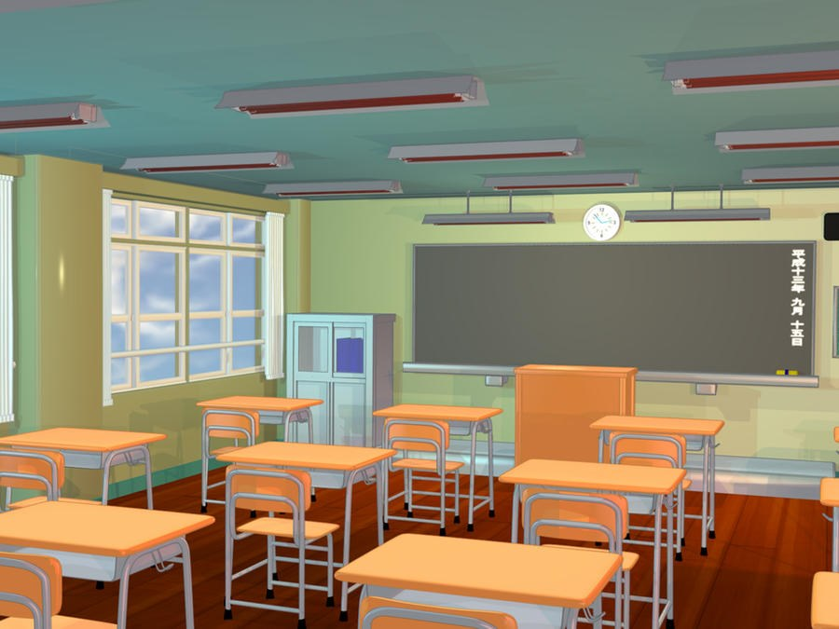

We are delighted to welcome two new members of staff to McLean this session.

Miss Zoe Stephenson has joined us as a Probationer Teacher this session. Miss Stephenson will be teaching P4b and will be supported by Ms Docherty.

Mrs Stephanie Morrison has joined us from Duloch Primary School on a one year temporary contract to cover Miss Anna Stevenson while she is on secondment. Mrs Morrison will be teaching P3a this year.

# Seesaw/Learning Journeys/School App



At McLean we use the app Seesaw to share your child's learning journey with you.

Termly targets will be shared with you through a link to our school website. This link will be shared on seesaw and the school app. This will allow you to see an overview of what your child(ren) will be learning that term. Terms will be split as follows:

Term 1 – August to December

Term 2 – January to April

Term 3 – April to June/July.

The class teacher will upload photos relating to your child(ren)’s learning on a weekly basis. This may be an individual photo, group photo or whole class photo depending on the learning taking place.

Please note that seesaw is not a social media platform. The app is a closed group and only parents/carers of children in that class will be able to see class or group photos. Individual photos will be seen only by you.

At the end of each term, your child(ren) will review their learning with their class teacher and this will be shared with you via seesaw.

# P.E Kit



Children should wear sports shorts or trousers and trainers on their P.E day. They should wear their school jumper on top. The class teacher will share which day your child will have P.E on via the school app or Seesaw.

# Homework



* Homework is issued on a Wednesday and should be returned the following Monday.
* Homework will consist of weekly reading (this will be a mix of reading novels and Rapid Readers to assess comprehension) plus either a literacy or a numeracy task linked to class learning. The tasks will alternate between literacy and numeracy each week.
* Homework should not take more than 30 minutes to complete each week (please let your teacher know if this is not the case).
* Please remember that if you would like to support your child more or they would like to complete more at home, you can check our school website. Teachers update this termly with websites which tie in with current learning for that term.
* Please know that we do understand how busy family life can be at times and we absolutely value family time and extra curricular clubs. With this in mind, we would like to reassure you that if there are weeks where homework is not completed, this is not an issue. If you would like to chat about this, please get in touch.

# Mobile Phones and Smart Watches





Can I please remind you that mobile phones are not permitted to be used in school or school grounds. If your child requires to bring a mobile phone to school, it should be turned off when entering the school grounds. Class teachers will agree with children where their phone should be kept during the school day. We cannot accept any responsibility for phones brought to school being lost or damaged.

Can we also please ask that children who use a smart watch do not use the watch to phone, text or take photos during school hours. We view these watches as similar to mobile phones. If your child has a smart watch, please can you disable the phone, camera and text function during school hours. This can usually be done on the app connected to the watch and is usually called class or school mode.

Please remind your children of these rules.

# Absence, Attendance and Appointments

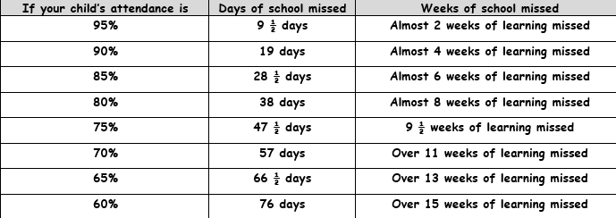

Absence

In our school we must follow Fife Council's attendance management policy and regularly monitor individual children's attendance. If your child's attendance at school is consistently below the thresholds that Fife Council set (95% attendance), you are likely to receive a letter from us highlighting this to you. If your child has been ill, we understand that this will impact upon their attendance, particularly if they have vomited or had diarrhoea and have to stay off school for 48 hours. You may still receive a letter as part of our attendance monitoring but the intention behind this letter is simply to raise awareness of your child's current attendance level and to offer support should it be needed. Please contact us if there is anything that is affecting your child's ability to regularly come to school and we can work together to ensure a positive solution.

If your child is absent you can now text the school to tell us they are absent and why, using the following number 07860 003 811. This number can be used to report absence only. Please do not report absences via Seesaw. If you do not supply us with this information we have a duty to contact you, so that we may be sure of the child’s whereabouts as this is a safeguarding measure.

Punctuality

Our school day starts at 9:00am. We understand that there may be the occasional time when children are late to school. However, children who are regularly late in the morning miss out on predictable routines and information about the day from their teacher and this can impact on their learning. Please get in touch if there is anything we can do to help your child/ren's punctuality.

Attendance

In line with all Fife schools, we continue to have an increased focus on attendance and punctuality. Our school attendance rate last session was 93.21%, which was just below our stretch target. With your support, we would like to increase this to 94%.

Appointments

It is generally better for children if these can be arranged outside school hours, but we know this is not always possible. If your child has an appointment during the school day, please let us know by calling or emailing. All children must be collected by a parent/carer for appointments and signed out at the office. On returning from an appointment, please bring your child back to the office. Medical and dental appointments count as authorised absences.

Holidays

It is not Fife Council policy to authorise holidays in term time. The only exemption to this is where parents serve in the armed forces or Police Scotland.

# School Uniform

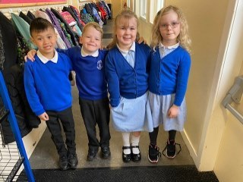

Thank you for sending your children back to school looking so smart in their uniforms this term! As we move through the school year, continuing to keep our standards high in terms of wearing school uniform helps to maintain the strong sense of school community that we have at McLean.

Wearing of school uniform helps us to create a very positive ethos and foster pride in our school community. We believe that wearing full school uniform also promotes:

* self-discipline and the fostering of positive attitudes to school
* improved security within school and on excursions
* reduction in peer pressure to wear fashion items
* assistance for parents in terms of economic and practical issues

McLean School Uniform:

* skirt/pinafore/trousers/shorts - black or grey
* polo shirt or shirt/blouse - white
* cardigan/jumper - royal blue
* school shoes - black
* summer dress - blue checked

Pre-loved Uniform

Our sharing table (outside our school office) is often full of good quality second hand school uniform and coats. Please come and just help yourself to what you need. We are always very grateful for any good quality uniform donations.

Please label everything!

Writing your child's name on the label of all clothing items really helps them and their teacher a lot! We would encourage you to continue to label any new clothing items (including footwear) throughout the year. Thank you in advance!

Waterproof

Please ensure that your child has a light jacket/waterproof with them each day this term. They may wear it to school or keep in their bag. Children participate in lessons and play outside everyday and need to be able to do so in all weather.

# School Lunch

Here are the school lunch menus for this session.

Please [click here](https://www.fife.gov.uk/kb/docs/articles/education2/schools-in-fife/school-meals) for information about Fife school lunches and for applying for free school meals/milk/clothing grant.

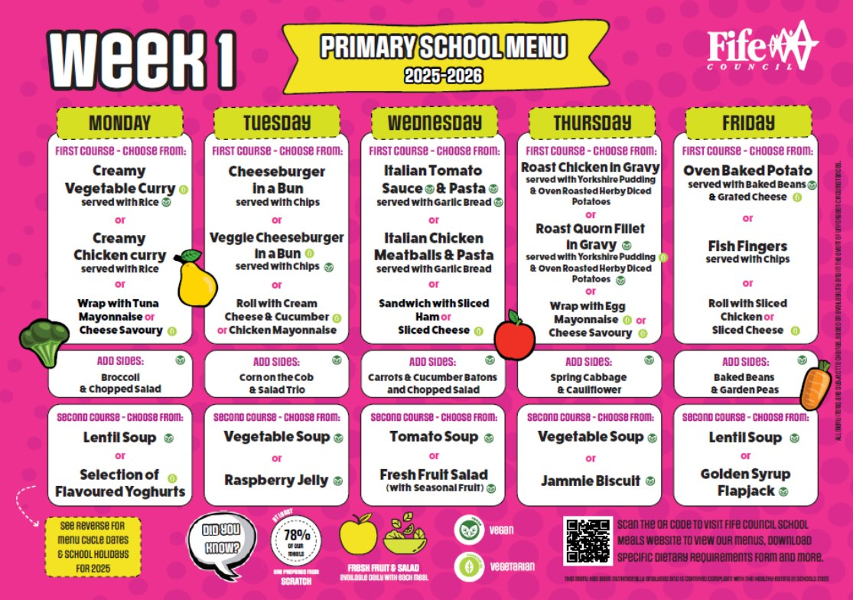

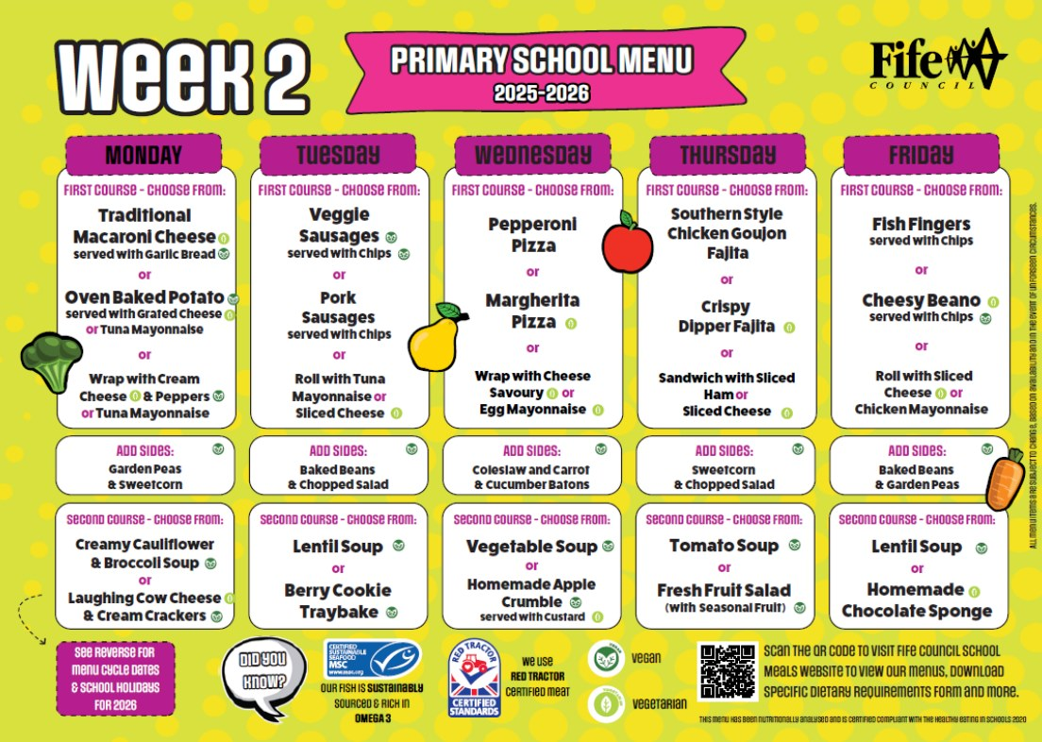

# Sharing Table

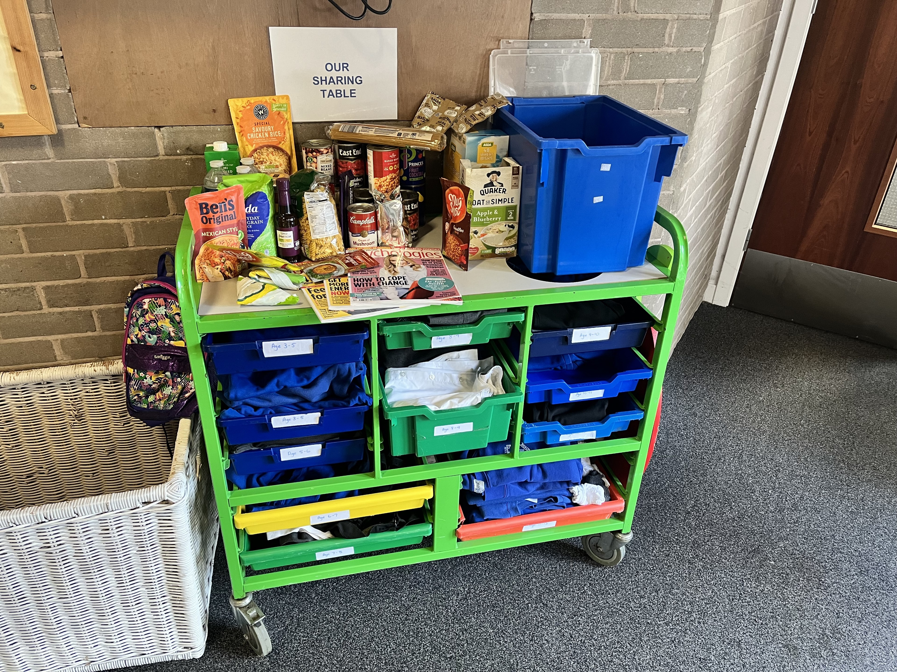

Thanks to our partnership with Fair Share Scotland and "The Big Hoose" we are provided with a range of foods from Tesco each week that are almost out of date and would otherwise go to waste.

Please help yourself to anything on our sharing table and help us in our drive in remaining as an eco friendly school!

# Communication



You can contact the school via email at McLeanps.Parentcommunications@fife.gov.uk or telephone 01383 602423.

If your child is absent you can now text the school to tell us they are absent and why, using the following number 07860 003 811. This number can be used to report absence only. Please do not report absences via Seesaw.

Our school website continues to be used for newsletters, policies and Parent Partnership Minutes which you can find at: <http://www.fifedirect.org.uk/mcleanps>

# Car Park

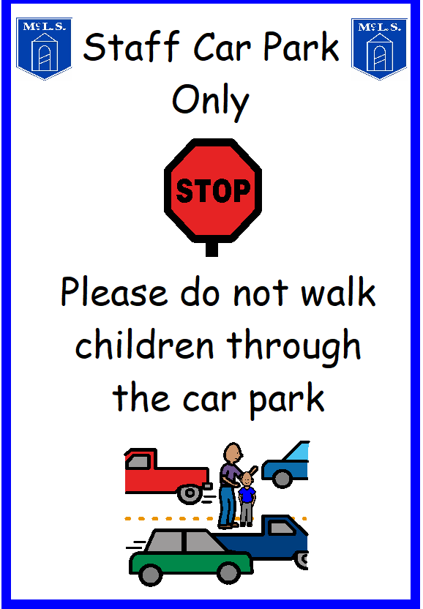

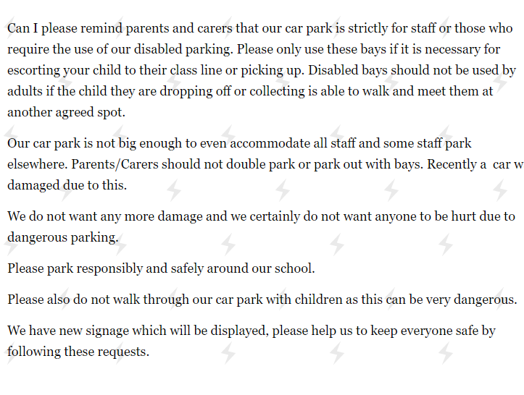

# Dates for Your Diary



August

Wednesday 20th August        Children return/start school

Friday 29th August                   Flu vaccination letters to be returned

September

Wednesday 3rd September     Homework starts

Thursday 4th September         School Photographer in school (more info to follow)

Friday 5th September              School Photographer in school if required

Friday 12th September            Learning Overview shared for August – December

Tuesday 16th September        Shared Finish for all classes. Parents/Carers welcome from 2.30pm

Friday 26th September -          Flu Vaccinations

October

Wednesday 1st October          Last day of homework this term

Tuesday 7th October               Autumn Assembly at 9.30am (P5 parents invited to attend)

Friday 10th October                 Last Day of Term (school closes at 3.05pm)

Monday 27th October             Return to school (9am)

Wednesday 29th October       Homework starts

November

Tuesday 4th November           Parents Night 3.30pm – 6.30pm

Thursday 13th November        Parents Night 3.30 – 6.30pm

Friday 14th November             Inset Day (children do not attend school)

Wednesday 26th November    Last day of homework for this term

December

Thursday 11th December        P4 Nativity – in school hall at 9.30am

Friday 12th December             Review of Learning uploaded on Seesaw by this date

Monday 15th December          P1-3 Carol Concert at Viewfield Church 10am

                                                P7 Christmas Party

Tuesday 16th December         P5&6 Christmas Party

Wednesday 17th December   P3&4 Christmas Party

Thursday 18th December        P1&2 Christmas Party

Friday 19th December             Festive Friday – children can come to school in Christmas Jumpers or festive clothes

                                                School closes at 3.05pm for 2 weeks.

# Thank You



We hope this first sway has been useful and would like to thank you in advance for you support and engagement in your child(ren)'s school journey.

Please don't hesitate to get in touch if you have any questions or concerns.

Best wishes,

Gillian Souter

Headteacher