**McLean Nursery and Primary School**

School Improvement Plan 2025 - 2026

**Learning, Celebrating and Achieving Together**



**Creativity Leadership Ambition Nurture**

**Context of the school**

McLean Primary School was opened in 1896, by Andrew Carnegie.

The building was modernised in 1984 and the internal accommodation is arranged in semi open plan areas and classrooms.

There are currently 13 classes accommodated in the school as well as an ICT suite, sensory room, nurture space, library and Teacher Resource Area.

Our hall is used for PE, Drama, Assemblies and also for lunches. It is a small hall, considering the size of the school, and this makes it very difficult to accommodate the number of children we have in school who stay for lunch or to have whole school assemblies or events for parents. We tend to make use of our local Church when bringing everyone together.

The hutted provision to the rear of the school has two rooms, which will be used as a music base, library and sensory room in session 2025 – 2026. We also have another temporary modular accommodation (TMA) to the front of our school, which will host our P7 classes.

A purpose-built nursery is set within the school grounds, which has 2 nursery rooms; Rainbow and Sunflower, both of which have outdoor play spaces. Our nursery is a 49-week provision offering a morning and afternoon session each day.

McLean serves a mixed catchment of private and local authority housing in northwest Dunfermline. The current school and nursery roll is approximately 467 children. Around 20% of the children at McLean receive free school meals.

McLean is part of the Queen Anne Cluster, which is made up of 14 Primary Schools and Queen Anne High School.

The current leadership team within the school comprises of a Joint Headteacher, Gillian Souter (Joint with Milesmark), Laura Walker (Depute Headteacher) and Emma Walker (Depute Headteacher).

**Vision, Values and Aims**

**Vision Statement**

Learning, celebrating and achieving together.

**School Values**

**Creativity Leadership Ambition Nurture (CLAN McLean)**

**School Aims**

As a school and Nursery:

We will be friendly, honest, fair and respectful to each other and behave responsibly.

We will try our best in our learning and be proud of our achievements in and out of school.

We will work together to look after our environment and everyone and everything in it.

We will work together to make our school even better involving our parents and others in our community.

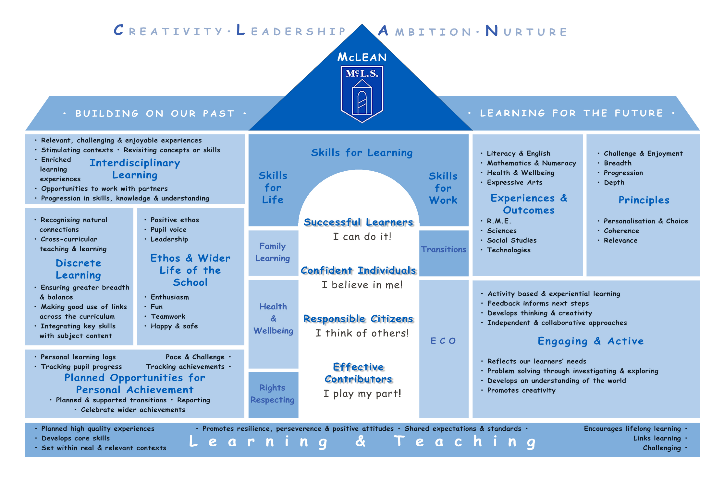

**Session 2025 -2026 Improvement Plan**

**Improvement Priority 1 - Achievement**

|  |  |  |  |  |  |
| --- | --- | --- | --- | --- | --- |
| **Education Directorate Improvement Plan:** Achievement | | | | | |
| **Focused Priority:**   * Plan a progressive curriculum for all children across 8 curriculum areas ensuring that all children receive their entitlement to a broad general education. * Use benchmarks for all curriculum areas to measure children’s progress and achievement of a level across the broad general education using a range of assessment evidence to inform professional judgements. | | | | | |
| **HGIOS4 Quality Indicators** | | | **HGIOELC Quality Indicators** | | |
| 1.2 – Leadership of Learning  1.3 – Leadership of Change  2.2 – Curriculum  2.3 – Learning, Teaching and Assessment  3.1 – Ensuring wellbeing, equality and inclusion  3.2 – Raising attainment and achievement | | | 1.2 – Leadership of Learning  1.3 – Leadership of Change  2.2 – Curriculum  2.3 – Learning, Teaching and Assessment  3.1 – Ensuring wellbeing, equality and inclusion  3.2 – Raising attainment and achievement | | |
| **Expected Impact** | **Strategic Actions Planned** | **Responsibilities** | | **Measure of Success**  ***(Triangulation of Evidence/QI Methodology)*** | **Timescales** |
| All children will experience planned, progressive learning experiences across the broad general education.  All staff will enhance their assessment skills through planned assessment and moderation activity, this will ensure all children are making progress across all areas of the curriculum  All staff will track children’s progress across the broad general education and use assessment evidence to support professional judgements to ensure children experience their entitlement to a broad general education.  Through planned opportunities with parents/carers, knowledge of the broad general education will be developed and this will ensure they can support children in their learning across the curriculum | **Forward Planning**   * All staff will improve confidence in using new online planning formats using the progression pathways for **all** curriculum areas to ensure planned learning experiences are progressive for all children. * Attainment and Forward Planning dialogues will support assessment within all curriculum areas linked to assessment evidence which informs professional judgements. * Staff will become aware the Numeracy phases and start to use the diagnostic assessments. * Staff will develop confidence in planning for assessment.   **Tracking & Monitoring**   * Develop agreement around jotter standards. * Involve staff in moderation of work and standards across McLean and Milesmark so that staff feel more confident in their CfE judgements.   **Learning, teaching and assessment**   * Continued focus for parent/carer workshops/shared starts and finishes to share progression across identified curricular areas * Continue with digital schools award | Led by SLT  All staff  Led by SLT  All staff  Led by cluster PT  Led by DHT | | **Data**  Analysis of attainment data in Literacy, Numeracy along with all/identified areas of the curriculum  Analysis of CFE and BASE/NSA data  Analysis of data for identified cohorts e.g., SIMD ASN, EAL, LAC, AF etc  **People’s Views**  Teacher views on new system  Teacher professional dialogue with SLT at FP & Attainment Meetings  Feedback from moderation activity  Parent/carer views on children’s experiences of BGE  Children’s views gathered through class groups and pupil focus groups on the learning experiences across the curriculum  **Observations**  Forward planning documentation monitoring  Jotter sampling – literacy/numeracy and other curriculum areas  Classroom observations linked to identified areas of the curriculum (QA calendar)  Focus for LP – analysis of data, learning experiences across the curriculum/identified area of curriculum, parent/pupil views of the delivery of the curriculum | October 2025  Jan 26  May 26 |
| **Ongoing Evaluation** | | | | | |
|  | | | | | |

|  |  |  |  |  |  |
| --- | --- | --- | --- | --- | --- |
| **Education Directorate Improvement Plan:** Achievement | | | | | |
| **Focused Priority:**   * Support and enhance the delivery of high-quality learning, teaching and assessment through professional learning on for all staff on the use of digital technology. * To support all staff through the use of digital technologies to create a more inclusive, engaging and personalised learning environment leading to improved outcomes for children and young people. | | | | | |
| **HGIOS4 Quality Indicators** | | |  | | |
| 1.3 Leadership of Change  2.2 Curriculum  2.3 Learning, Teaching and Assessment  2.4 Personalised Support  2.6 Transition  3.2 Raising Attainment and achievement  3.3 Increasing creativity and employability | | |  | | |
| **Expected Impact** | **Strategic Actions Planned** | **Responsibilities** | | **Measure of Success**  ***(Triangulation of Evidence/QI Methodology)*** | **Timescales** |
| All children will experience improved engagement and motivation in learning through creative approaches to delivering learning and teaching using a wide range of digital tools.  Through professional learning all staff will enhance their skills in using digital tools to deliver high-quality learning, teaching and assessment with appropriate differentiation, leading to improved outcomes for all children.    Children in P6 and P7 will become more proficient in using digital tools to support them in their learning, preparing them with skills for learning, life and work.  All staff will increase their knowledge of how to personalise learning using a wide range of software, digital skills, and accessibility tools to meet the needs of all children/young people at universal, additional and intensive levels.  Through planned opportunities with parents/carers, knowledge of the use of digital technology will be developed and this will ensure they can support children in their learning across the curriculum. | **Professional Learning Activity**   * As part of the agreed WTA of 5 collegiate sessions and 3 cluster sessions, staff will engage in professional learning on the use of iPads and associated apps to enhance the quality of learning, teaching and assessment. * All staff will have the option to upskill their knowledge through the awareness of resources and self-led professional learning available on the Apple Education Community and further professional learning will support teachers to make effective use of the software library and develop their digital skills. * All staff will engage in a small scale Practitioner Enquiry around differentiation using i-pads and be able to present their findings.   **Enhancing learners’ experiences**   * Enable all staff to personalise learning by tailoring content on digital platforms to suit individual/class needs. * Enable all staff to use digital tools to make learning and teaching more engaging. * Accessibility features will be available to ensure learning is more inclusive for children with ASN whilst promoting independence. * Staff will ensure they are able to always demonstrate safe and responsible use of digital.   **Learning, Teaching and Assessment**   * Teachers will use their digital skills to plan appropriate learning based on Fife’s curriculum progression pathways. * Teachers will use a range of digital tools to create and share explanations and to model learning processes. * Planning for key learning to be shared via digital platforms to support P6 and P7 children, to access during and outside of lessons. * Teachers will plan for differentiated learning by providing access to learning materials digitally allowing children to use the accessibility features and/or to access at their own pace. * Teachers involve children in the planning process, actively engaging them in decision making, allowing them to contribute ideas, select learning activities and co construct success criteria. * All staff will improve the way they gather evidence of learning through digital means and jotters. This will be monitored closely by SLT and mediated by staff.   **Assessment and Feedback**   * All staff will develop skills to improve their knowledge of the digital tools available that can be used to provide instant feedback to children. * Development of Digital Portfolios to showcase learning over time using Showbie. * Data to be gathered from the use of digital platforms in conjunction with all assessment evidence to plan for next steps in learning.   **Curriculum Rationale**   * Our Curriculum Rationale will be further developed to ensure that this reflective of the experiences all children are experiencing across the school in relation to the use of digital technology. | Led by ESO’s, Digital PT’s  All staff led by digital Ambassador, LD  Led by GS (HT) and EW (DHT)  Led by ESO’s, Digital PT’s  Led by SLT  All staff  Led by SLT  All staff  Led by LW (DHT)  Led by SLT  All staff  SLT | | **Data**  Analysis of attainment data in Literacy, Numeracy along with all/identified areas of the curriculum  Analysis of CFE and BASE/NSA data  Analysis of data for identified cohorts eg SIMD ASN, EAL, LAC, AF etc  **People’s Views**  Staff views on use of digital technology to enhance learning.  Self-evaluation (2.3) on strengths and next steps.  Staff professional dialogue with school/cluster colleagues.  Feedback from Professional Learning activity.  Parent/carer views on children’s experiences.  Children’s views gathered through class groups and pupil focus groups on the use of digital technology to support and enhance learning experiences.  **Observations**  Forward planning documentation.  Classroom observations linked to the use of digital technology to enhance learning, teaching and assessment.  Focus for LP – analysis of learning experiences through the use of technology. | May 26  Feb 26  April 26  May 26  May 26 |
| **Ongoing Evaluation** | | | | | |
|  | | | | | |

**Session 2025 - 2026 Improvement Plan**

**Improvement Priority 2 – Health and Wellbeing**

|  |  |  |  |  |  |
| --- | --- | --- | --- | --- | --- |
| **Education Directorate Improvement Plan:**  Equality & Equity, Health & Wellbeing, Attendance & Engagement | | | | | |
| **Focused Priority:**   * To create a supportive school environment that fosters mental and emotional wellbeing, enabling pupils to thrive academically and personally. | | | | | |
| **HGIOS4 Quality Indicators** | | | **HGIOELC Quality Indicators** | | |
| 1.2 – Leadership of Learning  1.3 – Leadership of Change  3.1 – Ensuring wellbeing, equality and inclusion | | | 1.2 – Leadership of Learning  1.3 – Leadership of Change  3.1 – Ensuring wellbeing, equality and inclusion | | |
| **Expected Impact** | **Strategic Actions Planned** | **Responsibilities** | | **Measure of Success**  ***(Triangulation of Evidence/QI Methodology)*** | **Timescales** |
| All staff will be confident in using consistent de-escalation strategies.  H&S violence and aggression reports will reduce from 40 to 30 (over a 24-month rolling period)  All staff will record bullying incidents accurately  Through workshops, families will understand resources (such as kitbag, emotion works, scripts) used to support health and wellbeing in school and will feel confident in adopting these strategies at home.  Staff, pupils and families will show respect and acceptance towards all 9 protected characteristics (Equality Act 2010). | **Professional Learning:**   * Staff to attend training around Emotion Works and this will be used consistently in school and nursery as part of our Positive Relationships and anti-Bullying Policy. * Strategic plan to be agreed and started for implementation of de-escalation being used throughout school and nursery * Staff to attend further training around the Circle framework.   **Curriculum:**   * Continue to work towards our silver award for Rights Respecting Schools. * Continue to work towards our eco goals with continuation of our Green Flag status * Deliver assemblies and class lessons which encourage acceptance of diversity and build on our inclusion and equality work. * Develop our SfL policy. | Led by HL (LS Teacher)  RRS group  Eco group  SLT  Pupils  Families  LS Staff | | **Data**   * Analysis of H&S violence and aggression reports * Analysis of Seemis reports on bullying incidents * Analysis of power BI data around SIMD, gender and other protected characteristics   **People’s Views**   * Parent/carer views on behaviour policy and bullying incidents ad how they are managed. * Family views on workshops and strategies used. * Children’s views gathered through class groups and pupil focus groups on their experiences of bullying, inclusion and equality throughout the school. * Staff views on success of de-escalation and other strategies and impact on classroom ethos.   **Observations**   * LP visit feedback around classroom ethos and use of policy. * SLT observations * Feedback from other agencies visiting school on ethos | May 26  Feb 26 |
| **Ongoing Evaluation** | | | | | |
|  | | | | | |