**McLean Nursery and Primary School**

School Improvement Plan 2023 - 2024

**Building on our Past Learning for the Future**



**Creativity Leadership Ambition Nurture**

**Context of the school**

McLean Primary School was opened in 1896, by Andrew Carnegie.

The building was modernised in 1984 and the internal accommodation is arranged in semi open plan areas and classrooms.

There are currently 15 classes accommodated in the school as well as an ICT suite and Teacher Resource Area.

Our hall is used for PE, Drama, Assemblies and also for lunches. It is a small hall, considering the size of the school, and this makes it very difficult to accommodate the number of children we have in school who stay for lunch or to have whole school assemblies or events for parents. We tend to make use of our local Church when bringing everyone together.

The hutted provision to the rear of the school has two rooms, which will be used as a music base and sensory room in session 2023 – 2024. We also have another temporary modular accommodation (TMA) to the front of our school, which will host our P5/6 and P6 classes.

A purpose-built nursery is set within the school grounds, which has 2 nursery rooms; Rainbow and Sunflower, both of which have outdoor play spaces. Our nursery is a 52-week provision offering a morning and afternoon session each day.

McLean serves a mixed catchment of private and local authority housing in northwest Dunfermline. The current school and nursery roll is approximately 457 children. Around 17% of the children at McLean receive free school meals.

McLean is part of the Queen Anne Cluster, which is made up of 14 Primary Schools and Queen Anne High School.

The current leadership team within the school comprises of a Joint Headteacher, Gillian Souter (Joint with Milesmark), Laura Walker (Depute Headteacher) and Sinead Davidson (Temporary Depute Headteacher).

**Vision, Values and Aims**

**Vision Statement**

We will maintain a sense of pride in McLean Primary School, to ensure a culture of continuous improvement, which involves children, parents, staff and the wider school community.

Everyone will be involved in shaping the school vision and aims.

Children will experience the highest quality learning and teaching which will maximise their potential and ensure every child experiences success and achievement. All children will be supported and challenged, enabling them to develop skills for learning, life and work across all aspects of the curriculum and at all levels.

They will develop the four capacities of A Curriculum for Excellence; to become confident individuals, effective contributors, successful learners and responsible citizens.

**School Values**

**Creativity Leadership Ambition Nurture (CLAN McLean)**

**School Aims**

As a school and Nursery:

We will be friendly, honest, fair and respectful to each other and behave responsibly.

We will try our best in our learning and be proud of our achievements in and out of school.

We will work together to look after our environment and everyone and everything in it.

We will work together to make our school even better involving our parents and others in our community.

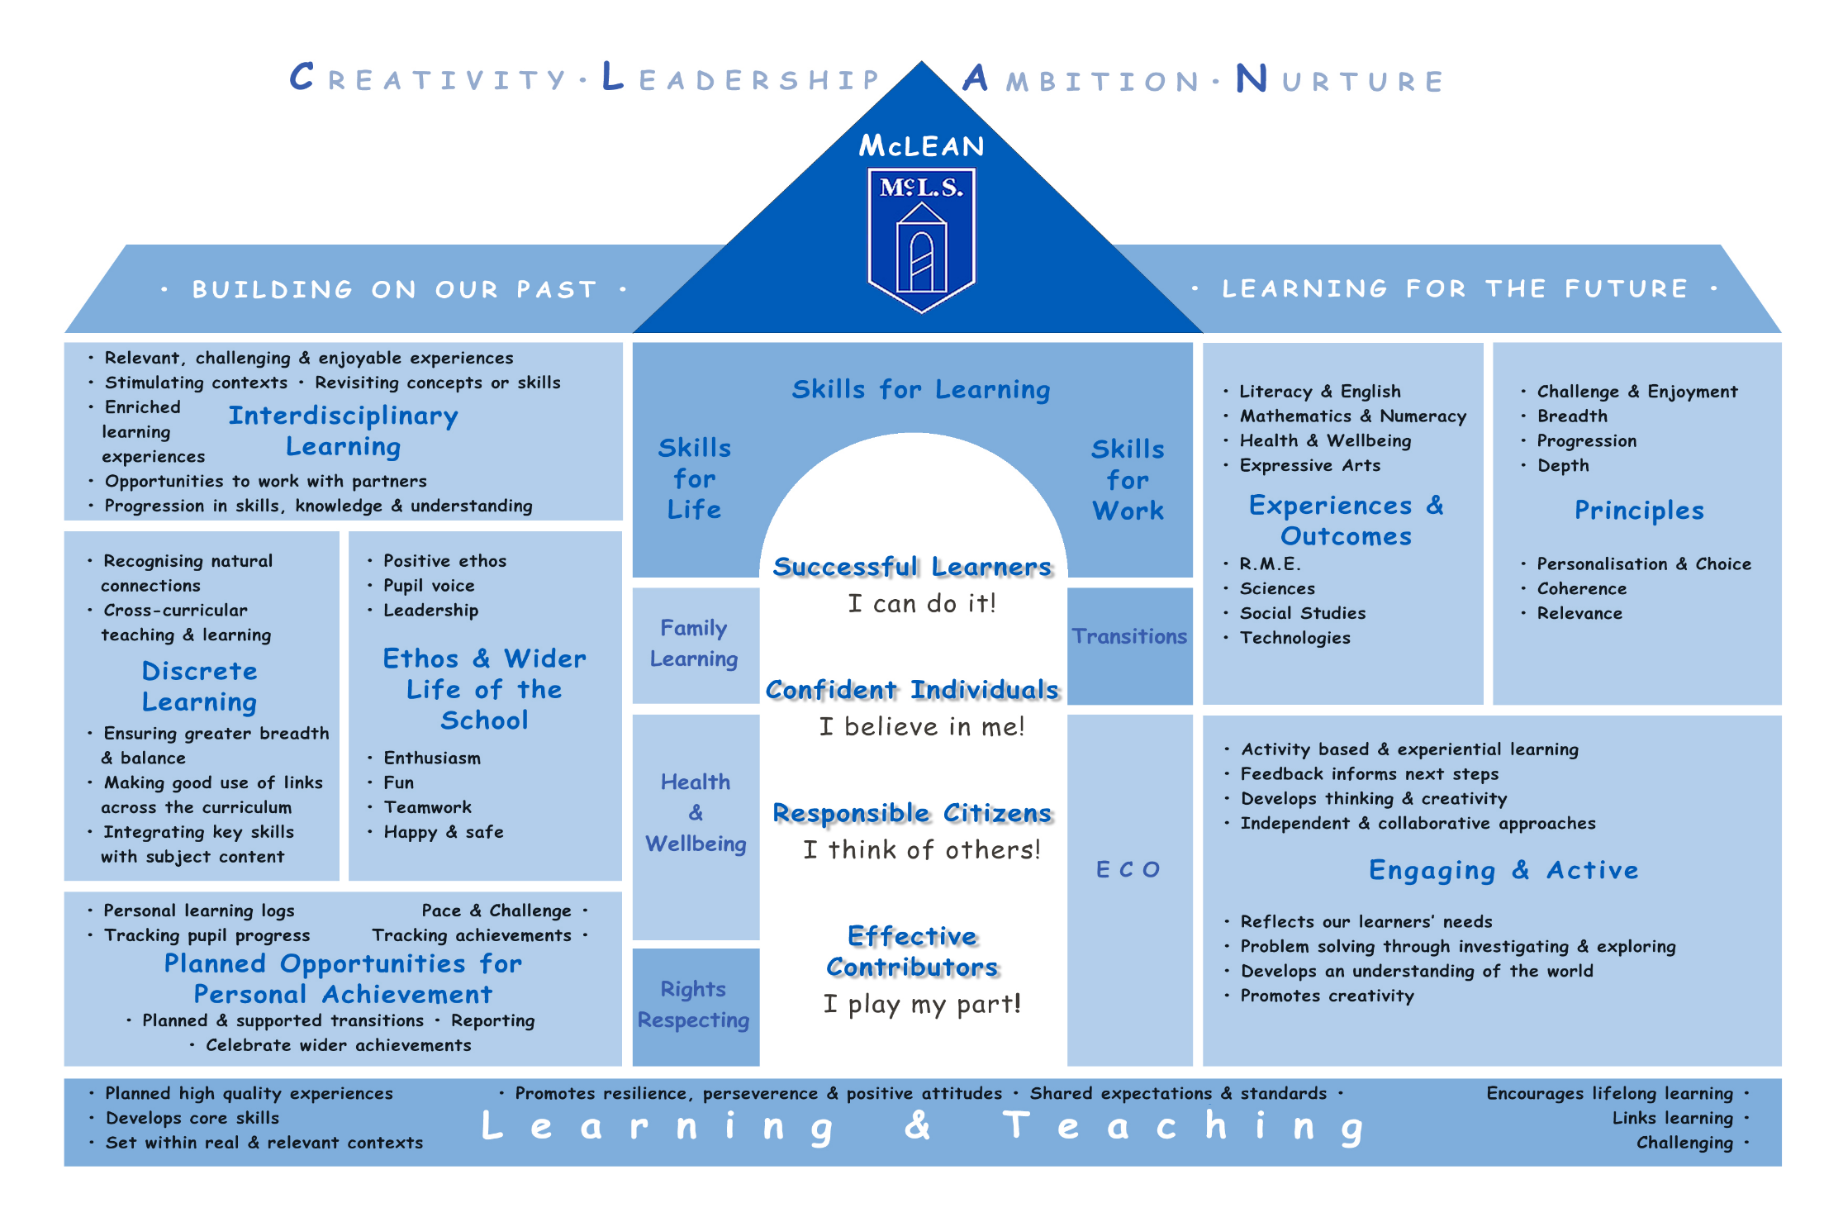

**Session 2023 -2024 Improvement Plan**

**Improvement Priority 1 - Curriculum**

|  |  |  |  |  |  |
| --- | --- | --- | --- | --- | --- |
| **National Improvement Framework Priority: Improvement in attainment in literacy and numeracy** | | | | | |
| **Focused Priority: Curriculum** | | | | | |
| **QI (HGIOS 4)** | | **HGIOELC** | | | |
| 1.2 Leadership of learning  2.2 Curriculum  2.3 Learning, teaching and assessment  3.2 Raising attainment and achievement | | 1.2 Leadership of learning  2.2 Curriculum  2.3 Learning, teaching and assessment  3.2 Securing Children’s progress | | | |
| **Expected Impact** | **Strategic Actions Planned** | | **Responsibilities** | **Measure of success** | **Timescales** |
| * Revised Planning using Fife Learning Pathways will ensure consistency across all stages and less bureaucracy. * Effective planning and assessment will ensure stretch targets are achieved across all stages in literacy and numeracy. * Stretch targets will be achieved in literacy (P4 – 71% and P7 – 73%) and numeracy (P4 – 77% and P7 78%) for session 23/24. * Revision of our curriculum rationale will ensure our curriculum is tailored to our individual setting and is relevant to all learners. * Play based learning will be further developed across P1 and into other stages. Staff and children will be able to confidently talk about the skills taught and developed through play. * Attainment across early years will improve. * Leadership opportunities will be available to pupils at all levels within Eco, RRS, Pupil Voice, Buddies etc. * Revision of our vision, values and aims across school and nursery will ensure they are in line with our Rights Respecting bronze status and will help us achieve our silver status. * Children will be better supported and challenged through digital literacy. | * Look at planning documents as a whole staff and ensure confidence in using pathways and Record of Understanding tool for literacy and numeracy. * Moderate learning, teaching and assessment across stage partners between McLean and Milesmark regularly. * All staff involved in the self-evaluation process, evaluating the current curriculum and identifying best practice. * Views sought from children, parents and the wider school community on what they feel the key features are that bring the curriculum ‘alive’. * Consider how play based learning can be evidenced across the curriculum. * Creation of Curriculum Rationale. * All staff and stakeholders involved in revising our vision, values and aims across school and nursery. * Ensure these are shared across all stakeholders in school and nursery and incorporated into our school policies and discussed at weekly assemblies. * Find out about the Digital Schools Award and what it would mean for the school. * Where are we now and what do we need to do to achieve this? * Continue to develop the use of new technology to improve experiences of learners. * Look at how parental engagement can be included possibly through the presenting of our learning through Microbit, Lego Spike and digital Literacy skills. | | All staff led by SLT  Play Pedagogy led by Sinead Davidson along with Helen, Inga, Claire, Laura D, Joanne, Caroline, Hayley  Curriculum Rationale: All stakeholders but led by HT.  Literacy: David, Anna,  Eco/Pupil Voice: led by Helen and Anna with Carole, Liz  STEM: led by Hazel  RRS: Laura Walker, Joanne Docherty  Laura Donaldson | * All staff will confidently use the Fife progression pathways and records of understanding in literacy and numeracy and this will be evident in Forward Planning documents and discussions. * Staff will have a deeper understanding around play pedagogy. This will be evidenced in FP meetings. * Data gathered via a forms survey will show all stakeholders are aware of and understand our Curriculum Rationale. * Data gathered via a forms survey will show that All stakeholders are clear about what McLean’s vision, values and aims are. * Achieve digital school award | * By Dec 2023 * By May 2024 but may cross into next session. * By May 2024 * By May 2024 |
| **Ongoing Evaluation** | | | | | |
|  | | | | | |

**Session 2021 -2022 Improvement Plan**

**Improvement Priority 2 – Health and Wellbeing**

|  |  |  |  |  |  |
| --- | --- | --- | --- | --- | --- |
| **National Improvement Framework Priority:** Improvement in children’s health and wellbeing. | | | | | |
| **Focused Priority: Improvement Priority: Improving Health and Wellbeing.** | | | | | |
| **QI (HGIOS 4)** | | **HGIOELC** | | | |
| 3.1 Improving wellbeing, equality and inclusion  2.2 Curriculum  2.7 Partnerships | | 3.1 Improving wellbeing, equality and inclusion  2.2 Curriculum  2.7 Partnerships | | | |
| **Expected Impact** | **Strategic Actions Planned** | | **Responsibilities** | **Measure of success** | **Timescales** |
| * Improving pupil emotional wellbeing resilience will be apparent. * Pupils will have more resilience and be able to talk and problem solve situations. * Almost all Pupils will have a more positive attitudes to dealing with emotions. They will use emotion works cogs to support this. * Improvement in attendance for targeted group working with PSO. Stretch target achieved (92.7%) * Increased Family engagement will lead to improved partnership working across school and nursery. * Families will feel more involved in their child’s learning and life at school and nursery. * There will be a consistent approach towards Positive relationships and behaviour management with an inclusive and equitable approach for all. * Staff will confidently support children to resolve peer conflict and self regulate their emotions effectively. | * Continue to use Emotion Works language at whole school level. * Continue to use Tree of Knowledge resource across all stages. * Increase family engagement in nursery through regular offers of PEEPS, bookbug and other opportunities with support from partner agencies around toilet training, bedtime stories, baby massage and more. * Family workshops organised in school to share strategies that we use with family members to ensure a more joined up approach. * Create action plan for De-escalation across whole school. * Work closely with EP to support training in de-escalation for all staff. * Share this work with all stakeholders. * Embed our Positive Relationships and Anti-Bullying Policy and ensure it is used consistently across school and nursery. | | * De-escalation led by Colleen with Fiona, Megan, * Attendance management led by HT and supported by Alison Dudley (PSO) and all staff. | * All stakeholders will have a working knowledge of our revised Positive Relationships and Anti-Bullying Policy almost all will agree it is used effectively (data gathered through questionnaire) * Staff have an increased knowledge and understanding of de-escalation strategies and use these confidently (data gathered through verbal feedback and exit passes at training) * Pupils and staff are using the updated Positive Relationships and Anti-Bullying Policy and this is becoming embedded across the school and nursery (data gathered from LP visitors) * Increased percentage of families surveyed will say they feel involved and have a say in school improvement (76% from last survey – hope to increase to 80% or above) * Improved attendance figures for targeted group (data used from power BI) | * Improved attendance by Dec 2023 and again in May 2024 |
| **Ongoing Evaluation** | | | | | |
|  | | | | | |