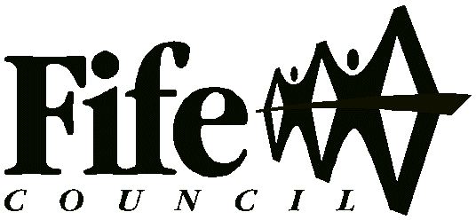

EDUCATION SERVICE

McLean Primary School



POSITIVE RELATIONSHIPS

& ANTI-BULLYING POLICY

Headteacher: Mrs G Souter
McLean Primary School
Baldridgeburn
Dunfermline
KY12 9EE
Tel No: 01383 602423
mcleanps.parentcommunications@fife.gov.uk
INTRODUCTION FROM THE HEADTEACHER

Dear Parents/Carers,

This policy has been drafted in consultation with staff, pupils and parents in an effort to ensure that there is a consistent approach to promoting positive relationships at McLean Primary School.

I hope it will be a working document for discussion at home and school with the children and we welcome feedback from parents.

It is my hope that this policy will support us all in building on the positive learning environment we already have at McLean Primary School. We are proud of the attitudes and behaviour of the children in our school, and visitors to our school frequently remark upon it.

However, conflict and breakdown in relationships can occur from time to time and it is our aim to treat such incidents in a consistent, fair and supportive manner. Reported incidents of bullying will be investigated and acted upon in a timely fashion.

All staff throughout the school use restorative approaches to help children deal with conflict and disagreements as well as following our agreed system of staged interventions, to deal with most incidents. However, repeated incidents or incidents of a more serious nature are handled by the senior leadership team. In such cases, we work with the pupils and if necessary, the parents to resolve the problems and agree on the best course of action to repair harm done to individuals and relationships.

In some cases, to fully meet the needs of pupils and their families, there may need to be involvement from external agencies, e.g. pupil support, Family Support Service, educational psychologists and/or the community paediatrician. In serious cases, formal disciplinary procedures would have to be followed using Fife Council’s Exclusion Policy and Procedures.

The key to positive behaviour by all is partnership between school and home. If we work together then we can achieve our aims as outlined in our policy.

At McLean, we strive to be inclusive. Any form of derogatory language or treatment of minority groups will not be tolerated. We strive to combat conscious and unconscious bias within our school and to teach our children to celebrate and respect diversity.

Gillian Souter
Headteacher
THE AIMS OF OUR POSITIVE RELATIONSHIP AND ANTI-BULLYING POLICY

We have eight school aims which support us in achieving our school vision. All of our school aims are focussed on providing every child with the highest quality learning experiences in order to maximise their potential and ensure every child experiences success and achievement.

Two aims in particular focus on developing positive relationships within a supportive learning environment to ensure happy children at McLean Primary School.

To promote positive relationships within an inclusive school community characterised by mutual respect, fairness, honesty and responsibility.

To work in partnership with other agencies to provide the whole school community with positive experiences that promote and protect their physical, social, mental and emotional health and well-being.

Our positive relationship and anti-bullying programme is designed to help achieve these aims.

School Environment

We realise the impact the school environment has on morale, relationships and the potential for learning.

There have been many physical changes to the school building, the surrounding grounds and resources within the school to provide a safe, pleasant and stimulating environment for learning.

We use our wall spaces to celebrate achievements throughout the school as well as provide current and relevant information. Developments are ongoing as we strive for continuous improvements.

We want pupils, parents and staff to be proud of McLean Primary School.

McLean Primary School Values & Aims Charter

Lifelong success depends on learning to make sensible choices and to take responsibility for our own actions. We want our school to be safe and stimulating, a place where children are happy and success is celebrated. To help us to achieve our agreed school aims we have created a School Values & Aims Charter.

Children and adults have a number of ‘rights’ and we have identified those most closely related to time spent at school. When working together to ensure all children have their rights respected, we embedded our shared school values of:

Creativity Leadership Ambition Nurture

INCENTIVES TO PROMOTE POSITIVE BEHAVIOUR

At McLean we believe that nurturing and rewarding success is a crucial part of the learning process. Personal achievements of individual children need to be recognised and celebrated in order to improve self-esteem and motivate children to become life-long learners.

Clan System
Every child in the school is allocated a Clan:
Castle, Loch, Abbey or Nevis.
Family groups will normally be put in the same clan and they will remain in this clan throughout their time at McLean Primary School, (unless changes have to be made due to children leaving or joining the school and the numbers in clans becoming uneven).

Within each class, a Class Charter, will be developed at the beginning of each session which outlines the shared expectations of everyone in the class. The children will be encouraged to adhere to this agreement throughout the year in all areas of the school environment.

Any adult in the school can reward Clan points in any area of the school environment, including the playground.

At the end of each week, the number of Clan points earned by each Clan group, in each class will be counted and a running total will be displayed in the assembly hall. At the end of the term, the Clan group with the highest total will receive a special treat!

Skills Groups
Children who have earned their 50 minutes Skills Group Time, have the opportunity on a Friday afternoon to take part in a range of masterclasses that promote key principles of the Curriculum for Excellence, e.g. challenge and enjoyment, personalisation and choice. Classes will award first choice of these masterclasses each week on a rota basis or as part of teamwork from tables. These masterclasses will provide opportunities for children to develop the 4 capacities of successful learners, responsible citizens, effective contributors and confident individuals.

Feel Good Friday Assemblies

Feel Good Friday assemblies will take place once a week.They will be given a high profile in order to celebrate children’s school and wider achievements.

Teachers will nominate 1 or 2 children per week to receive a Headteacher award sticker. They will be nominated to celebrate a great piece of work, for improved effort or for demonstrating one or more of our school values. The children’s photographs will be shared on our school facebook page.
Children who have achievements from out of school can also share these with everyone at assembly.

RESTORATIVE APPROACH

Staff and pupils in our school use restorative discussions to handle conflicts and disagreements that inevitably occur in and out of school.

Restorative approaches put repairing harm done to relationships and people over and above the need for assigning blame and dispensing punishment.
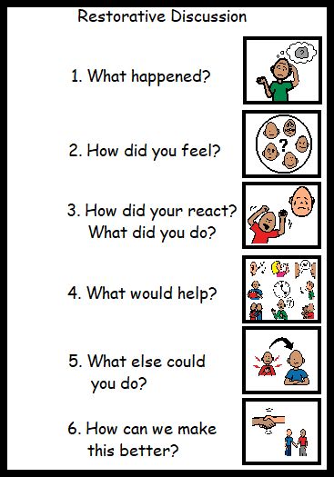

Restorative Approaches

Schools are complex institutions, where there will always be competing ideas, tensions and personal disagreements. Restorative Practices offer ways to the pupils and staff, to manage these fairly and positively, to prevent conflict and harm but still allow for the expression of difference.

The restorative approach supports the victim, ‘ giving them a voice’, as well as listening to those who have harmed relationships or property, while working together to reach a resolution.

We aim to equip the children with different strategies, which they can use when they meet conflict or tension, allowing them to reach decisions calmly.

STAGED INTERVENTIONS

However, should a pupil continue to make poor choices in their behaviour, it is important to ensure that they are aware of the consequences of their actions. The details of the staged interventions are given below.

Stage 1
Low level and one-off behaviours will be dealt with by a verbal instruction or questioning as to the appropriateness of the action and a quiet reminder on how to behave positively and what our class charter agreement is.

Stage 2
Learners who are not showing they are ready, respectful, safe and not sticking to the school or class charter will progress to Time to Think and will be encouraged to reflect on their choices with:
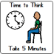
- Five minutes thinking time as required in class
- Time out of the playground to talk through choices with an adult

Learners who continue to not be ready, respectful or safe and are not sticking to the school or class charter will progress to Time to Restore and will be encouraged to reflect on their choices:
- This may take place during break or lunch time or during skills group time on a Friday and will be a chance for the child to talk through the Restorative Discussion Questions with an adult. A time to restore sheet is also available to help older children write down their thoughts and feelings around an incident.
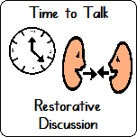
Stage 3
If a child requires 3 or more “Time To Restore” sessions in a week:

- Teacher will make a phone call home to chat things over with parents/carers.
- A further phone call from HT/DHT will be made to arrange a meeting to discuss choices and next steps if the Time to Restore sessions continue.

Stage 4
While it is always a last resort, if a child continues to display unsafe behaviour or displays serious violence, more formal involvement of parents will occur and a possible exclusion from school could take place, in accordance with council guidelines.

Please note that this is a progression of events unless the incident has seriously compromised the safety of individuals within the school.
Staff know each child well in school and will always follow the GIRFEC (Getting It Right for Every Child: https://www.gov.scot/policies/girfec/principles-and-values/) principles in school. Sometimes children will require more individualised support due to additional support needs or difficulties in other areas and this may affect the order of stages and the support in place.

Time to Restore
Name |  |  | Date
Why have you been asked to take time to restore?

In the box below, draw or write: What happened? Who else was involved?
Me
What can I do to repair the harm done?
Signed (child) |  |  |  | Date
Signed (management) |  |  |  | Date
Signed (parent) |  |  |  | Date
I now feel…
At the time I felt…
They now feel…
At the time _____ felt…

ANTI-BULLYING POLICY

Within school we work with the National approach to anti-bullying and follow the guidance as set out within the Respect me campaign.

Research and practice experience over time have led to an emerging understanding of bullying as a complex behaviour. Bullying can be understood as behaviour which leaves people feeling helpless, frightened, anxious, depressed or humiliated. Bullying behaviours may include:

name calling, teasing, putting down or threatening
ignoring, leaving out or spreading rumours
hitting, tripping, kicking
stealing and damaging belongings
sending abusive text, email or instant messages
making people feel like they are being bullied or fearful of being bullied
targeting someone because of who they are or are perceived to be

In addressing the issue of bullying we recognise that children and young people will naturally fall in and out of friendships in the course of growing up. Such difficulties, disagreements or conflicts might be relatively minor and short-lived, but at other times may lead to serious conflict requiring direct intervention to ensure resolution. At whatever level such conflict occurs it is important to distinguish it from bullying, and to ensure that all involved understand this distinction. It should also be recognised of course that unresolved conflict might, in time, lead to bullying.

The challenge that faces Scotland and therefore our school is to go beyond the acceptance that bullying exists so that:

“Every child and young person in Scotland will grow up free from bullying and will develop respectful, responsible and confident relationships with other children, young people and adults. Children and young people, and their parents or carers, will have the skills and resilience to prevent or respond to bullying. All children will expect help and know who can help them; while those adults working with them will follow a consistent and effective approach in dealing with and preventing bullying from early years onwards.”

Aims and Expectations

We want all of our children and young people to be healthy, achieving, nurtured, active, respected, responsible, included and above all safe. These are the basic requirements for our children and young people to grow, develop and become successful learners, confident individuals, effective contributors and responsible citizens. Under Curriculum for Excellence health and wellbeing, including the mental, social and emotional wellbeing of children and young people, is the responsibility of all staff within the learning community. Bullying can be a barrier to fully engaging and benefiting from Curriculum for Excellence. Bullying can also prevent children and young people from experiencing opportunities for personal development within and beyond school.
In school we will work with every child through the curriculum to support them to become well rounded individuals who are kind and respectful to all.

What will happen in school?

If a pupil/parent brings an incident to the attention of a member of staff, the member of staff will deal with it as appropriate – this may involve a restorative discussion and any harm done put right. They will follow the agreed class charter agreement and use agreed steps if necessary.
If the incident is thought to have involved bullying behaviour, it will be reported to the school SPOC (single point of contact – HT/DHT) who may record the incident on our school record keeping system SEEMiS.
Pupils who display bullying behaviour will be supported though our positive behaviour policy. We will work in partnership with families to support the child to change their behaviours. Pupils who experience and display bullying behaviours will be supported by school staff, in partnership with their parents, to find solutions. We will also work hard to ensure that children are able to get the help they need, when they need it.

Parents and children are well informed about who to contact and what to do if they are worried about their child in school.

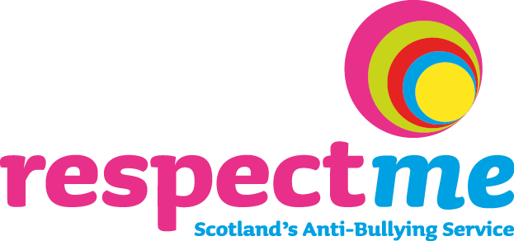

Resources

We use a number of resources to support the delivery of Health and Wellbeing in school.

‘Being Cool in School’
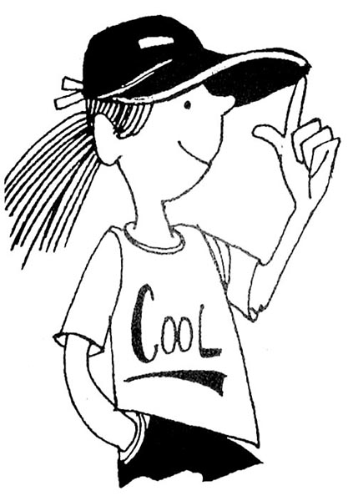
This programme produced by Fife Council Education Service aims to empower children to cope with challenging situations they are likely to encounter in their daily lives. The units explore and rehearse via discussion, reflection and role-play a range of skills and strategies that equip children to manage themselves positively.

This resource is currently being refreshed by Fife Council and will be reintroduced once this has been finalised.

Self Regulation
With some children, a self regulation approach is used to enable them to take more control over their emotions, behaviour and learning, by developing the skills which enable them to problem solve, plan, set goals and reflect.

For some of our learners this is an area of particular challenge, and can be evidenced by behaviours such as difficulty in paying attention, staying on task, tolerating frustrations, or working co-operatively. By modelling self regulation and using coaching techniques, children can be supported to gain greater control over such behaviours.

Peer Mediation
The role of peer mediators is now used in our school. Children from P6 work through a programme to enable them to develop skills in mediation. This allows children to act as facilitators to help other children with relationship difficulties come up with a solution that everyone can agree on. They act as mediators in our playground to help diffuse situations at an early stage.

The roles of Playground Mediators:

- They help to make the positive things happen more often

- They help sort out the negative things when they do happen.

- They listen and try to understand.

- They are a neutral and do not get involved in conflict themselves.

Rights Respecting Schools
As referred to earlier in this document, we are currently developing as a Rights Respecting School. Throughout the curriculum and the life of the school, we are developing children’s awareness of their rights, and respect for the rights of others. An understanding of the responsibilities associated with membership of a social community contributes to development of positive and caring relationships and behaviour, and encourages the development of positive citizenship.

Circle Time/Class Meetings
A basic building block of developing restorative practices within the school is the development of active, empathic listening. Children also need an opportunity to express their feelings, opinions and ideas in a secure setting.

Circle times and/or class meetings take place in all classes as required to help to resolve any difficulties. This involves all children taking a collective responsibility for solving problems and issues that they themselves have highlighted. The physical act of sitting in a circle emphasises unity and equality, whilst encouraging attitudes of honesty and trust.

Building up trust will help create a class where there is mutual support, where everyone listens to one another and where everyone takes turns to speak.

Clan and Depute Chieftains
The Clan Chieftains and Depute Chieftains are elected by the children at the beginning of each session to represent each Clan, (Castle, Loch, Abbey or Nevis).

Clan Chieftains and Depute Chieftains promise:

We will be role models to the children across all stages of the school, by demonstrating the school’s shared values of Creativity, Leadership, Ambition and Nurture.

We will be approachable and find ways of communicating with children in all classes in the school to find out their ideas, concerns and/or opinions on school matters.

We will represent McLean at school events, supporting the staff.

We will be involved in the decision-making process to bring about improvements in the school.

To gather the views of the children they are representing the Clan Chieftains and Depute Chieftains use a range of strategies:
- A ‘Suggestion Box’ for each Clan is placed at the Clan Wall, in the entrance foyer adjacent to the lunch hall, for children to drop notes of ideas or suggestions.
- The Clan Chieftains or Depute Chieftains meet with the Headteacher to discuss key suggestions or areas of concern.
- A weekly slot at assemblies is held to share any information with children.

HOW WILL WE ACHIEVE OUR AIMS?
Pupils, parents and staff must take collective responsibility for promoting positive behaviour in our school in order to achieve our aims.
Pupils
- Pupils should demonstrate positive behaviour by following school, shared values at all times of the school day and in all areas of the school.
- Pupils should become increasingly aware of the benefits to them and to others of following our shared values and class charter.
- Pupils should be aware of the staged interventions of not being ready, respectful or safe and why these interventions are necessary.
- Pupils who have specific targets to improve their behaviour should work hard to achieve them.

Parents
- Parents should contribute to, be aware of and support the school’s Positive Relationships and Anti-Bullying policy.
- Reinforce our shared values outwith school.
- Parents should praise their child when they receive awards for their behaviour/effort.
- Respond to and work with the school in partnership to address and resolve any difficulties that may arise.
- Trust the school to investigate any incidents fairly.

Staff
- Staff should contribute to, be fully aware of and adhere to the school’s Positive Relationships and Anti-Bullying policy.
- Staff have a responsibility to promote our shared school values at all times and throughout the school in their actions and in their expectations of behaviour from pupils.
- Teachers will establish routines for promoting positive behaviour in their classrooms and will also be consistent and fair.
- Staff have a responsibility to establish positive relationships with their pupils.
- Staff will work together as a team to support one another, share information and strategies to ensure a consistent approach to promoting positive behaviour and handling disruptive behaviour.
- Staff should keep abreast of new developments to continue to promote positive behaviour and support those children with additional needs.

Leadership (Leadership refers to leaders at all levels in the school community)
- Effective leadership is active, visible, supportive, clear and consistent in demonstrating a commitment to an inclusive, whole school approach based on a very good ethos, relationship of mutual respect, and high expectations of achievement, attainment and behaviour.
- To prioritise resources, including staff, to the greatest need, making the most effective and efficient use of the available budget.
- To actively promote inclusion and minimise the need for exclusions, recognising that exclusion is damaging to the achievement, attainment and life chances of children and their inclusion within the school and wider community, (GIRFEC).
- To support staff development, incorporating basic behaviour management, covering key areas of learner engagement, building, maintaining, repairing and restoring positive relationships, and preventing and managing difficult situations.
.

