School Travel Plan

McLean Primary School
Baldridgeburn
Dunfermline
KY12 9EE
Headteacher Mrs C Newton

Introduction

The School Travel Plan (STP) is a nationwide initiative designed to encourage the whole school community - children, parents, teachers, staff, and members of the local community - to review their current travel modes and consider changing their attitudes in how they chose to travel to and from school.

A School Travel Plan is a working document identifying aims and objectives to reduce car use and promote more sustainable transport options for the school journey. By developing a STP, schools can identify current and preferred travel modes and highlight specific travel / traffic issues pertaining to that individual school. The travel plan not only seeks solutions to specific problems, but also investigates ways of improving the journey for everyone travelling to and from school – pupils, parents, teachers and staff. The STP also aims to encourage healthier ways of travelling to and from school, specifically walking and, where appropriate, cycling.

At McLean Primary, we are hoping to improve the health and safety of children travelling to and from school. The STP also links with other initiatives we run in the school such as being an Eco School in which we are increasingly aware of how our actions impact on our environment.

Wellwood

From session 2016-2017 onwards, pupils who reside within one mile of McLean will be encouraged to follow the Route 1 Safer Route to School (as identified in appendix 2). Pupils who reside in Wellwood outside of this one mile boundary will continue to be eligible for free transport to school, although where practicable will also be encouraged to take part in the active travel initiatives described in this school travel plan.

Our School

McLean Primary School is situated in the north-west edge of Dunfermline. To the front of the main building we have a busy main road as shown in figure 1 below. We presently have 453 school pupils, of which 88 are nursery children and 42 staff. We also have a number of visitors coming and going each day. We provide a range of after school clubs in the school hall Monday to Friday (e.g. football, gymnastics, karate, fencing, mini warriors and hockey).

Figure 1 Aerial view of McLean PS

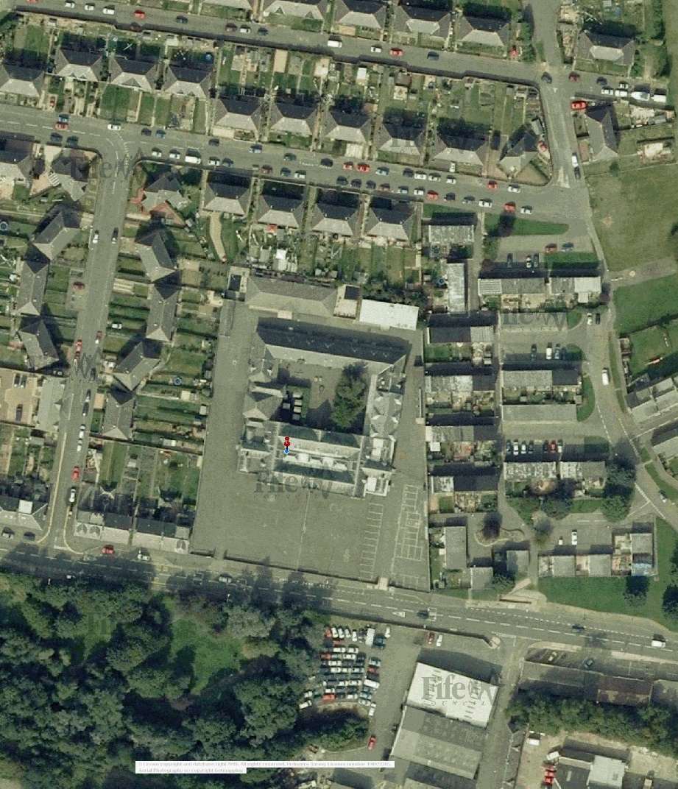
Current Situation

There are two gates at the front of our school. The main entrance is pedestrian only and used by children, parents and visitors. There are School Crossing Patrollers at the roundabout at Broomhead Flats and at the corner of Bernard Shaw Street and East Baldridge Drive. There is a pelican crossing on the east side of the school entrance. The drop off zone is used at the start and end of the day by our school bus which transports pupils who live in Wellwood. The staff entrance is beside the recently (2015) redesigned car park with 32 spaces including 2 for disabled users. This is strictly for staff and disabled users. From June 2018, our janitor stands at this gate at the beginning and end of the day to discourage parents from using the carpark unless they have a Blue Badge. Historically, staff, parents and local residents have highlighted that the entrance to the school and the drop off zone is very congested at the beginning and end of the school day, particularly because of vehicles parking. Parents are encouraged to “Park and Stride” with their children from Scott Street, Miller Road or David Millar Place instead of parking in the drop off area.

Policy and Objectives

Policy background

We are producing a School Travel Plan to improve the health and safety of children travelling to and from school. The reduction of pollution in the air surrounding the school would also be in keeping with our Eco Schools, Green Flag Status.

Aims and Objectives

At McLean Primary our School Travel Plan aims to:

- improve the safety of pupils on their journey to and from school
- reduce the number of pupils travelling to and from school by car
- reduce congestion around the school gates especially at the beginning and end of the school day
- encourage more pupils and staff to walk or cycle to and from school
- to make staff, pupils and parents aware of the health advantages of walking and cycling, including improved fitness in the pupils
- reduce pollution in the air surrounding the school
- to ensure the STP continues to be successfully integrated into the ethos of McLean Primary School.

Data Analysis
Summary from Parents’ and Pupils’ Questionnaires

198 children and 37 parents completed the survey.

For the question: “What would make your journey to and from school better?” the main issues for children were cars being absent from the school entrance (38%) and safer places to cross (38%). For parents the parking and the absence of a supervised crossing at Scott Street were the main issues

HUS survey

Below is a spreadsheet of the most recently completed Hands Up Scotland survey (HUS). This information indicates that 75% of pupils travel actively to school (walk, cycle or scooter/skate). Additionally the percentage of children travelling to school by car has been reduced by 13% to 21% from the 2014 survey.

 | McLean |  |  |  |  |  |  |  | Total Pupil Response
Year | Walk | Cycle | Scooter / Skate | Park & Stride | Driven | Bus | Taxi | Other
P1 | 29 | 3 | 8 | 0 | 15 | 1 | 0 | 0 | 335
P2 | 25 | 3 | 5 | 2 | 17 | 3 | 0 | 0
P3 | 18 | 2 | 5 | 9 | 8 | 2 | 0 | 0
P4 | 28 | 0 | 0 | 13 | 4 | 1 | 0 | 0
P5 | 20 | 0 | 2 | 8 | 11 | 3 | 0 | 0
P6 | 17 | 0 | 5 | 16 | 3 | 3 | 0 | 0
P7 | 24 | 0 | 8 | 1 | 12 | 1 | 0 | 0
Total | 161 | 8 | 33 | 49 | 70 | 14 | 0 | 0
Total as % | 48% | 2% | 10% | 15% | 21% | 4% | 0% | 0%

Issues Arising from Our School Survey

- There is a continuing problem with the congestion caused by parents dropping off/picking up children from the school site; especially parents queuing to get into the drop-off zone to the west of the gate and the two bays to the east.

- There is a continuing problem in parents dropping off children on the south side of Baldridgeburn. Cars are stopping beside the pedestrian barriers and letting children out into the live lane to run across the road through the drop off zone where cars are stopping and moving off.

- We have a few parents still choosing to use the staff car park.

- There is concern about the unsupervised crossing at Scott Street.

Possible Solutions

- Parents should be encouraged through publicity etc. to park further away from the school entrance, alleviating congestion and encouraging children to walk to school.

- School could also keep in contact with the Community Police Team, who could visit occasionally to speak to parents doing this.

- Promote benefits of walking to school

- Highlight safer routes to school

- Continue road safety education

Targets

Traffic congestion outside school gates

- Reduce the number of parents parking around the school gates.
- To promote benefits of walking and cycling to maintain the target of 80% or more of children walk at least part of the way to and from school.
- To enlist help of McLean parent partnership to raise awareness of appropriate parking areas around the school.

Safety on journey

- Promote safer routes to school by including road safety as part of the curriculum for all children
- Road safety reminders at assemblies provided by JRSO twice yearly with focused competitions
- Travel information is provided for all new pupils through the welcome pack

Cycle training

- To continue Bikeability training for all pupils in P5 and P6
- To recruit parents to assist in delivery of Bikeability training in P6.

Initiatives

We are currently involved with the following initiatives and plan to continue this to support the work of the School Travel Plan

Walk once a Week (WoW): WoW Scotland works by encouraging pupils, parents and carers actively travel (walk, cycle, scoot etc.) to school at least once a week.

Partnership working with Fife Council Asset, Transport and Environment and Fife Constabulary Road Safety Unit

Eco Schools Programme (School has renewed Green flag status at Sept 2015. This is valid for 2 years)

Health Promoting Schools (We have achieved our award and are now monitoring to ensure that we maintain the high standards)

Hands Up Scotland Survey (HUS)

Big Pedal

Active Travel Month

Bikeability Training

Bike to School Week

Moving in the right direction – update (February 2017)

Since the HUS survey we have used the WOW data to track progress in promoting active journeys to school. The data at this time shows an increase of 2% in children walking to school, an increase of 14% in children choosing to park and stride, a decrease of 12% in children being driven to school and a decrease of 2% in children taking the bus to school. (this is in comparison to last year’s updated data). The current data shows an increase in active journeys taken to school and a decrease from 34% to 9% in children being driven to school since we started our travel plan in 2014.

Moving in the right direction – update (June 2018)

Since the last update we have used the WOW data to continue to track our progress. This year, in addition to our normal daily tracking of how pupils get to school, we have also taken part in a school wide Health Week, Sustran’s Big Pedal and Fife Council’s Active Travel Passport month. All of these initiatives have raised the profile of the importance of maintaining an active lifestyle. We continue to improve our numbers of children walking to school, we have increased another 7% and now have 57% of our role reporting as walking to school. The percentage who cycle has remained at 2%, the percentage who skate or scoot has dropped to 5% but the number who park and stride has increased from 15% to 31%. Overall we have 95% of pupils who report that they come to school using some sort of active travel, 4% who are driven and 1% who take the bus.

Plans for Evaluation, Monitoring and Review

The Travel Action Group

- Collect evidence towards achievement of Action Plan Targets e.g. Walk Once a Week initiative.
- Will review the actions throughout the year and report once per term to a member of the management team.
- Every year we will continue to partake in the HUS survey, Bikeablity Training and Bike to School week. The results from these will be used in monitoring and evaluating the progress of the STP action plan.
- Update Action Plan annually and modify actions as required.
- Our Travel Plan will be incorporated into our School Improvement Plan and continued revisions that maybe made to this.

McLean Primary School Travel Action Plan session 2017-2018

Green = achieved Amber = ongoing Red = not yet begun
Issue | Solution | Who | Target | Timescale | Update - June 2018
Traffic congestion outside school gates | To promote benefits of walking and cycling to school. Through promoting WoW and celebrating success. Each month the class with the highest percentage of pupils who actively travel to school are awarded a trophy to hold for the month. Individual pupils are awarded pin badges each month for travelling actively to school. | DHT, Health and Eco Groups | Over 90% of the children are now travel to school actively. This level of success needs sustained. | Ongoing | Pupils have maintained this high level of actively coming to school.
 | Reduce the number of parents parking around the school gates by promoting WoW.  Develop appropriate signage to emphasise that the reason for parking restrictions is not to make life inconvenient for the parents but to protect children. | DHT/Health and Eco Groups  Parent Partnership | Reduce number of parents parking around the school.  Painted warning on pavement next to school carpark needs redone since resurfacing work. | Ongoing | Was advised by Council that painting is not necessary because pedestrians have right of way at gates.  Janitor now does not man a crossing patrol at the start and end of the day but stands at school car park to stop parents using the car park unless they have a blue badge.  Both gates from the carpark into the school playground now have a lock on them and only those who legitimately should have access know the code.
Safety on journey | Highlight safer routes to school. | DHT, Eco groups | Children using safer routes to school. | Ongoing
 | Road safety as part of the curriculum. | All Staff | Children manage journey to school safely. | Ongoing
 | Road safety reminders at assemblies. | DHT, Eco groups |  | Twice yearly
Cycle proficiency training | Enlist parent helper volunteers.  Re commence P5 pupil Bikeability Level 1 training.  Continue P6 pupil Bikeability Level 1 and 2 training. | DHT  P5 pupils  P6 pupils | Complete adult volunteer training.  Complete P5 pupil Bikeability Level 1 training.  Complete P6 pupil Bikeability Level 1 and 2 training.  Contact Community Police group for support with this while Mr Batchelor is seconded to another post for 6 months. | Ongoing | The police ran one session of Level 1 training for pupils but could not commit to many sessions. A longer term solution was sought by asking parents if they would be willing to undertake training themselves and then run sessions for pupils. A parent (Mr. Ferrier) has undertaken Bikeability training in May 2018 and is running a level 1 training for 15 P6 pupils in June 2018.

McLean Primary School Travel Action Plan session 2018-19
Issue | Solution | Who | Target | Timescale | Update - June 2019
Traffic congestion outside school gates | Make the travel plan better known and issue the names of the 3 streets that are designated for park and stride. | DHT | Reduce number of parents using drop off area as a car park. | October 2018
Bikeability 1 not delivered to all P5 and Level 2 to P7 | Now have a trained parent who is willing to run courses. | Mr. Ferrier and Upper DHT. | Have all P5s who want to gain Level 1, trained by end of June 2019.  Have all P7s who want to gain Level 2, trained by end of June 2019. | June 2019

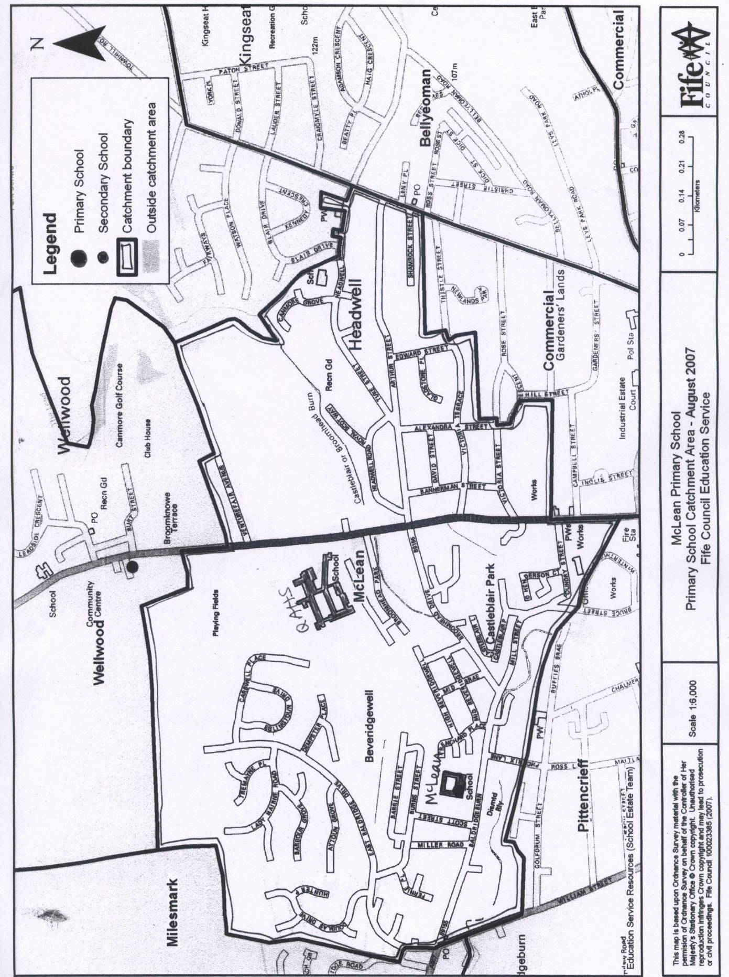
Appendix 1

Appendix 2
Designated walking routes from Wellwood to McLean Primaries
