Masterton Out of School Club
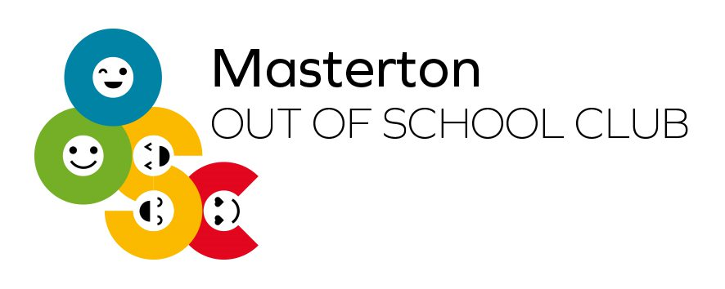
Masterton Out of School Club is one of 72 Out of School Clubs operating across Fife and is based within the main hall of Masterton Primary School. The club has experienced significant growth and is now one of the largest provisions in Fife, with capacity for up to 48 children during morning sessions and 64 children during afternoon sessions. We have access everyday to the great outdoor space we have and the gym hall, as well as the “SNUG” (Chill out area).

Prices
- Breakfast Club: £6.15
- Extended Breakfast Club: £7.25
- After School Club: £14.80
- Holiday Club (Full Day): £28.95
- Holiday Club (Half Day): £15
- Trips: £11.40 (on top of full day charge)
- Late Collections: £12.35 per 15 minutes

Sickness/Not coming to club
If your child isn’t attending club on day/s they should be can you please message the club or email in to let us know. We will update the school and teachers with changes.

Contact Details
- Manager Email: Fiona.santiago@fife.gov.uk
- Manager Phone Number: 07850213151
- Senior Email: euan.coote@fife.gov.uk
- Club Email: Masterton.oosc@fife.gov.uk
- Club Phone Number: 07860957888

