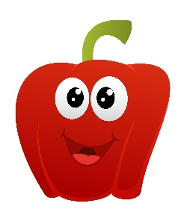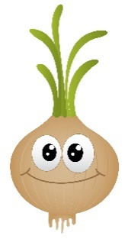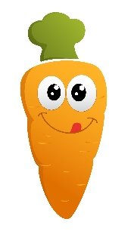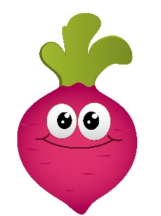
Central & West Fife Agricultural Society
Art Competition 2026

We would like you to design a picture for the cover of the Annual West Fife Show Catalogue.
Our show is not only a competitive event but also gives a snapshot of farming life in the West Fife area.
We have lots of exhibits at the show, which is held on Saturday 6th June 2026, at Easter Bucklyvie Farm, Cowdenbeath, including cows, sheep, goats, horses, tractors, machinery, dog show, tug-of-war, arts & crafts together with lots of different locally produced food & drink.
This year the theme for the competition is ‘Vegetables’
This ties in with The Royal Highland Education Trust’s annual project
(The Journey of Food - The Story of Vegetables - Royal Highland Educational Trust)
So, get your thinking caps on and pens at the ready as we’d love to see your creations.
We have 2 age categories, P1-3 & P4-7.
There will be a 1st, 2nd & 3rd prize for each age category who will all receive free admission to the show together with 1 accompanying adult.
The two 1st prize posters will be printed on the front cover of the show catalogue and will also be displayed at the show, together with the remaining prize winners’ posters.
We would also ask that ALL prize winners be available for a photo that will feature on our website, social media channels and the local press.

RULES:
*The poster must be A4 size
*The poster must be LANDSCAPE orientation
*The poster must be done in pen (preferably) / pencil
*The poster should NOT include any writing
*Primary School, Pupil Name, Class, Teacher name & e-mail address should be written on the back of the poster
CLOSING DATE: FRIDAY 22nd MAY 2026
Entries should be posted to Angela Mill, Shawsmill Farm, Cardenden, Lochgelly, Fife, KY5 0AN
Enquiries: angelam@rhet.org.uk Website: www.westfifeshow.com

