Scottish Poetry Challenge

Primary Six

Homework for Monday 2nd February

To celebrate Burns Day, we would like everyone in the school to learn one Scottish poem.

Your teacher will help you to understand the poem, but the rest is up to you! We would like you to learn your poem at home for homework and be able to recite it on Monday 2nd February.

Suggestions for learning:
- ‘Chunk it down’ – learn 1 verse at a time
- Know the meaning of the words (it gives you a clearer picture)
- Learn a little at a time and practise as often as possible

- Try to have as many people as possible listen to you

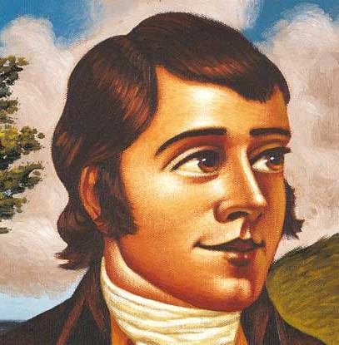

What are we looking for?

▪

People who remember their words

▪

Clear speaking

▪

Using actions for expression

▪

Having good eye contact

▪

Enjoy performing your poem

