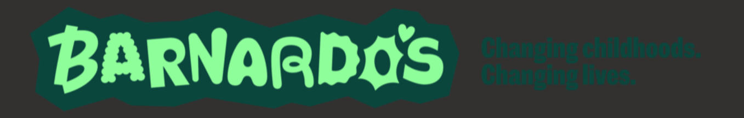

Thursday 28.9.25 Barnardo’s visited both Primary 7 classes to discuss Substance Misuse and dangers of Smoking/Vaping.

They have sent us some helpful links to share with you below:

- Barnardo’s Empowering Change (BEC) Service supports young people and families impacted by alcohol or other substance use. Further details are HERE on our Toolkit.

- Mental Health and Wellbeing Service provides 1-1 support and groupwork programmes for children/young people (and their parents/carers) aged 5-25 who are experiencing mild-moderate mental health difficulties. Please note that all requests for assistance for 1:1 support by school staff should come through the Child Wellbeing Pathway as outlined HERE but young people or parents can also self-refer to this service by emailing wellbeinginfife@barnardos.org.uk There is a waiting list at the moment.

- Children’s Rights & Advocacy Service provides rights and advocacy services for Fife children and young people who are either in foster care, kinship care, residential care, on a home-based CSO or CSO away from home. This includes advocacy for children/young people at Child Protection Planning Meetings and Children’s Hearings, as well as other work to ensure that their rights are being upheld. School staff can refer directly to the service using this form. There is currently no waiting list.

