**Accessing Microsoft Teams Through Glow**

To find the Glow website quickly, you can use Google to search for ‘glow login’:

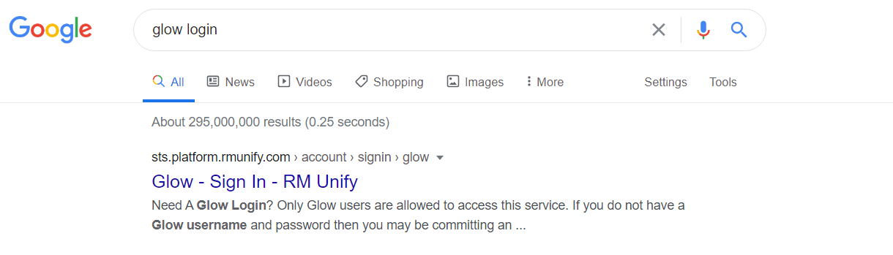

The first item in the search results should be the Glow website:

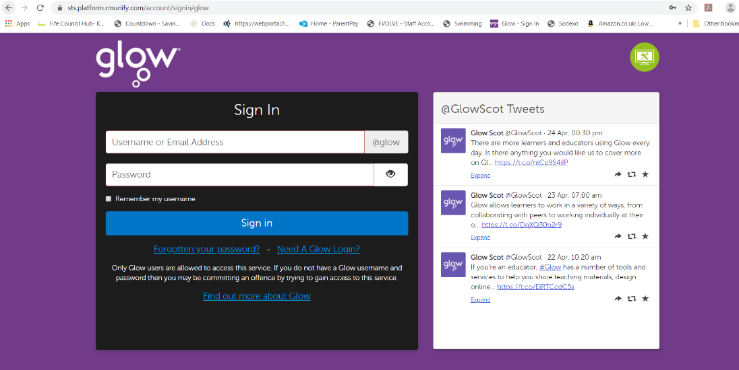

Use the username (or your GLOW email address) that I’ve sent you that begins with gw…. And the password to log in.

***If you are using a mobile or a tablet/ipad then you will need to **firstly download the Teams app** from your app store. The app is free to download.

After installation, the app will prompt you to create an account – YOU DO NOT NEED TO DO THIS as your child already has an account. Ignore this prompt and log in using the Glow EMAIL address that was given to your child. This will redirect the app to the purple screen above where you can log in to glow using the same Glow email and password supplied.

From your Launch Pad screen below, click on the **Teams tile**. If you can’t see it, you can search for it on the right-hand side of the page and add it to your launch pad.

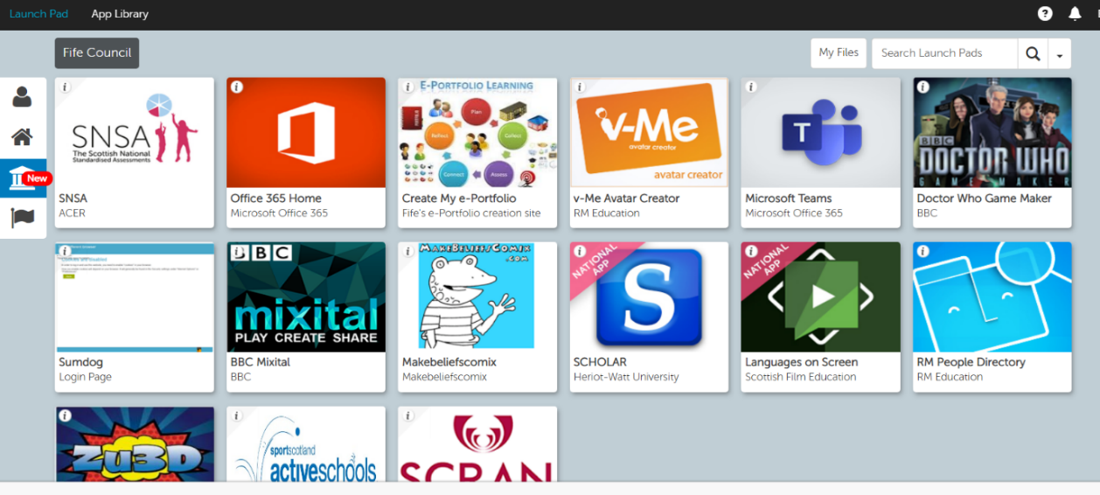

You should see this screen showing that you are part of the Primary 5/6 team. Click on the link to access the Team page:



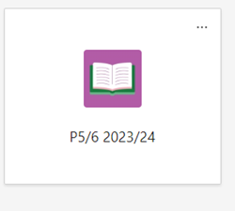

Use the ‘New Conversation’ button in the ‘Posts’ section to send me a message to let me know your favourite book so that I know that you’ve managed to log in.

