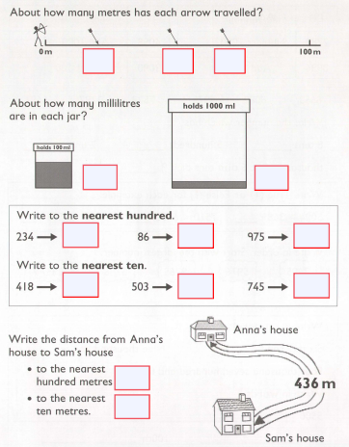

Roman Numeral Help:

Roma n numerals

