LYNBURN PS
SCHOOL TRAVEL PLAN
2023/24

REACH FOR THE STARS


AT LYNBURN

Head Teacher: Louise McIIhatton

School Address: Nith Street
Dunfermline
KY11 4LU

Telephone No: 01983 602433
Social Media/Website: Website


CONTENTS PAGE

3: 1.0 WHY HAVE A SCHOOL TRAVEL PLAN

3.: 2.0 BENEFITS OF HAVING A SCHOOL TRAVEL PLAN
4: 3.0 Current Travel Habits
3.1 Family Questionnaire Data
6: 3.2 Staff Questionnaire Data

7: 4.0 MAPPING WORK AND ROUTE AUDIT OF KEY ROUTES TO SCHOOL
4.1 Access Arrangements

8: 5.0 ACTION PLAN

9: 6.0 MONITORING AND EVALUATION

9: 7.0 DISTRIBUTION OF SCHOOL TRAVEL PLAN

10: ROUTE AUDIT REPORT

1.0 WHY HAVE A SCHOOL TRAVEL PLAN
School-related traffic congestion and the risks congestion poses to the safety of the pupils, teachers, parents, residents, and motorists in and around school locations is a significant problem in communities around Fife.
The most obvious cause of traffic congestion around our schools is vehicles, and the biggest source of those vehicles is parents’ dropping off and picking up their children from school.
Statistics highlight that 1 in 4 cars during the hours of 8:30 to 9:15 and 2:30 to 3:15 is primary school traffic.
Our annual Hands Up Survey highlights that 23%, that’s 5562 primary school children are driven to the school gate each day with a further 17% opting to Park and Stride. That is an additional 4111 pupils being driven in and around the school streets.
Fife Council’s Road and Transportation Service are working with schools in Fife to develop School Travel Plans and support Junior Road Safety Officers to develop campaigns such as Walking Buses, Park n Stride sites, Parking Pledges, available routes to school maps, delivery of Bikeability as well as looking at any engineering works that may be required to make active travel to school your first choice of travel.
2.0 BENEFITS OF HAVING A SCHOOL TRAVEL PLAN?
The benefits of encouraging active travel are clear and a school travel plan can ensure that your school has a long–term vision with aid to support Junior Road Safety Officers with delivering campaigns to;-
- Improve health and well-being by reducing harmful emissions and increasing activity levels.
- Improve safety through engineering measures and increasing road safety education.
- Improve access and opportunity by developing pupils’ skills for safe and independent travel.
- Improve the environment by reducing pollution and CO2 emissions.
- Gain school accreditations such as Fresh Air Frankie STP Awards, Active School Award Eco School Award, Cycle Friendly School Award
- Have access to additional funding and support.
All work associated with School Travel Planning has been designed to fit into the Curriculum for Excellence.

3.0 CURRENT TRAVEL HABITS

Each year all Fife schools undertake the Hands Up Survey which gives a true reflection of how pupils are travelling to school and the latest results show that 63% of pupils are actively travelling to school at Lynburn.

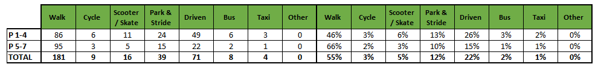

3.1 Family Questionnaire

109 families answered the school travel plan online questionnaire, and the results are detailed in the graphs and text below.

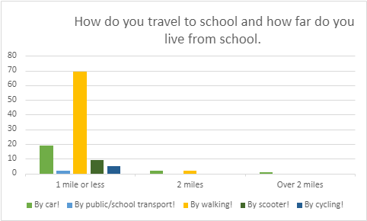

Those parents who are already actively travelling to school were asked if they would like to volunteer to help the school set up a walking bus; of the 71 parents who answered this question only 5 said yes.

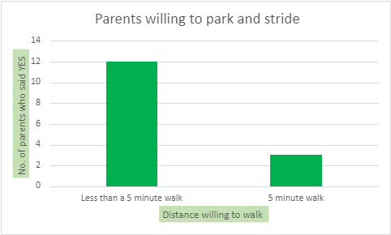
All parents who stated that they drive to school were asked if they would consider using a Park and Stride Site away from the school gate to help with congestion.

Those parents were then asked what could they do to help with safety concerns with regards to parking around the school gate?

- I park at my parents round the corner so I am not involved in any congestion
- Park away from the school
- Clear and strict parking zones to ensure parents are not parking in zones they are not supposed to. Often creating dangerous areas.
- Have a school bus
- I always park where I do not disturb other drivers or pedestrians. I am not always travelling by car and sometimes I do walk to school.
- If they park in safe places
- Park further away
- I park in a drive way away from school gates
- Should be more car park spaces around the school
- Enforce parking restrictions.
- Park with care
- Walk to school
- I don’t park near the school. I park at a relatives home nearby and walk from there
- Double yellow line
- I park a short distance away from heavy traffic then walk to the gates. Alternative travel isn't an option as I'm disabled. Sometimes my child walks home alone.
- I already park in a family members driveway 1 street away from school.
- I have osteoarthritis in my knees and while I do walk the children (2) to school I also use the car on my bad days
- Make a car park for parents to park in .
- Don’t allow parking near the school. Double yellows all the way around
- School or school van is more helpful to reduce the congestion and increase the safety
All parents were then asked if there was anything that they would like to tell us about their journey to school, only 4 parents responded.

Those who live within 1 mile.

- Does a combination of walking and cycling unless late (then we use the car). He has to walk on Kids Club days as he cannot take his bike there.
- Car to friends house then walks the rest.
- Currently using breakfast club so parking and traffic is minimal, when walking parents parking creates dangerous situations due to lack of visibility and parking places where it limits visibility.
- A zebra crossing would possibly make it safer outside school on Tweed Street entrance.

Those who live 2 miles and over.

- Need safer crossings on Tinto Place to school

3.2 Staff Questionnaire

Staff were asked about their travel to school
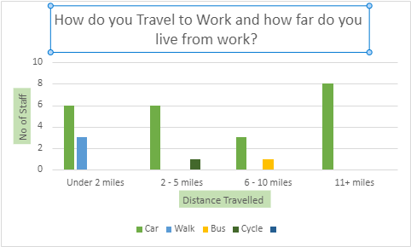

Of those staff who drove to work majority stated they parked with the school grounds.

When asked what would encourage them to consider an alternative mode of transport to work the majority stated nothing, however the following were suggested:

- A secure, covered area to store staff bikes
- Cheaper and more convenient travel
- Express bus
- Someone to collect their children after school.

4.0 MAPPING WORK AND ROUTE AUDIT

A mapping exercise was carried out within the school to identify the routes pupils travelled. These were then analysed and categorised into active travel routes as well as routes driven by parents.
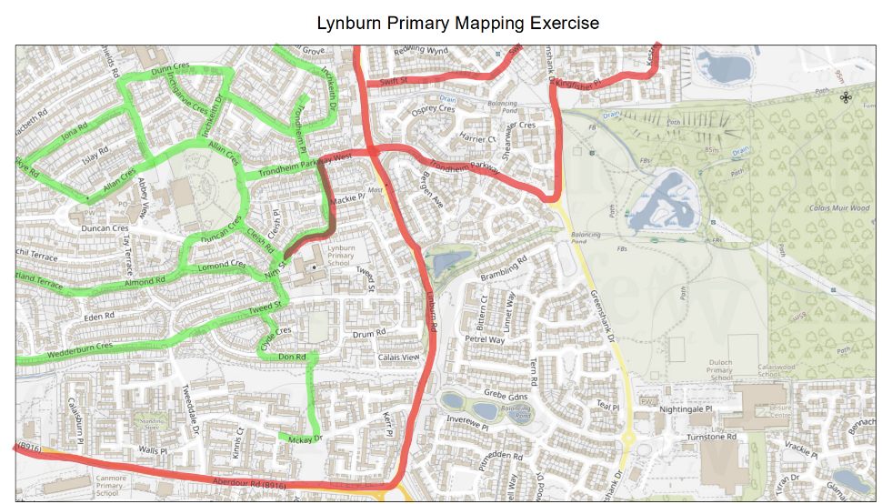

4.1 Access Arrangement

The school has 3 pedestrian entrances 1 on Nith Street, 1 on Tweed Street and 1 on Tinto Place.
The vehicular entrance to the school is via Nith Street and a parking area is currently provided for a number of vehicles.

5.0 ACTION PLAN

Action | Solution | Action Owner
Promote School Travel Plan | - Upload plan to website and social media pages  - Create a JRSO notice board or story board  - Create articles for school newsletters, social media, and assemblies,  - Keep the school travel plan team updated on all work carried out to include in the Fresh Air Frankie termly newsletter. | School
Travel Tracker | - Update the travel tracker every day | School
Local and National Campaigns | Term 1  Week 1 11th Sept Hands up Survey Active Travel  Week 2 18th Sept Cycling Competition  Week 3 25th Sept Bike Week  Week 4 2nd Oct Interschool Active Travel Challenge  International Walk to School Month  Term 2  Week 16th Nov Launch #dontparkhere Campaign  Week 2 13th Nov Parking Letter to Parents  Week 3 20th Nov Road Safety Week  Week 4 27th Nov Be Bright Be Seen Competition  Term 3  Create an active travel leaflet for the new starts that can be included in the school induction pack.  Term 4  Week 1 8th May Walk to School Week  Week 2 15th May Scoot to School Week  Week 3 22nd May Active Travel Treasure Hunt  Week 4 29th May Bike to School Week | School  School/Travel Plan Team
Reduce congestion | Develop the following:- Parking Pledge  Park N Stride Site  Walking Bus | School/Travel Plan Team
Bikeability | Set up cycling staff and deliver Bikeability | School/Bikeability Team
Awards | Work towards gaining the Fresh Air Frankie School Travel Plan and  Active Schools Award | School/Travel Plan Team

6.0 MONITORING & EVALUATION
The JRSO will continue to meet periodically to monitor progress.
Specific progress will be monitored by participation in the “Hands Up Travel Tally” each year and a repeat of the full travel survey will take place in 2026. The school’s ongoing commitment to travel planning will be publicised in the school handbook, the school newsletters, the Parent’s notice board and through assemblies.

7.0 DISTRIBUTION OF SCHOOL TRAVEL PLAN
The following bodies will receive a copy of the School Travel Plan:
• Fife Council Sustainable Transport and Travel via the Travel Plan Team
• Fife Council Education Service
• Fife Council School Estates Team
• Parent Partnership
• Active Schools
• Copies will also be made available to the parents from the School Office and via
the school information sites

.

Route Audit

1. BACKGROUND

The mapping work enabled the JRSO’s to pick out a core network of streets used to travel to school. A route audit of walking and cycling routes to the school was then carried out in November 2023. The route audit was attended by:
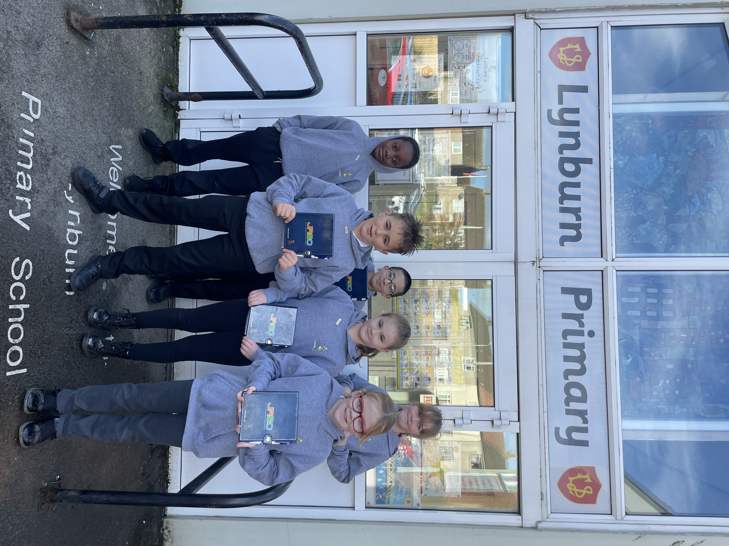
6 Pupils JRSO’s

Trudy Brown:
Fife Council Travel Plan Co-ordinator

Marta Ramage:
Fife Council Travel Co-ordinator

2. CURRENT SITUATION

There are good opportunities for parking and walking a short distance from the school. The roads around the school generally seemed to be well equipped with traffic calming measures but in places very congested with resident parking. At the time of undertaking the route audit the JRSO stated that parents parking outside the school gate caused concerns but was not a barrier to them actively travelling to school.

Any interventions named within this report should include Education, Engineering and Enforcement to improve active travel and to support a successful School Travel Plan.

Where engineering measures have been identified, these will only be implemented when the School Travel Plan has been approved and signed off.

3. CORE NETWORK
The strategic routes chosen for audit are:

Nith Street
Duncan Crescent
Eden Road
Trondhien Parkway
Tweed Street

4. AVAILABLE ROUTE AUDIT

4.1 Nith Street

Nith Street forms one of the main routes to the school, which can be busy at school times with a lot of parked vehicles. The school is accessed off Nith Street by a busy pedestrian gate and its only vehicle access.

As part of the school Traffic Management Plan pedestrians should only use the pedestrian gate and should not enter/exit the school through the vehicle gate.

JRSO stated that parents enter the school grounds despite access being restricted to staff and authorised vehicles only. These vehicles then make dangerous turning manoeuvres within the car park putting pupils at risk.

Clearer signage into the school car park or closing off the school gates each morning and afternoon would resolve this problem and ensure pupils within the area are safe.

4.2 Trondheim Parkway West
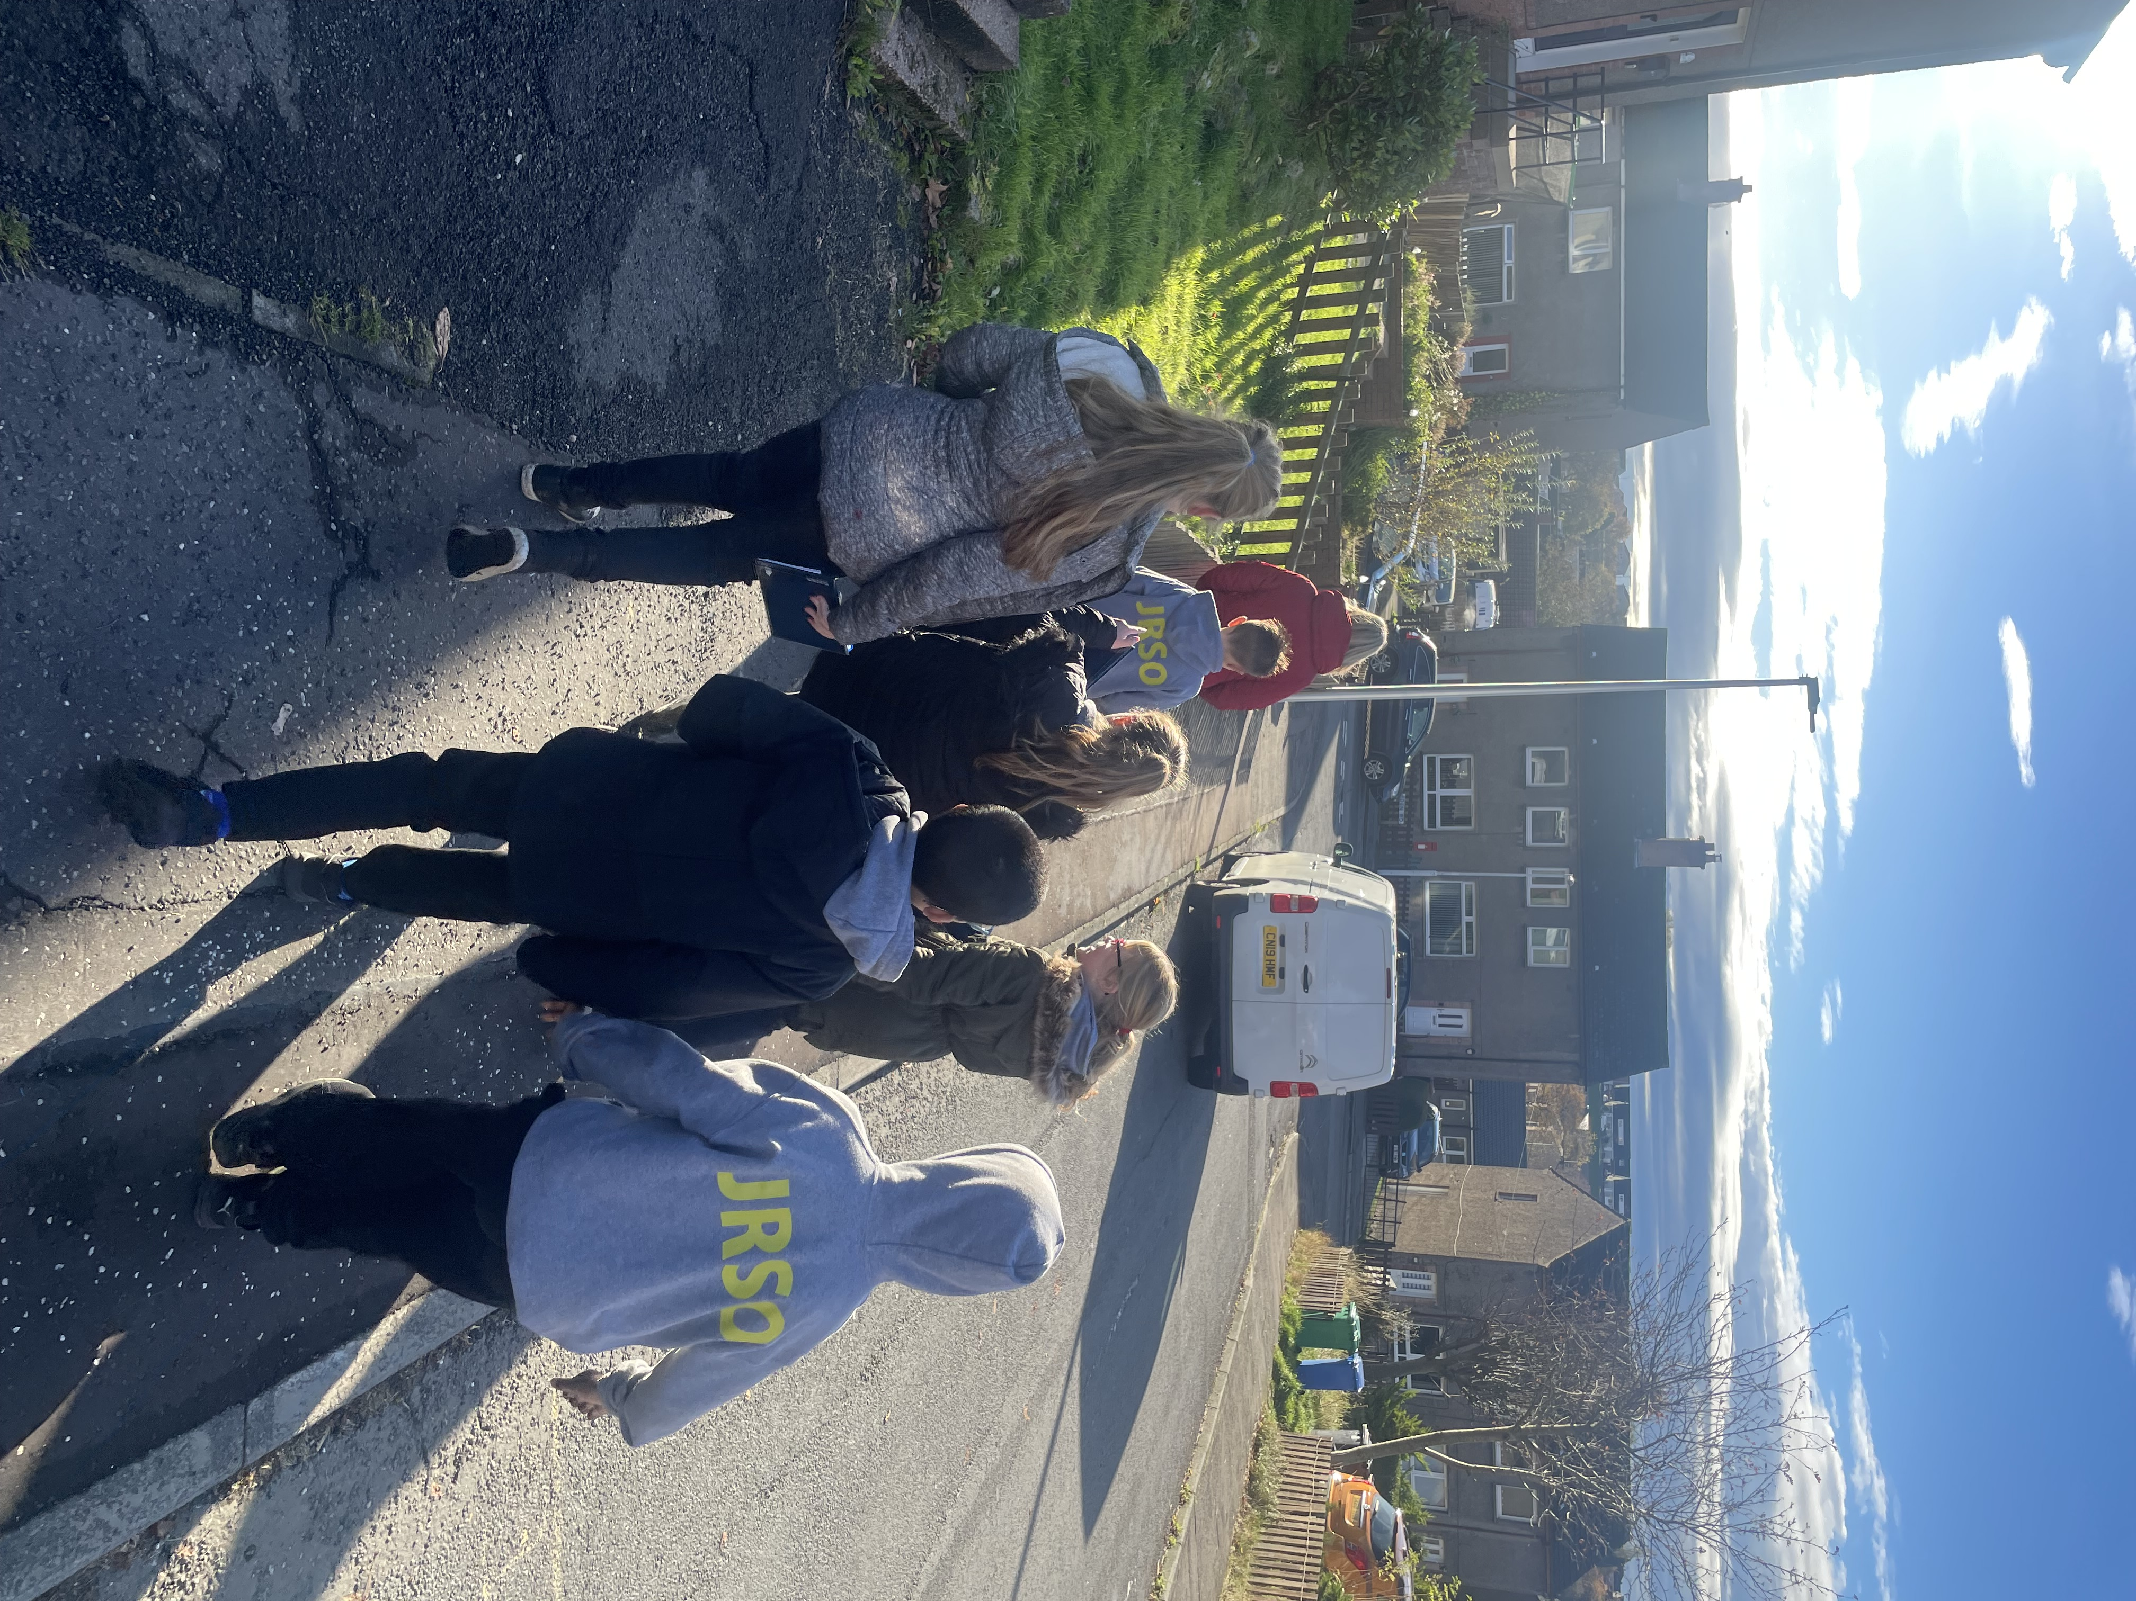
This is a busy road and forms part of the main distribution network for the residential area. A lot of development has taken place along this route, resulting in increased traffic and additional accesses to cross.

JRSO pointed out the difference in the volume and noise of traffic at this point but stated that they did not have any issues with this. They were reminded that when choosing to cross the road that the shortage way is not always the safest way and by walking a few metres further up or down the path they would find a safer place to cross.

4.3 Duncan Crescent/Allan Crescent
Alan Crescent and Duncan Crescent are both minor distributor roads within the Abbeyview area. Traffic flow can be relatively high for a residential road and these roads form a main link to the school from the north with pedestrians passing through the local park.

The traffic calming in place on Alan Crescent and Duncan Crescent is in the form of kerbside build-outs. These provide a point on the road where it is narrower to cross, traffic speeds are lower and traffic is restricted to one direction at a time as traffic has to give and take.

4.4 Tweed Street
There is a dedicated pickup/drop off point which parents tend to abuse at pick up times by parking there from around 2:45pm. This causes issues for pupils who sightlines are impaired by these parked cars.

4.5 Eden Street
There were no clear issues with Eden Street and the surrounding streets as these are within the 20 mph zone and have less traffic flow than the main distributor roads. JRSO’s were reminded that being always mindful of their surroundings.

5.0 Summary

Whilst the school have had a travel plan in place since 2008, little has changed in that time. There has been extensive work carried out in the area with regards to 20 mph zones which include adding speed bumps, raised areas for pedestrians to cross, chicanes and priority signing as well as speed restrictions. The CONGESTION areas around the school are caused by parents parking. It is suggested that the school continues to work with its school travel plan co-ordinator and safer communities’ officers to raise awareness with parents through active travel campaigns as well as road safety campaigns.


