Lochgelly South Primary School & Nursery

ELC/SCHOOL IMPROVEMENT PLAN
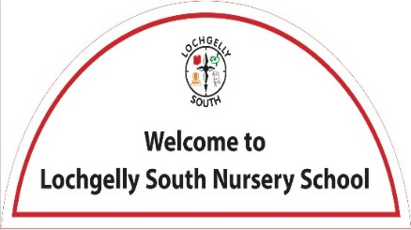
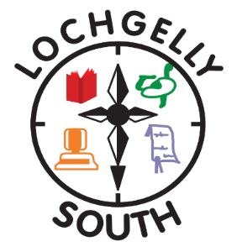
SESSION 2026-2027
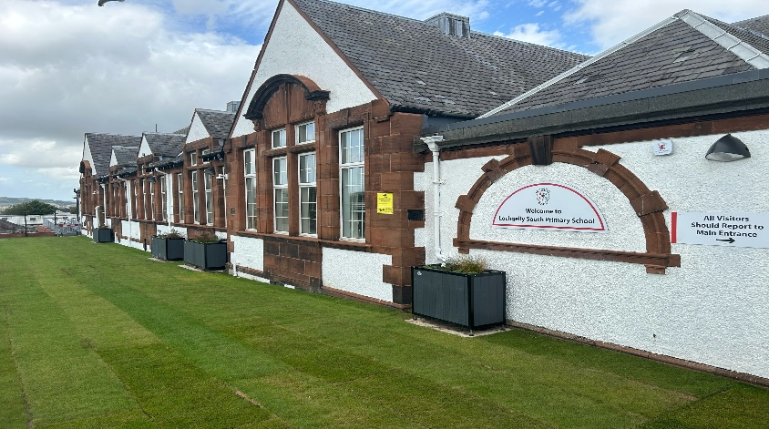

Education Directorate Improvement Plan:
Improving Learning, Teaching & Assessment

Focused Priority 1: Improving learning, teaching and assessment, with a focus on writing
A minority of children across the school are achieving expected levels in the talking, listening and reading elements of literacy, but not in writing. Indicating that writing is reducing the overall literacy attainment figures for the school. There are also a significant cohort (10%) who’s attainment in writing is not as strong as their attainment in the other elements of listening, meaning there is potential for them to go off track without interventions.
In P1, the school did not meet this year’s writing stretch target, and whole-school data confirms that lower attainment in writing is impacting overall literacy outcomes. This highlights a need for greater consistency in teaching approaches and increased targeted support, particularly in the early stages. Our BASE scores indicate a higher level of literacy potential than we are realising in writing.
External feedback further supports this focus:
- HMI identified that the quality of writing in the early years should be improved, particularly in relation to progression, independence and the overall standard of children’s written work
- Learning Partnership feedback highlighted variability in the quality of feedback, noting that it is not yet consistently supporting children to understand next steps or improve their writing over time
Taken together, this evidence highlights the need to:
- Improve the quality and consistency of writing pedagogy in the early years
- Strengthen the impact of feedback on pupil progress
- Target support effectively to close the poverty-related attainment gap

HGIOS4 Quality Indicators |  | Quality Improvement Framework
- 1.2 Leadership of Learning  - 2.3 Learning, Teaching & Assessment  - 3.2 Raising Attainment & Achievement |  |  | - Learning, Teaching and Assessment  - Playing, Learning and Development  - Leadership of Continuous Improvement  - Children’s Progress
Expected Impact | Strategic Actions Planned |  |  | Responsibilities | Measure of Success  (Triangulation of Evidence/QI Methodology) | Timescales
Attainment in writing will improve at all stages by June 2027, with P1 increasing from 72.4% to at least 80%, P4 from 70.8% to at least 78%, and P7 from 80% to at least 85%. This will ensure most learners achieve expected CfE levels.  A reduction of at least 5% in the gap between reading and writing will be evident across all stages by June 2027, demonstrating greater consistency in literacy.  Improved writing quality will be evident in at least 85% of learners by May 2027, including increased length and complexity, greater accuracy in spelling and punctuation, and clear evidence of editing and redrafting.  Consistent implementation of the agreed whole-school writing pedagogy will be achieved by December 2026. This will be evident in 100% of classes and will reduce variability in practice.  Most learners (at least 90%) will understand and act on feedback by June 2027, using the correction code consistently and demonstrating improvement between drafts.  Targeted learners, including those affected by poverty, ASN or attendance below 90%, will show accelerated progress by June 2027. At least 70% will move from off-track to on-track, with increased independence, engagement and confidence supported through digital and assistive technology.  Increased family engagement will be evident, with at least 75% of families attending one or more literacy sessions and most early level families attending two. This will strengthen support for writing at home.  Greater consistency in assessment will be achieved across the school by June 2027. All teachers will use agreed moderation processes, ensuring alignment between professional judgement and attainment data.  By June 2027, most learners will write confidently across a range of genres and purposes, demonstrating independence, appropriate challenge and clear progression over time.  Clear evidence of impact will be seen in improved jotter work and digital outputs, alongside consistent recording in Summary of Support plans, demonstrating how digital and assistive technology supports engagement, progress and achievement in writing.  Added value in ELIPS and BASE results at the end of session assessments will be evident for the majority of children.  In accordance with The Promise, care-experienced young people will receive enhanced tracking to ensure that appropriate improvement work and support is directed towards their needs, if required. | Policy  Refresh of Feedback Policy, to ensure consistency of approach across the school.  Review and update of Literacy to ensure there is clear expectations and expected approaches outlined.  Professional Learning  Use of Fife’s professional learning materials and the Writing Assessment pack, alongside the CFE benchmarks, to ensure robust assessments of children's writing and identification of next steps for learners, particularly those who are not on track. This will ensure appropriate supports can be implemented and their impact tracked.  Engage with the draft Literacy Technical Framework, with a particular focus on the writing Concepts and the Understand-Do-Know progressions. So that changes made to our writing programme/progression are informed by the Curriculum Improvement Cycle and new curriculum design.  Professional learning to allow for the development of an approach for the explicit teaching of writing.  Use of appropriate assistive technology and accessibility tools will be taught to all teachers. The use of an immersive reader is to be implemented, as appropriate, across the whole school. (see Priority 2)  Supporting Learning  Appropriate referrals to ATSS will be made for all pupils, so we are confident the correct supports are in place.  Partnership working with DLD Team to ensure we are making appropriate referrals and implementing supports for those children where DLD may be a barrier to learning and impacting writing ability.  Learning, teaching, and assessment  Implementation of the PM Writing Programme.  Review and update of the school’s Writing Progression and planning materials, to ensure that they are reflective of current practice and consistent use of the new materials.  Quality assurance and activities to ensure consistency of approach. Peer observations and jotter moderation  Enhanced support during writing lessons. All teachers to be supported during their weekly extended writing session by at least one additional adult.  A standard will be set for approaches to feedback that are more meaningful and accessible for children.  Parental Engagement  Workshop for supporting Reading and Writing at Home to be offered to all parents before Family Times. - - Book Creator | Reading and Writing at Home  All parents/carers to be invited into a shared writing experience with their child during Family Time.  Nursery  From observations, e LIPs data and Leuven’s Scale results, target individuals for early literacy intervention and support, using the ELips Toolkit, SALT Helpline, SEIC Literacy Toolkit and Communication Handbook.  Engagement with Essentials of Literacy 0-7 Tina Bruce and Jenny Spratt book as shared professional learning.  PEEP, Rhyme Time, Kodaly, and Bookbug Professional Learning, to allow the expansion of literacy-based family engagement sessions. |  |  | Lorraine Taylor (HT) and Helen Campbell (DHT)  All staff  Emma McLean (Assessment QAMSO)  All teaching staff  Lorraine Taylor (HT) and Helen Campbell (DHT)  All teaching staff  All staff – led by Elaine McDonald (SFL)  Elaine McDonald (SFL)  Teaching staff.  DLD Team to deliver  - SFL – 6 hours PL  - CTs – 4 hours PL  - PSAs- 2 hours PL  Lorraine Taylor (HT) and Helen Campbell (DHT)  All teaching staff  All teaching staff  Lorraine Taylor (HT) & Helen Campbell (DHT) to co-ordinate  Lorraine Taylor (HT)  All staff  Elaine McDonald (SFL) & Helen Campbell (DHT)  Teaching staff – during Family Time  Helen Campbell (DHT)  Rebecca Schulz (PNT)  EYOs | Data  Base line data from writing assessments  NSA data at P4 and P7  NSA data over time  Records of understanding Progress tracking application  People’s Views  Staff evaluations and feedback  Pupil Voice and Pupil Attainment Groups  Planning & Tracking Meetings  Direct Observation Classroom observations  Learning Partnership  Jotter evidence and moderation  Literacy Policy  Feedback Policy | Completed May 2026  Completed May 2026  Sept – Nov 2026  August 2026 (In-set)  September -February 2027  From September 2026, then ongoing  From September 2026, then ongoing  Throughout 2026/27 – sessions tbc  Starting August 2026  April – May 2027  Starting August 2026  Completed by May 2027  Term2 & 3 – dates tbc  From September 2026  November In-set – 13.11.26  From September 2026
Ongoing Evaluation

Education Directorate Improvement Plan:
Improving Learning, Teaching & Assessment
Equality & Equity

Focused Priority 2: Transforming Learning

In the school, initial professional learning (approximately 5 hours) has not been sufficient to embed consistent, high-quality use of digital technology in learning, teaching and assessment. Practice remains variable, and there is a need to deepen staff confidence and pedagogy. There is also a clear opportunity to extend the use of accessibility tools to support a wider range of learners and to strengthen parental engagement through digital platforms.
In the nursery, this priority is supported by recent HMIE/Care Inspectorate feedback, identifying digital technology as an area for continued development. Increased access to devices through the Transforming Learning initiative now provides a timely opportunity to build staff capacity and ensure digital technology is used purposefully to enrich play-based learning.
Overall, continued focus will support a more consistent, inclusive and high-quality approach to digital learning across the setting, improving engagement, equity and outcomes for all children.

HGIOS4 Quality Indicators |  |  | Quality Improvement Framework
1.3 Leadership of Change  2.2 Curriculum  2.3 Learning, Teaching, and Assessment  2.4 Personalised Support  3.3 Increasing creativity and employability |  | - Learning, Teaching and Assessment  - Playing, Learning and Development  - Leadership of Continuous Improvement
Expected Impact | Strategic Actions Planned |  |  | Responsibilities | Measure of Success  (Triangulation of Evidence/QI Methodology) | Timescales
Through targeted professional learning, all staff will confidently use digital tools to design engaging, interactive learning experiences by June 2027, evidenced in all classes and leading to increased pupil motivation, participation and improved outcomes across learning, teaching and assessment.  Improved access to digital technology and effective use of accessibility tools will reduce barriers to learning by June 2027. All identified learners will use appropriate supports, with at least 70% demonstrating increased independence and improved progress in writing, as evidenced in planning and Summary of Support.  Across all classes, staff will effectively personalise learning by June 2027 using a wide range of digital tools and accessibility features. This will result in increased engagement, more inclusive practice and improved progress and attainment at universal, targeted and intensive levels.  By June 2027, children at second level will use the My World of Work profiling platform to reflect on and showcase their learning. At least 90% will be able to identify their skills, achievements and next steps through their profiles.  Increased parental confidence in using digital technology to support learning will be evident by June 2027. At least 75% of families will report improved confidence, leading to greater consistency between home and school and more effective pupil use.  By June 2027, digital approaches to assessment will be embedded across all classes. This will improve the quality and timeliness of feedback, with at least most learners able to understand and act on their next steps.  Effective use of digital technology to enhance differentiation will be evident in all classes by June 2027. Learning will be appropriately challenging and accessible, with improved engagement and progress for learners requiring additional support.  Progression in transferable digital skills will be demonstrated by all children by June 2027, including creativity, collaboration, communication and problem-solving. Clear development from nursery to P7 will be evidenced through planning, observations and learner profiles.  EYOs will plan and deliver at least one meaningful digital learning experience per fortnight by June 2027. These will support creativity, problem-solving and communication through play, with progression evidenced in PLJs.  Improved practitioner confidence in using digital technology will be evident by April 2027. Higher-quality interactions and responsive planning will lead to increased engagement in digital play experiences.  By June 2027, digital technology will be used consistently and purposefully across the playroom. Each child’s PLJ will include at least one observation per term evidencing progress in digital literacy, creativity and communication.  In accordance with The Promise, care-experienced young people will receive enhanced tracking to ensure that appropriate improvement work and support is directed towards their needs, if required. | Professional Learning Activity  - All staff will engage in further targeted professional learning to develop confidence and consistency in using digital tools, software and accessibility features to enhance learning, teaching and assessment.  - Opportunities for ongoing support, collaboration and professional dialogue will be built in to embed effective digital pedagogy across the school.  Enhancing Learners’ Experiences  - Improved access to digital technology and accessibility tools will enable targeted learners to engage more independently, reducing barriers to learning, particularly in writing.  - Staff will effectively personalise learning using digital tools, ensuring inclusive practice and increased engagement for all learners at universal, targeted and intensive levels.  - All children will develop transferable digital skills, including creativity, collaboration, communication and problem-solving, with clear progression from nursery to P7.  Learning, Teaching and Assessment  - Teachers will use their digital skills to plan appropriate learning, implementing Fife’s Technology Progression Pathway at all stages. Specifically - Education professional learning - Technologies - Computing Science (Early to Second).pdf - All Documents and Education professional learning - Technologies - Digital Literacy.pdf - All Documents  - Teachers will use a range of digital tools to create and share explanations and to model learning processes.  - Teachers will plan for differentiated learning by providing access to learning materials digitally, allowing children to use the accessibility features and/or to access at their own pace.  - P6/7 Digital Leaders will support the use of technology throughout the school.  - Children at second level will use My World of Work profiling platform to reflect on and showcase their learning, identifying strengths, achievements and next steps.  Assessment and Feedback  - All staff will continue to develop skills to improve their knowledge of the digital tools available that can be used to provide instant feedback to children.  - Further development of Digital Portfolios to showcase learning over time using Showbie and My World of Work profiles.  - Staff will use digital data and assessment evidence to inform planning, track progress and target support effectively, including enhanced monitoring for care-experienced learners where appropriate.  - Care-experienced children will have enhanced monitoring and support if required.  Nursery  A programme of professional learning, visits to other nurseries and peer collaboration will help to improve staff confidence and consistency in using digital technology to support children’s learning through play opportunities and experiences. Professional Learning - Early Learning and Childcare – DigiLearn  Focus areas include:  - Digital pedagogy in early years  - Using digital tools for assessment and documentation  - Creativity and digital literacy  A robust self-evaluation will help to create an action plan for increasing and embedding the use of digital technology across the playroom. To ensure there are regular planned play experiences and opportunities that help to build digital skills and support the creative use of technology.  Our Curriculum Rationale will be further developed to ensure that this is reflective of the experiences all children are experiencing across the school in relation to the use of digital technology. |  |  | Led by ESO’s, Digital PT’s  WTA – KM – reflected in collegiate calendar  All staff  PRD Option  PSAs – additional hour  Elaine McDonald SFL – accessibility tools  SLT  All staff  Supported by NH (Transforming Learning Champion)  ATSS Team  2nd Level CTs  Helen Campbell (DHT) to lead and facilitate.  All EYOs  Helen Campbell and Rebecca Schulz (PNT) to lead EYOs  Helen Campbell (DHT) | Data  - Analysis of attainment data in Literacy, Numeracy along with all/identified areas of the curriculum  - Analysis of CFE and BASE/NSA data  - Analysis of data for identified cohorts e.g. SIMD, ASN, EAL, LAC etc.  People’s Views  - Staff views on use of digital technology to enhance learning.  - Self-evaluation (2.3) on strengths and next steps.  - Staff professional dialogue with school/cluster colleagues.  - Feedback from PL activity.  - Parent/carer views on children’s experiences.  - Children’s views gathered through class groups and pupil focus groups on the use of digital technology to support and enhance learning experiences.  - Trialing – Can WoW Profiles be used to replace Target Setting in Learning Logs?  Observations  - Forward planning documentation (school)  - Responsive planning and provocations (nursery)  - Classroom observations  - Focus for LP  - PLJs – technology focus | Ambassador Training  - 27.08.26  - 29.09.26  - 05.11.26  - 13.11.26 – In-set  - 01.12.26  - 14.01.27  - 02.02.26  - 04.03.27  - 15.04.27  - 11.05.27  - 10.06.27  PSA Professional Learning  - 10.02.27 – In-set  Teacher Professional Learning (online)  - ATSS dates tbc  - Using iPads in P1-5, 16.02.27  - Adaptive Teaching 02.03.26  Teacher Professional Learning (in person)  - Supporting Metacognition 28.09.26 or 27.01.27  - ATSS – Accessibility for Everyone & Supporting Learners with ASN – 2 session – dates tbc  Everyone Can Create – optional online sessions  - 30.09.26 - drawing  - 03.02.27 - photo  - 28.10.26 - video  - 18.11.26 - music  Family Times – showcasing learning – termly  Sharing practice sessions – twice per term, Terms 2-4  Learning Partnership – Term 3 (tbc)
Ongoing Evaluation
PEF Plan
Pupil Equity Fund allocation for session 2026/27 |  | £ 57 500.75
School Context
- School Role – 178 (7 classes)  - ELC Role – 23 (39 weeks, 9-3)  - Combined Role – 201  - SIMD Profile – 3.9 & Quintile Profile – 2.2  - FME – 42.6% (P6 & P7)  - ASN - 35%  - EAL – 5.6%  - LAC – 3.4% | 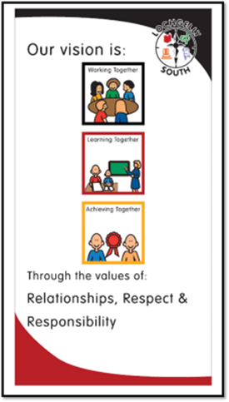  Our vision is Working Together, Learning Together and Achieving Together. Underpinning this are our values, which are Respect, Responsibility and Relationships, and our aims, which we recently (Jan 2025) aligned with the Wellbeing Indicators (Safe, Healthy, Achieving Nurtured, Active, Respected, Responsible, and Included).
Cost of the School Day (In what key ways do you plan to mitigate against Costs within the School Day)
At Lochgelly South Primary School, we understand the necessity of removing the Cost of the School Day, so poverty is less of a barrier for our young people accessing and engaging in the full programme of learning and experiences available. We examine the school day to try and ensure equity across the following areas: uniform, travel, learning, friendship and community, school trips, eating, clubs, and home learning.
To mitigate costs, we
- Make appropriate applications to access additional funding.
- Fundraise so costs are spread across the community. These are also not mandatory and are planned to avoid the costly times of the year.
- Work with local charities and businesses so we receive surplus resources for our children and families.
- Ensuring that free sanitary wear is readily available to our parents, young people, and staff.
- P6 & P7 have access to ‘Care Boxes’, so our young people have access to personal care items.
- We have a bank of underwear, uniform, and tights/socks that children can access as required.
- FairShare Thursday – provides access to heavily discounted food.
- Regular uniform, costume, Christmas jumper, and book swaps.
- Employ an Equity Calendar to ensure we are aware of costly times of the year, so we can work to support during these times.

Stakeholder engagement |  |  | Participatory Budgeting
We consult regularly with stakeholders in the following ways  - All parents/carers have the opportunity to provide feedback on improvement priority work through questionnaires, providing an opportunity for them to select the priority they feel is most important to them.  - Pupils' ongoing feedback gathered through regular pupil focus groups, pupil leadership groups, and questionnaires.  - PupilWise and ParentWise surveys.  - Parent Council discussions on a termly basis. |  |  | We do not currently use our PEF funding to support participatory budgeting, as we do not have any excess funding. However, this is something we can offer via our school fund to pupil leadership groups.
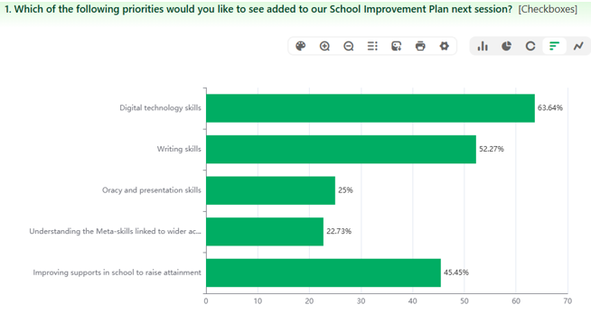
When consulted on what they would like to see PEF funding allocated to next session, parents/carers were most in favor of the following 2 options:
- Digital Technology Skills
- Writing Skills
This feedback is reflected in the School Improvement and PEF Plans, which are both closely linked.
This is reflective of our own self-evaluation and feedback from staff.
It is expected that the planned PEF intervention will also ‘improve supports in school to raise attainment’, which was also a popular priority identified by parents and within the StaffWise survey, where Support for Learning was one of the tied, top 3 priorities.
Additionally, parents and carers recognised the need to maintain the current levels of staffing, particularly the Pupil Support Staff.

Rationale  Raising Attainment in Writing |  | Amount of Fund allocated - £ 23 000  - 0.12 Probationer offer  - 0.2 CT - £1400  - 0.8 DHT – £9000 (approx.)
Reducing the poverty-related attainment gap in writing remains a key priority. Analysis shows that children in receipt of FME are less likely to be on track in writing, despite many achieving expected levels in the talking, listening and reading elements of literacy. This indicates that writing is a key barrier to overall literacy attainment.
In P1, the school did not meet this year’s writing stretch target, and whole-school data confirms that lower attainment in writing is impacting overall literacy outcomes. This highlights a need for greater consistency in teaching approaches and increased targeted support, particularly in the early stages. Our BASE scores indicate a higher level of literacy potential than we are realising in writing.
There is also a clear correlation between lower attendance and lower attainment in writing. Targeted strategies, led by the DHT, will focus on improving attendance to ensure that identified pupils have access to at least 90% of writing learning opportunities. We have clear evidence that those children with attendance below 80% are more likely to be off track with their learning. Additionally, the majority are in receipt of free school meals and are more likely to be exposed to poverty.
External feedback further supports this focus:
- HMI identified that the quality of writing in the early years should be improved, particularly in relation to progression, independence and the overall standard of children’s written work
- Learning Partnership feedback highlighted variability in the quality of feedback, noting that it is not yet consistently supporting children to understand next steps or improve their writing over time
Taken together, this evidence highlights the need to:
- Improve the quality and consistency of writing pedagogy in the early years
- Strengthen the impact of feedback on pupil progress
- Target support effectively to close the poverty-related attainment gap

Expected Impact | Interventions Planned |  | Measure of Success | Impact on children
Intervention links with School Improvement Priority 1  Increase P1 writing attainment by at least 5% from the current 72.4%, bringing outcomes more closely in line with BASE literacy performance.  Increase P2 writing attainment by 5% or more from the current 72.4%, ensuring stronger progression from early level.  Achieve agreed writing stretch targets at P1, P4 and P7, ensuring a greater proportion of learners exceed expected levels. Across the whole school, we aim to move from the majority to most learners achieving the expected level in writing.  By October, the PM Writing approach will be fully implemented across all stages, with planning showing clear progression. By December, all teachers routinely use modelling and shared writing, evidencing consistent approaches during SLT and peer observations.  By May, jotter monitoring and sampling will show that at least 85% of pupils demonstrate improved quality of writing over time, with clear evidence of acting on teacher feedback (e.g. editing, redrafting, and improving key writing skills), as validated through jotter moderation, pupil focus groups and observations.  By June, reduced P1 class sizes (15 & 17) will lead to improved attainment in writing and across the BGE, with at least 5% increase in writing attainment, and potentially numeracy too. It is anticipated that smaller class sizes will increase time for quality interactions, personalised support, improved engagement and wellbeing outcomes for the majority of learners. | Staffing & Class size  CT 0.2 FTE + 0.12 FTE probationer offer – to implement smaller P1 class sizes (15/17) through targeted staffing to maximise direct teaching time and individual feedback  Deploy staff flexibly to prioritise writing sessions and targeted groups  Early Intervention  Deliver a consistent, systematic phonics programme with PSA-supported practice  From September in P2 and January in P1, use 5 Minute Literacy Boxes daily to reinforce key writing skills (sentence structure, spelling, punctuation)  Accelerate identification and referral to SFL/ ATSS to address barriers at the earliest stage  Support:  Ensure PSA support in all writing lessons to enable focused group teaching and immediate feedback  Provide SFL team-teaching (100 mins/week) in each class, sharply focused on raising writing attainment  Increase targeted use of assistive technology (e.g. Clicker 8, speech-to-text) to support independence and reduce barriers  Tracking  Use robust baseline assessments to identify gaps and set clear targets  Implement enhanced tracking of targeted learners (DHT-led), with regular review of progress  Apply improvement methodology (e.g. fishbone analysis) to evaluate interventions and refine practice quickly  Build in regular moderation and peer observation to ensure consistent expectations and high-quality teaching  Methodology  Embed PM Writing approach consistently across all stages, with a clear progression of skills’  Prioritise high-quality modelling, shared writing and structured opportunities for independent writing  Additional adult support will ensure the provision of high-quality and timely feedback to support children in improving their writing.  Attendance  DHT to continue to rigorously monitor attendance to ensure that almost all targeted children are attending 90% of writing lessons. |  | Data  Attendance data cross-referenced with attainment. Power BI Attendance Current Session (Cumulative) + AAE Current Session.  In-house monitoring tracking alongside attainment data Tracking and attainment data – particularly attainment over time in literacy.  Views  Pupil, staff and parent feedback  Staff self-evaluation – SQR  Professional dialogue  Direct observations  Peer observations of writing lessons  Learning Partnership evidence.  Observations of the children in writing lessons  Jotter monitoring and moderation  Use of new documentation and materials

Pupil Equity Financial Plan Session 2026-2027
All costings are based on projections from April 2026 – August 2027
