



September 2025

Dear Parents and Carers,

Welcome back to nursery for Term 1 of the 2025-26 session. We are delighted to welcome all returning children and new children into nursery! We hope you find all of our news updates below and important dates for your diary for the remainder of Term 1 and beginning of Term 2!

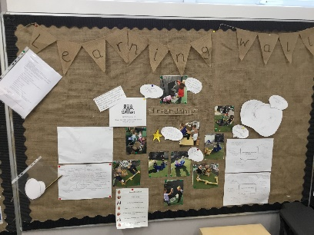

**Learning Wall and Floor Book**

Children and staff have been adding to a new Learning Wall all about friendships and relationships. They have been working on building positive friendships, sharing friendship stories and discussing how to be a good friend.

Be sure to visit our Learning Wall when you visit next and ask your child to tell you about our learning.

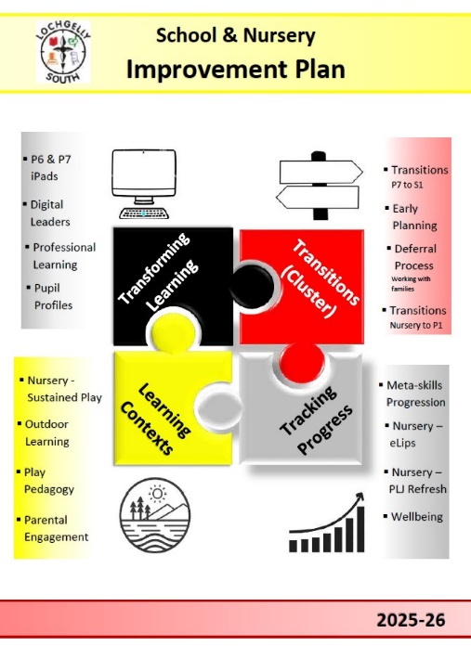

**Nursery and School Improvement Plan 2025-26**

Following consultation with families at the end of last term, our Nursery Improvement Priorities for this session are:

* **Transitions (cluster priority)** - Transitions from Nursery to P1 and into Nursery, early planning and working with families where deferral may be appropriate.
* **Learning Contexts** - Outdoor Learning, Play Pedagogy, Parental Engagement and sustained play in Nursery.
* **Tracking Progress** - Nursery eLips, Nursery PLJ refresh and tracking wellbeing.

We have started to track our journey to improvement through a display in nursery, adding children’s views of what it means to them along the way. More information and consultation on transitions, learning contexts and tracking progress will be shared with families over the course of the school year.

The School and Nursery Improvement Plan can be viewed on our website, alongside our PEF Plan for 2025/26. Our final draft of our School Improvement Plan and Standards and Quality Report will also be shared with families before the end of the term.

**Parent and Home Communication**

Your child’s keyworker will be in touch, if they haven’t already, to arrange your first parent chat of the new year. For our new children, this is an important part of your child’s transition into nursery, providing an opportunity for staff to share more about your child’s learning, how they’ve settled into nursery and for families to share their views. For our returning children, this is a good opportunity for staff to share more about your child’s learning and progress within nursery.

Chats should take place before the end of term. However, we have an open-door policy and welcome parents/carers into nursery anytime. We especially enjoyed welcoming parents/carers in for the first Stay and Play session this term. Our second Stay and Play session is coming up on **Tuesday 30th September from 2.15pm**.

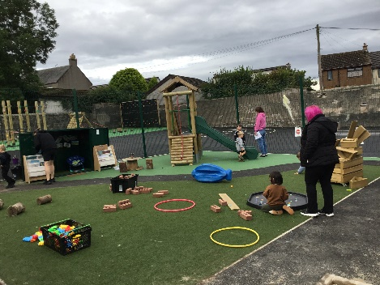

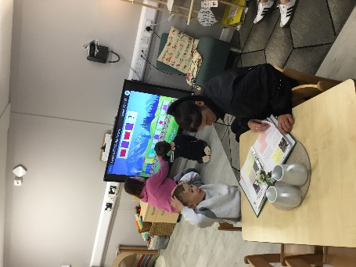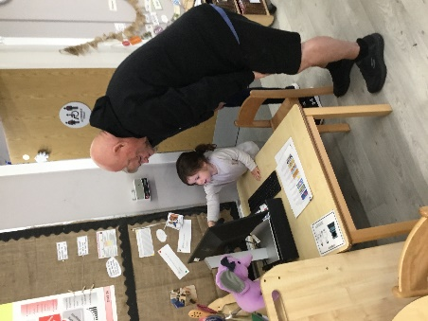

**Seesaw**

Seesaw is our main form of communication with parents and carers. We will share photos of your child and any relevant information about upcoming events. Please share your child’s journal with them and discuss their learning in nursery.

**MacMillan Coffee Morning**

We are pleased to be holding our annual MacMillan Coffee Morning event, hosted by Primary 5 in the main hall on **Thursday 9th October,** from **9.15am.** This event is open to children, families and the wider community. Pupils and their visitors will be asked to donate 50p per child and £1 per adult, which will entitle them to entry to the main hall for a drink and biscuit. There will also be a selection of cakes and candy on sale, as well as table games for pupils.

**All donations for the cake stall, shop-bought or home-baked goods, would be gratefully received the day before or the morning of the event.**

A letter will be shared in due course, detailing visiting times for classes and nursery children, and further information about the arrangements for the morning. We hope you can join us!

**Outdoor Clothes**

As we wave goodbye to the summer weather and welcome the cooler, wetter seasons, we ask parents/carers to ensure their child has a pair of wellies and an outdoor suit at nursery for the garden. Children will continue to use the nursery garden through all-weather types, as long as they have appropriate footwear and clothing. We keep a small supply of outdoor wear in nursery for children to use if required. We can also source suitable outdoor items from the “**Big Hoose**” as and when it is available, please contact a member of staff if you would like anything in a particular size. The “Big Hoose” clipboard and order form is also kept at reception if you would prefer to make a note there.

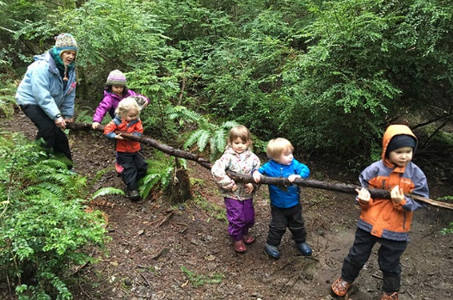**Woods Visits**

Children will visit the local woods again this term. We aim to provide frequent and regular opportunities for children to explore and learn outdoors as part of our core curriculum in Fife. This includes the woods once a fortnight and the beach on a termly basis.

The woods have been carefully risk assessed to ensure they are safe spaces with lots of opportunities for exploration and fun. More information on your child’s woods visit dates will be shared in the coming week. As always, we welcome parents/carers to join us on our visits. Please let a member of staff know if you are interested in volunteering.

**Snacks and Lunch in Nursery**

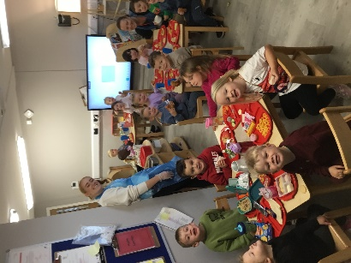Lunches continue to be provided for all nursery children free of charge. We are pleased to share that lunches are now being served in the playroom, previously this happened in the school lunch hall. The move into the playroom has been a success, reducing the number of transitions our children experience during the day. The lunchtime experience is calm and enjoyable, with children demonstrating independence and self-serving their food and drinks.

Children are also provided with a healthy snack each morning and afternoon in the snack area. Children can enjoy milk, fruit, crackers, toast or cereal.

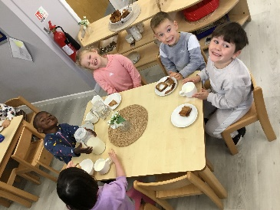

Fruit, water and milk are available throughout the day. Allergies and intolerances have been discussed during enrolment and transition, however, if your child has any changes or develop allergies or food intolerances, please speak to your child’s key worker.



**Dates for your diary**

**Monday 22nd September** ~ Tempest School Photographer

**Tuesday 30th September** ~ Stay & Play from 2.15pm

**Thursday 2nd & Friday 3rd October** ~ Nursery Woods Visits (details to follow)

**Thursday 9th October** ~ MacMillan Coffee Morning, from 9.30am

**Friday 10th October** ~ End of Term 1

**Monday 13th – Friday 24th October** ~ October Holidays

**Monday 27th October** ~ Start of Term 2

Please do not hesitate to speak to staff if you have any concerns about your child.

Kind regards,

The Nursery Team