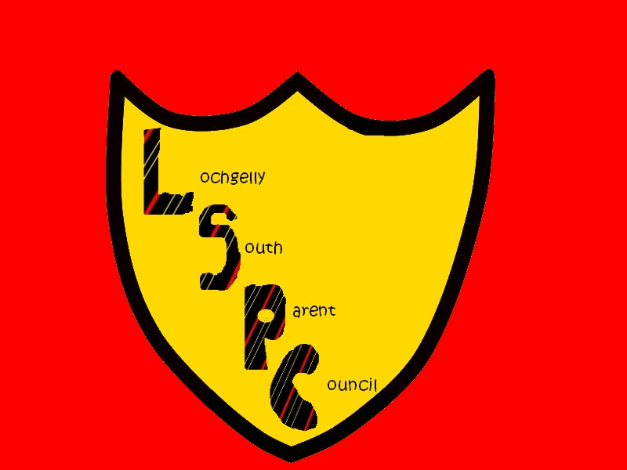


LOCHGELLY SOUTH PRIMARY & NURSERY SCHOOL
High Street,
Lochgelly,
Fife
KY5 9LW

E-mail : lochgellysouthps.enquiries@fife.gov.uk
Headteacher: Mrs Lorraine Taylor

Parent Council Minutes – 01.02.24

In attendance: Mrs Taylor, Mrs Campbell, Kerry Johnstone, Ashley Foy,

Apologies: Mr Jones, Debbie Paterson, Louise Parker, Kelly Smith, Jo Hood.

Big thank you for your help with the Christmas Fayre, it was a huge success and raised £1060.

Welcome

Decant Update – still on track. A gentle reminder has been sent out regarding safety at drop off and pick up. Bus conduct letters have been introduced regarding pupil behaviour on buses. A building services letter with an update will be coming out in the coming weeks. Currently looking at items for the interior of the building.

PEF & School Budget
There is a healthy carry forward in the school budget, allowing us to spend this on return to Lochgelly South. PEF is also partially funding a DHT post.
Wellbeing packs – looking to introduce these through PEF funding, e.g. Gratitude Journal and Diary of a Brilliant Kid, tissues, mindful colouring, chocolate/snack bars.
Other mental health support in school – Mrs Steel’s Time to Talk Groups at lunchtimes, enhanced transition groups for S1 (Sports and Resilience with Active Schools), Together We Can groups (through Active Schools), P6/7 girls and boys and Seasons for Growth with Mrs Campbell and Mrs Lawson.

Upcoming Events
Upcoming events have been shared in the January/February Newsletter. Planning for the Easter Service on 27th March is under way, with the hope for this to happen at St Serf’s Church in Lochgelly with bus transportation being to be confirmed. Sports Day planning is also ongoing for Friday 24th May. The Summer Fayre will be at the end of May. Communication about all of these events will come out to parents/carers nearer the time.

Parent Council Budget Update
A third of the P7 Leavers Hoodies is to come out of the budget, approximately £160.

AOCB
It was suggested that a flyer to hand out at Parents/Carers Nights to explain a bit more about the Parent Council, what is involved and how often we meet, to encourage new members.

Date of Next Meetings
Thursday 16th May – time and venue tbc
Thank you to all in attendance.
As always, all welcome.

