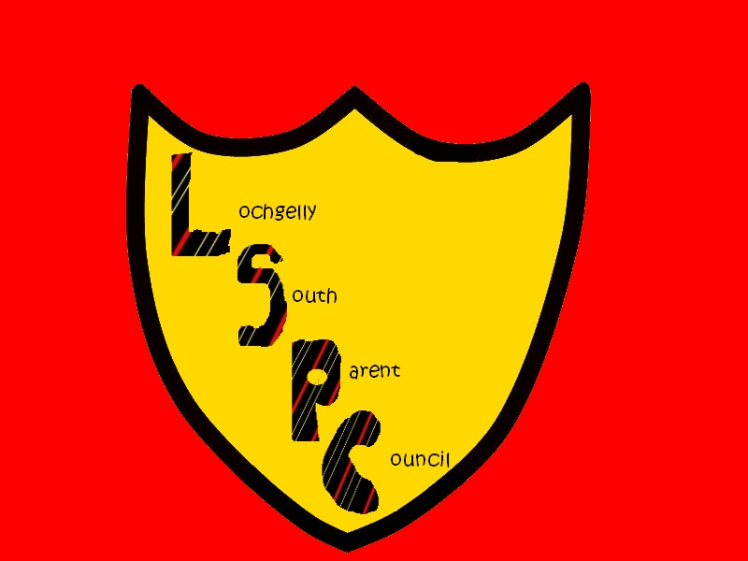
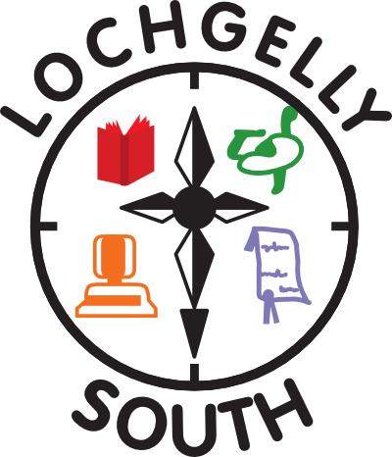

LOCHGELLY SOUTH PRIMARY & NURSERY SCHOOL
High Street,
Lochgelly,
Fife
KY5 9LW

E-mail : lochgellysouthps.enquiries@fife.gov.uk
Headteacher: Mrs Lorraine Taylor

Parent Council Minutes – 01.10.24

In attendance: Mrs Taylor, Mrs Campbell, Debbie Paterson, Jo Hood , Jodie Salmond, Tracy Hughes & Steven Tervit,

Apologies: Mr Jones, Louise Telford, Kerry Johnson, Kelly Smith

Welcome back - decant went smoothly and the school has benefitted from a number of improvements, including – MUGA, library, conference Room, Nurture Space and Multi-purpose Room

School Improvement Plan
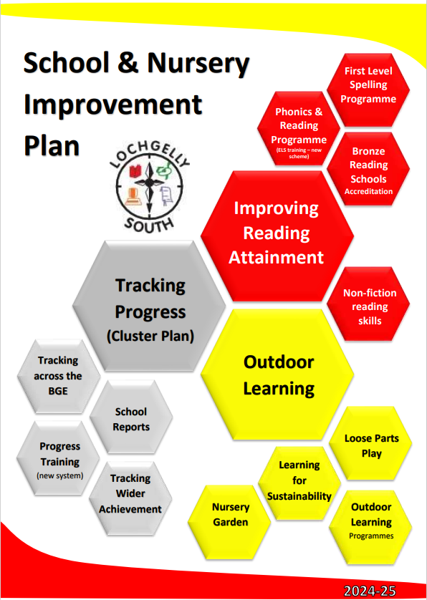
School Improvement Plan is well on track.

Currently undertaking training for implementation of new reading scheme. Letter for parents to follow.

Focus on Outdoor Learning will mainly begin after Christmas.

Progress is a new computer programme to track pupil progress, this will be introduced from November, although, most parents won’t be aware of the change until the formal reports come out in June 2025. Staff are currently involved in training.

Pupil Equity Funding (PEF) :

This is Scottish Government funding, allocated to tackle the poverty related attainment gap
Amount £57 575
- Pupil Support Assistants (approx. 38 hours per week) - £31 542 . Allocation based on consultation, with almost all parents opting to direct funding towards maintaining the level of adult support in school.
- Raising Attainment Teacher (2 days) - £25000
- Probationer contribution £2000
- Raising Attainment DHT (0.8 days) – £8000, deficit from PT to DHT
    - Costing subject to pay awards
    - £9000 deficit from other budgets
    - Staffing costs appear higher than actual salaries due to onboarding costs (pension contributions, holiday pay etc)

School Update

Ongoing work with the Cottage Centre & amazon to tackle poverty.
Destination Judo tasters.
Babcock science workshops

Applications are in for the school for funding :
- Exxon, £2000 - Science Workshops
- Community council £1400 - – Fair Share set up

Upcoming Dates

Halloween Disco - Wednesday 30th
P1-4 5-6pm
P5-7 6.15 – 7.30pm
Parent Council to organise snack bags, balloon arch
School to organise photo booth, music, decorations & dooking for apples etc

Christmas Coffee Morning – DTBC
Panto – Dick Whittington – Friday 13th Dec, Lochgelly centre - £5 per head

PTA Update
Asda rewards £177
Community council – you decide Lochgelly- we got £800 into the PTA funds
PTA are looking at other fundraising ideas.

Parent Council Budget
Current £1766.46

Outgoings
£250 for PE equipment lost in the move

Potential Outgoings
Hoodies for 2025 Leavers , £200 approx.

Income
£800 – gardening & outdoor play equipment

Date of Next Meetings

We are keen to have full representation of parents from all stages across the school. New members always welcome.

Tuesday 12th November 4pm
Thursday 30th January – 4.30pm
Thursday 15th May – 4.30pm

Thank you to all in attendance.

Minute taker: Jo Hood

