March 2026

Positive Relationships and Behaviour Policy

Lochgelly West Primary School


Caring, Ambitious, Respectful Learners
Lochgelly West Primary School
Positive Behaviour and Relationships Policy

Introduction and Rationale

At Lochgelly West we believe that every child should have the opportunity to thrive. This policy has been created to support a positive ethos across the school community so that effective learning, teaching and assessment can take place. We encourage all children to make the right choices and to respect the right to learn of everyone in the school community. We all have a responsibility to manage and support the behaviour around the school in a positive way.

At the heart of the positive behaviour we see at Lochgelly West are the positive relationships across the school. To achieve this, we must ensure that there is a consistency of approaches across the school from all members of staff. Our approaches should be positive, supportive and clearly underpinned by our agreed school values of Caring, Ambitious, Respectful, Learners – helping all at Lochgelly West aim to ‘Shine Bright’.

Aim of policy

- To highlight the importance of high-quality relationships to support learning.
- To ensure that all children are able to learn in a safe and caring environment.
- To promote a positive attitude to learning across the school.
- To support children when they make mistakes.
- To ensure all staff and pupils recognise that behaviour is a form of communication.
- To create clear guidelines for everyone in the Lochgelly West community.
- To apply a consistent and calm approach at all times, guided by the principles of nurture, de-escalation and trauma informed practice.
- To ensure that restorative approaches are embedded practice.

Setting the context

Our school community consists of 175 pupils across seven classes and a term-time nursery. We serve an area within SIMD 3, with [insert %] of pupils in receipt of free school meals, and 39% of children identified as having additional support needs. Our vision, Shine Bright, and our values of being caring, ambitious and respectful learners are embedded across all aspects of school life and underpin our approach to behaviour and relationships. We are committed to fostering a nurturing environment where every child is supported to succeed, recognising the importance of positive relationships and the role of trusted adults in helping each child to thrive.

Contents

1. Approaches at Lochgelly West

1.2 Nurture Approach
1.3 Restorative Approach
1.4 Decider Skills

2. Visible Consistencies

2.1 Class Charter
2.2 Relentless Routines and Expectations
2.3 Calm Corner and Learning Environment
2.4 Scripting

3. Positive Recognition and Celebration

3.1 VIP Certificates and Meta-Skills Awards
3.2 Merit System
  - House System
3.4 Other Celebrating Successes

4. Communication

4.1 Regular Teacher – Parent Dialogue
4.2 Inappropriate Language

5. Anti-Bullying

6. Additional and Intensive Support

6.1 PAMPS
6.2 Outreach

Appendix 1
Appendix 2

- Approaches at Lochgelly West

1.2 Nurture Approach

At Lochgelly West, nurture is embedded within our whole-school culture and is available to all. Through our nurturing approaches, we actively promote a strong sense of belonging, self-worth and connection - enabling children to build positive, trusting relationships across the school community.
We recognise that children who feel safe, valued, and regulated are more able to learn effectively. When children are emotionally supported, they are better equipped to focus, manage impulses, and participate fully in learning. Creating these conditions is a shared responsibility, and all staff play a role in nurturing the wellbeing of every child.
By adopting a nurturing approach, we remain curious and responsive to behaviour. We know that behaviour is communication. We seek to understand the underlying needs that may be driving behaviour and consider appropriate support where needed, ensuring that every child is given the opportunity to thrive. Our understanding and use of Trauma Informed approaches enhances this further.
Examples of nurture support available in our school:
Universal Support | - Breakfast in Class  - Playground Leaders  - Sensory Resources  - Class Visual Timetable  - Whole School Scripting – Stop and Think  - Fix it Folders  - Emotion Works  - Calm Corners  - Rupture, Repair, Reconnect  - Family Volunteers  - Active Schools
Additional Support | - Breakfast Check in Group  - Personalised Visual Timetables  - Emotional Check Ins – 1:1 / small groups  - Interventions in Crystal Room (nurture hub)  - Rainbow Room – break/lunch clubs  - Daily Decompression and Mindfulness Group  - Kit Bag  - Mindfulness  - Decider Skills  - Tapping  - TEACCH Stations  - Wellbeing Webs  - PCPs – Pupil Centered Plans
Intensive Support | - Seasons for Growth (Pupil)  - DAPL counselling service  - Family Health and Wellbeing Group  - PAMPs – pro-active management plans  - 5-Point Scale/Fizz Scale  - Leuven Scale – Wellbeing  - Family Bereavement Counsellor  - Barnardos  - 1:1 Support  - Daring Ventures Trained Staff  - Primary Mental Health Worker Trained Staff

1.3 Restorative Approach

Restorative approaches are a way of repairing relationships when harm has been caused.

There are two main aims of restorative practice:

- To proactively build healthy relationships and prevent challenging behaviour and conflicts
- To reactively address conflict or wrongdoing

Restorative approaches aim to work with people rather than doing things to or for them and is built on values which separate the person from the behaviour. They promote accountability and seek to repair any harm caused in a situation.

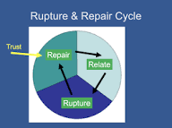
A restorative approach may involve having a restorative conversation. Staff and senior pupils will use our ‘Fix It Folders’ to support these conversations, providing a structure and visual prompt as needed. Restorative language and questions are used to allow children to understand the impact of their behaviours.

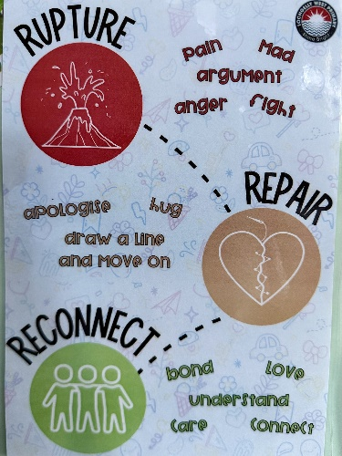
Our restorative approach goes hand in hand with our understanding of the Rupture and Repair Cycle (Zeedyk, 2005). We know that ruptures are inevitable, but it is through both the repair and reconnect stage where trust is formed, relationships are strengthened and learning takes place.

See Appendix 1 for further reading.

1.4 Decider Skills
At Lochgelly West, we use the Decider Skills approach to support children’s emotional wellbeing, positive behaviour and healthy relationships. Decider Skills provide children with practical, easy-to-remember strategies to help them understand and manage their thoughts, feelings and actions.

By learning and regularly practising these skills, children develop greater self-awareness and emotional regulation. They are better able to pause, reflect and make positive choices, even in challenging situations. This supports them to build resilience, reduce anxiety, manage conflict calmly and maintain respectful relationships with others. Each class is developing their own ‘Fizz Scale’ to support with this, similar to a 5-Point Scale.
The Decider Skills approach gives children a shared language for talking about emotions and behaviour. It empowers them to take responsibility for their actions, strengthens their confidence, and promotes independence. Over time, this contributes to a safe, supportive and inclusive school community where everyone can learn and thrive.

- Visible Consistencies

2.1 Class Charter

We are in the early stages of developing Class Charters for every classroom and are working towards having all classes with a Class Charter, which is created at the start of the school year and is linked to the articles of the UNCRC. Children should agree on the actions they will take as ‘rights holders’ and adults take as ‘duty bearers’ to ensure that their rights are realised and respected. Children should demonstrate their agreement to their Class Charter by signing their name or adding images to represent themselves. Class Charters are working documents which should be referenced frequently and reviewed regularly. Class Charters make rights real and provide a framework for a positive environment where rights are respected, protected and promoted.

2.2 Relentless Routines and Expectations

Consistent, well-established routines are fundamental to creating a calm, purposeful and safe learning environment. At Lochgelly West, we prioritise clear and predictable routines because they provide children with structure, security and clarity about expectations. When routines are taught explicitly and reinforced consistently, children know what to do, how to do it and what is expected of them throughout the school day. In our school:

- Children line up quietly and in an orderly fashion at designated areas.
- Staff greet pupils on time, warmly and set the tone for a calm transition into school.
- Children walk quietly in corridors.
- All staff model, reinforce and recognise calm, respectful movement throughout the building.
- Staff lead the children at transitions, praising respectful and caring interactions.
- Movement around the school is purposeful.
- Children should use the toilet during break times where possible. If needed during class, one child at a time should go.
- P7 Prefects reinforce expectations by role modelling and providing reminders when carrying out duties.

2.3 Calm Corner and Learning Environment

Every classroom has a Calm Corner for children to access as required, to help them self-regulate and manage overwhelming emotions. They are safe spaces, equipped with sensory tools to help children process their feelings so that they can regain control and rejoin learning when ready.

The CIRCLE framework is embedded across the school to help get it right for every child, and all staff use the audit tool to carefully set up learning spaces. The physical environment is vital in meeting children’s needs and supporting positive behaviour. Learning spaces at Lochgelly West should:
- Be calm, welcoming and well organised, creating a space where children feel safe and ready to learn.
- Provide clear visual structure, including labelled resources, visual timetables and consistent classroom layouts.
- Minimise sensory overload, with careful consideration given to noise levels, lighting, displays and clutter.
- Include quiet or low-stimulation areas (Calm Corner) to support regulation and emotional wellbeing.
- Ensure resources are accessible and inclusive, enabling all children to work independently and confidently.
- Display positive and inclusive imagery, reflecting diversity and promoting a sense of belonging.
- Offer flexible seating and workspace options to meet a range of learning and sensory needs.
- Use signage and prompts that reinforce routines, expectations and supportive language.

2.4 Scripting

We use the ‘Stop and Think’ script throughout the school to support individual children to co-regulate when needed. This script is a reminder to children of the following techniques:

- S - Stop: Halt whatever you are doing or about to do at the moment you notice a strong emotion or impulsive urge.
- T - Take a breath: Take a few slow, deep breaths to anchor yourself in the present moment and calm your nervous system.
- O - Observe: Notice what is happening internally (thoughts, emotions, body sensations) and externally in your environment without judgment.
- P - Proceed mindfully: From this place of awareness and relative calm, choose a course of action that is intentional and aligns with your values, rather than reacting on autopilot.

When supporting children who are dysregulated, it is important for staff to remain deliberately calm, modelling each step for the child. Calm should be seen in facial expressions, through open and slow body language, and using a quiet and composed voice. If needed, staff should swap with other colleagues to support.

Language is very important when supporting co-regulation and supporting children to name and recognise their emotions helps to alleviate the feelings inside them. We should help name the emotion.

See Appendix 2 for further scripting.

- Positive Recognition and Celebration

3.1 VIP Certificates and Meta-Skills Awards

Each week, we hold two whole school Assemblies. In the first, we introduce a ‘Value of the Week’, ‘Meta-Skill of the Week’ and ‘Wellbeing Indicator of the Week’ - discussing with children what these look like and feel like, sharing examples. In the second, we award certificates for children who have exemplified our school value or metaskill of the week. The weekly focus for our 4 school values and 12 MetaSkills are rotated, and class teachers choose a child from their class to receive each certificate. Their photos are taken and shared with our wider school community on social media to further celebrate their success.

3.2 Merit System

Each child has a Values Recognition Record held within class and when a child exemplifies any of our school values, they can be given a stamp in their records by any member of staff, working through their Bronze, Silver, Gold and Platinum Award. They need 12 stamps to achieve an Award. We hold termly Values Assemblies where certificates are awarded to children who have achieved their Awards.

  - House System

We have four houses in Lochgelly West; Rubies, Ambers, Emeralds and Sapphires. Children have the opportunity to earn house points at any point for showing our school values or for going above and beyond. Children add physical coloured tokens to jars within their classrooms and on a weekly basis, the 4 House Captains and 4 Vice House Captains collect in all house points and totals are shared at the weekly Assembly, with the physical tokens displayed in the main gym hall. The winning house takes part in a ‘house treat’ at the end of each term, organised by the Captains.

3.4 Other Celebrating Success

- SLT regularly encourage children to share learning with them throughout the day, providing stickers for their effort and achievements. Children are given the opportunity to talk about their learning.
- Children and families are encouraged to share photos and examples of any wider achievements outside of school, and these are captured on a WOW Wall in school.
- Positive Postcards are written by SLT for children who have gone above and beyond with our school values and these are shared in Assemblies, then taken home by children to share with families.
- Class teachers share photos with parents/carers on a weekly basis through Showbie, a digital learning platform. These photos showcase the learning that has taken place over the week.
- Each term, every class puts on a Showcase for parents/carers, giving an insight into what the children have been learning and allowing them to display this in a creative way, with all children taking a role in this.

- Communication

4.1 Regular Teacher – Parent Dialogue

Strong, open communication between school and home is essential in promoting positive behaviour and relationships. Whether sharing successes or raising any concerns, we value the importance of taking the time to open up dialogue with parents/carers in order to ensure that children experience a joined-up approach that strengthens both their wellbeing and their progress. When parent partnerships are strong, low level issues can be addressed quickly and effectively, minimizing any disruption to learning.

Teachers should find regular opportunities to communicate with parents/carers - in person at pick up times, by phone call or by text/email organised through the school office. Following any initial conversation, SLT can support as required.

Teachers/SLT should log any communication in their class ‘Communication Log’ live document in OneDrive.

4.2 Inappropriate Language

An ongoing approach to tackling inappropriate language is still in place, where any reports of this is passed to the school office and a text message is sent home to parent/carers to inform them. Parents/carers have the opportunity to discuss this further as needed.

- Anti-Bullying
We are committed to creating and sustaining a safe, supportive and inclusive environment where every child feels respected, valued and able to learn free from fear of bullying. Bullying in any form is never acceptable and will be addressed proactively through our whole-school approach to positive relationships and behaviour.
Our anti-bullying practice aligns firmly with the Fife Anti-Bullying Policy (January 2026), which in turn is grounded in the national approach outlined in Respect for All: The National Approach to Anti-Bullying for Scotland’s Children and Young People.
This guidance makes clear that anti-bullying work must sit within the wider context of positive relationships, equality and inclusion and that bullying prevention and response is a shared responsibility across the whole school community.
We also align our policy and practice with the principles and support offered by respectme, Scotland’s anti-bullying service. Respectme emphasises that bullying prevention is most effective in environments where respectful, trusting relationships are consistently modelled and encouraged by pupils and adults alike.

We have 2 groups of Anti-Bullying Ambassadors within the school and following a recent pupil voice survey, they formed a clear action plan with key areas for development. They are actively working to support children to:

- Understand what bullying is and isn’t
- Feel confident talking about it
- Know how to report it safely
- Learn how to support others

We recognise the importance of involving the children in creating a respectful school culture where bullying isn’t accepted, and they feel empowered to promote anti-bullying practices.

All members of staff have a responsibility to follow Fife’s guidance to report, record and monitor bullying, as outlined in the Fife Anti-Bullying Policy.

See Appendix 1 for further reading.

- Additional and Intensive Support

6.1 PAMPS

At times we support children who may be finding school life challenging and need additional or intensive level support to regulate their emotions and make safe choices. We use Pro-Active Management Plans, which detail personalised strategies to support a child. These are reviewed regularly with the team around the child.

6.2 Outreach

When needed, we can access PSS Outreach Support or Enhanced Provision Outreach Support to consult with other colleagues on finding the best ways to support children at an additional or intensive level. At times they will visit our school and work with us in our setting, all discussed with the team around the child.

___________________________________________________________________

Appendix 1 - Further Reading

1 | Fife’s Anti-Bullying Policy
2 | Respect for All: The National Approach to Ant-Bullying for Scotland's Children and Young People
3 | Fife’s Promoting Positive Relationship and Behaviour in Our Schools guidance.
4 | Fife’s Professional Learning Relationships Modules
4 | For all:  . Module 1 – Values & Inclusion  · Module 2 – Attachement  · Module 3 – Stress  · Module 4 – Resilience & Attunement  · Module 5 – Co & Self Regulation  · Module 6 – Whole School Approaches  Intro To Positive Relationships for Learning  · 6 Principles of Nurture  · Trauma Informed Practice  · De-escalation  · Relationships, Sexual Health & Parenthood  · Staff Wellbeing | For those who have an existing knowledge of relational approaches:  · The Safe Base  · Relational Responses  · Resilience & Regulation
5 | Fife’s Nurture Nook (Virtual Library)  A range of 38 easy read guides, toolkits & top tips to support children & young people. Titles include: Planning for tricky moments, Reframing Behaviour, Low Demand Communication, Supporting Demand Avoidant Learners, Scripts that help anxious children.
6 | Fife’s Core Approaches (Trauma Informed Practice/ De-escalation)  Information & Resources to support children & young people. The practice exemplars might be of particular interest (videos of schools who have embedded approaches). The A-Z of Positive Relationships resource will also be helpful.
7 | Rights Respecting Schools in Fife. Information & Resources to support schools in their Rights Respecting accreditation journey.
8 | Susan Zeedyk - Rupture Repair Cycle
9 | Paul Dix – When the Adult Changes Everything Changes
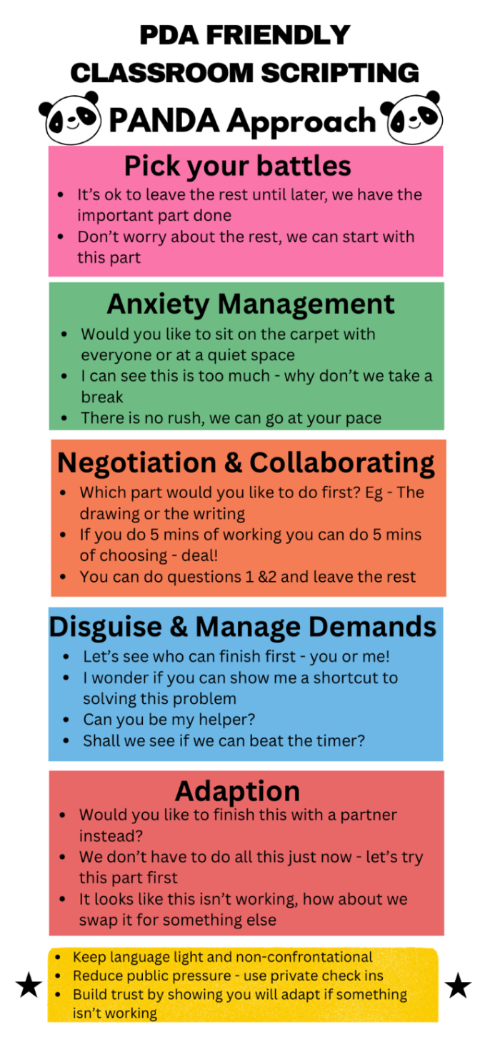

Appendix 2 – Further Scripts

