**Lochgelly West approach – Four Capacities**

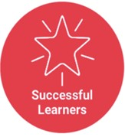

**with**

* self-respect
* a sense of physical, mental and emotional wellbeing
* secure values and belief
* ambition

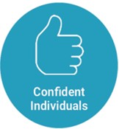

**with**

* enthusiasm and motivation for learning
* determination to reach high standards of achievement
* openness to new thinking and ideas

**and able to**

* relate to others and manage themselves
* pursue a healthy and active lifestyle
* be self-aware
* develop and communicate their own beliefs and view of the world
* live as independently as they can
* assess risk and take informed decisions
* achieve success in different areas of activity

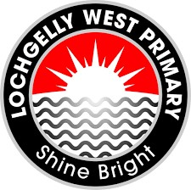

**and able to**

* develop knowledge and understanding of the world and Scotland’s place in it
* understand different beliefs and cultures
* make informed choices and decisions
* evaluate environmental, scientific and technological issues
* develop informed, ethical views of complex issues

**To enable all children at LWPS to become,,,**

**and able to**

* communicate in different ways and in different settings
* work in partnership and in teams
* take the initiative and lead
* apply critical thinking in new contexts
* create and develop
* solve problems

**with**

* an enterprising attitude
* resilience
* self-reliance

**and able to**

* use literacy, communication and numeracy skills
* use technology for learning
* think creatively and independently
* learn independently and as part of a group
* make reasoned evaluations
* link and apply different kinds of learning in

new situations

**with**

* respect for others
* commitment to participate responsibly in political, economic, social and cultural life

