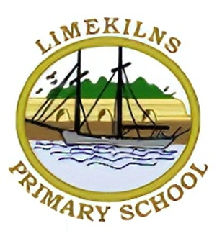
Limekilns Primary School

Phonics - Information for Families
What is phonics?
Phonics is a basic skill used in learning to read and write.
At its simplest, phonics is the relationship between the letter you see on the page and the sound (not the letter name) that it makes when you say it, i.e. knowing that the letter ‘a’ will have the sound /a/ as in apple or ant.
How do we teach phonics?
At Torryburn Primary we use ‘Jolly Phonics’ for the initial teaching of sounds and letters.
In Jolly Phonics the 42 main sounds of English are taught, not just the alphabet. The sounds are in seven groups:
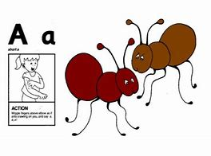
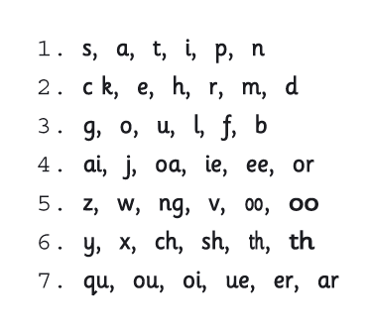
Each sound has an action which helps children remember the letter(s) that represent it. As a child progresses you can point to the letters and see how quickly they can do the action and say the sound. As a child becomes more confident, the actions are no longer necessary.
Children should learn each letter by its sound, not its name. This will help in blending (or sliding) the sounds together when they read. The names of each letter can follow later.
The letters have not been introduced in alphabetical order. The first group (s,a,t,i,p,n) has been chosen because they make more simple three-letter words than any other six letters. The letters b and d are introduced in different groups to avoid confusion.

Using phonics
Phonics will help your child to work out those words they have not seen before when reading and to choose the right letters for the sounds in words when writing. For example, if a young child comes across the word ‘shop’ for the first time they will try to read it by breaking it down into its three phonic sounds
/sh/ /o/ /p/
and then ‘slide’ these sounds together (blend) to say the word shop.
This is called decoding.
If they were asked to write the word they would break the word down into its sounds and write the letter or letters that represent each sound that they hear – ‘sh’, ‘o’ and ‘p’ – this is called encoding.
How can you help your child with reading and phonics?
Saying Sounds correctly
This is really important when you are helping your child to learn the sounds. Just remember not to add an uh or i to the end of the consonant sounds – so say mmm not muh, lll not lii etc, because then later it’s easier to blend the sounds together to make words.
Linking sounds to letters
Encourage your child to make a link between the sound and the written letter shape. Start with the sounds in your child’s name and then look out for them in the environment when you are out and about.
Sounds represented by more than one letter
Some sounds are represented by more than one letter such as sh in ship, ch in chat, th in thin, qu in quick and ng in sing. Point out examples of these to your child too.
Practise, practise, practise
Build up knowledge of the letters and sounds quite quickly with your child and keep practising so that it becomes automatic. Keep reminding ‘Do you remember when we were talking about the sound ch...?’, or ‘Oh look! There’s a big t (sound) on that poster!’.
Putting sounds together to read simple words
Say the sounds c-a-t to read cat, sh-o-p to read shop and s-t-r-ee-t to read street. If your child gets stuck and is struggling to blend the sounds, say the sounds yourself, quickly, until your child can hear the word. Only beginner readers need to sound out every word as they read all the time. However, they will still need to work out new and long words.
Tricky words
Some everyday words in English have tricky spellings and can’t be read by blending. Imagine trying to read the word said or does by blending each letter! These are sometimes called high frequency, common words or tricky words. These words just have to be learned by sight and flashcard-type games are a good way to practise these.
Reading books
Our school uses a synthetic phonics scheme called Jolly Phonics and Oxford Reading Tree is our main reading scheme. These books will contain decodable words, which means the books contain mostly words that children can read by sounding out. This will get the children off to a good start with independent reading. After your child has read a page, you can read it aloud again, to make sure that the story is enjoyed and understood.
Using pictures
Pictures are great for sharing and talking about a story (which is really important too!)
Writing letters
Teach your child how to write the letters as the letter sounds are learned. Correct formation is important. There are lots of fun multi-sensory ways of doing this, for example, sky writing or writing with a finger on a back. Don’t forget to show your child how to hold the pencil correctly too! Chunky triangular pencils are handy to keep at home as they naturally encourage the desired tripod grip.
Share lots and lots of books together!
Carry on sharing and reading lots and lots of stories and information books to and with your child. Most importantly, remember that your child will learn much faster with encouragement, and praise.
If you have any questions or need further support, please pop in and speak to Mrs Iafrate, Mrs Hay or Mrs McCallum.


Here are some useful websites to support home learning:
www.playtalkread.scot
www.readwritecount.scot
www.scottishbooktrust.com
www.education.gov.scot

