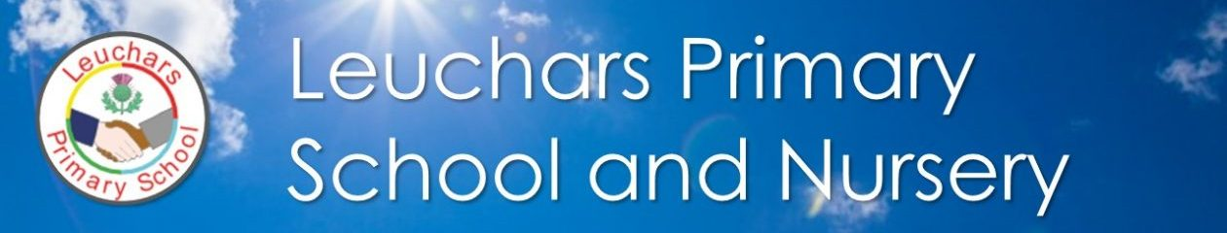

|  |
| --- |
| **Our Vision**  **Be the best you can be** |

|  |
| --- |
| **Our Aims**  * To educate our children and prepare them for the future * To provide a safe, welcoming, nurturing environment * To celebrate diversity * To develop respect and empathy * To meet the needs of every child * To develop strong links with the local community |

|  |
| --- |
| **We Value**   * Kindness * Tolerance * Responsible * Ambition * Honesty * Teamwork |

|  |
| --- |
| **The United Nations Convention on the Rights of the Child**  **Children have the right to:**  Be listened to, have their views respected and to be given the right information  Have an education which develops their abilities and talents  Play  Have a safe and tidy school with quality resources  Have healthy food, clean water and clean air |