Positive Behaviour Policy
Leuchars Primary School
Version 1 March 2022
.

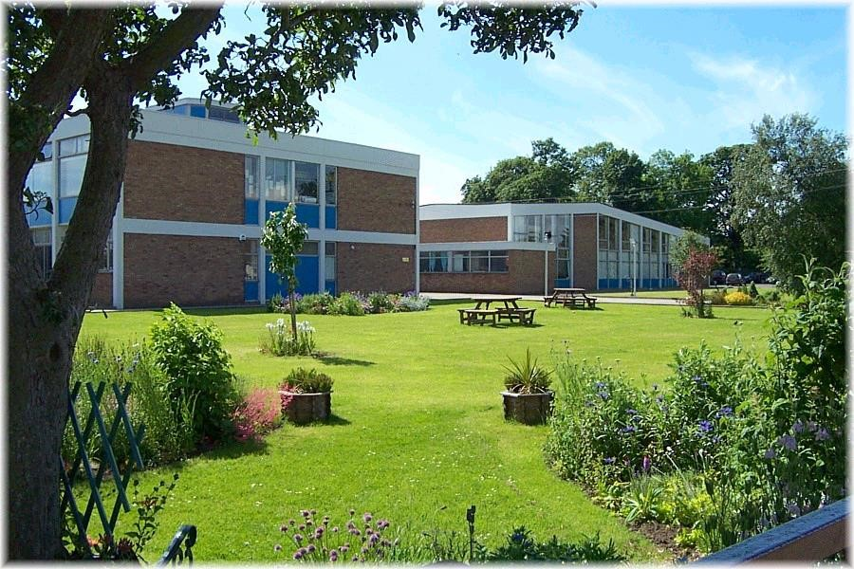

Introduction and Aims

At Leuchars Primary School, we recognise that the majority of our pupils come to school ready to learn. The aim of this policy is to make clear how we create an ethos that allows children to flourish in a safe, welcoming and supportive environment.
We recognise that all behaviour is communication and seek to understand and address the reasons behind negative behaviour in order to promote the positive.

This policy should be read alongside our anti-bullying policy.

We Value:

- Kindness
- Tolerance
- Responsibility
- Ambition
- Honesty
- Teamwork

Our Aims:

- To educate our children and prepare them for the future
- To provide a safe, welcoming, nurturing environment
- To celebrate diversity
- To develop respect and empathy
- To meet the needs of every child
- To promote a healthy lifestyle
- To develop strong links with the local community

It is important that our children are taught to know and understand the values and aims and to understand their importance alongside and connected to the United Nations Convention on the Rights of the Child (UNCRC) and the Wellbeing Indicators. Each class displays a ‘What’s Important to Us?’ Poster and this should be referred to by all staff at appropriate times. In particular, we ensure that there is understanding of the word “Tolerance”. We do not tolerate swearing, hitting or disrespectful behaviour but we do show tolerance of different ideas and opinions, to different cultures and to different needs.

At Leuchars Primary School, we acknowledge the different backgrounds and experiences which our pupils bring to school. Over 60% of our pupils belong to Service Families and have regular changes of school. This impacts on these pupils and also upon our local population who face a lot of changes of friendships during their time with us. We aid transitions by using buddies and by making opportunities for pupils to discuss change. We use Circle Time to build resilience, create good classroom ethos and make use of “Being Cool in School”. We value our pupils’ opinions and give them opportunities to be involved in decision making. We recognise the importance of listening to pupils to ensure they feel respected. We make use of restorative approaches to help pupils resolve conflict and ensure all views are heard.

Rights Respecting Charters:

As a part of our work as a Rights Respecting School, each class, at the start of the session, engages with the UN Convention on the Rights of the Child to write a Rights Respecting Charter. This charter lays down the pupils’ rights at school, the actions they need to take to respect each others’ rights and the responsibilities of the adults around them. We promote a culture of mutual respect between adults and pupils where all are expected to show respect for each other.

We use assembly times as an opportunity to extend understanding of children’s rights and explore issues such as bullying and internet safety from a Rights Respecting perspective. This is done both though a Sway presentation as well as assemblies in the hall (subject to any restrictions brought about by Covid).

These charters form the basis of our expectations within school. Staff’s expectations are high and relate to the charters to ensure all pupils understand their role in respecting rights. Staff use the language of the charter in their conversations with children e.g. “when you are shouting out in class you are forgetting that everyone has the right to listen to help them learn”.

Praise/Rewards:

Our teachers run their own reward systems within each class. Rewards may include: stickers, points, certificates or treats (earned over a period of time). It is appropriate that each class has its own reward system as this can be put in place through consultation with the children, responding to the particular dynamics of the class and can be changed during the year to keep it fresh. In relation to a pupil’s work, rewards will be given for good effort as well as for attainment. It is good practice when pupils are behaving inappropriately, to acknowledge the good behaviour of those who are behaving well by awarding points to them.

Certificates:

We also have the “Star Pupil Certificate” which is presented on a Friday Afternoon as part of our Sway presentation. This is awarded to a child each week in every class. In addition we have our “UNICEF Certificate” which is given for a particular positive action supporting the aims of UNICEF. Finally, there is the “Headteacher’s Award” for a child who has done something exceptional.

Green Card:

When a class has been working really well, the teacher can send a “Green Card” to the office. A member of SLT will then go to the class to see what the class have been doing and to give praise and encouragement.

We use praise and rewards with care. It is good practice to acknowledge pupils who are respecting rights and to use the language of the charter to do so e.g. “Thank you, you are listening well and that is letting everyone learn”. Acknowledging the behaviour of those who are respecting rights is usually more effective than drawing attention to those who are not.

Our House System:

We have a whole school system of house points. We have four houses called Athernase, Bruce, Earlshall, Eden. All staff can award house points in 1s or 2s to pupils who are particularly helpful, kind, making an effort or otherwise going above and beyond. Staff do not award house points in class (as they have their own reward systems in place) but can award house points to pupils at playtimes or lunchtime or to pupils who they see moving around the school in a sensible way. House points cannot be removed. House points are given in the form of large buttons which are placed into special containers so as to give a visual representation of how well each house is doing.

“Sparkle Assemblies”

In an assembly PSAs can give out a “Sparkly Star” for either positive behaviour in the playground or good work in a group. The children who receive these stars are then allowed to take part in a special activity eg arts and crafts.

Restorative Conversations:

We will use restorative conversations as part of dealing with behavioural issues. We use the following questions to guide our conversations:

- What happened?
- What were your thoughts at the time?
- What have been your thoughts since?
- Who has been affected by what happened?
- How have they been affected?
- What needs to happen now?

Consequences:

Our children will often respond better to praise/rewards than to consequences. Sometimes, however, our children display behaviour which is inappropriate and which needs to be challenged and changed. This is to ensure that all our children can learn and play in a safe and happy environment and that staff can carry out their jobs effectively. We make use of the following consequences:

- Time out from class or playground
- Reflective exercises
- Purple Card
- Report Card
- Communication with parents

Timeout:

A Timeout is an intervention where a child goes to a location within the school which is an alternative to the child’s usual classroom setting. A Timeout is a short-term intervention that is focused on enabling the child to reduce feelings of distress or anxiety and return as soon as possible to their usual learning environment.

A Timeout may involve:

- Being asked to sit away from their group for a short time (within the teacher’s sight).
- Being asked to move away from the group to talk about something which is upsetting them or about the behaviour which is upsetting others.
- Coming in from the playground or being kept in for a specified period to be supervised by a member of SLT.
- Doing their work away from the classroom for a specified period. This could be in another classroom or a breakout area near the classroom.

No child should be kept inside at playtime or lunchtime without the HT, DHT or PT being consulted and without a plan being put in place for where the pupil will be, what activity they will be doing and who will be supervising them.

Reflective Exercises:

It is sometimes helpful for a child to carry out a reflective exercise. This can take a number of forms and might include writing or drawing about the inappropriate behaviour and writing or drawing to make a plan to behave appropriately in the future. A reflective exercise can also be done orally with a staff member. A reflective exercise will usually happen during timeout. Care should be taken to match the reflective exercise to the ability and age of the child. If the child is upset or angry following an incident, this is not the appropriate time to do a reflective exercise; it should be done when the pupil is calm and able to reflect.

Purple Card:

When a teacher needs support in class to deal with a pupil’s behaviour, they should send a Purple Card to the office with a child. The office will arrange for another adult (HT, DHT, PT) to come and support. This may result in the child concerned being removed from the class for a time.

Report Card:

If a child on more than one occasion has failed to complete a particular activity through poor behaviour, then a Report Card can be issued for a limited period (2 or 4 days). The teacher establishes a target and then comments on if the child has met this on the Report Card. The Headteacher will inform the parent/carer at the start of the report and will report back to the parent/carer at the end. The Report Card is kept by the teacher but shown to the child.

Communication with Parents:

At Leuchars PS, we believe in working in close partnerships with parents and we know that the parents value good communication. Parents will be made aware if their child is having difficulties with friendships or with their behaviour. This communication will in most cases be made by the HT, DHT or PT.

Solution Focussed Approach:

Examples of solution focussed approaches can include:

- Making a curricular change for a pupil who is not coping with a specific task or activity.
- Adjusting planning to increase the amount of differentiation
- Making a timetable change.
- Changing seating arrangements.
- Organising lunch sittings to minimise the time specific pupils are together in the playground.
- Ensuring pupils play with others of their own age.
- Setting up a ‘Circle of Friends’.
- Increasing supervision of unstructured times.
- Providing nurture support (eg Kitbag)
- Seeking advice from an outside agency

Appendix 1: Useful Approaches to Promoting Positive Behaviour

- Getting down to a small child’s level when speaking to them.
- Keep instructions short. Some children will have short term memory issues which means they can only retain a limited amount of information.
- Recognition of processing time – if a child does not respond immediately, give them thinking time and then repeat an instruction using the same language. If a child frequently needs a lot of thinking time, it may be that language needs to be simplified for them.
- Avoid using a big voice as a routine tool but we recognise there are occasions when a big/firm voice is needed for safety reasons e.g. a firm ‘Stop!’ There is a distinction between big/firm voice and shouting which should always be avoided.
- Be aware that a distressed child will not be able to follow an instruction and attempting to use language to stop them behaving in a distressed way is likely to escalate the situation. Give time and space to a child who is distressed – read their body language to know when they are ready for you to approach them or start talking.
- Saying what you do want, not what you don’t want.
- Make use of visuals and signing.
- Simple scripting e.g. ‘I’ll know you are ready when…’
- Discussion of emotions (supported by visuals)
- Praising role models
- Diverting attention or distracting
- Ensuring the environment is well organised to support positive behaviour. E.g areas are not cluttered, rooms are organised to ensure safe flow and discourage running, resources are accessible, play opportunities are set up,
- Avoid using language which the child will not understand e.g. rhetorical questions, jokes, sarcasm.

Advice for working with children with Additional Support Needs (ASN):

Children who have difficulty regulating their behaviour/emotions/anger may benefit from a targeted intervention eg “Kitbag”. It is good practice to be open in conversations with children and promote the concept that while a child’s behaviour might not be acceptable, they are wanted and understood.

Appendix 2

The following tables outline some examples of inappropriate behaviours.
Yellow behaviours | Orange behaviours | Red behaviours
- Name calling/ deliberately unkind e.g. put downs  - Misuse of school property  - Messing about/ preventing self and others from working - fiddling/ distracting  - Poor participation in class activities - not paying attention  - Delay tactics such as wandering around the classroom or needlessly visiting the toilet  - Swinging/ rocking on chair (repeatedly)  - Lying - dependant on context e.g. in defence  - Not responding to adult when called. | - Persistent repetition of low level behaviours  - Purposeful defiance  - Deliberate throwing of objects e.g. rubber, pencils, paper - Rough play - pinching and pushing  - Misbehaviour in toilets  - Lying - dependant on context e.g. in defiance  - Ignoring instructions  - Misbehaviour in the dining hall  - Non-directed swearing  - Climbing on school furniture  - Cruel name calling with intent to belittle e.g. friendship issues that can be resolved with intervention  - Responding inappropriately/ rudely to correction of behaviour | - Persistent repetition of medium level behaviours  - Absolute defiance  - Wilfully damaging property  - Throwing objects with the intention to hurt  - Swearing directly at someone  - Aggressively arguing with a member of staff  - Constant refusal to cooperate with reasonable requests  - Removing themselves from close supervision i.e. running out of the class without permission/ running away from a member of staff  - Racist comments  - Homophobic comments  - Sexist comments  - Gender identity comments  - Biting  - Striking anyone eg punch, kick

Yellow and Orange behaviours: Actions/ consequences that may be taken are:

- Child may be required to write an account of what happened
- Child may be verbally reprimanded
- Child may need to apologise, either verbally or in writing
- Position in class changed for a period of time decided by the class teacher
- Be separated from others for a specific period – within class
- Loss of part or all break time (this must be supervised)
- Catch up with the work missed in lesson time - during playtime, work sent home
- Tidying up mess made
- Restorative activity
- Children may have their behaviour monitored over a period of time eg Report Card
- Where any property is damaged, parents are informed

Red Behaviours: Actions/ consequences that may be taken are:

- Reported to the Headteacher immediately
- Removal from class. Time out agreed between Headteacher and Class Teacher
- Parents informed (by a member of SLT) and – where appropriate – invited into school to discuss

