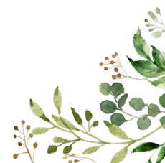
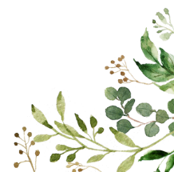
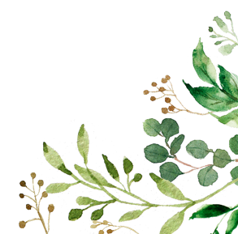
The 6 Principles of Nurture



- Children’s learning is understood developmentally
- We are all individuals.
- Everyone learns and develops at a different pace.
- The classroom is a safe base
- School should be a calm and safe environment for everyone
- The school environment keeps everyone safe and healthy.
- The importance of nurture for the development of wellbeing
- Looking after ourselves and others is good for our mind and body.
- We can do this by showing kindness and celebrating our achievements.
- Language is a vital means of communication
- What we say to people tells them a lot about us and how we’re feeling.
- Talking to someone you trust can make you feel better and help them to understand you.
- All behaviour is communication
- The way we’re behaving also says a lot about how we’re feeling. Are we frustrated or upset?
- When we put ourselves in other people’s shoes and imagine how they are feeling, this is called empathy.
- The importance of transition in children’s lives
- Change happens all the time. It can be exciting but it can also be scary.
- It is good to talk to people you trust about how you’re feeling about any changes.
Live, Love and Learn at Leslie

Nurture
Groups
2024/25

This year, we will work with small groups of children to help support them as they grow, working to promote the 6 principles of nurture.

These groups will focus on a number of different skills, primarily
- Supporting our learners to develop social and emotional skills and understanding.
- Helping to promote and support our learners’ resilience and self-esteem.

This booklet will outline some of the activities and topics we hope to outline throughout the year.

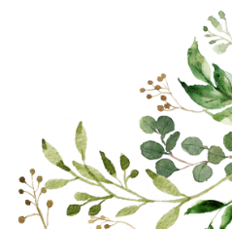
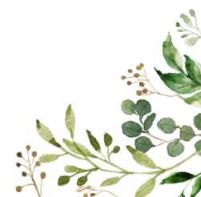
Lego Therapy
Lego therapy is a play-based group which helps children develop skills in turn-taking, sharing, listening, conversation, team-work and problem solving. Each child is given a ‘role’- the engineer, builder or supplier who must all work together to complete a task. Ultimately, it is great fun and the children feel a sense of achievement at their completed project.
5-Point Scale

Many children benefit from the use of a 5-point scale, a tool to help develop self-regulation. The scale is used to approach issues in a very direct and honest way, by addressing the facts of the situation, helping to understand social and emotional concepts by breaking down the concepts into parts, which in turn reduce anxiety. It is a simple way to share this with others around them. These are co-created with children and then used to help support them in class, and if necessary, at home too.

Life Skills
Small groups of children will work on developing skills for life. Last year, these groups had many opportunities to develop life skills through baking, wall papering, learning how to write and post letter, use the phone and even planned and carried out their own shopping trip!

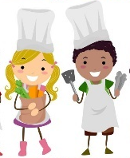
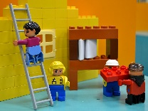

Kit-Bag
Kitbag contains a number of resources to help promote calmness, resilience, and understanding for one another to help grow positive relationships. It helps to create a safe space for sharing thoughts and feelings. Resources in the bag include ‘feelings’ cards, animal cards, finger puppet, calming oil, minute timers, and a talking stick.

Connected and Compassionate Classroom
An Education Scotland resource, used with children in upper primary school. It aims to help children:
- understand that experiencing adversity and trauma can happen to anyone
- their relationships with others and understand that they have the right to be protected and supported by the adults in their lives.
- to provide them with strategies and personal coping skills to help them deal with challenge and develop resilience.

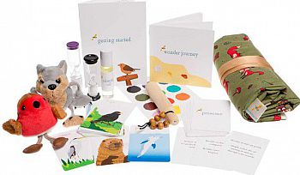

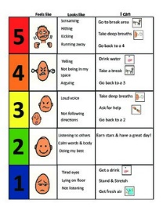
Gross motor skills: are abilities that let us do tasks that involve large muscles in our torso, legs and arms. They involve whole-body movements and we use them for all sorts of physical activities. These groups will allow children to practice developing these skills through a variety of fun games, exercises and movements.
Gross and Fine Motor Skills

Fine motor skills: are the abilities to make movements using the small muscles in our hands and wrists. These groups will spend time practicing skills including pencil control, pincer grip, cutting, tying shoe laces, threading and manipulating small objects.

