**Lawhead Primary School – Letter Formation and Joins**

P1 and P2:

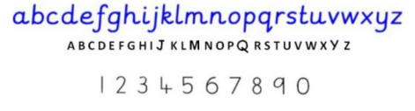

P3 – P7 (may introduce for some P2’s):

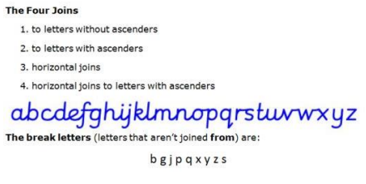

To begin with pupils will not join from the s to other letters but this can be introduced when they are ready.

This is based on Nelson Handwriting – see teacher book for lesson ideas and activities.

Handwriting should not be resource driven but Nelson can be used to support your lessons. Please use the Highland Literacy Handwriting Progression to track your learner progress and plan when to introduce particular joins.