

Lawhead Primary School

Strathkinness Low Road
Lawhead School Wynd
St Andrews
Fife KY16 9NG
Telephone: 01334 659426

Email: lawheadps.enquiries@fife.gov.uk
Website: Lawhead Primary School and Nursery | Aiming High! (glowscotland.org.uk)

Head Teacher: David Mitchinson

Site Traffic Management Plan

October 2023
(Next review date August 2024)

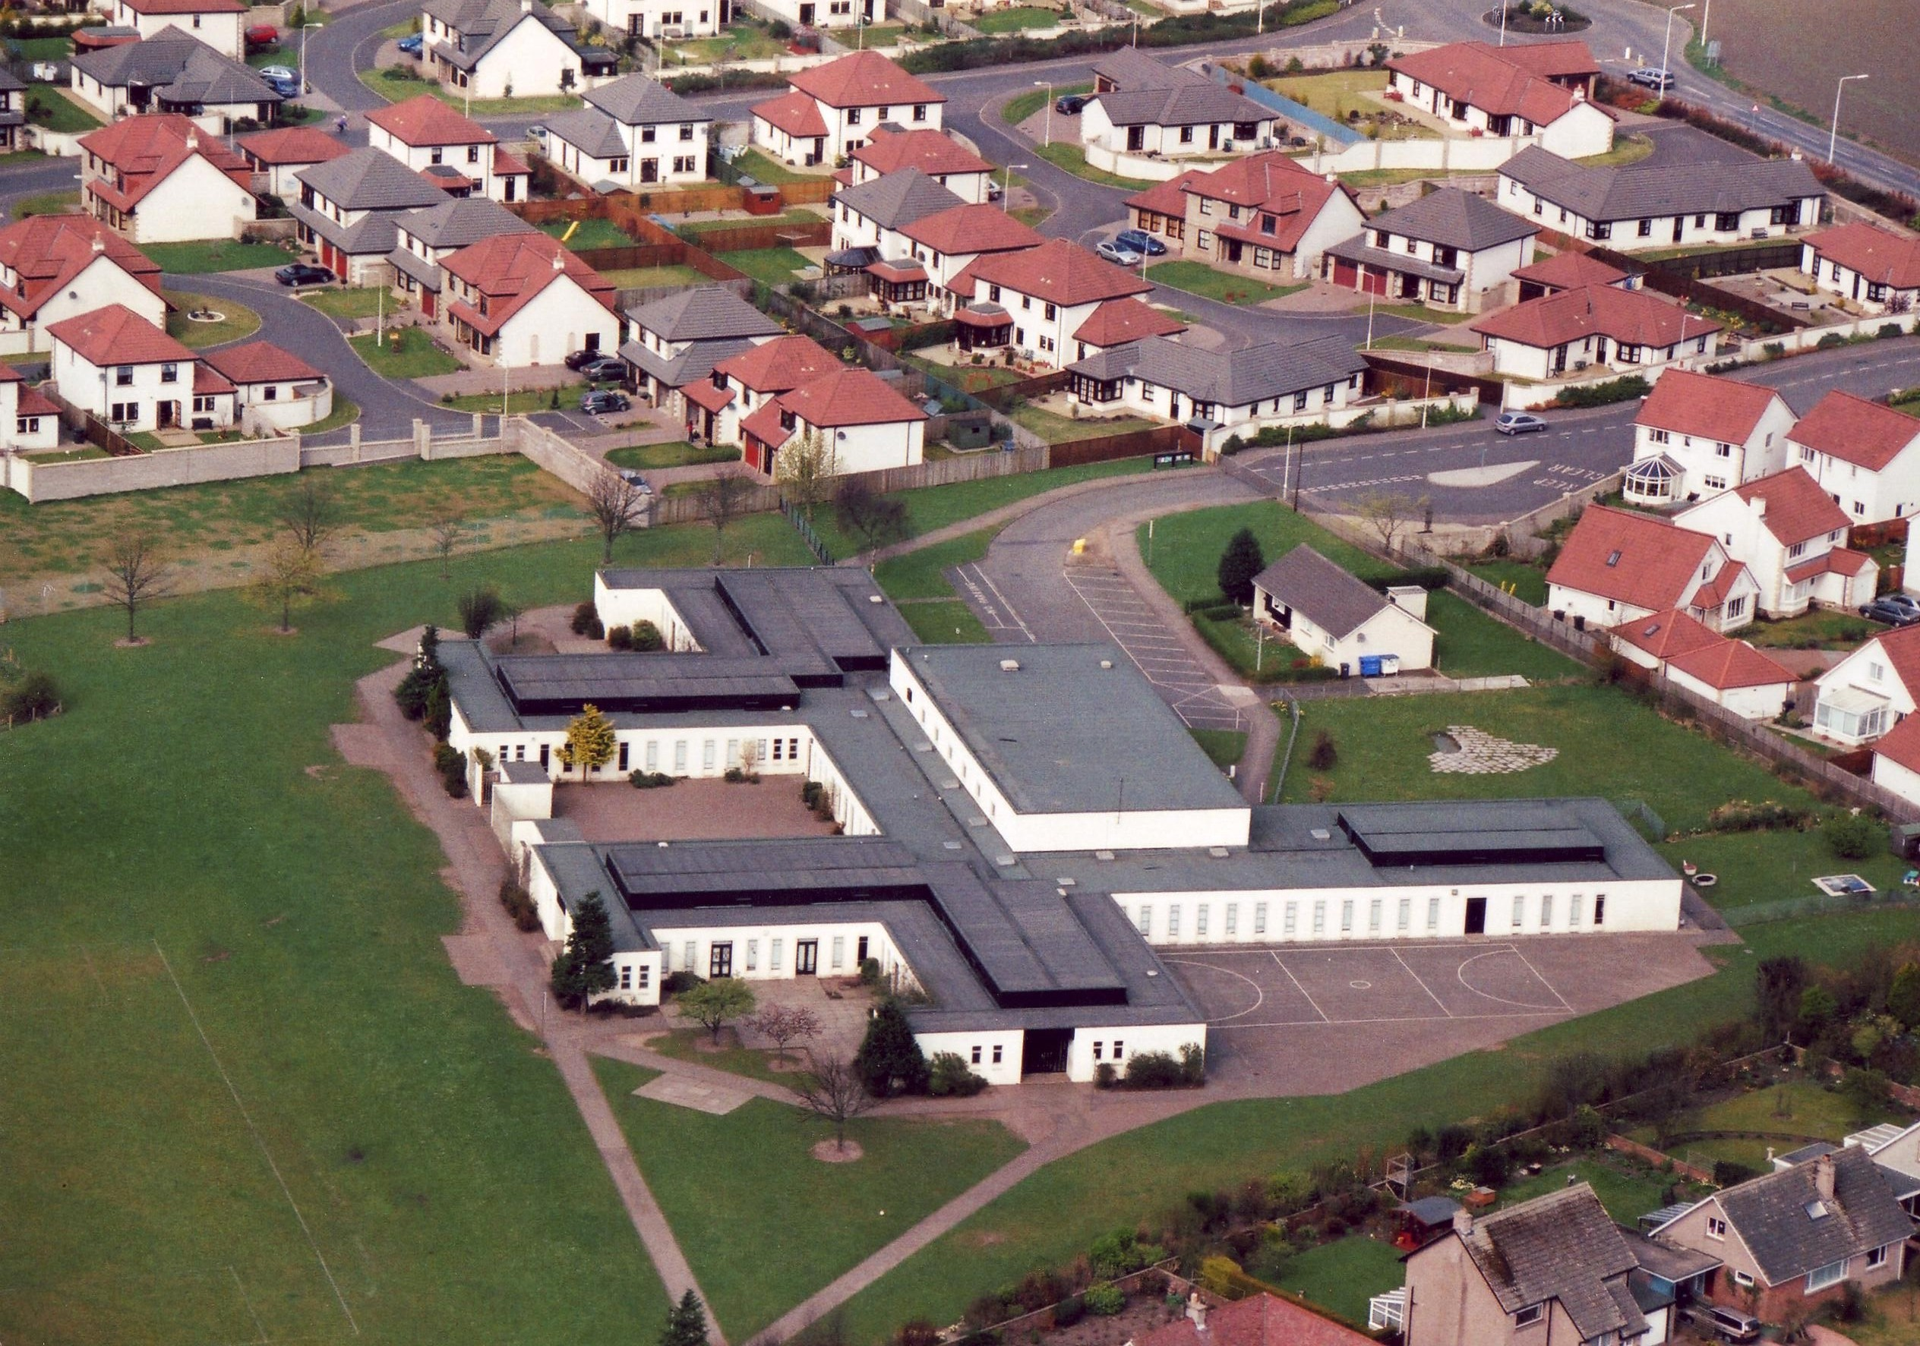

Contents

Section

- Introduction
- Layout / Access
- Pedestrians
- Pupils / Students
- Staff
- Visitors
- Servicing / Deliveries
- School Buses
- Contract Hire Services
- Disabled Access
- Out with the School Grounds
- Management Practices
Appendix A

- Introduction

This document has been prepared to inform and instruct employees, pupils, parents and others who come onto the site, including visitors (both pedestrians and people in vehicles), about the site rules concerning pedestrian and vehicle separation.

Lawhead School takes the health and safety of all site users very seriously. It is therefore, imperative that individuals take care, exercise caution when in the school grounds or within the vicinity of the school grounds and follow instructions to avoid risk of injury. If there are any concerns about traffic safety, they should be reported to the school management team.

We urge all site users to read this document carefully and act in accordance with the instructions contained therein. The instructions constitute site rules. Pupils in breach of the site rules may be subject to disciplinary action.
.

Copies of this document have been given to school staff, pupils, parents and carers. Copies are also available from the office and on the school website:
Lawhead Primary School and Nursery | Aiming High! (glowscotland.org.uk)

The document will be reviewed annually and awareness raised regularly through parental events, pupil sub-groups, assemblies and school meetings.

For further information, please contact:

Paul Anderson, Business Manager paul.anderson-d1@fife.gov.uk

Donna Bain, Head Teacher lawheadps.headteacher@fife.gov.uk

- School Layout / Access at Lawhead School Wynd

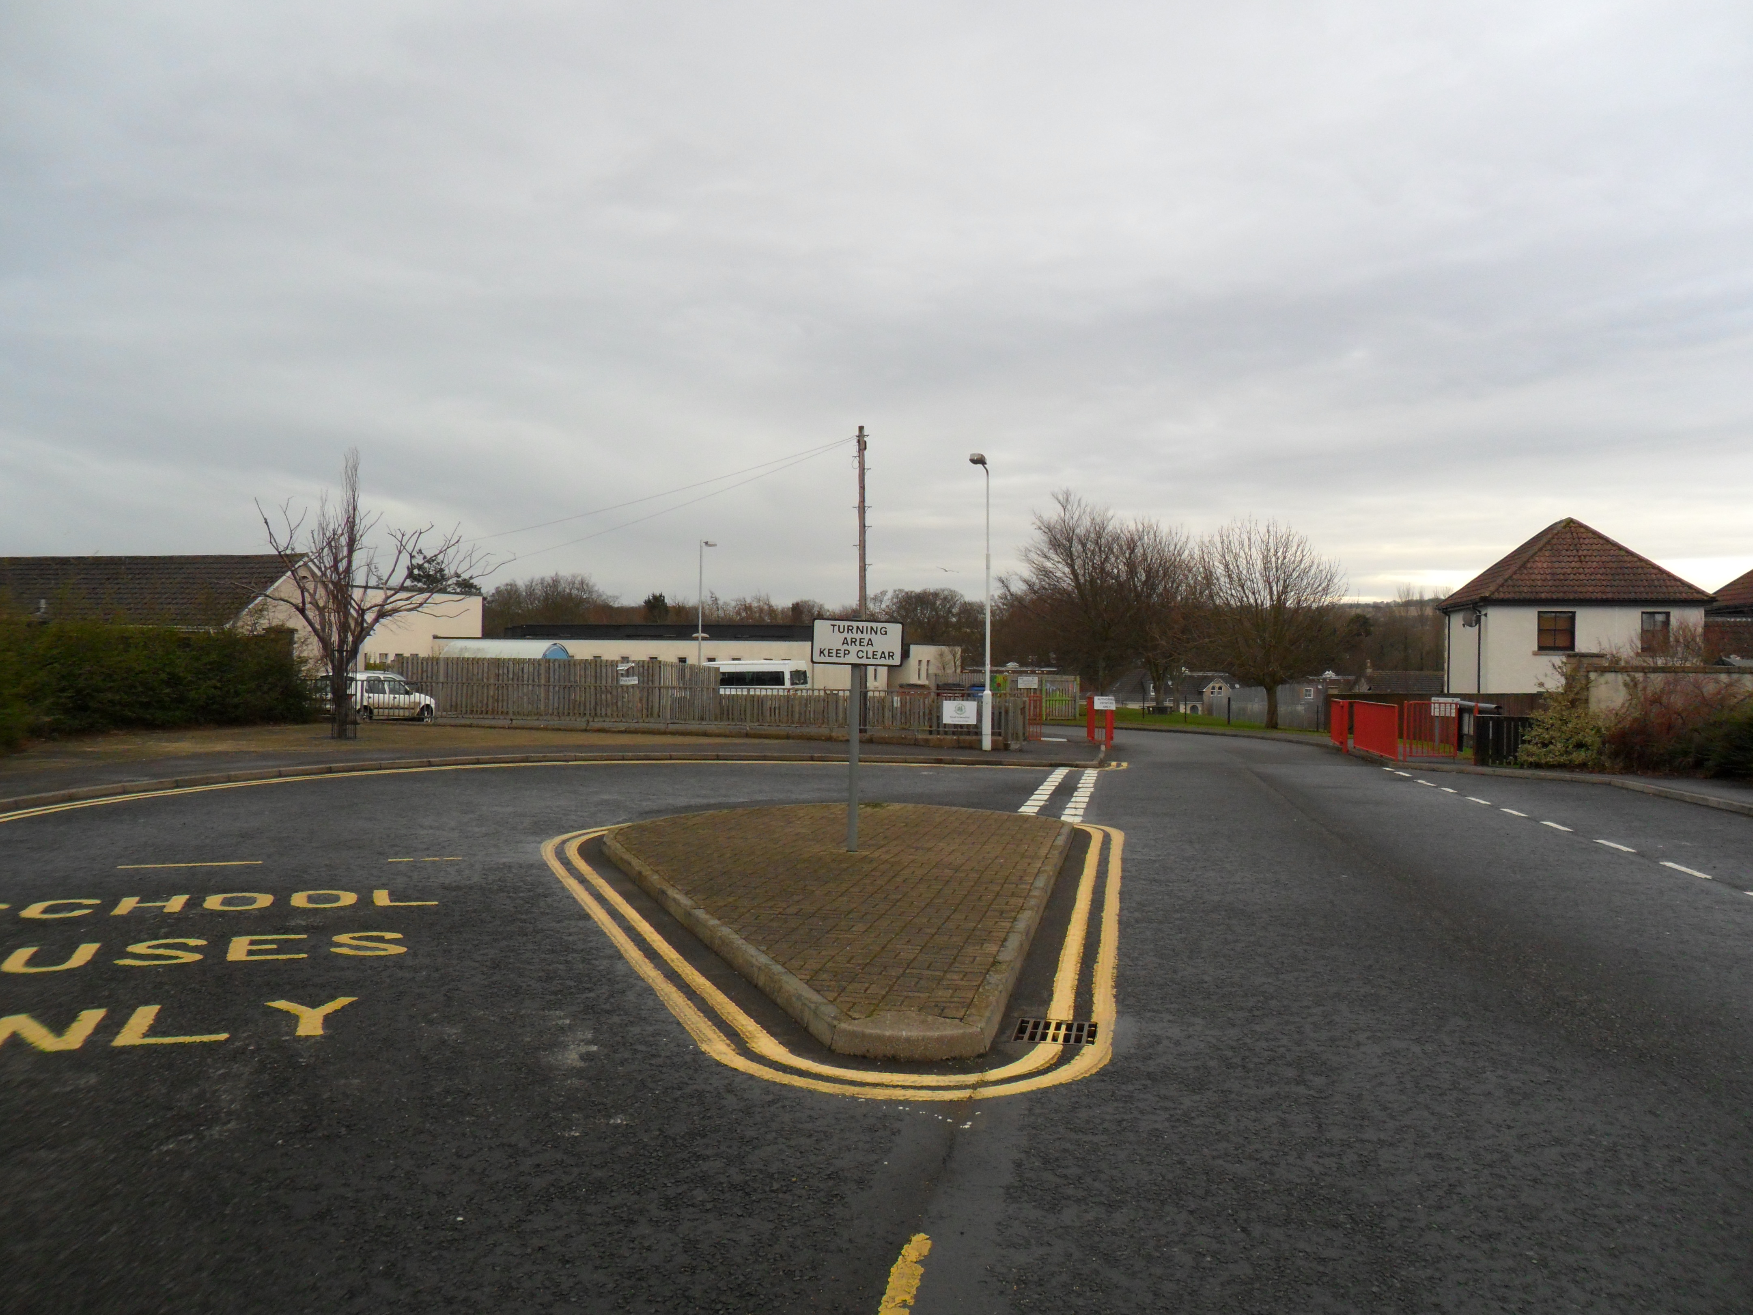

Turning Circle

Access for permitted vehicles

Pedestrian Access Points
Drop off point and permitted parking area

3. Pedestrians

There is a pavement at either side of the main school entrance on Lawhead School Wynd and pedestrians should make sure that they use either one of these safely and avoid spilling onto the road. Pupils walking in groups should take this into account and allow other users to pass safely.

There is also a pedestrian access on Hepburn Gardens.

Pedestrians should only access the school from the designated entry points.

Designated Entry Points

Pedestrians should follow the footpaths on either Lawhead School Wynd or Hepburn Gardens depending on their point of entry. Entry into the school building is through the main door which is to be found if you follow the path on the left-hand side as you enter the Lawhead School Wynd access point. If using the Hepburn Gardens entry point you continue up the path and then keeping to the right hand side of the school follow the path around through the nursery garden or keeping to the left hand side follow the path through the playground to the main entrance.

4. Pupils

It is very important that pupils set a good example to others, particularly in the spirit of being a safe school. There are a number of site related areas pupils should be aware of:
- Pupils should be particularly aware that the main exit gates flow straight onto either Lawhead School Wynd or Hepburn Gardens where there is likely to be moving vehicles. Care should be exercised when exiting through these gates to ensure that it is in a controlled manner.
- Pupils arriving by school bus or taxi should exit the vehicle onto the pavement side at the turning circle as the staff car park is likely to have vehicles entering or exiting at this point.
- Pupils returning home by bus or taxi should meet the driver on the same side as the school path and only enter the vehicle from this side to avoid meeting a moving vehicle.

Drop Off

The designated drop off point for pupils is situated on Lawhead School Wynd. Drivers should use the turning circle to turn safely to enable them to then park on the left-hand side as you are facing away from the school. The turning circle is not a drop off point or a parking area and must not be used for either of these purposes.

5. Staff

Staff are to be mindful when entering or leaving the staff car park that there is likely to be pedestrians crossing either at the entrance or near the bike shed.
Only designated areas within the school car park should be used. If there are no spaces, staff should use the drop off point or a nearby street outside the school.

6. Parents and Visitors

Please note that the car park is usually full and you should look for a space nearby where you can park your car responsibly and with due respect to our neighbours.

If you are a disabled badge holder and require to come into the school please let a member of the office staff know and we will arrange for you to park as near to the entrance as possible.

7. Servicing / Deliveries

Drivers of service vehicles (if they have not been on the site before or obtained instruction in advance) should report to the office to advise the nature of their visit and get clarification on where they can park. Parking for a short period can be permitted, where possible.

8. School Transport

The minibus when hired drops off and collects children within the school car park. The member of staff on duty is responsible for ensuring that the children leave and re-enter the bus safely and are escorted to and from the nursery/school at all times. The children must not be allowed to run ahead.

School pupils entitled to be transported to school are brought to and collected from the school car park. Pupils must adhere to the safety procedures detailed earlier and follow the instructions of the designated driver.

Pupils are reminded about good conduct while traveling on the school bus or taxi.

Pupils being collected by the Cosmos Centre after school will be collected at the main office and then escorted to the designated vehicular pick up point within the turning circle. Please note this is the only vehicle permitted to park in this area,

9. Contract Hire Services

Contracted vehicle drivers (including taxis and minibuses) will have specific instructions given to them through Transportation & Environmental Services as part of the terms of the contract.

10. Disabled Access

Pedestrian access is primarily via the main front entrance.

Parking
Any visitors wishing disabled access should contact the school office where provision can be made. 01334 659426 or call in at the school office.

11. Outwith the School Grounds

The school accepts that parking near the school is not easy. Hepburn Gardens is a residential street, used by Service buses as well as car traffic into and out of the surrounding area. It is important that the school is a good neighbour to local residents. Lawhead School Wynd leads into Forbes Place where householders need access to their homes.

Parents/Carers are encouraged when ever possible not to park too near the school and allow their children to walk the remaining distance if they drop them off further away. Parking indiscriminately, such as mounting pavements, double parking, stopping on any yellow lines, obstructing access points to streets and driveways and parking near junctions causes danger to pupils and other road users. Accidents can arise if views are obstructed or pedestrians have to negotiate between parked vehicles. In addition, the roads can become congested which results in frustration and delays to services and ongoing journeys.

Please act responsibly by parking as far away from the school as possible to keep the pupils at Lawhead School, local residents and other road users safe.

12. Management Practices

Key to the ongoing monitoring of the plan is the role of the Head Teacher and other staff. All staff have a responsibility to make sure that they are acting in such a way as to not compromise the health and safety of themselves or others.

Supervision

School staff ensure younger pupils are collected by a responsible adult either at their class entrance or at the main office if attending an Out of School Club out with our premises.

Older pupils who are permitted to make their own way home are seen off the premises from the designated cloakroom or from the main office if attending an after school club.

Monitoring of compliance against this plan

All staff take a responsibility in ensuring that the aims of this pan are adhered to.

Non-compliance

If there are concerns or incidents that constitute non-compliance these will be recorded on the form by those monitoring the site and appropriate action will be taken. This includes possible disciplinary action and reports going to Contractor or Service management which may result in investigative action.
Appendix A

Traffic Management Plan Monitoring Form

Completed by:

Date | Area | Observations | Incidents | Signed by

