Lawhead Primary
School Travel Plan

2022 - 2028

Head Teacher: Mrs Donna Bain
School Address: Lawhead School Wynd
St. Andrews
KY16 9NG

Telephone Number: 01334 659426
Summary
The following travel plan is a collaborative effort by parents, children, staff and stakeholders who have researched and devised the content, agreeing the actions and aims to make the overall journeys to and from Lawhead PS safer, healthier, more environmentally friendly and more enjoyable by:

- Reducing congestion around the school by reducing the number of cars used for the
school journey
- Increasing the number of families choosing active travel (cycling, walking, scooting)
- Promoting alternatives to car travel, increasing the percentages of active and sustainable travel and educating all about road safety.
- Improving facilities in school (bike and scooter storage, helmet storage etc.)

This plan is valid for 6 years and will be reviewed during year 3 (2025).

In 2022, an online survey was conducted with members of the school community about active travel. The survey received 86 responses.

Headline findings include:
- More drive than use active travel to get to school - 41 indicated they use active travel, whilst 44 drive
- 79% of respondents were happy with the way their children travel to school
- 47 respondents said they do not have a safe active travel route to school
- Of those who drive, most park close to the school on Lawhead School Wynd
- Barriers to using more active travel options included safe crossings on busy roads, speed, and inconsiderate parking
- 53 respondents were not aware of any active travel initiatives at the school
- When asked what would improve active travel uptake, suggestions included walking bus, cycle paths, better parking, traffic calming, less cars.
Approximately 50% of Lawhead’s pupils live outside catchment. The challenge will be encouraging parents and pupils to change their behavioural patterns by introducing active travel into their routine. This will help reduce congestion, improve air quality and improve safety around the school gate and improve relations with the school’s neighbours.

Promoting safe walking routes and seeking the implementation of the recommendations should make the trip to school more enjoyable and encourage more participation in active travel.
The following behavioural and physical measures are proposed in this plan to help achieve our aims:

Behavioural Measures

- Organised school activities (active travel months, Bike Week, Walk to School Week)
- Promote safer routes to school (maps, comms to parents/pupils)
- Road safety education (poster campaigns, Road Safety Week)
- Reduce congestion around the school gate (parking pledge, walking bus/park and stride, speed/traffic/parking enforcement)
- Cycle training (Bikeability, cycle friendly school accreditation)

Physical Measures
- More safe road crossing points – eg Strathkinness Low Road/B949, Lawhead Road West, Forbes Place
- Signage relating to speed/parking near the school gate (eg ‘keep clear’ signs)
- More traffic calming measures
- Creation of cycle routes/paths to school
INTRODUCTION

Lawhead Primary opened in 1974 and is situated on the periphery of St Andrews close to the western section of the Lade Braes walk. It is an open plan building and has a nursery within the building with outside garden space.
The school roll is currently sitting around 230. There are extensive grounds for the children to play and learn in. The nursery roll has a capacity of 30 with an extensive and well developed outside space.
Within the main school there are, at present, nine open teaching areas. Each teaching area has a small side room adjacent where the class can meet together and shut the door. We have a large multipurpose hall which is used extensively throughout the week for P.E., drama, music, assemblies, school productions, having lunch and after school clubs.
Entrance to Staff Car Park
Main Entrance for Pupils

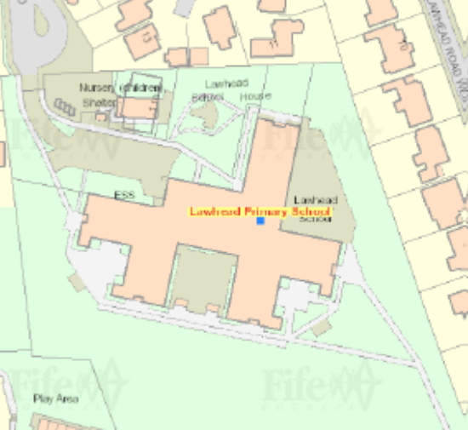

Pupil Entrance from Hepburn Gardens

JUNIOR ROAD SAFETY OFFICERS (JRSO)
In 2022, Lawhead established a travel action group of JRSOs to help address the issues raised with congestion and the impact on air quality around the school gate and to work on future initiatives. At the time of the site visit, these included Caitlin Foulkes – P6 JRSO, Ezra Shackman – P6 JRSO, Emily Green – P6 JRSO, and Fearne Jarrett – P6 JRSO.
KEY ROUTES TO SCHOOL
A mapping exercise was carried out within the school to identify the routes pupils travelled. These were then analysed and the 4 main active travel routes to school were identified.
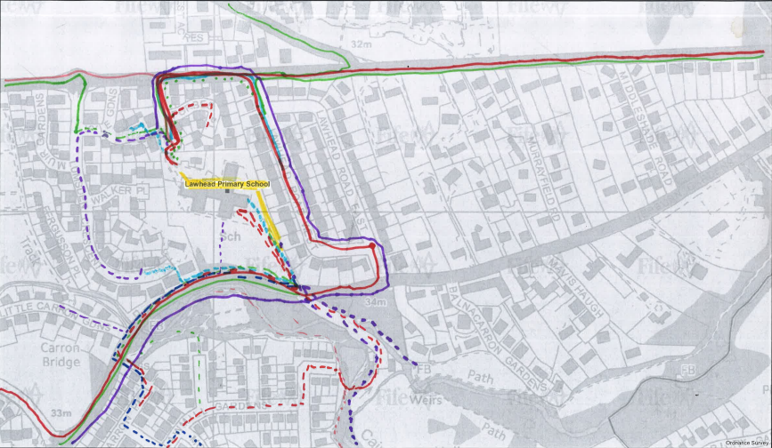

A site visit of the above key routes was carried out on morning of 31st January 2022 by the Head teacher, the Junior Road Safety Officers, and representatives of the Parent Council.
The key routes audited were:
- Lawhead School Wynd
- Lawhead Road East/West
- Hepburn Gardens/Lade Braes
- Buchanan Gardens
The main issues identified were as follows:

- The site is the main drop off point for those driving pupils to school and at times is very congested with parents parking, idling and reversing. The street is marked with school keep clears and evidence of traffic calming measures can be seen.
- There were issues about overgrown vegetation in the Spring/Summer months. Some of the street markings were faded.
- Funnelling of cars around the entrance to Lawhead Road Wynd due to the restricted space for cars to pass one another safely.
- The potential to use neighbouring streets (within the 20mph zone) as park and stride sites, acknowledging the need for a parking pledge to prevent blocking drives.
- Keep clear and zig zag lining faded and ensuring the flashing 20 signs are working.
- Those who park in surrounding streets (eg off the Strathkinness High Road) have difficulty crossing due to no safe marked crossing point at the pedestrian path to West Acres.

BEHAVIOURAL ACTION PLAN
Action | Solution | Action Owner | Target Date (Academic year)
Organised school activities | Take part in Walk to School Week (19-23 Sept)  Take part in Active Travel Days / Months  Take part in Bike Week  Take part in the Sustrans Big Walk and Wheel (March/April 23?) | School/TAG  School/TAG  School/TAG  School/TAG | Term 2 & 4  Term 4  Term 3  Term 2
Promote safer routes to school | Upload map of routes to website  Put information board up at parents’ nights  Articles in school newsletters, social media and assemblies | School  School/TAG  School/TAG | Term 1  Term 2 & 4  Ongoing
Road safety education | Run poster campaigns  Take part in Road Safety Week (14-20 Nov)  Termly JRSO events | School/TAG  JRSO/School  JRSO/School | Ongoing  Term 2  Termly
Reduce congestion around school gate | Develop the following:  - Parking Pledge  - Park and Stride site / Walking bus  - Liaise with Police Scotland re traffic/parking enforcement around the school | School/TAG | Ongoing
Cycle training | - Offer Bikeability cycle training to all P6 and P7 pupils  - Apply for cycle parking fund and investigate becoming a Cycle Friendly school through Cycling Scotland. | School | Ongoing

PHYSICAL MEASURES ACTION PLAN
Action | Action Owner | Target Date
- More traffic calming measures | Fife Council | Tbc
- Safe road crossings – Strathkinness Low Road/B949, Lawhead Road West, Forbes Place | Fife Council | tbc
- Signage relating to speed/parking near the school gate | Fife Council | Tbc
- Creation of cycle routes/paths to school | Fife Council | Tbc

MONITORING & EVALUATION
The JRSO’s will continue to meet periodically to monitor progress and will review the Travel Plan on an annual basis.
Specific progress will be monitored by participation in the “Hands Up Travel Tally” each year and a repeat of the full travel survey will take place 6 years after initial launch.
The school’s ongoing commitment to travel planning will be publicised in the school handbook, the school newsletters, the Parent’s notice board and through assemblies.
TAG will carry out periodic questionnaires to measure impact and improvements in uptake of active travel.
DISTRIBUTION OF SCHOOL TRAVEL PLAN

The following bodies will receive a copy of the School Travel Plan:

- Fife Council Assets, Transport and Environment via the Travel Plan Team
- Fife Council Education Service
- Fife Council School Estates Team
- Parent Council
- Active Schools
- St Andrews Councillors

Copies will also be made available to the parents from the School Office and via the school information site.

Annexe A – Survey of current travel patterns
The following analysis is based on the data from the 86 respondents to the survey in 2022.
41 families highlighted that active travel was their main mode of travel to school followed by 44 families citing that they drive to school

Those who indicated that they drove to school were asked “Where do you park, please give the name of the street or car park”.

A full list of streets can be found below.
The following diagram showcases the answers from the question “How long does your journey to school take” with 46 families indicating that their journey to school takes between 5 and 10 mins.
According to the survey 79 % of families are happy with the way their child/children travel to school with only 9% stating that they were neither satisfied nor dissatisfied and 12% saying they are somewhat dissatisfied. However, of those citing they were dissatisfied none gave an explanation to why! Further exploration is required.
When asked “What factors might affect your decision whether to let your child/ren travel actively to school, or to the bus stop families indicated that the reduction of inconsiderate parking around the school gate is the main barrier. – doesn’t match the data

Those families who chose other, were asked what factors affect your decision to allow your child to actively travel to school. Although only 29 families answered other 82 responses were given. A full list can also be found in below.
53 families indicated that they were not aware of any active travel initiatives taking place at school to encourage pupils to be more sustainable.
When asked if you consider yourselves as having a safe walking/cycling route to school 47 said no.
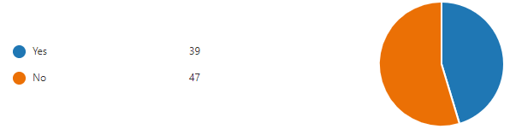
Finally, families were asked if there was one thing that would improve your child’s journey to school, what would it be. The following are a few of the main answers.
- Walking Bus/Organised Park and Walk
- Better Cycle Paths
- Better parking facilities
- Traffic Calming Measures
- More School Keep Clears and Double Yellow Lines
- Less Cars

Where do you park?

In lay-by or in adjacent street
Lumsden Crescent
Varies usually road leading into school.
Lawhead west and east
Lawhead road west/ lumsden crescent
Lawhead school wynd and Kyle gardens
School Down side street
drop at school on turning circle (don't park, don't stay) or park at West Acres
Lumsden crescent or Lawhead school wynd
Lawhead Wynd
Lumsden Cresent most of the time occasionally elsewhere
We drop off in the turning circle OR park in Lawhead Road East OR in West Acres road.
just drop off and pick up if cannot find a space in the school lay by area or out on the main road
Both walk and by car 50/50
Car usually drop off at turning circle, usually park on Hepburn Gardens for pick up.
Lawhead school wynd
Forbes Place
West Acres or Fife Park
Drop off at school main entrance
Lumsden Crescent or Lawhead Road West
Lawhead School Wynd
Main road
Lawhead School Wynd layby
Outside school gates
Either lawhead school wynd or the housing estate past the school, on the left
Lawmill Gardens, by the duck pond
Behind the school.
Don't park - drop off on Hepburn Gardens
buchanan gardens
Hepburn Gardens or Lawhead School Wynd drop off point
Lawhead school wynd
David Russel apartments
Lawhead Road West
Little Carron Gardens
Lumsden Crescent
Near to Balnacarron care home
Street behind the school
Lawmill gardens
Hepburn Gardens or Melville Road
Lumsden Crescent or West Acers
Hepburn gardens
School road
Forbes Place school car parking area

