**Name: Amy Niven**

**Position: Chair**

**Children: Lottie in P5 and Ed in P4/3. Bea is 2yo.**

**A little bit about me:**

My family moved to St Andrews when I was 9 and apart from school exchange programs, gap year adventures and my time at university, it’s been home ever since.

I loved growing up here and although so much has changed I still feel it’s a great place for our kids to grow up.

My kids love to be busy and active. When they aren’t at school you’ll usually find me ferrying them back and forth to the various clubs they attend, from dancing and horse riding, rugby and triathlon club and a fair bit in between- they like to keep me busy!!

I’m lucky to have lots of family close at hand. My parents and my husband Stuart’s family are all local to St Andrews too. I’ve been missing our usual big family get togethers lately which are some of my favourite times.

I am a self employed Architect. I mainly work with private clients on their homes although for the last few years my husband and I have moved into designing and building houses on a small development outside St Andrews in conjunction with my husband’s family firm, Stuart Niven and Son.

I have found my time on the PTA and School Council, as it was known, to be hugely rewarding and a great way to feel part of the school. Seeing the kids having fun at an event we’ve organised or hearing how equipment we’ve funded is helping their learning makes all the effort worthwhile. It’s an exciting and challenging time for the school and I hope we can continue to build on the positive start we’ve made to this academic year.

I love hearing feedback and ideas from other parents so please feel free to grab me for a chat or message me through FB.

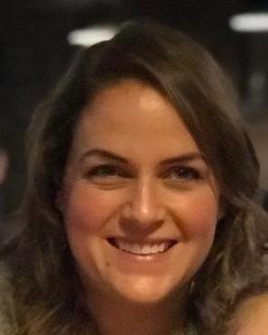

**Name: Kate Duff**

**Position: Vice Chair**

**Children: Jessica in P3 and Isabel in Lawhead Nursery**

**A little bit about me:**

My family moved to St Andrews in 2018 as my husband was starting a new job at the R&A. Having grown up just outside London, this was quite a big move for us (me in particular), especially moving away from family and friends. However we quickly fell in love with St Andrews, such a wonderful place to bring up our children and the shift in quality of life is incredible.

The girls both love school and are in to the usual activities of ballet, gymnastics, tennis, swimming and more recently golf, so that certainly keeps us busy. In between all the ferrying around, during lockdown I recently found a love of running and been enjoying discovering beautiful routes around St Andrews!

My husband and I both used to work in golf, running professional tournaments around the world. When moving up here, I left IMG however have continued to work for them on a freelance basis for a few events. This has worked really well for me whilst settling in to a new life and focusing on the children.

St Andrews and particularly the Lawhead family have been so welcoming to us as a family. Being involved in the PTA and School Council has been a great way of meeting lovely people and getting involved in school life.

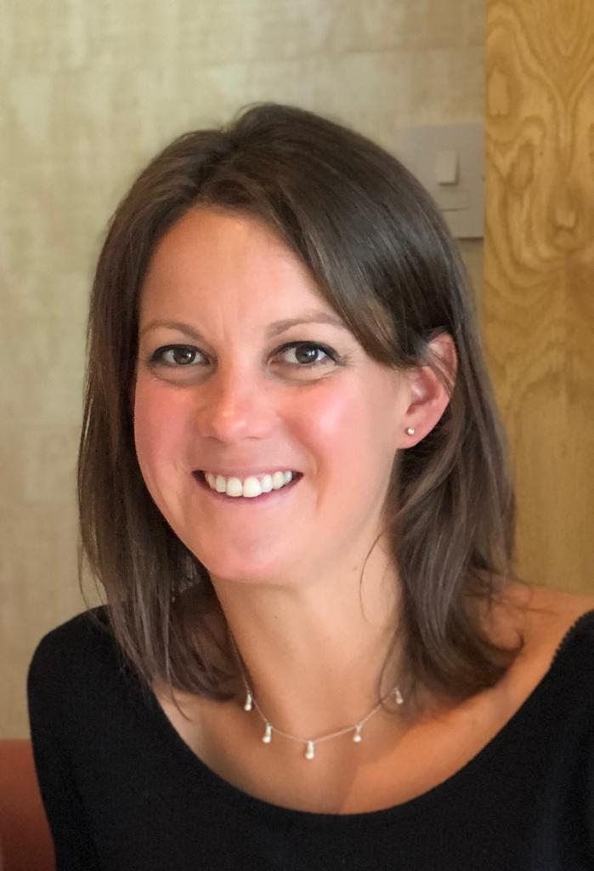

**Name: Marije Sneddon,**

**Position: Secretary**

**A little bit about me:**

Being proudly Dutch, I have lived in the UK for 15 years now and love my adopted country. My family and I moved to St Andrews in 2014 and we felt at home immediately. I have three kids and my youngest is in P3 at the moment. I have been on the school council for three years now. I joined the council as I wanted to know more about how the school works. I appreciate the direct communication from the school leadership about their decisions and point of views and find it important to increase parental involvement in the school.

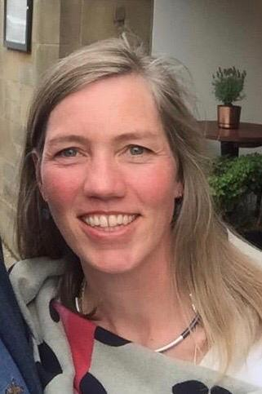

**Name: Cathy Taylor**

**Position: Treasurer**

**Children: Teddy (P3) and Max (2yo)**

A little bit about me:

I am a GP partner in the East Neuk, having moved from Edinburgh in 2015.

We absolutely love living in St Andrews and being part of the Lawhead community. We are very lucky to have so many extra curricular activities on our doorstep.

Being the least green fingered person I know I have somehow managed to start the volunteer gardening group with the help of a dedicated handful of other parents and grandparents. This is simply the beginning of paving the way to improving our children’s outdoor education.

Please feel free to stop and chat if you see me at school (usually end of week) or send me a message on Facebook.

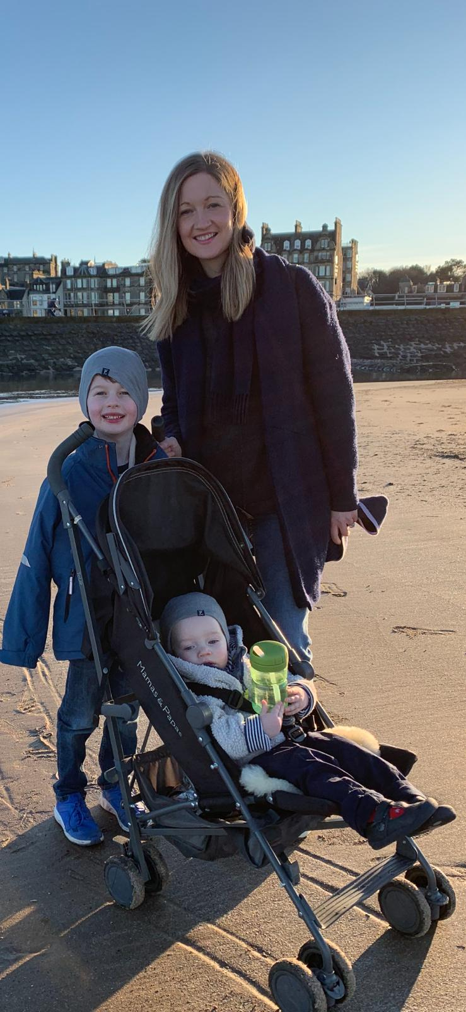

**Name: Sarah Donald**

**Position: Council Member**

**Children: Olivia (P2), Alexander (nursery), Johnny (2yrs old)**

**A little bit about me:**

Apart from a few fantastic years living and working in Mallorca, I have lived in the St. Andrews area all my life.

As a local headteacher, I fully understand the important role the Parent Council plays in supporting the school in its work with pupils and being a voice for parents and carers; I wanted to be an active participant in the life of the school and it was because of this that I joined the Parent Council when Olivia started P1.

Due to work, I rarely have the opportunity to be at the school gates - being part of the Parent Council has provided a much needed connection with the school ... and I have met some great people too!

Remember, we are here to represent your views, so please get in touch if you suggestions, questions, comments or queries...

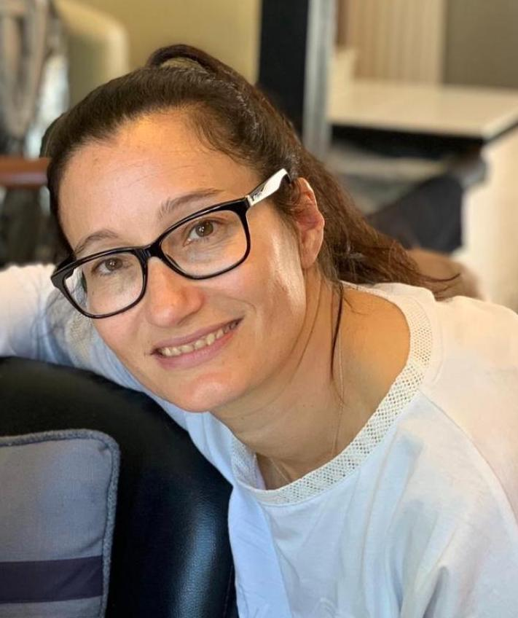

**Name: Lucy Scott**

**Position: Parent Council Member**

**Children: Emily (P4/3) Isla (P1)**

**A little bit about me:**

I have been a member of the Parent Council and PTA since 2016 when Emily attended Lawhead Nursery.

I was brought up in St.Andrews and following 4 years at Aberdeen University I returned to St.Andrews, met Brian (my husband) and the rest is history! We live out of town and so chose for our children to attend Lawhead Primary School.

I have found it incredibly valuable being a part of the Parent Council ; meeting new people, keeping up-to-date with important matters, supporting the school to see through their visions and help raise much needed funds to better our children’s learning experience.

I am a Primary School Teacher myself, currently working part-time in a small rural school and so see first hand the value of a supportive parent body.

If you would like more information about becoming more active within the school, have any questions, ideas or suggestions please feel free to chat to me.

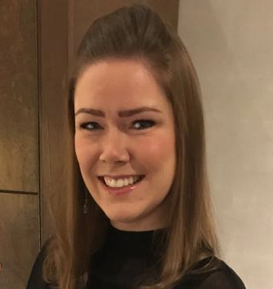

**Name: Laura Tasker**

**Position: Council Member**

**Child: Harry (P2)**

**Little Bit About Me :**

I moved to St Andrews 3 years ago and myself and my husband spent the last year building our house. I am a primary teacher in a nearby school, and although I am not at the school gates often, I am always happy to chat anytime I am! I joined the school council and PTA when Harry first started school as a way of feeling more connected, with not being able to be at the school as much as I would like due to work commitments. I’ve really enjoyed getting to meet so many other parents and families and look forward to meeting more in future!

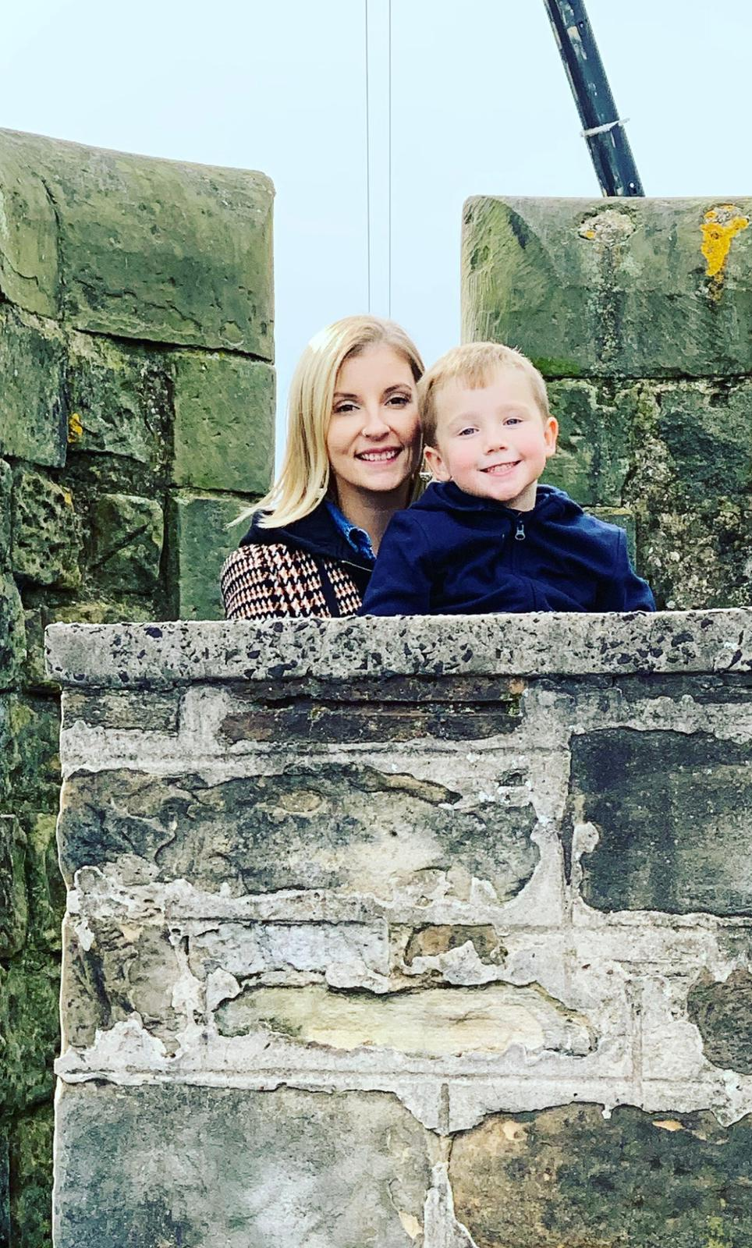

**Name: Sarah Kay**

**Position: Council Member**

**Children: Logan P2/1 and Eilidh starting nursery in January**

**A little bit about me:**

Originally l’m from central Scotland but l’ve had a long time away doing various work and travels and spent the last 12 years in London. After having the kids my husband and I decided to return and we moved to St Andrews last year.

We’ve loved being back, St Andrew’s is such a lovely community and a great place for children to grow up with so much outdoor space. Joining the council was an opportunity to meet other parents and be more involved with activities for the children. It’s been great getting to meet families through various events and seeing Logan settle into a great school.

Always happy to chat, please feel free to approach me anytime.

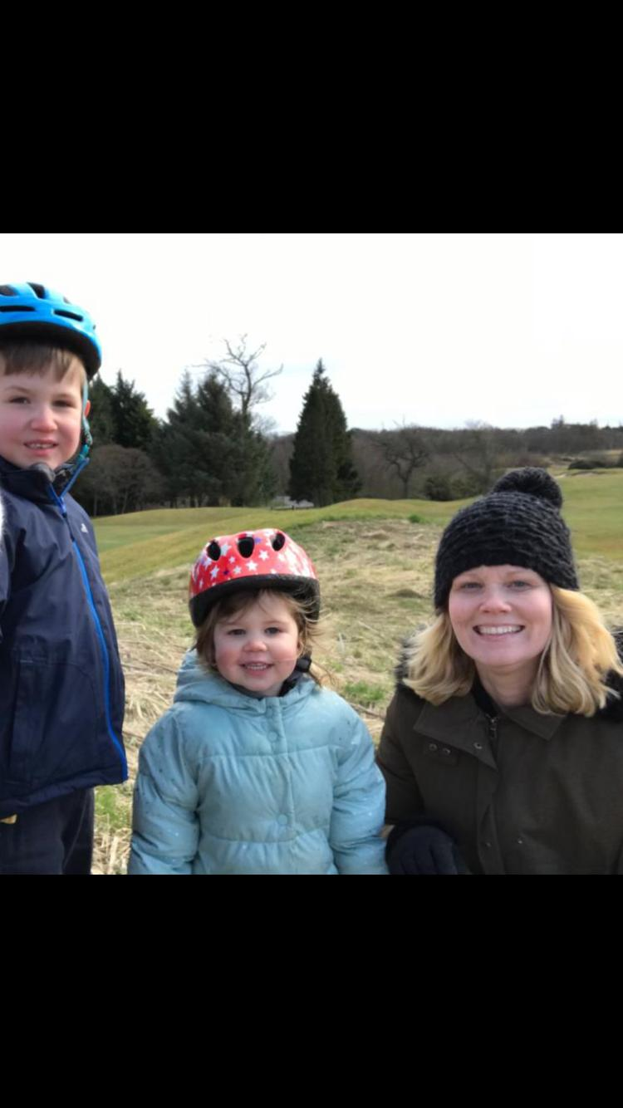

**Name: Pam Robinson.**

**Position: Community Member**

**A little bit about me:**

We moved to St. Andrews, from Northern Ireland, 5 years ago to be near our daughter and her family. The golf was a big plus for my hubby! I’m Cathy Taylor’s mum and Teddy P3’s gran. I was asked to join the School Council as a Community Member, but had already been a volunteer on the gardening group. As well as working in banking for 35 years, before moving here I had many voluntary roles; School Governor, PTA , Brown Owl, Guiding District Commissioner , Church Assistant Treasurer etc. I love being involved in the local community here and am honoured to be on Lawhead School Council.

../../../../Desktop/Pam%20pic.pdf

**Name: Diane Palmer**

**Position: Community Member**

**Children: Grandparent to Lottie and Eddie Niven.**

**A little bit about me:**

I was born and grew up in Dunfermline. I went on to live in lots of different countries and places over the years, returning to Scotland in 1989.

After a career in advertising, I trained as a primary school teacher as my own children reached school age. I was a headteacher in two schools in Fife and one in Edinburgh prior to retiring a couple of years ago.

I love being a Granny and love spending time with my four (soon to be six!) grandchildren. My husband and I enjoy spending our free time walking, going for drives in my husband’s classic MG and holidaying in Devon in our caravan.

I’m delighted to be a community member of the parent council and able to contribute to and support Lawhead school.

