
Ladybank Primary School
47 Church Street,
Ladybank,
Fife.
KY15 7LE
01334 659424
ladybankps.enquiries@fife.gov.uk

Site Traffic Management Plan

August 2024

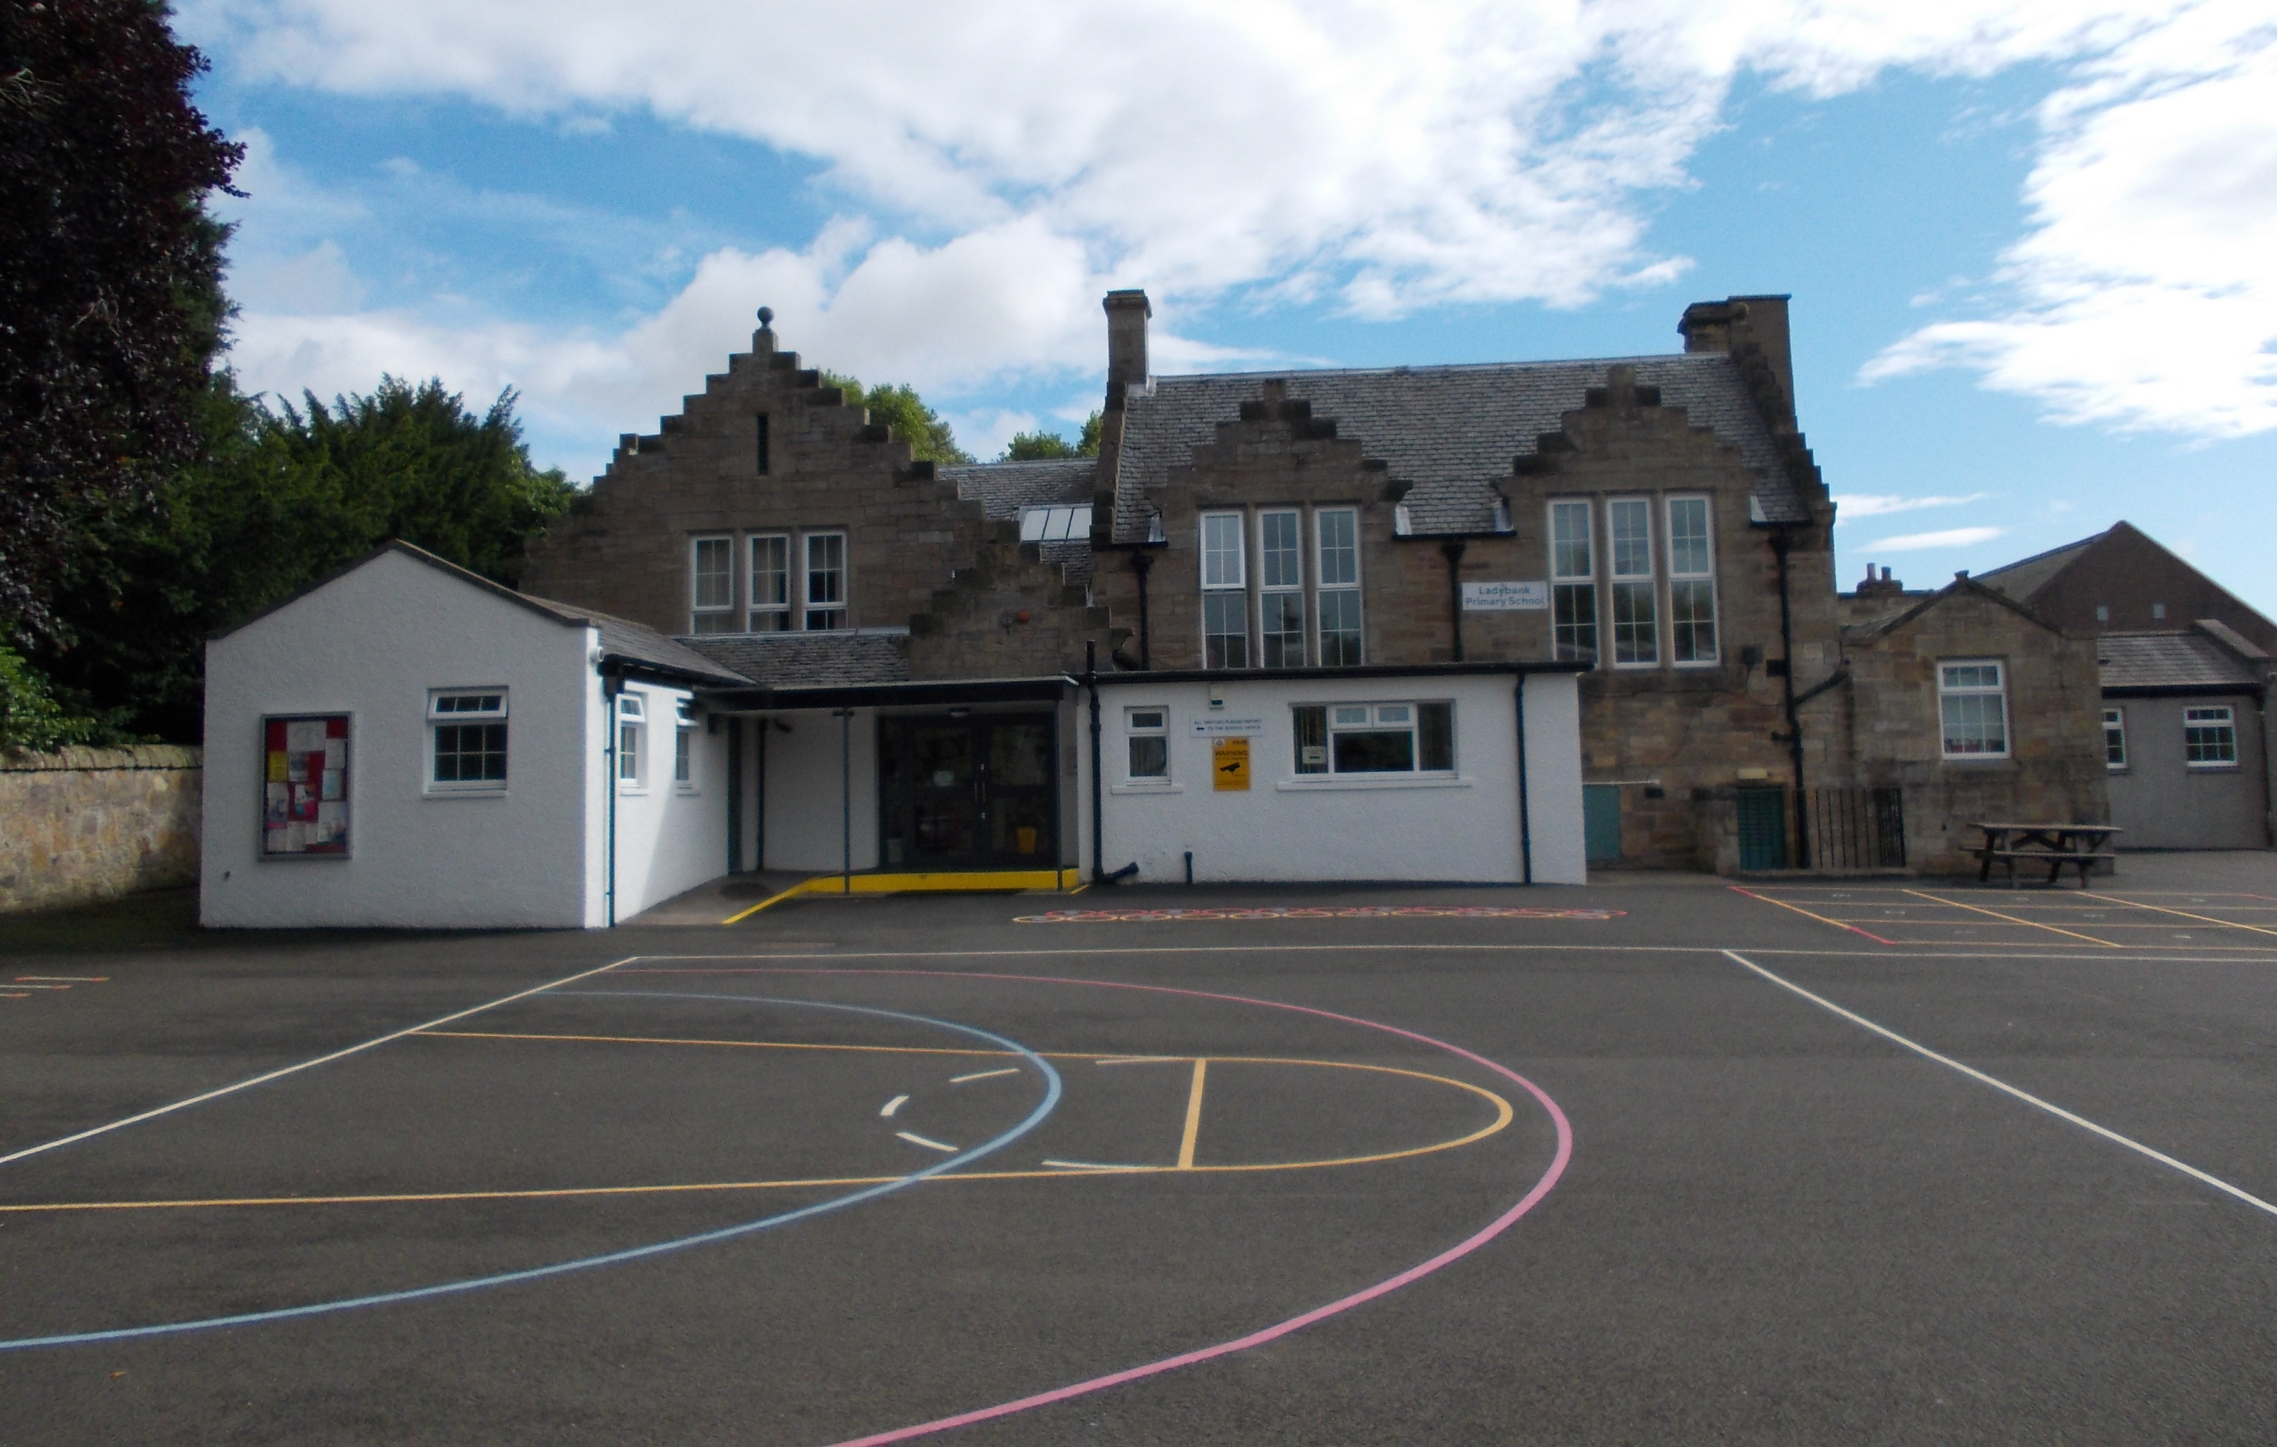

Contents

Section

- Introduction
- Layout / Access
- Pedestrians
- Pupils / Students
- Staff
- Visitors
- Servicing / Deliveries
- School Buses
- Contract Hire Services
- Disabled Access
- Out with the School Grounds
- Management Practices
Appendix A

1. Introduction

This document has been prepared to inform and instruct employees, pupils, parents and others who come onto the site, including visitors (both pedestrians and people in vehicles), about the site rules concerning pedestrian and vehicle separation.

Ladybank Primary School takes the health and safety of all site users very seriously. It is therefore, imperative that individuals take care, exercise caution when in the school grounds or within the vicinity of the school grounds and follow instructions to avoid risk of injury. If there are any concerns about traffic safety, they should be reported to the school management team.

We urge all site users to read this document carefully and act in accordance with the instructions contained therein. The instructions constitute site rules. Pupils in breach of the site rules may be subject to disciplinary action.

Copies of this document have been given to school staff, pupils, parents and carers via email and shared in class (pupils). Copies are also available from reception. The document will be reviewed annually and awareness raised regularly through parental events, pupil sub-groups, assemblies and school meetings.

For further information, please contact:

Lesley O’Brien, Headteacher on 08451 55 55 55 + ext. 451278 ladybankps.headteacher@fife.gov.uk

2. School Layout / Access

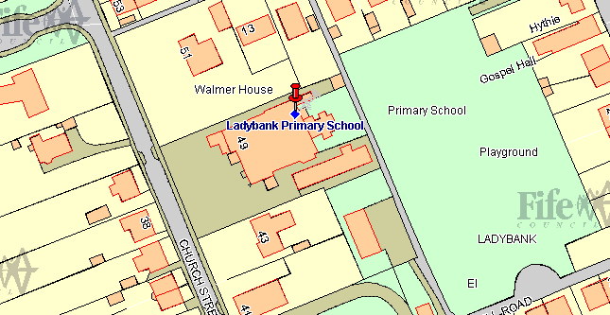

Main entrance
Rear entrance for staff only
Main pedestrian access from Church Street.
Access to building for workmen out with beginning and end of day and break times.

Staff and visitor car park to rear of building in Scout Hall grounds.

3. Pedestrians

There is a pavement at the front of the school and pedestrians should make sure that they use this safely and avoid spilling onto the road. Pupils walking in groups should take this into account and allow other users to pass safely.

Pedestrians should only access the school from the designated entry point at the main entrance.

Designated Entry Points

Pedestrians should follow the local footpaths to Church Street where there is a pedestrian access point to the playground which leads to the main entrance. Entry into the school building is through a set of double doors.

4. Pupils

It is very important that pupils set a good example to others, particularly in the spirit of being a safe school. There are a number of site related areas pupils should be aware of:
- Pupils should be particularly aware that entry into the school ground via vehicular access points (school car parks, bus park and the service area) is strictly forbidden. Whilst this may seem a quick way into the school, it is a breach of the site rules and compromises personal safety and the safety of others.
- Pupils found to be climbing over railings or walls, not following staff instructions in relation to the site, or not adhering to the contents of this plan will be in breach of the site rules and may be subject to disciplinary action.

Drop Off
There is no designated on site drop off for pupils. No vehicle should be accessing the car park for this purpose, without permission.

5. Staff

There is a car park to the rear of the school building which can be used by staff and visitors during the school day. Drivers should proceed slowly within the car parks at all times.

Staff are expected to act responsibly on the site when parking and accessing the school building. If you are aware of unauthorised use of parking bays, this should be reported via the school receptionist or to the school’s Business Manager who will inform/remind the offending driver of the correct use of the site. It would be helpful if staff could supply the school with your registration number so that you can be contacted if there is a need to do so.

6. Visitors

Visitors are welcome to park in the school grounds, but should only use the car park noted in section 5 and as illustrated in section 2. The car park is often busy, however visitors should only park in available designated bays. Doing so will allow unrestricted movement of other vehicles during the school day or at peak times.

Alternative on street parking is available in the surrounding area, but if you are unfamiliar with the area, please make sure that you do not block residential driveways or park where this could cause an obstruction.

Access into the school is only permitted from the main entrance on Church Street. Visitors need to press the security buzzer located outside the external double doors and wait for the doors to open. All visitors must report to reception and sign in before going anywhere in the school. On departure, visitors should sign out at reception and leave the building by the main entrance door.

If visitors need any advice on access or parking before their visit, please call the school reception on 01334 659424.

7. Servicing / Deliveries

Drivers of service vehicles (if they have not been on the site before or obtained instruction in advance) should report to the reception desk in the main building to advise the nature of their visit and get clarification on where they can park. Drivers may be issued with a copy of this plan for reference or simply be advised of the site rules in relation to the area they are parking at the time.

Where the contractor is on site to carry out works by prior arrangement, please call the school reception on 01334 659424 in advance to agree the most suitable parking location.

Where work is carried out in the playground and vehicles must be present, drivers should not move vehicles in the playground between 8:30-9:15, 2:45 and 3:15, at break times or during after school activities.

Drivers should be aware that they are working in a school environment - exercise extreme caution and be vigilant when carrying out vehicle manoeuvres in any part of the school grounds.

8. School Buses

Mini-buses that collect mainstream pupils should park down from the yellow hazard lines on the school side of Church Street.

The bus should be at a complete stop before allowing pupils to get on or off the mini-bus with the engine switched off. Only when pupils are clear of the vicinity or all on board, should drivers begin the journey.

Pupils are reminded about good conduct around the bus park in section 4 of this plan, however if there are any other concerns about how this is being managed; they should be raised with the Headteacher.

9. Contract Hire Services

Contracted vehicle drivers (including taxis and minibuses) will have specific instructions given to them through Transportation & Environmental Services as part of the terms of the contract. However there are some specific comments to make in relation to the site at Ladybank.

Minibus and Taxis for mainstream pupils

These vehicles should park on school side of Church Street at either side of the yellow hazard lines and come in to school to collect the child/children.

- Contracted vehicles should limit the use any reverse movements. These should only be carried out where there is ample space to do so, where there are no adults or pupils in the vicinity.

- Pupils who are transported by contracted vehicles should be dis/embarked on the pavement side only. No pupil should be on the concourse at any time. No driver should allow exit or entry from/into the vehicle if not within the drop off zone.

10. Disabled Access

Disabled access is primarily via the main front entrance. Alternative disabled access into the building is via janitor’s office round the back of the school building.

Parking
There are no disabled bays in the car park.

If visitors, staff or pupils require information on access or any other considerations, they should contact the school reception in the first instance on 01334 659424.

11. Outwith the School Grounds

The school accepts that parking near the school is not easy. Church Street is a residential street, used by Service buses as well as car traffic into and out of the surrounding area. It is important that the school is a good neighbour to local residents. Parents/Carers are encouraged not to park near the school and allow their children to walk the remaining distance if they drop them off further away.

Parking indiscriminately, such as mounting pavements, double parking, stopping on any yellow lines, obstructing access points to streets and driveways and parking near junctions causes danger to pupils and other road users. Accidents can arise if views are obstructed or pedestrians have to negotiate between parked vehicles. In addition, the roads can become congested which results in frustration and delays to services and ongoing journeys.

Please act responsibly by parking as far away from the school as possible to keep the pupils at Ladybank Primary School, local residents and other road users safe.

12. Management Practices

Key to the ongoing monitoring of the plan is the role of school managers and other staff. All staff have a responsibility to make sure that they are acting in such a way as to not compromise the health and safety of themselves or others.

Supervision

The Headteacher will spot check access to the school. Janitorial staff will be providing limited monitoring of the access to the school. High visibility waistcoats will be worn when carrying out this duty.

Monitoring of compliance against this plan

The Headteacher will spot check access to the school. Where issues arise with vehicular access, taxi/minibus drivers and staffing, these will be dealt with or escalated by the school Business Manager. The Headteacher will be responsible addressing the conduct of all pupils where this is not consistent with the requirements of this plan.

Non-compliance

If there are concerns or incidents that constitute non-compliance these will be recorded on the form by those monitoring the site and appropriate action will be taken. This includes possible disciplinary action and reports going to Contractor or Service management which may result in investigative action. On days where there is no monitoring carried out and there is an instance of non compliance, these should be escalated immediately to the Headteacher who will make a record on the form and take appropriate action.
Appendix A

Traffic Management Plan
Weekly Site Monitoring Form

Completed by: Headteacher/Business Manager (delete as applicable)

Date | Area | Observations | Incidents | Signed by

