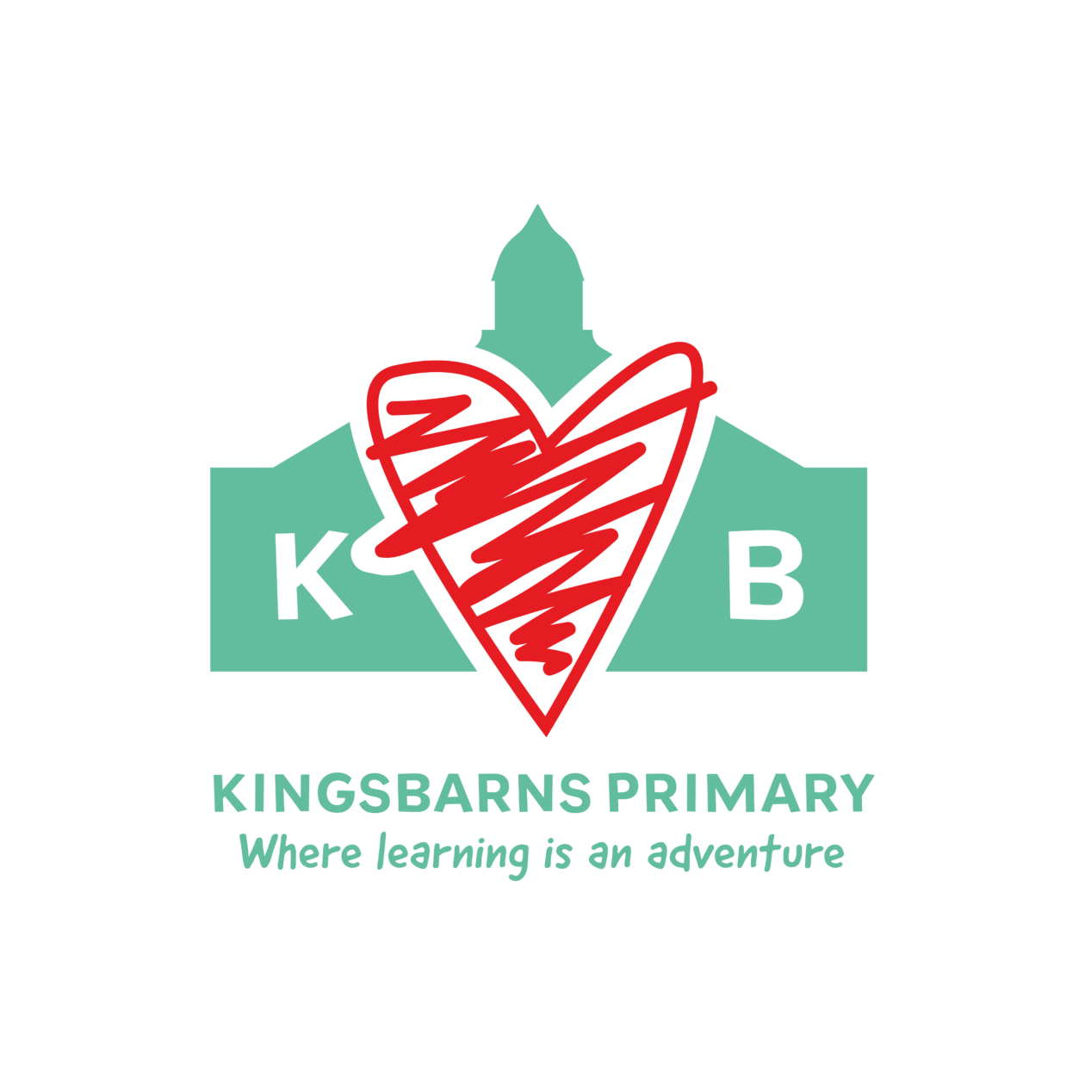
Rights Respecting Steering Group

Purpose
The Rights Respecting Steering Group ensures that children’s rights are understood, respected, and embedded across school life at Kingsbarns, in line with the UN Convention on the Rights of the Child (UNCRC).

Steering Group
- 2 older pupils from p4-6
- 2 younger pupils from p2-3
- 1 adult

Aims
- Raise awareness of children’s rights
- Ensure children’s voices are heard
- Make rights visible in daily school life
- Support wellbeing, behaviour, and inclusion (and our school values)
- Prioritise goals based on information from pupil/staff questionnaire:
- 22% only sometimes felt that they were valued for being themselves at school.
- 31% felt that other pupils were only sometimes kind and helpful.
- 22% said ‘no’ they could not tell an adult at school if they had a worry (13% said sometimes).
- 50% said that the school celebrates different backgrounds and cultures. 28% said sometimes and 13% said no. Possibly - ‘taste the world’ families bring food from places of origin or where they have links?
-25% (a quarter of children) said that they sometime enjoyed being at school and 9% said ‘no’.
- 44% said they sometimes felt positive about their learning. Looking at Growth Mindset
- Only 38% had talked about children’s rights with another person outside school in the last three months. Rhino?
- From the adults in school:
32% were not sure if the school encourage and support pupils to advocate for children’s rights locally and globally.

How the Group Works
- Meet once a month
- Focuses on 1–2 rights each meeting
- Create rights displays and posters
- Lead assemblies (Mrs Beckett already planning) and class discussions
- Gather pupil voice feedback
- Link rights to behaviour and school values

Impact & Review
- Termly review of pupil understanding
- Evidence through displays, assemblies, surveys
- Celebrated through certificates and school communications

UNICEF Rights Respecting School Award Alignment

Knowledge & Understanding
- Children learn about specific UNCRC articles each term
- Rights explained in age-appropriate language
- Peer-to-peer learning led by steering group

Teaching, Learning & Assessment
- Rights linked to behaviour expectations
- Rights language used in classrooms and playgrounds
- Pupil feedback informs staff

Leadership, Participation & Wellbeing
- Children actively involved in decision-making
- Steering group gathers and reports pupil voice
- Children feel safe, respected, and listened to

Evidence the Group Can Provide
- Meeting notes and action plans
- Photos of displays and events
- Pupil voice surveys and quotes
- Assembly plans and presentations

Our Rights Respecting Group
Who is in the group?
- 2 older children
- 2 younger children
- 1 grown-up to help us

Roles:
- Chair (p6 Marna): Helps lead meetings and keeps everyone involved
- Vice-Chair (p3 Woody): Helps with ideas and reminds the group of children’s views
- Rights Reporter (p4 Angus): Shares group ideas with classes and assemblies
- Creative Champion (p3 Emma): Leads posters, drawings, displays and activities

Who are we?
We are a small group of children who help everyone learn about children’s rights and make our school fair, safe, and happy.
Who is in the group?
- 2 older children
- 2 younger children
- 1 grown-up to help us

What do we do?
- Learn about children’s rights
- Tell other children about their rights
- Listen to children’s ideas and worries
- Help make school a better place
How do we help?
- Make posters and drawings
- Talk in assemblies
- Visit classes
- Share children’s ideas with teachers

Our Rights Respecting Mission Statement
“Kingsbarns Primary School is a place where everyone is safe, listened to, and treated fairly.
We know we have rights, and we respect the rights of others.
We include everyone, celebrate our differences, and work together to make our school a happy place to learn and grow.”

Article 2 – All children have the right to be treated fairly and included
Article 3 – Adults should always do what is best for children
Article 12 – Children have the right to have their voice heard
Article 19 – Children have the right to be safe
Article 28 – Children have the right to learn

Created by the Rights Respecting Steering Group

First Steering Group Meeting
Welcome
- Mrs Griffin welcomes pupils
- Everyone shares their role and favourite thing about school.

What Are Children’s Rights?
- Simple explanation of children’s rights
- Introduce the UN Convention on the Rights of the Child (UNCRC)
- Discuss: Why are rights important?
Our Job as the Steering Group
- Explain the purpose of the group
- Agree group rules (listening, taking turns, respect)
- Decide roles (Chair, Vice-Chair, Reporter, Creative Champion)
Choosing Our First Right of the Month
- Look at the results from our pupil questionnaire
- Discuss which rights need focus within Kingsbarns
- Vote or agree together on the first right we will look at as a school.
Next Steps & Close
- Decide one small action (e.g. poster, assembly idea)
- Confirm when the group will meet again
- Celebrate everyone’s ideas and thank the group

Second Steering Group Meeting
- Quick discussion: What went well since our last meeting?
- Share any comments children have heard from other pupils.
Review Our First Right of the Month
- Look at posters, displays or activities completed
- Discuss:
  - Did children notice the right?
  - What worked well?
  - What could we improve?
Pupil Voice Time
- Class feedback
- Discuss any worries or ideas raised by pupils
Plan the Next Right of the Month
- Introduce the new right
- Decide:
  - What display or activity to create
  - Whether to share in assembly or classes
  - Which children will help with each task
Next Steps
- Agree one goal before the next meeting
- Confirm next meeting date

Rights of the Month – Long Plan for Mrs Griffin within class.
This plan supports whole-school awareness of children’s rights with in Kingsbarns.

Spring Term
Jan/Feb – Article 12: The Right to Be Heard
Focus: Children’s voices matter
Activities: Class discussions, suggestion box, pupil voice survey
March– Article 19: The Right to Be Safe
Focus: Feeling safe in school and playground
Activities: Safety posters, playground expectations linked to rights
– Article 28: The Right to Learn
Focus: Respecting learning and school rules
Activities: Classroom charters, learning behaviours linked to rights

Summer Term
April – Article 24: The Right to Be Healthy
Focus: Physical and mental wellbeing
Activities: Healthy choices week, mindfulness or wellbeing focus
– Article 2: The Right to No Discrimination
Focus: Fairness, equality and inclusion
Activities: Diversity discussions, kindness challenges
May – Article 31: The Right to Play and Rest
Focus: Importance of play and downtime
Activities: Playground surveys, play leaders, quiet zones
– Article 29: The Right to Be the Best You Can Be
Focus: Encouragement, effort and achievement
Activities: Celebration boards, goal-setting activities
June – Article 6: The Right to Life, Survival and Development
Focus: Growing, learning and feeling supported
Activities: Transition discussions, emotional support awareness
– Article 42: The Right to Know Your Rights
Focus: Celebrating learning about rights
Activities: Rights Respecting Week, assemblies, pupil-led activities

Review & Celebration
- Steering group reviews impact each term
- Collect pupil voice and photos as evidence
- Celebrate achievements in assemblies and newsletters

